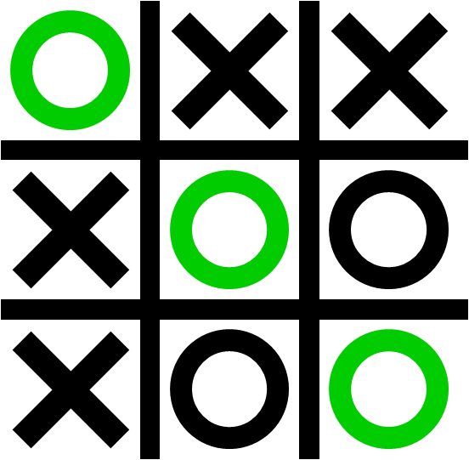 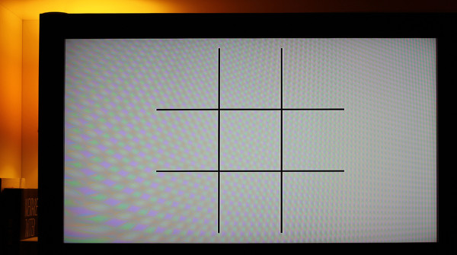

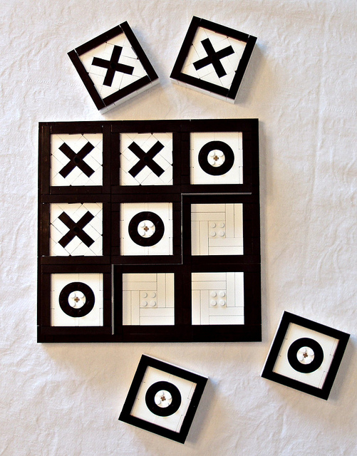 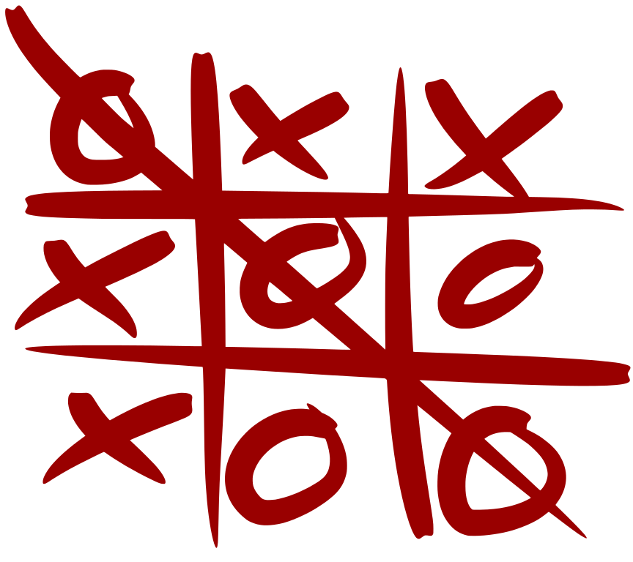

**TIC TAC TOE**

**SOURCE CODE**

#include <iostream>

using namespace std;

char box[]={'O','1','2','3','4','5','6','7','8','9'};

void playboard()

{

cout<<"Tic Tac Toe"<<endl;

cout<<"Player 1: X"<<endl<<"Player 2: O"<<endl;

cout<<" | | "<<endl;

cout<<" "<<box[1]<<" | "<<box[2]<<" | "<<box[3]<<endl;

cout<<"____|____|____"<<endl;

cout<<" | | "<<endl;

cout<<" "<<box[4]<<" | "<<box[5]<<" | "<<box[6]<<endl;

cout<<"____|____|____"<<endl;

cout<<" | | "<<endl;

cout<<" "<<box[7]<<" | "<<box[8]<<" | "<<box[9]<<endl;

cout<<" | | "<<endl;

}

int checkwin()

{

if(box[1]==box[2] && box[2]==box[3])

return 1;

else if(box[4]==box[5] && box[5]==box[6])

return 1;

else if(box[7]==box[8] && box[8]==box[9])

return 1;

else if(box[1]==box[4] && box[4]==box[7])

return 1;

else if(box[2]==box[5] && box[5]==box[8])

return 1;

else if(box[3]==box[6] && box[6]==box[9])

return 1;

else if(box[1]==box[5] && box[5]==box[9])

return 1;

else if(box[3]==box[5] && box[5]==box[7])

return 1;

else if(box[1]!='1' && box[2]!='2' && box[3]!='3' && box[4]!='4' && box[5]!='5' && box[6]!='6' && box[7]!='7' && box[8]!='8' && box[9]!='9')

return 0;

else

return -1;

}

int main()

{

int player=1,i,choice;

char mark;

do

{

playboard();

player=(player%2)?1:2;

cout<<"Player: "<<player<<endl<<"Enter your choice: ";

cin>>choice;

mark=(player==1)?'X':'O';

if(choice==1 && box[1]=='1')

box[1]=mark;

else if(choice==2 && box[2]=='2')

box[2]=mark;

else if(choice==3 && box[3]=='3')

box[3]=mark;

else if(choice==4 && box[4]=='4')

box[4]=mark;

else if(choice==5 && box[5]=='5')

box[5]=mark;

else if(choice==6 && box[6]=='6')

box[6]=mark;

else if(choice==7 && box[7]=='7')

box[7]=mark;

else if(choice==8 && box[8]=='8')

box[8]=mark;

else if(choice==9 && box[9]=='9')

box[9]=mark;

else

{

cout<<"invalid move";

player--;

cin.ignore();

cin.get();

}

i=checkwin();

player++;

}

while(i==-1);

playboard();

if(i==1)

cout<<"Player "<<--player<<" WINS";

else

cout<<"Match Draw";

cin.ignore();

cin.get();

return 0;

}

**OUTPUT**

**1.**

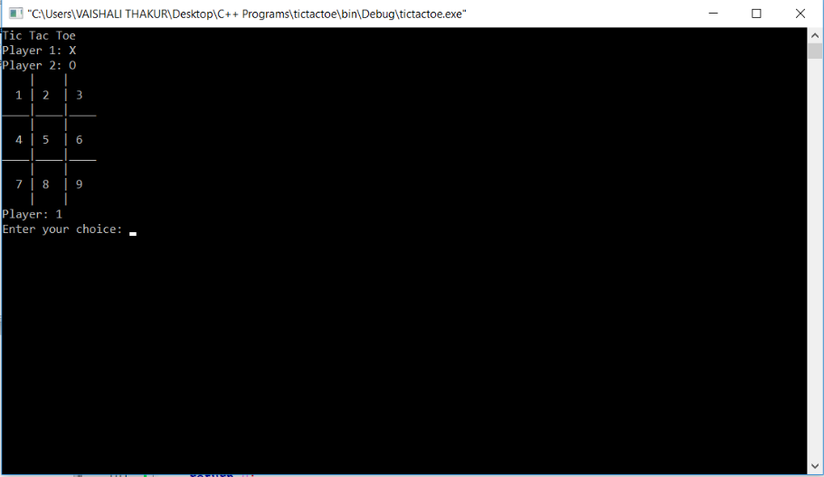

**2.**

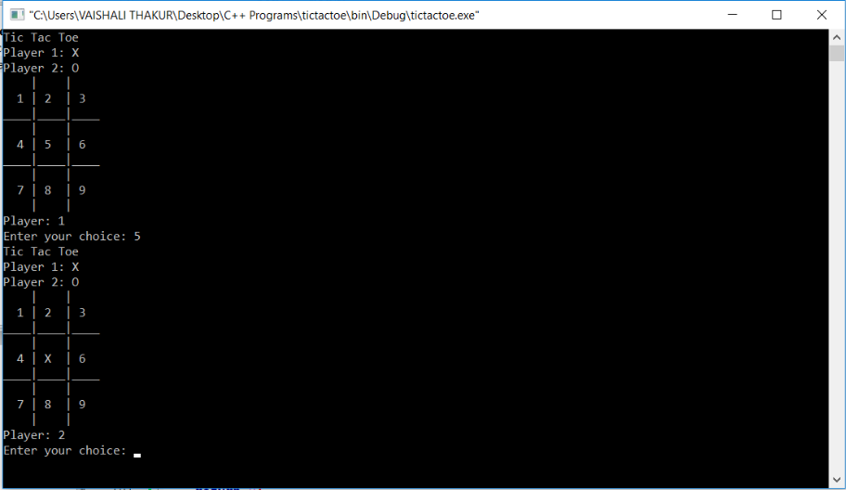

**3.**

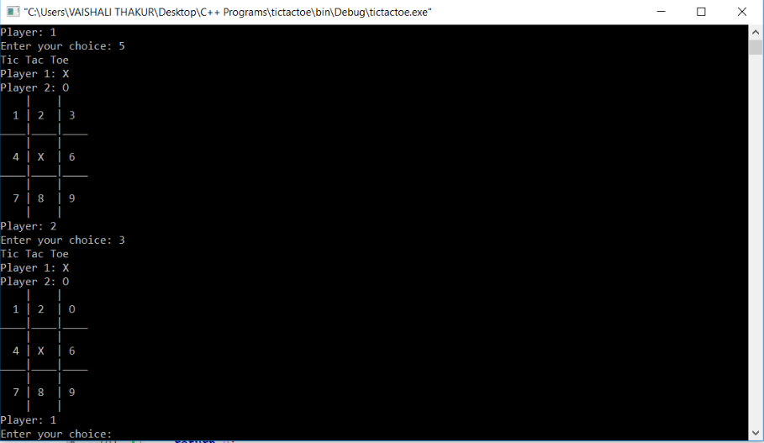

**4.**

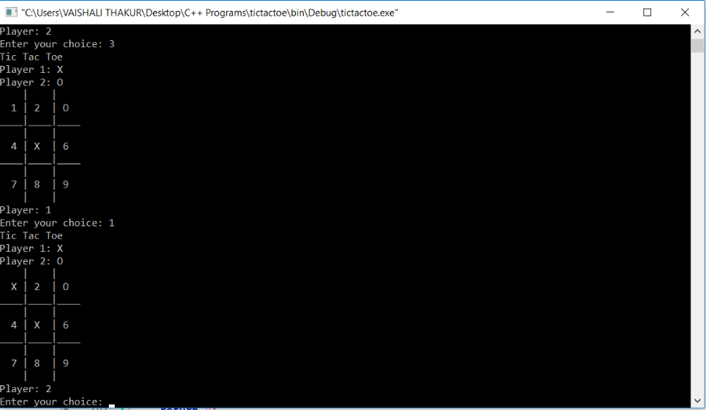

**5.**

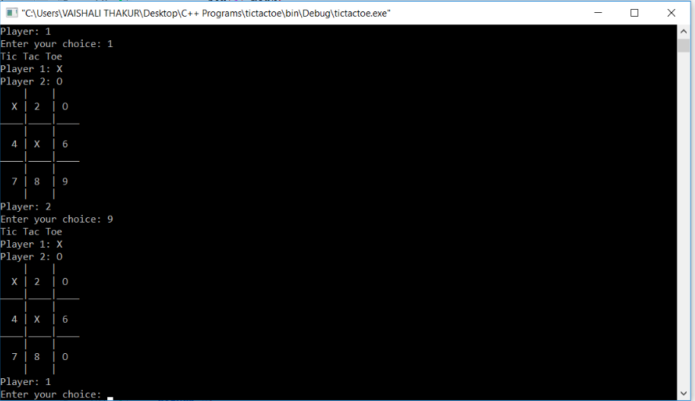

**6.**

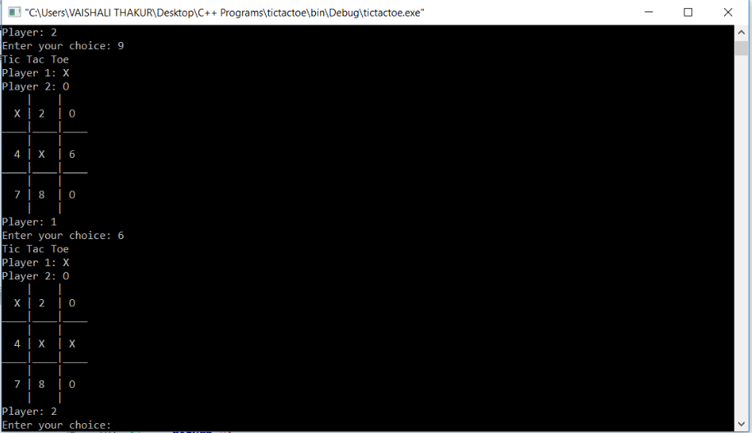

**7.**

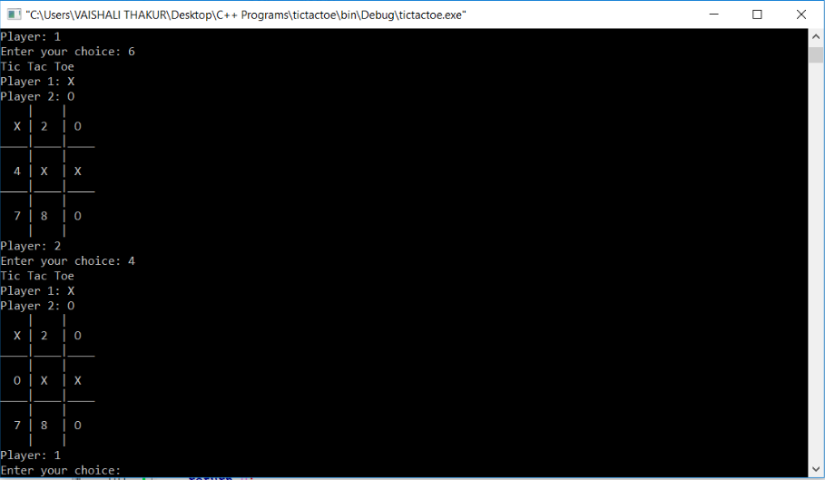

**8.**

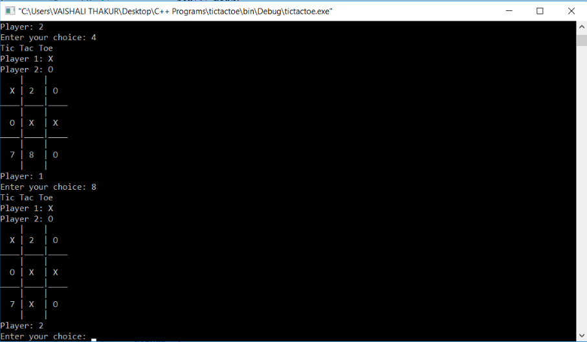

**9.**

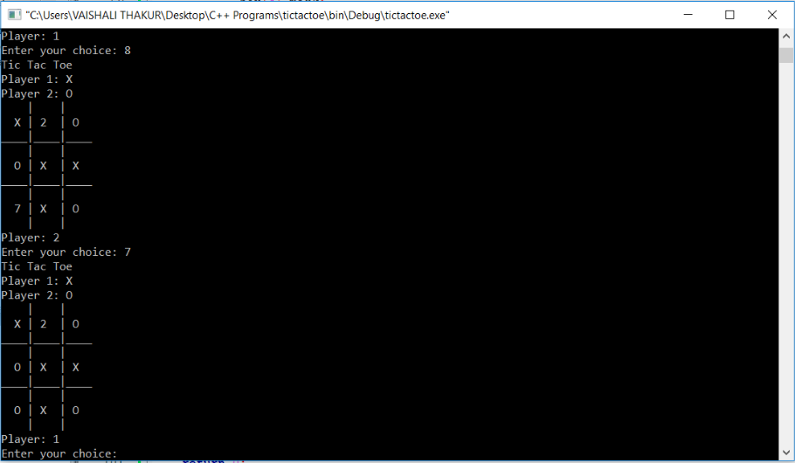

**10.**

