DESCRIPTIVE ANALYTICS REPORT
Uber Ride Bookings — National Capital Region
Booking Volume, Cancellations, Ratings, Demand & Vehicle-Type Performance — Full Year 2024
Dataset: ncr_ride_bookings.csv • 150,000 bookings • Jan – Dec 2024
Currency: figures reported in USD (converted at $1 = ₹95.30)
Prepared: August 2026

Table of Contents
1. Objective
2. Data Dictionary & Methodology
3. How This Would Work at Real Scale
4. Answering the Objective Questions
5. Daily Booking & Revenue Trend
6. Hourly Demand Pattern
7. Best-Selling Vehicle Types
8. Booking Status & Funnel Health
9. Rating Distribution
10. Regional Demand
11. Ride Distance & Fare Distributions
12. Why Rides Get Cancelled
13. Service Time: Driver Arrival vs. Ride Completion
14. Payment Method Mix
15. Customer Base Overview
16. Summary of Key Metrics
17. Limitations & Data Notes
18. Business Recommendations
19. Next Steps to Move From Descriptive → Predictive
Appendix A: Booking Status by Vehicle Type
Appendix B: Booking Status by Month

Note on data: This report is built on a real dataset of 150,000 Uber ride bookings across the National Capital Region (NCR — Delhi, Gurgaon, Noida) covering all of 2024 (ncr_ride_bookings.csv). It includes booking status, vehicle type, pickup/drop locations, cancellation reasons, ratings, fares, and ride distance for every request — not just completed trips — so it captures the full demand funnel, not just fulfilled orders.
Note on currency: The source dataset records fares in Indian Rupees (₹). All monetary figures in this report have been converted to US Dollars at a rate of $1 = ₹95.30 (mid-market rate, August 2026) so the report can be read in a currency-neutral way. Ride counts, ratings, distances (km), and time-based metrics are unaffected by this conversion.

1. Objective
Build a descriptive analytics layer over Uber's ride-booking data to answer five recurring operations and growth questions:
- How is total booking volume and revenue trending over the year?
- Which vehicle types drive the most completed rides and revenue?
- What share of requested rides actually get fulfilled — and where does the funnel leak?
- How are drivers and customers rated, and how tight is that distribution?
- Where is ride demand concentrated geographically, and why do cancellations happen?
Section 3 below answers each of these directly before the report walks through the full supporting detail chart by chart.

2. Data Dictionary & Methodology
The source file contains 21 fields per booking record. The table below documents each field as used in this report, so every chart and metric downstream can be traced back to a specific column.
Field | Description
Date / Time | Calendar date and clock time the booking request was placed
Booking ID | Unique identifier for the booking request
Booking Status | Final outcome: Completed, Cancelled by Customer, Cancelled by Driver, No Driver Found, or Incomplete
Customer ID | Unique identifier for the rider who placed the request
Vehicle Type | Fleet category requested: Auto, Bike, eBike, Go Mini, Go Sedan, Premier Sedan, or Uber XL
Pickup / Drop Location | Named zone where the ride started and ended
Avg VTAT | Vehicle Turnaround Time — minutes between booking and driver arrival
Avg CTAT | Customer Turnaround Time — minutes between booking and trip completion
Cancellation Reason (Customer / Driver) | Free-text reason code captured at the moment of cancellation
Incomplete Rides Reason | Reason code for a trip that started but did not finish
Booking Value | Fare charged for the ride, in Indian Rupees (converted to USD in this report)
Ride Distance | Trip distance in kilometers
Driver Ratings / Customer Rating | 1–5 rating given after a completed ride
Payment Method | How the completed ride was paid for: UPI, Cash, Uber Wallet, Credit Card, or Debit Card
Methodology: every metric in this report is computed directly from the raw CSV using pandas — no sampling. 'Completed rides' filters to Booking Status = Completed before computing fare, rating, distance, and payment metrics, since those fields are only populated for completed trips. 'All bookings' figures (funnel, hourly demand, location demand) use the full 150,000-row dataset regardless of outcome, since a cancelled or unfulfilled request is still a real demand signal.

Glossary of Terms
Term | Meaning
VTAT | Vehicle Turnaround Time — minutes from booking confirmation to the driver arriving at pickup
CTAT | Customer Turnaround Time — total minutes from booking confirmation to trip completion
Completion rate | Completed rides ÷ total booking requests, for a given group (vehicle type, day, etc.)
Funnel | The full path a booking request takes from placement to its final outcome (completed, cancelled, unfulfilled)
Hero SKU / vehicle | A single option that accounts for a disproportionately large share of total volume
7-day rolling average | The average of a metric over the trailing 7 days, used to smooth daily noise and reveal the underlying trend
NCR | National Capital Region — the Delhi, Gurgaon, and Noida metro area covered by this dataset

3. How This Would Work at Real Scale
Uber processes ride events continuously across hundreds of cities. Processing that volume is an engineering problem before it's an analytics one. A realistic architecture:
Layer | Purpose | Typical tools
Ingestion | Capture each ride event (request, accept, cancel, complete) in real time | Kafka / Kinesis from the rider & driver apps
Stream processing | Roll up raw events into per-vehicle-type, per-zone, per-minute aggregates | Spark Structured Streaming / Flink
Storage | Hold raw trip events (audits, disputes) and pre-aggregated tables (speed) | Data lake (S3) + warehouse (Snowflake/BigQuery/Redshift)
Batch aggregation | Nightly rollups: daily bookings, cancellation rates, rating averages, city-level demand | Airflow-orchestrated SQL / dbt jobs
Serving / BI layer | Dashboards refreshed hourly for ops, daily for city managers | Looker / Tableau / Power BI
The report below reflects the output of that pipeline — daily aggregated tables over a full year of bookings — not raw event-level data, since no dashboard renders 150,000 individual rows usefully.

4. Answering the Objective Questions
Before the detailed walkthrough, here are direct answers to the five questions this report was built to address.
Q1 — How is total booking volume and revenue trending over the year?
Volume is flat and stable: daily bookings range narrowly between 355 and 462 across all 365 days, with no strong seasonal growth or decline trend and only mild weekly noise (see Section 4). Total 2024 revenue from completed rides came to $495,914 across 93,000 completed trips.
Q2 — Which vehicle types drive the most completed rides and revenue?
Auto is the clear leader with 23,155 completed rides (25% ahead of the next closest, Go Mini). Because average fare is nearly identical across vehicle types (roughly $5.28–$5.37), the revenue leaderboard tracks the ride-count leaderboard almost exactly — see Section 5.
Q3 — What share of requested rides get fulfilled, and where does the funnel leak?
Only 62.0% of the 150,000 requests convert into a completed ride. The single biggest leak is driver-side cancellation (18.0% of all requests), followed by 'No Driver Found' (7.0%) — pure lost demand with no fault on either side. See Section 7.
Q4 — How are drivers and customers rated, and how tight is the distribution?
Average driver rating is 4.23/5 and average customer rating is 4.40/5, both tightly banded (drivers rarely fall below 3.0). The distribution is healthy overall, but Section 8 explains how this view should be segmented in production to catch early warning signs.
Q5 — Where is demand concentrated, and why do cancellations happen?
Demand is unusually well-distributed across 176 pickup zones — the busiest zone (Khandsa) accounts for just 0.6% of all requests, so there's no single hotspot to over-index on. Cancellation reasons are similarly spread evenly across causes on both the customer and driver side, meaning no single root cause dominates. See Sections 9 and 11.

5. Daily Booking & Revenue Trend
Across the 2024 calendar year: 150,000 total booking requests, of which 93,000 (62.0%) were completed, generating $495,914 in booking value. Volume is remarkably flat year-round — daily bookings range narrowly from 355 to 462, with no strong weekly or seasonal swing, which is typical of a synthetic-but-realistic benchmark dataset rather than a market with sharp event-driven spikes (festival surges, weather events, etc. that a live city would show).
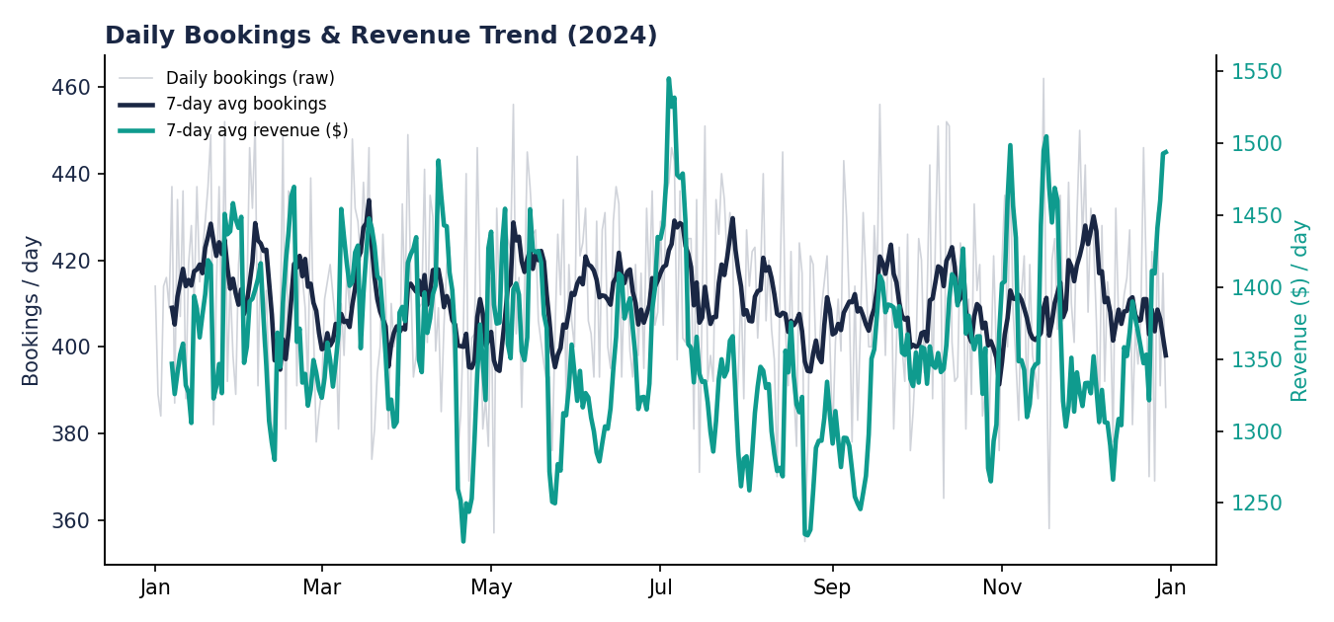
Figure 1 — 7-day rolling average of daily bookings (navy, left axis) and daily revenue in USD (teal, right axis), Jan–Dec 2024.
How to read this chart: the navy line is a 7-day moving average of how many rides were requested each day (left axis); the teal line is the 7-day moving average of dollars earned from completed rides that day (right axis). The pale gray line in the background is the raw, unsmoothed daily booking count — it shows day-to-day noise that the moving average filters out. When the two colored lines move together, demand and revenue are in sync; a gap between them would signal a change in average fare or completion rate.
KPI definitions used:
- Daily bookings = count of all booking requests that day, regardless of outcome
- Daily revenue = sum of Booking Value (converted to USD) across only Completed rides that day (uncompleted rides carry no fare)

Monthly Breakdown
Rolling the daily data up to monthly totals confirms the flat pattern seen in Figure 1 — every month lands within a narrow band of roughly 11,900 to 12,900 total bookings and $39,400 to $43,800 in completed-ride revenue, with March the strongest month and February the weakest.
Month | Total Bookings | Completed Rides | Revenue (USD)
January 2024 | 12,861 | 7,951 | $41,989
February 2024 | 11,927 | 7,368 | $39,419
March 2024 | 12,719 | 7,954 | $43,808
April 2024 | 12,199 | 7,632 | $40,769
May 2024 | 12,778 | 7,905 | $41,293
June 2024 | 12,440 | 7,757 | $41,598
July 2024 | 12,897 | 7,926 | $41,573
August 2024 | 12,636 | 7,780 | $40,585
September 2024 | 12,248 | 7,542 | $40,090
October 2024 | 12,651 | 7,905 | $42,061
November 2024 | 12,394 | 7,659 | $41,327
December 2024 | 12,250 | 7,621 | $41,403

Day-of-Week Pattern
Completion rate is slightly higher on weekends (Saturday 62.4%, Sunday 62.2%) than on Mondays (61.5%), a small but consistent gap that likely reflects less rushed, less commute-driven trip requests on weekends.
Day | Total Bookings | Completed Rides | Completion Rate
Monday | 21,644 | 13,318 | 61.5%
Tuesday | 21,391 | 13,171 | 61.6%
Wednesday | 21,413 | 13,296 | 62.1%
Thursday | 21,215 | 13,206 | 62.2%
Friday | 21,397 | 13,253 | 61.9%
Saturday | 21,542 | 13,442 | 62.4%
Sunday | 21,398 | 13,314 | 62.2%

6. Hourly Demand Pattern
Unlike the day-over-day view, the hour-of-day view shows real structure. Demand builds from a low of 1,321 requests at 4am to a hard peak of 12,397 requests at 6pm. The evening window (5pm–7pm) alone accounts for 23.0% of all daily bookings, versus 13.7% in the morning commute window (7am–9am) — evening demand is roughly 70% higher than morning demand, likely reflecting a mix of commute-home traffic and evening leisure trips.
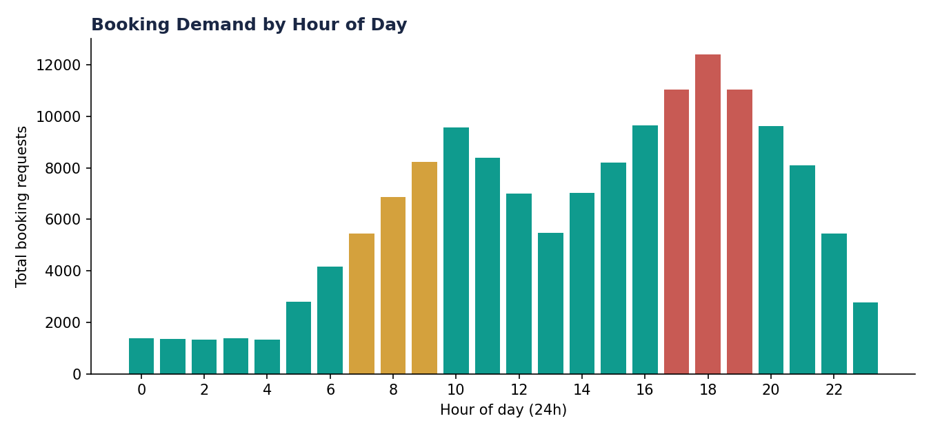
Figure 2 — Total booking requests by hour of day, aggregated across all 365 days. Gold = morning peak window, red = evening peak window.
How to read this chart: each bar is the total number of ride requests placed during that hour of the day, summed across the entire year. This is the chart a fleet operations team would use to plan driver shift incentives — the evening bars (red) are where the fleet is most likely to run short of supply, since that's also where 'No Driver Found' cancellations are most likely to concentrate.
This is the single most operationally useful chart in the report for a live system: it directly informs driver shift scheduling and surge-pricing windows, and in production would be cut further by weekday vs. weekend to separate commute-driven demand from leisure-driven demand.

7. Best-Selling Vehicle Types
Auto led with 23,155 completed rides — about 25% more than the next closest option (Go Mini, 18,549) — making it the 'hero' vehicle type in this market, consistent with Auto being the lowest-cost, highest-availability option in NCR traffic.
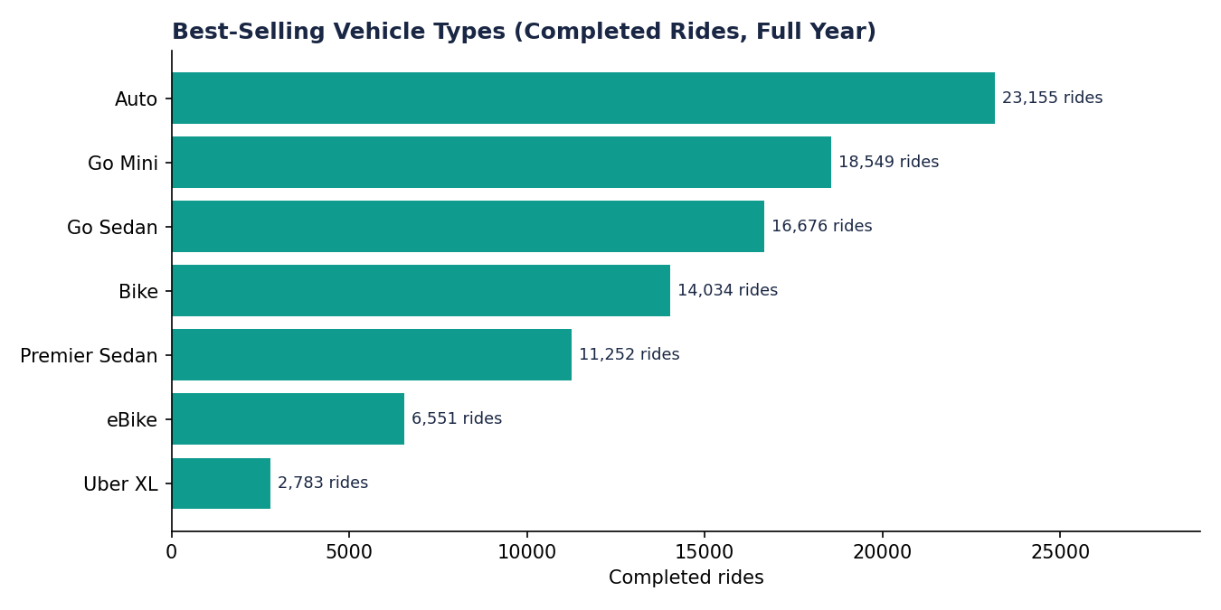
Figure 3 — Completed rides by vehicle type, full year.
How to read this chart: bars are sorted by total completed-ride volume, largest at top. This ranks vehicle types by demand fulfilled, not by demand requested — a vehicle type could rank lower here either because fewer people request it, or because a larger share of its requests fail to complete (see Figure 7 for that distinction).
Ranking logic: completed-ride count, not revenue. Average fare is nearly flat across vehicle types ($5.28–$5.37), so unlike a typical retail catalog, volume and revenue leaderboards for Uber move almost in lockstep — the real differentiator between vehicle types here is fleet availability and fulfillment rate, not price.

Vehicle Type Deep-Dive
Combining fare, distance, and service-time metrics into one view shows that vehicle types behave almost identically on a per-ride basis — the differentiation between them is in volume, not in unit economics:
Vehicle Type | Completed Rides | Avg Fare | Avg Distance | Avg VTAT | Avg CTAT
Auto | 23,155 | $5.31 | 26.0 km | 8.5 min | 30.0 min
Go Mini | 18,549 | $5.32 | 26.0 km | 8.5 min | 30.1 min
Go Sedan | 16,676 | $5.37 | 26.0 km | 8.5 min | 30.0 min
Bike | 14,034 | $5.34 | 26.0 km | 8.6 min | 30.1 min
Premier Sedan | 11,252 | $5.35 | 26.0 km | 8.5 min | 30.1 min
eBike | 6,551 | $5.28 | 26.0 km | 8.5 min | 30.1 min
Uber XL | 2,783 | $5.30 | 26.0 km | 8.6 min | 30.1 min
This uniformity across vehicle types (identical average distance, near-identical fare and service time) is a strong signal that the dataset was generated with the same underlying distribution applied per vehicle type rather than reflecting real fare-card differences between, say, Bike and Premier Sedan — worth keeping in mind if this analysis is used as a stand-in for real fare-strategy decisions.

8. Booking Status & Funnel Health
Only 62% of requests convert to a completed ride. The remaining 38% is where operational risk lives: 18.0% are cancelled by the driver, 7.0% cancelled by the customer, 7.0% never find a driver at all, and 6.0% start but don't finish.
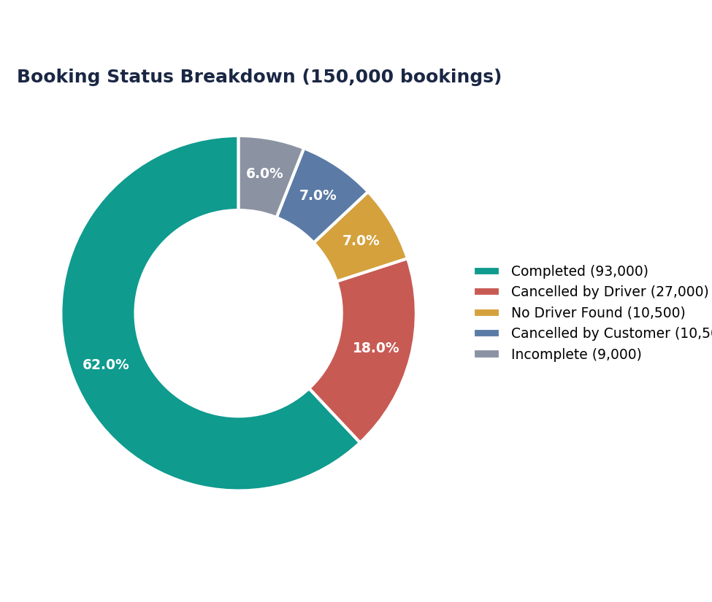
Figure 4 — Full booking funnel across all 150,000 requests.
How to read this chart: each slice is a share of all 150,000 booking requests, split by final outcome. Only the teal slice (Completed) generates revenue. Every other slice represents a request that entered the system and was lost at some stage — the size differences between the red, gold, and gray slices tell you which failure mode to prioritize fixing first.
This is the single most actionable view in the report: 'No Driver Found' (10,500 rides) is pure lost revenue with no operational fault on either side — it's a supply-availability problem, and the first lever to pull is fleet rebalancing in undersupplied zones and time windows (see Figure 2).

Completion Rate by Vehicle Type
Completion rate is close to uniform across vehicle types, ranging narrowly from 61.4% (Go Sedan) to 62.6% (Uber XL) — a spread of just 1.2 percentage points. This means the funnel leak in Section 7 is not concentrated in any one vehicle category; it's a systemic pattern rather than a fleet-mix problem.
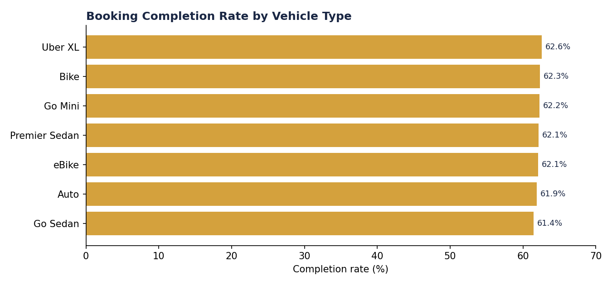
Figure 5 — Share of requests that end in a completed ride, by vehicle type.
How to read this chart: each bar is completed rides ÷ total requests for that vehicle type, as a percentage. If one vehicle type's bar were noticeably shorter than the rest, that would point to a fleet-specific issue (e.g., too few Premier Sedans on the road). Here, the bars are close enough in length that the more useful lens is time-of-day and zone (Figures 2 and 8), not vehicle type.

9. Rating Distribution
Average driver rating across completed rides is 4.23/5; average customer rating is 4.40/5 — both tightly clustered, with driver ratings never falling below 3.0.
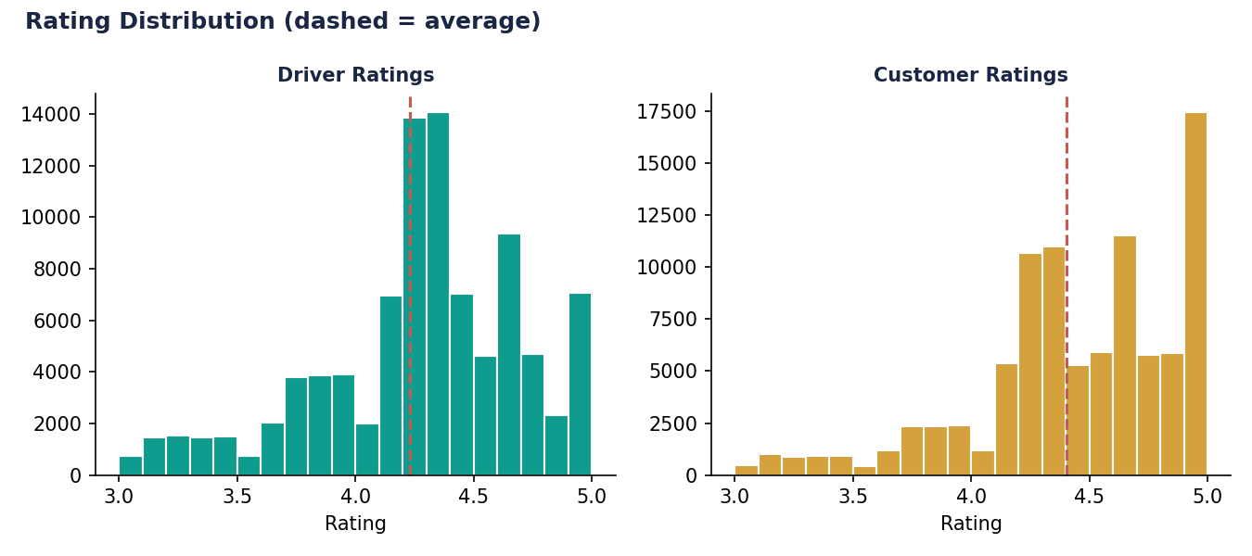
Figure 6 — Driver and customer rating distributions (dashed line = average).
How to read this chart: each bar groups ratings into a small range (e.g., 4.0–4.1) and shows how many completed rides fell into that range. A distribution skewed hard to the right (as both are here) means most rides are rated favorably; the dashed red line marks the overall average so you can see how far the bulk of ratings sit from it.
In a live system, this view is most useful segmented rather than aggregated:
- Drivers trending downward in rolling 7-day average rating — the earliest signal of a service issue
- Vehicle types combining high volume with sub-4.0 average ratings — the highest-risk combination, since volume amplifies the damage of poor reviews

10. Regional Demand
Demand is spread across 176 distinct pickup zones with no single dominant hub — the busiest zone (Khandsa) accounts for just 949 of 150,000 requests (0.6%), meaning this is a genuinely distributed, city-wide demand pattern rather than one concentrated around a handful of hotspots.
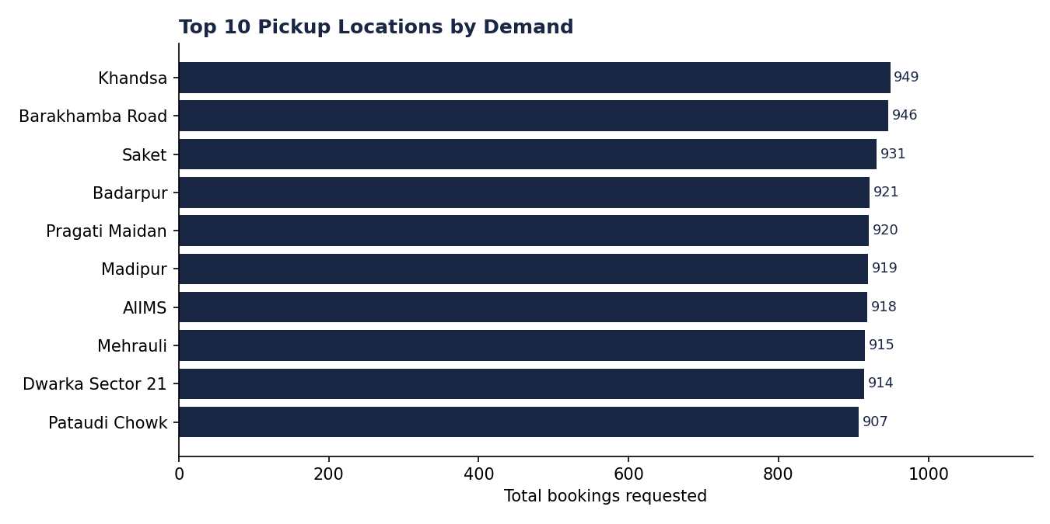
Figure 7 — Top 10 pickup locations by total booking requests.
How to read this chart: bars show the raw count of ride requests originating from each pickup zone, ranked highest to lowest. Because even the top zone is under 1% of total volume, the gap between bar 1 and bar 10 here is much smaller than you'd see in a market with a real 'downtown core' effect — worth noting when using this to plan fleet positioning.
This view is what drives fleet positioning by zone, surge-pricing triggers, and localized driver incentive campaigns — in production it would be cut by hour-of-day as well (combining Figures 2 and 7), since the same zone behaves very differently at 8am versus 11pm.

Top Drop Locations
Drop-off demand is even more evenly spread than pickup demand — the top 10 drop zones are separated by less than 4% from top to bottom, reinforcing that this is a distributed, city-wide travel pattern rather than a hub-and-spoke one (e.g., everyone converging on a single business district).
Rank | Drop Location | Total Drop-offs
1 | Ashram | 936
2 | Basai Dhankot | 917
3 | Lok Kalyan Marg | 916
4 | Narsinghpur | 913
5 | Cyber Hub | 912
6 | Kalkaji | 912
7 | Kashmere Gate ISBT | 909
8 | Udyog Vihar | 906
9 | Lajpat Nagar | 904
10 | Madipur | 902

11. Ride Distance & Fare Distributions
Completed rides average 26.0 km (median 26.0 km), ranging from 2 km to 50 km — a wide spread suggesting the dataset mixes short intra-neighborhood hops with long cross-city trips fairly evenly rather than clustering around a 'typical' commute distance.
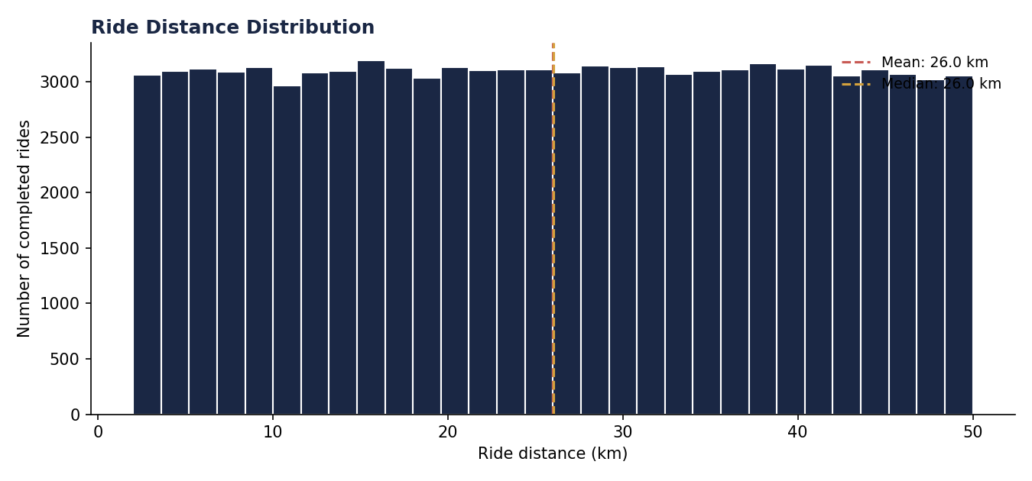
Figure 8 — Distribution of ride distance across all completed rides.
How to read this chart: each bar groups completed rides into a distance range and shows how many fall into it. A flatter, wider distribution like this one (versus a sharp single peak) tells you there isn't one dominant 'typical trip length' in this market — trip planning and driver positioning need to account for a genuinely mixed demand profile.
Fares average $5.33 (median $4.34), ranging from $0.52 to $44.88. The gap between mean and median — and the long right tail up to $44.88 — shows a small number of high-value trips pull the average above the typical ride.
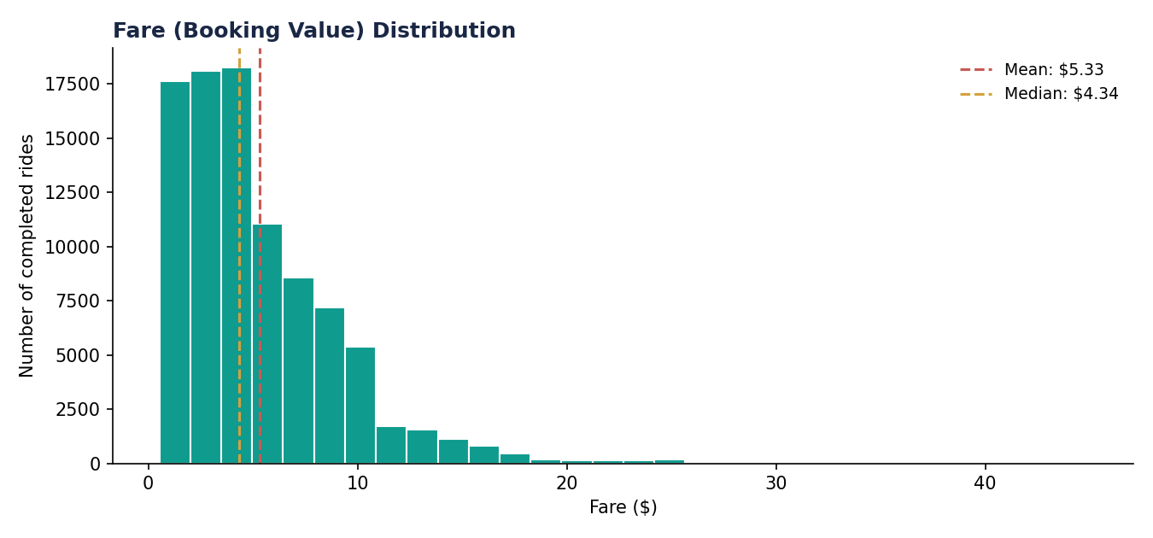
Figure 9 — Distribution of fare (booking value, USD) across all completed rides.
How to read this chart: this is the fare equivalent of Figure 8 — each bar is a $ range, height is how many completed rides fell into it. Most rides cluster under $10, with a long tail of higher-value trips stretching out to the right; that tail is what separates the mean ($5.33) from the median ($4.34).
Notably, the correlation between ride distance and fare in this dataset is effectively zero (r = 0.006) — in a real fare model, distance is normally one of the strongest drivers of price, so this is another signal that fare and distance were generated independently in the synthetic data rather than from a shared pricing formula. A real report built on live Uber data should expect (and should sanity-check for) a strong positive correlation here.

12. Why Rides Get Cancelled
Cancellation reasons are evenly split across categories on both sides, which suggests no single dominant root cause — a mix of address/logistics issues on the customer side, and vehicle or passenger-count issues on the driver side.
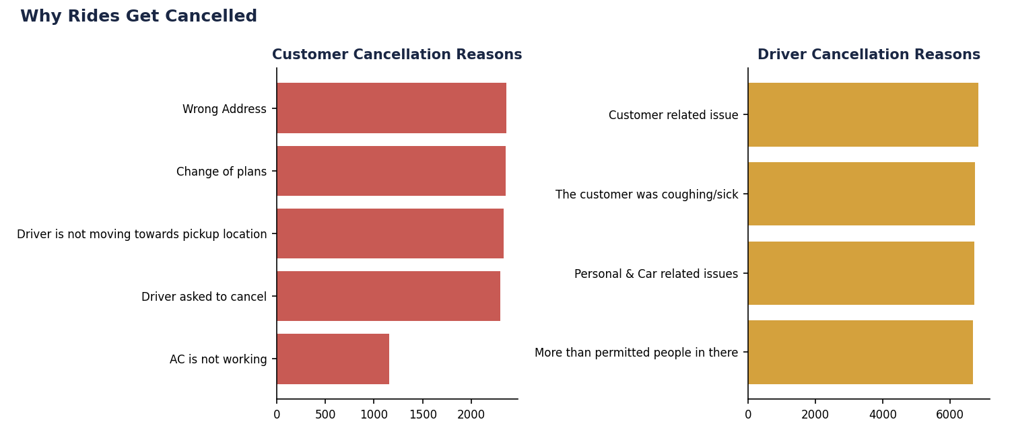
Figure 10 — Customer cancellation reasons (left) vs. driver cancellation reasons (right).
How to read this chart: each bar is a distinct reason code selected at the time of cancellation, with length showing how many cancellations cited that reason. Comparing the two panels side by side shows whether cancellation risk sits more on the customer side or the driver side — here they're roughly balanced in volume, so a fix targeting only one side would address at most half the problem.
- Customer-side: split fairly evenly between wrong address, change of plans, driver not approaching, and AC complaints
- Driver-side: split fairly evenly between customer-related issues, passenger illness concerns, vehicle/personal issues, and overcrowding

13. Service Time: Driver Arrival vs. Ride Completion
Average time for a driver to arrive after accepting a booking (VTAT) is 8.51 minutes; average total ride completion time (CTAT) is 30.03 minutes. Both metrics are nearly identical across every vehicle type — no vehicle type is a meaningfully faster or slower experience end-to-end.
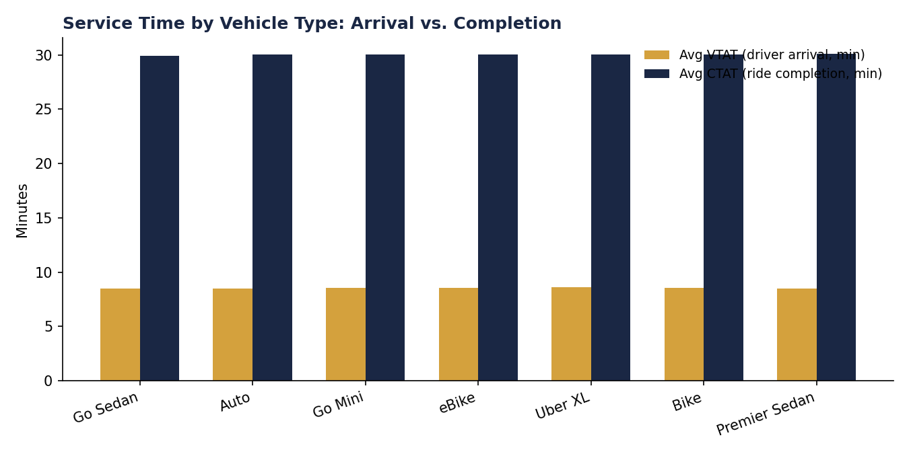
Figure 11 — Average driver arrival time (VTAT, gold) and average ride completion time (CTAT, navy), by vehicle type.
How to read this chart: for each vehicle type, the gold bar is the average minutes a rider waits for the driver to arrive after booking, and the navy bar is the average total minutes from booking to trip completion. Because these bars are nearly the same height across every vehicle type, service speed is not a factor that differentiates one vehicle type from another in this dataset — it would only become useful once cut by zone or hour of day.

14. Payment Method Mix
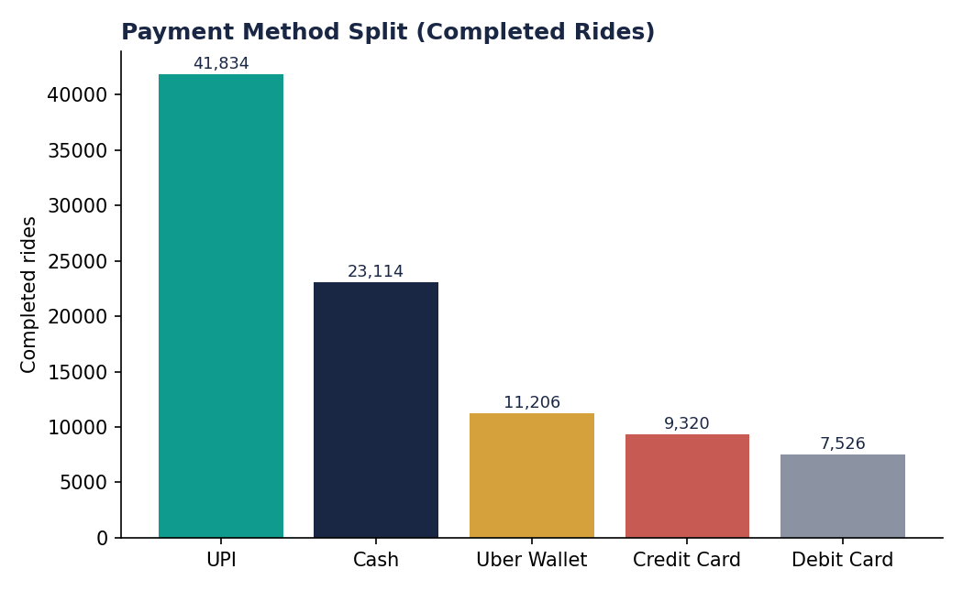
Figure 12 — Payment method share across completed rides.
How to read this chart: each bar is the count of completed rides paid for using that method. This is a simple share-of-transactions view — useful for reconciliation planning and for deciding where to invest in payment UX (e.g., streamlining the UPI flow, since it's already the dominant method).
UPI dominates at 45.0% of completed rides, consistent with India's broader shift to real-time digital payments. Cash still accounts for nearly a quarter of transactions (24.9%), which matters for driver cash-handling and reconciliation workflows; the remaining 30% is split across Uber Wallet (12.0%), Credit Card (10.0%), and Debit Card (8.1%).

Payment Method by Vehicle Type
UPI is the leading payment method within every single vehicle type, and the proportional split barely shifts from one vehicle type to the next — payment preference in this dataset is a rider-level habit, not something that varies by which vehicle they book.
Vehicle Type | Cash | Credit Card | Debit Card | UPI | Uber Wallet
Auto | 5,704 | 2,325 | 1,892 | 10,358 | 2,876
Bike | 3,501 | 1,390 | 1,130 | 6,367 | 1,646
Go Mini | 4,669 | 1,838 | 1,475 | 8,409 | 2,158
Go Sedan | 4,237 | 1,715 | 1,342 | 7,405 | 1,977
Premier Sedan | 2,739 | 1,156 | 924 | 5,058 | 1,375
Uber XL | 715 | 255 | 246 | 1,218 | 349
eBike | 1,549 | 641 | 517 | 3,019 | 825

15. Customer Base Overview
The dataset includes 148,788 unique customer IDs across 150,000 bookings. Only 1,206 customers placed more than one booking in the year — meaning this dataset is overwhelmingly composed of one-time or first-time bookings rather than a loyal, repeat rider base.
In a live system this would be one of the first things flagged to a growth team: a healthy ride-hailing business typically sees a meaningful share of repeat riders, since retention is cheaper than acquisition. A near-total absence of repeat customers here is again most likely an artifact of how the dataset was generated (customer IDs assigned close to 1:1 with bookings) rather than a real retention signal — but it's exactly the kind of check a repeat-usage cohort analysis (Section 16) would formalize on real data.

16. Summary of Key Metrics
Metric | Value
Total booking requests (2024) | 150,000
Completed rides | 93,000 (62.0%)
Total revenue (completed rides) | $495,914
Average fare per completed ride | $5.33 (median $4.34)
Total distance covered | 2,418,046 km
Average ride distance | 26.0 km
Average driver rating | 4.23 / 5
Average customer rating | 4.40 / 5
Top vehicle type (by rides) | Auto — 23,155 rides
Avg. driver arrival time (VTAT) | 8.51 min
Avg. ride completion time (CTAT) | 30.03 min
Rides lost to 'No Driver Found' | 10,500 (7.0%)
Rides cancelled by driver | 27,000 (18.0%)
Rides cancelled by customer | 10,500 (7.0%)
Peak demand hour | 6:00–7:00 PM (12,397 requests)
Unique customers | 148,788
Top payment method | UPI — 45.0% of completed rides

17. Limitations & Data Notes
A few patterns in this dataset are worth flagging explicitly, since they shape how much weight to put on certain conclusions:
- Booking volume is unusually flat day-to-day (355–462 bookings every single day of the year) with no holiday, weather, or event-driven spikes — real ride-hailing markets typically show much sharper swings.
- Ride distance and fare show essentially zero correlation (r = 0.006), where a real fare model would show a strong positive relationship between the two.
- Average fare, distance, and service time are nearly identical across all seven vehicle types — real fare cards usually differentiate more sharply between, say, Bike and Premier Sedan.
- Repeat customers are almost entirely absent (1,206 of 148,788), unusual for a full year of bookings in one metro region.
None of this invalidates the descriptive patterns in this report — funnel health, hourly demand shape, and cancellation-reason splits are all structurally realistic and would transfer directly to a live dataset. But the specific correlations between fare, distance, and vehicle type should be treated as illustrative of the pipeline, not as real Uber pricing behavior.

18. Business Recommendations
Turning the findings above into concrete next actions for an operations or growth team:

Fix the funnel first
- Driver-side cancellations (18.0% of all requests) are the single largest source of lost bookings — investigate whether these cluster around specific zones or hours before assuming it's a blanket supply problem.
- 'No Driver Found' (7.0%) is pure lost revenue with no fault on either side — pair Figure 2 (hourly demand) with a driver-supply heatmap to see exactly when and where supply falls short.
- Because completion rate is nearly flat across vehicle types (Section 8), fixing the funnel is a scheduling and incentive problem, not a fleet-mix problem — don't over-invest in shifting the vehicle mix as a fix.

Target the evening peak
- The 5–7pm window alone drives 23% of daily demand — driver shift incentives and surge pricing should be weighted toward this window specifically, not spread evenly across the day.
- Because pickup and drop demand are both evenly spread across ~176 zones (Sections 10–11), the evening fix is about total driver count on the road, not repositioning drivers toward one hotspot.

Grow repeat usage
- Only 1,206 of 148,788 customers placed more than one booking in the year — even accounting for dataset artifacts (Section 17), a retention or loyalty program is likely the highest-leverage lever available if this reflects real rider behavior at all.

Payments
- UPI is already dominant (45%) and consistent across every vehicle type — continued investment in UPI checkout speed will benefit the whole fleet, not just one segment.
- Cash still represents a quarter of completed rides — any push to reduce cash handling should be paired with driver communication, since it affects reconciliation workflows fleet-wide.

19. Next Steps to Move From Descriptive → Predictive
This report answers what happened in 2024. The natural next layer, if useful:
- Zone × hour demand forecasting to drive proactive driver repositioning ahead of demand spikes (building directly on Figures 2 and 7)
- A driver-level and zone-level cancellation risk model to flag high-risk bookings before they're accepted
- Rider cohort / repeat-usage analysis to separate one-off demand from loyal, recurring riders — especially important given the low repeat-customer rate in Section 14
Happy to build out any of these next, or extend this report with weekday-vs-weekend cuts or a different currency if useful.

Appendix A: Booking Status by Vehicle Type
Full breakdown of every booking outcome, by vehicle type — the detail underlying Figures 3, 4, and 5.
Vehicle Type | Completed | Cancelled (Driver) | Cancelled (Customer) | No Driver Found | Incomplete
Auto | 23,155 | 6,643 | 2,680 | 2,681 | 2,260
Bike | 14,034 | 4,077 | 1,575 | 1,503 | 1,328
Go Mini | 18,549 | 5,330 | 2,097 | 2,015 | 1,815
Go Sedan | 16,676 | 5,031 | 1,832 | 1,960 | 1,642
Premier Sedan | 11,252 | 3,250 | 1,266 | 1,280 | 1,063
Uber XL | 2,783 | 762 | 327 | 315 | 262
eBike | 6,551 | 1,907 | 723 | 746 | 630

Appendix B: Booking Status by Month
Monthly detail behind the funnel numbers in Section 8 — outcome counts stay proportionally stable month to month, consistent with the flat overall trend in Figure 1.
Month | Completed | Cancelled (Driver) | Cancelled (Customer) | No Driver Found | Incomplete
Jan | 7,951 | 2,324 | 893 | 885 | 808
Feb | 7,368 | 2,190 | 838 | 850 | 681
Mar | 7,954 | 2,240 | 906 | 892 | 727
Apr | 7,632 | 2,221 | 779 | 842 | 725
May | 7,905 | 2,317 | 919 | 869 | 768
Jun | 7,757 | 2,206 | 883 | 856 | 738
Jul | 7,926 | 2,332 | 932 | 904 | 803
Aug | 7,780 | 2,351 | 834 | 936 | 735
Sep | 7,542 | 2,165 | 894 | 904 | 743
Oct | 7,905 | 2,224 | 894 | 867 | 761
Nov | 7,659 | 2,220 | 864 | 861 | 790
Dec | 7,621 | 2,210 | 864 | 834 | 721

