CMOS 12 by 4 Inverter Circuit without Capacitor-

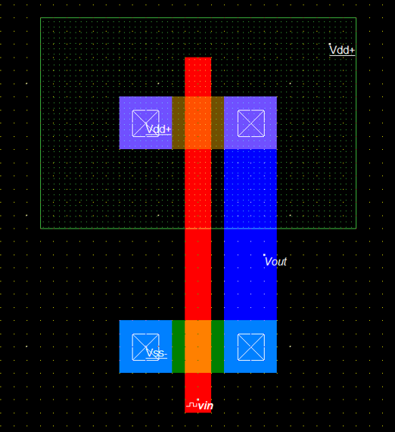

CMOS 12 by 4 Inverter Circuit without Capacitor-

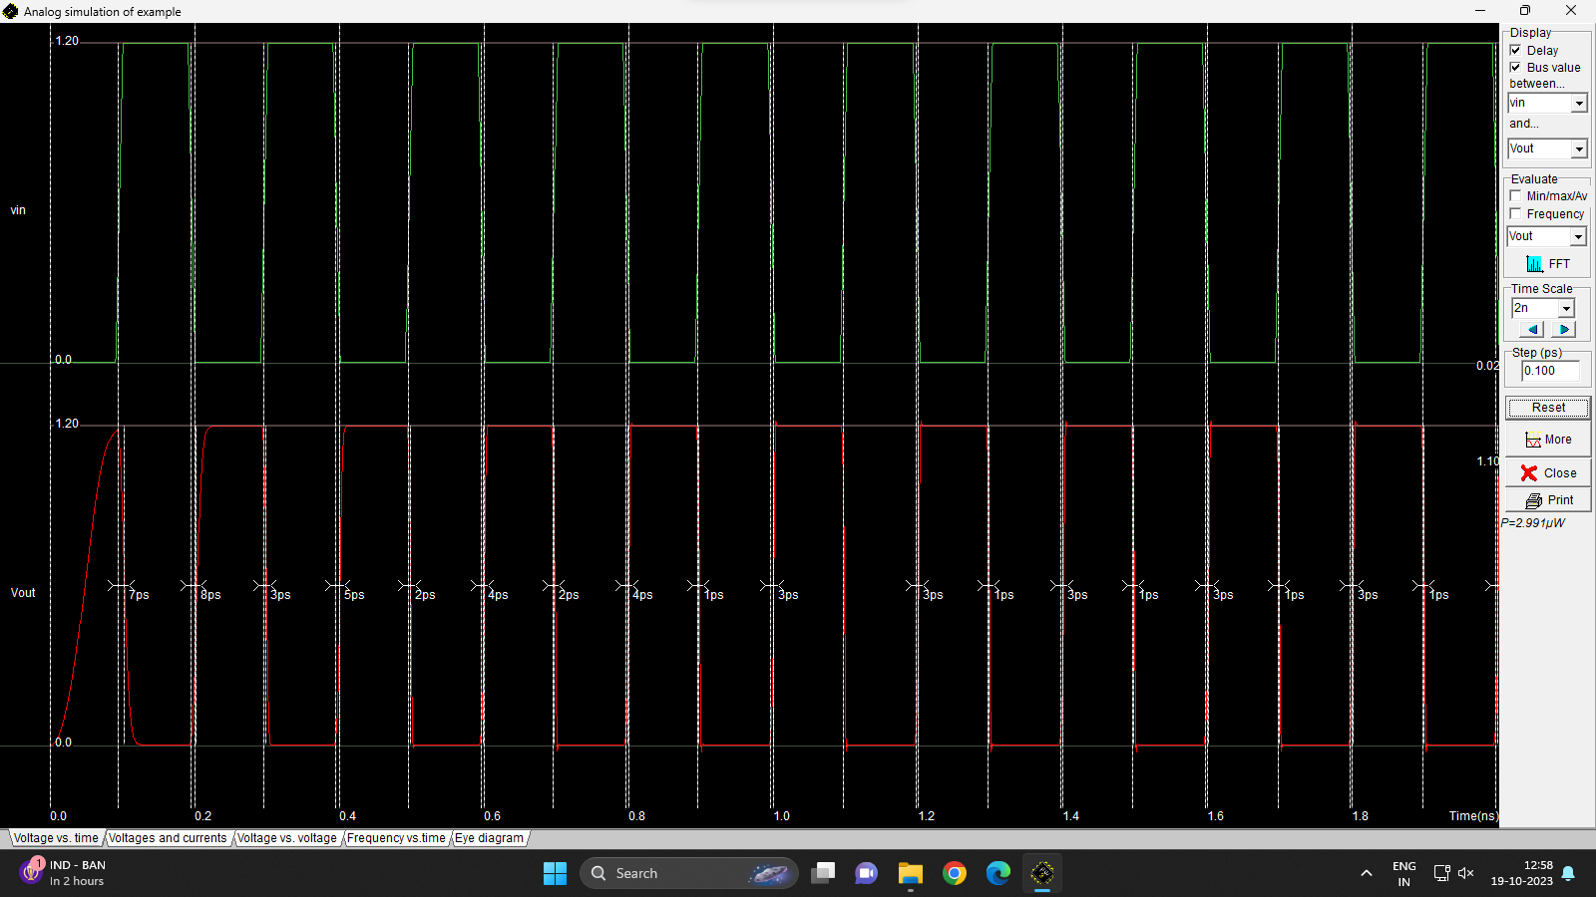

CMOS 12 by 4 Inverter Circuit with Capacitor-

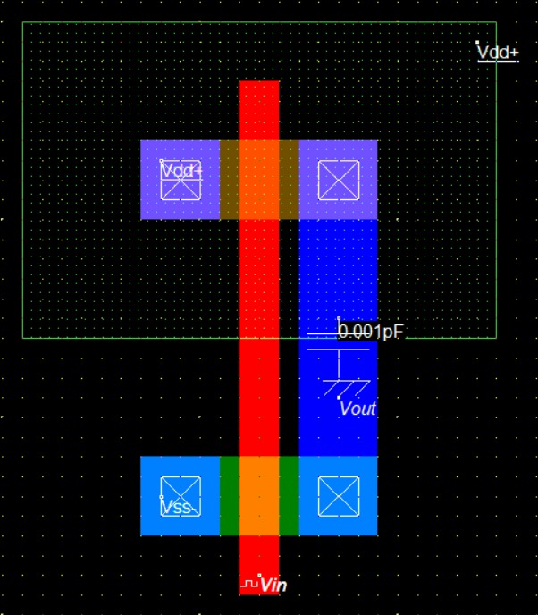

CMOS 12 by 4 Inverter with Capacitor Waveform-

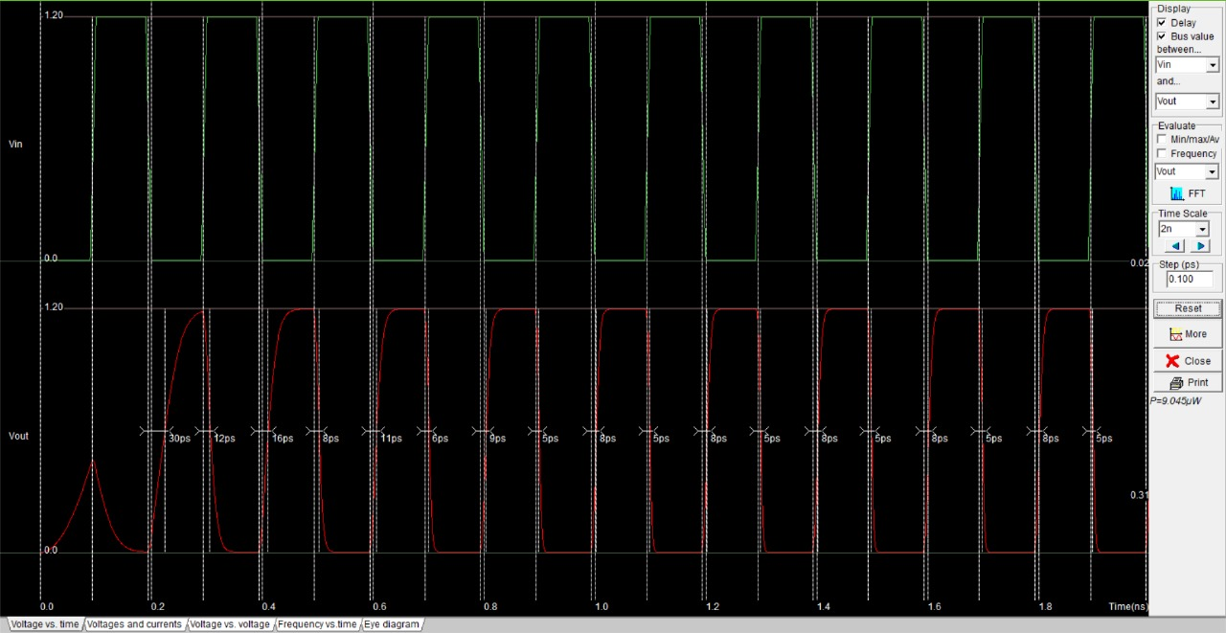

CMOS 12 by 12 Inverter Circuit without Capacitor-

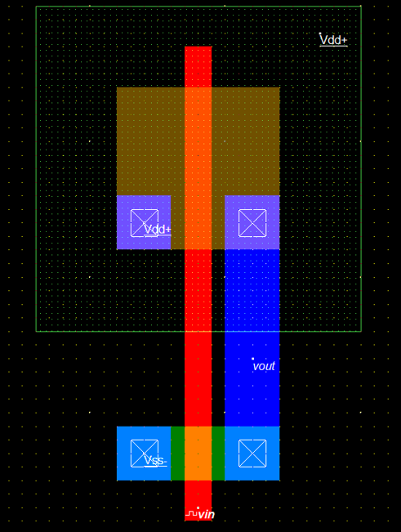

CMOS 12 by 12 Inverter Circuit without Capacitor Waveform-

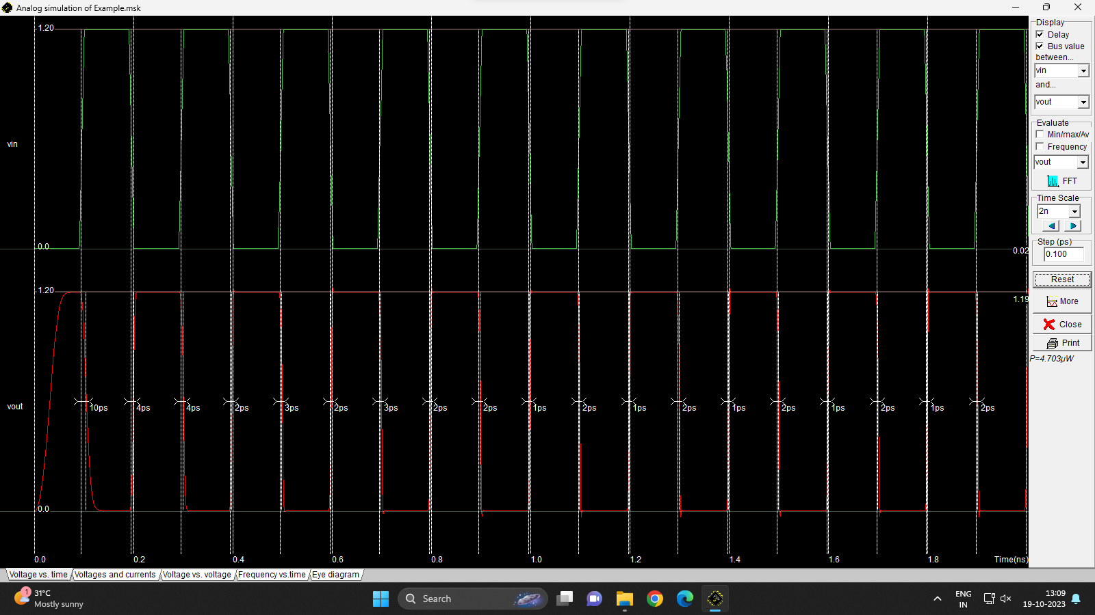

CMOS 12 by 12 Inverter with Capacitor Circuit-

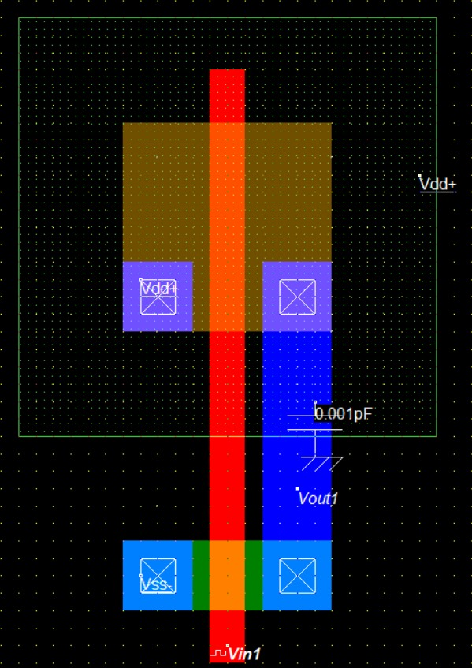

CMOS 12 by 12 Inverter with Capacitor Waveform-

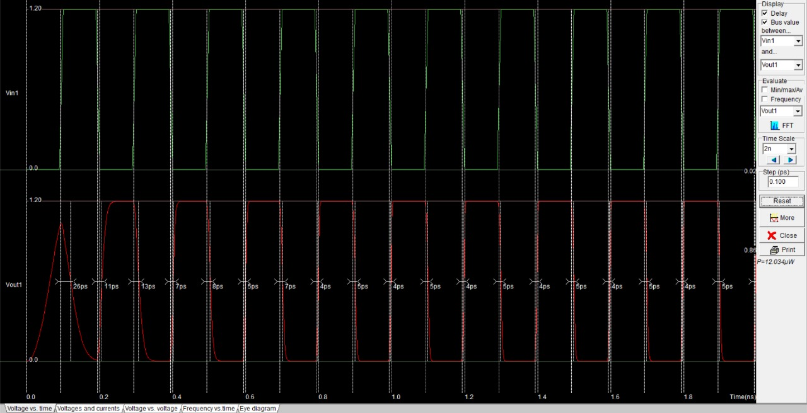

CMOS NAND Gate Circuit-

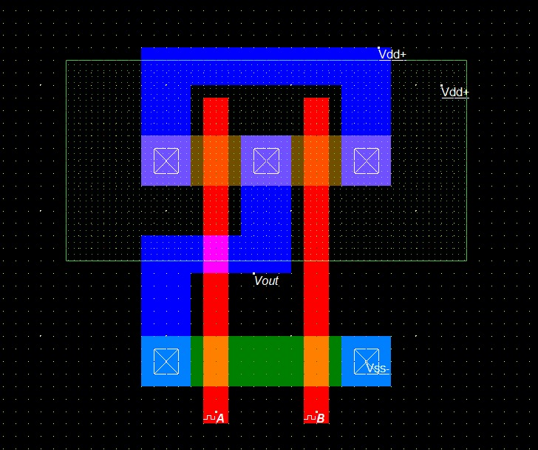

CMOS NAND Gate Waveform-

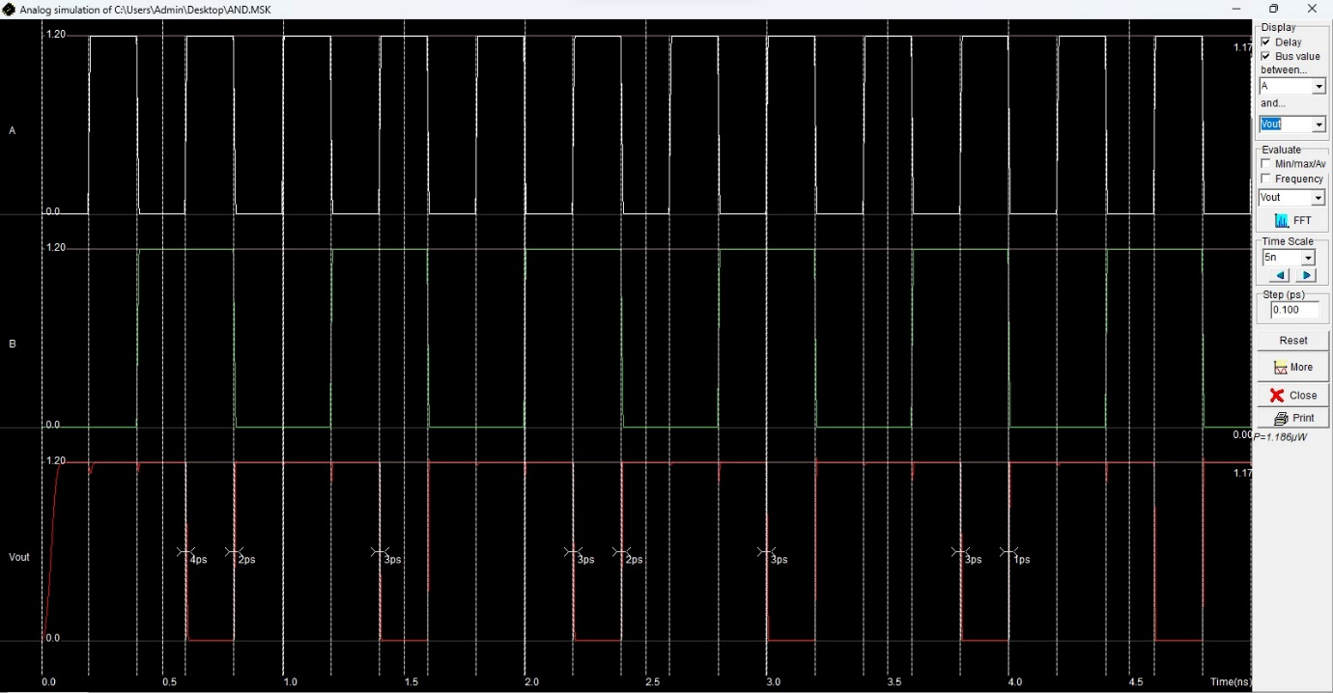

CMOS NOR Gate Circuit-

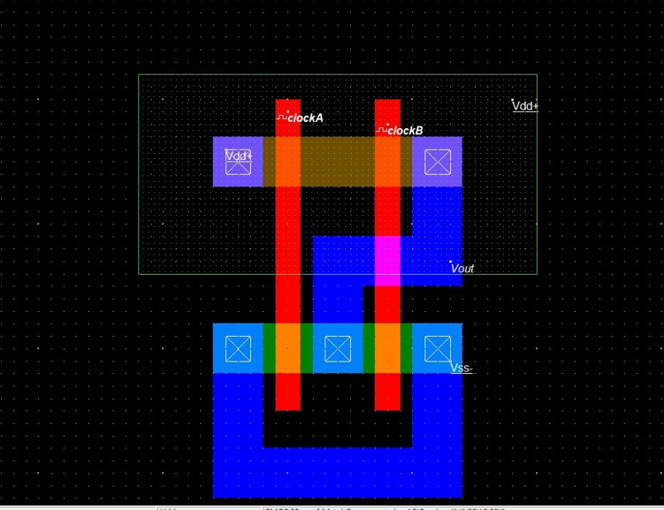

CMOS NOR Gate Waveform-

