**Accessible Emergency Notification System for Public Crisis Outreach to the Deaf and Hard of Hearing**

**Abstract**

According to the 2021 American Community Survey, approximately 3.6% of the U.S. population, around 11 million individuals, identify as Deaf or have serious difficulty hearing. In Rochester alone, nearly 40,000 individuals are Deaf and Hard of Hearing (DHH). While the region’s emergency system offers some accessibility, gaps remain in fully supporting DHH individuals during emergencies. This proposal aims to develop an inclusive alert system that ensures DHH individuals receive timely, accessible emergency notifications. The system will aggregate alerts from federal and state-level sources, offering users location-specific, radius-adjustable, and free subscription alerts. These alerts will be transmitted to IoT devices used in daily life. The platform will be developed as a Progressive Web App, utilizing Vue for the frontend, Node.js with Express for the backend, MongoDB for the database, and AWS for RSS feed processing. This solution enhances the current alerting infrastructure, providing accessible, location-based alerts and empowering users to receive notifications on their preferred devices, ultimately helping to save lives.

**1 Introduction**

In times of crisis, such as natural disasters, severe weather events, or public safety emergencies, timely and accurate communication is critical. Emergency alert systems have evolved significantly, transitioning from radio and television broadcasts to robust, multi-platform networks that include mobile devices, digital signage, and Internet-based alerts. Systems like the Emergency Alert System (EAS) and Wireless Emergency Alerts (WEA), coordinated through the Integrated Public Alert and Warning System (IPAWS), have helped streamline the dissemination of critical, real-time information to the public [1]. As illustrated in Figure 1, this evolution has improved general outreach; however, it still leaves critical accessibility gaps

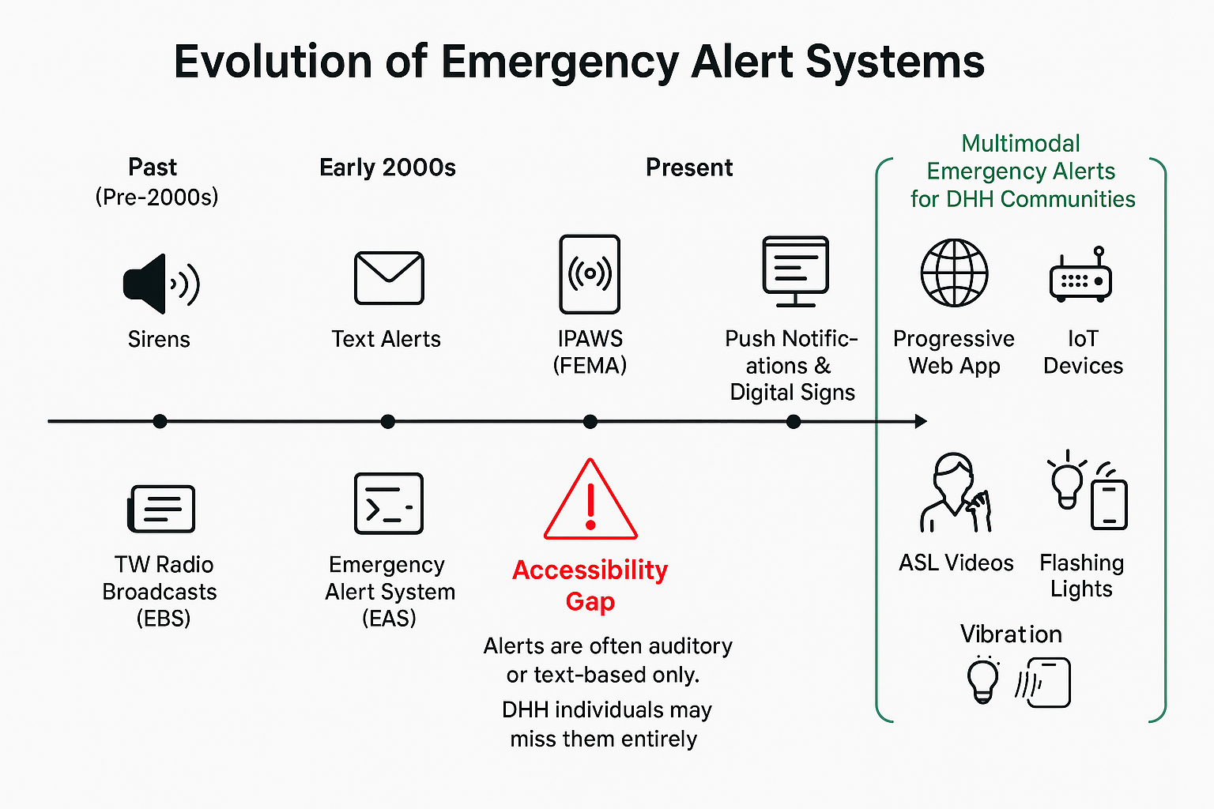

Figure 1: Evolution of the Emergency Alert System[1]

Despite these advances, a significant accessibility gap persists. Traditional emergency alert systems rely heavily on auditory signals and spoken or written language, often leaving individuals who are Deaf or Hard of Hearing (DHH) at a disadvantage. With more than 11 million DHH individuals in the U.S. (Mitchell et al., 2006) and over 40,000 residing in Rochester, NY, a city known for having one of the country's highest per capita DHH populations [2], this exclusion is not a marginal issue. It is a systemic oversight with life-threatening implications.

Accessibility in emergency communication is not merely a technical concern but a civil right. The Americans with Disabilities Act (ADA) and Section 508 of the Rehabilitation Act mandate that public services be inclusive and accessible, particularly in matters related to safety and health (U.S. Department of Justice, 2010; U.S. Access Board, 2017). Yet, many individuals with DHH report missing alerts entirely or receiving them in inaccessible formats (National Council on Disability, 2014).

This proposal introduces a scalable, multimodal emergency alerting platform designed to serve the DHH community through inclusive, customizable communication. By aggregating alerts from federal, state, and local sources such as FEMA, the National Weather Service (NWS), and 911 call centers, and distributing them through a Progressive Web App (PWA) and Internet of Things (IoT) devices, this system ensures timely, location-specific alerts are received in accessible formats. Notifications are delivered via flashing lights, haptic feedback, and visual text, allowing users to receive information in the modality best suited to their needs.

This platform fills a critical gap in public safety infrastructure and affirms the fundamental right to accessible communication. It empowers individuals to take informed, independent action during emergencies, promoting equity, safety, and community resilience.

**2 Problem**

**2.1 Problem statement**

**Ideal Situation:**

An inclusive emergency alert system that provides real-time, multimodal notifications through text, American Sign Language (ASL) video, flashing lights, or Internet of Things (IoT) devices, such as smart homes, to ensure accessibility for all deaf and hard-of-hearing (DHH) users. It would allow full customization, letting individual choose their preferred alert format, language, and even adjust the notification radius to prioritize relevant threats. The system would eliminate fragmentation and ensure comprehensive coverage by aggregating data from multiple sources, such as IPAWS, FEMA, NWS, 911, etc., into a single platform. Furthermore, it would support two-way communication, enabling DHH users to signal for help or notify loved ones during emergencies.

**Current Situation:**

Despite advancements in emergency alert systems, DHH individuals in the United States still face significant barriers to receiving timely and accessible emergency notifications. Systems like FEMA’s Integrated Public Alert and Warning System (IPAWS) and Wireless Emergency Alerts (WEA) primarily rely on audio-based alerts such as sirens and radio broadcasts, along with text-based notifications that may not fully accommodate DHH users in situations like being in a state of reduced consciousness, such as sleeping. Many alerts lack visual or tactile alternatives, leaving individuals who rely on ASL captions or vibration-based warnings disadvantaged. Additionally, current systems offer limited customization, preventing users from selecting preferred formats, such as high-contrast text or ASL video. Geographic limitations further complicate accessibility, as localized alerts such as those from 911 are not always integrated into broader national warning systems. As a result, many DHH individuals must rely on intermediaries such as family members or interpreters to relay emergency information, leading to dangerous delays.

**Consequence:**

The lack of a fully accessible and unified emergency alert system has serious and potentially life-threatening consequences for DHH individuals. Without real-time, multimodal alerts tailored to their communication needs, DHH users often experience delays receiving critical information, increasing their risk during emergencies such as natural disasters, public safety threats, or hazardous weather conditions. The absence of ASL video alerts, flashing light notifications, or vibration-based signals, except through phone notifications, limits situational awareness and forces reliance on hearing individuals for interpretation, an unreliable solution in urgent scenarios.

Furthermore, the fragmentation across emergency systems, such as IPAWS, WEA, and local 911 alerts, creates inconsistencies in coverage, leaving gaps in critical communication. These limitations also hinder personal agency, as individuals with DHH often cannot customize how they receive alerts or respond to them, reducing their ability to act independently in times of crisis. The inability to initiate two-way communication. Compounds the issue, preventing DHH users from seeking help, confirming safety, or updating loved ones.

**2.2 Project Goals**

This project aims to develop a Progressive Web App (PWA) enabling users to connect with federal and state-level emergency alerts like IPAWS, FEMA, NWS, and 911. The platform will offer customization options that allow users to choose which types of alerts they want to receive and define the mode of delivery, such as haptic feedback, email, text message, and IoT device notification. Additionally, users can set location-based preferences, including an adjustable alert radius, to ensure they receive only relevant alerts based on their geographical area. It will also allow users to mute alert notifications with low severity. This system is designed to enhance emergency communication and ensure accessibility for DHH individuals.

**2.3 Project Objectives**

Objective 1: Perform a Literature review of previous work in the field of accessible emergency alerting systems.

Objective 2: Collect and organize information on all types of alerts to be served through this system.

Objective 3: Evaluate current emergency alerting solutions and design an accessible user interface (UI) for the PWA.

Objective 4: Implement the PWA by creating frontend, backend, and database services to support the proposed features.

Objective 5: Test the platform’s robustness and the accuracy of alerts received to ensure stability.

Objective 6: Creating an analysis report of the accuracy of alerts received on different mediums like emails, text messages, IoT devices, etc.

**3 Prior Work**

The use of Internet of Things (IoT) technologies in emergency alerting systems has seen significant development in recent years, providing the foundation for scalable and responsive public safety infrastructure. Early work has emphasized the architectural flexibility of IoT frameworks, especially in smart cities, where sensor-driven data can be harnessed for real-time event detection and alert dissemination. For example, Di Mauro et al. proposed the CityAlarm system, a distributed architecture capable of spatial and temporal event detection using sensor data, which could be applied to multi-tier emergency alerting platforms [3]. Similarly, Lopez et al. conducted a comprehensive review of early warning systems integrated with IoT, identifying best practices in system design such as interoperability, modularity, and energy efficiency [4].

To support reliable communication within IoT ecosystems, several protocols have been proposed and assessed in the context of emergency services. Lightweight messaging protocols such as MQTT and CoAP have been shown to outperform traditional HTTP in latency-sensitive applications due to their lower overhead and support for publish-subscribe models [5]. These protocols have proven especially useful for constrained devices like the M5Stack Core2 used in your system's MVP. In line with this, fire safety systems and building evacuation networks have successfully employed MQTT over Wi-Fi and LoRa to ensure timely alert delivery during hazardous events [6].

Beyond architectural and protocol-level concerns, the literature also underscores the importance of secure communication in emergency alerting systems. A recent survey on edge-enabled IoT security frameworks highlights how distributed alert systems face threats such as spoofing, data injection, and denial of service (DoS) attacks [7]. Mitigation strategies include the implementation of secure communication layers, device authentication, and encryption protocols that can be adapted for systems like yours that aim to expand nationally. In another study, researchers proposed a hybrid wireless sensor network and cellular system for use in disaster-struck areas, emphasizing redundancy and secure fallback communication paths [8].

Scalability and system resilience are recurring themes in modern emergency alerting research. Advanced architectures using software-defined networking (SDN) and network function virtualization (NFV) have been proposed to manage large-scale deployments across cities and rural regions [9]. These systems provide dynamic resource allocation and fault-tolerant routing, essential as your project moves from a county-based proof-of-concept to a nationwide deployment. Moreover, self-adaptive architectures that reconfigure system behavior in response to real-time context changes (e.g., device loss, network instability) are emerging as a critical feature in disaster-resilient alert systems [10].

Taken together, these studies highlight the current trajectory in emergency alerting systems research, emphasizing robust architecture, secure and lightweight communication, and adaptive design. Your proposed expansion aligns well with this direction, particularly in its aim to integrate M5Stack Core2 devices, enable nationwide coverage, and maintain real-time, secure alert dissemination. By building on this foundation, your system can evolve into a model platform for scalable, community-oriented emergency management.

**4 Methodology**

**4.1 Plan**

The approach outlined provides a well-structured and all-encompassing framework that seamlessly integrates with the overarching research design. The primary goal is the development and improvement of a PWA designed to send alerts from different state-level and federal-level alerting bodies.

**Literature Review** (Objective 1)

A comprehensive literature review has been conducted to explore how accessibility has been addressed in emergency alerting systems in other countries. This review draws on multiple papers presented at the ISCRAM Information Systems for Crisis Response and Management conference, along with additional scholarly and technical documents, to gain a deeper understanding of how current emergency alert architectures can be enhanced, particularly through the integration of haptic-driven technologies. Beyond academic research, a field survey will be conducted to directly capture the needs and preferences of the DHH community, focusing on effective alert reception even during moments of reduced awareness or acute consciousness. Feedback from key stakeholders, including DHH individuals and emergency management officials, will be gathered at each stage to ensure the proposed system aligns with real-world requirements and practical considerations.

**Alert Data Collection** (Objective 2)

As part of the research, all necessary and verified federal and state emergency alert sources will be identified and verified. Since alerts from these sources are delivered in varying formats, a data normalization process will be implemented to standardize the data. This will involve cleaning and standardizing the data retrieved from source APIs to ensure consistency and accuracy. The core alert messages will be extracted without modification to preserve authenticity. During this process, rigorous data cleaning will be conducted to address common issues such as duplicate alerts, missing information (e.g., dates or locations), and inconsistent formatting.

Once cleaned, the alerts will be processed by the backend system. Full messages will be delivered to the PWA. At the same time, condensed versions, created by extracting key terms and summarizing the content, will be sent to resource-constrained IoT devices, such as the M5Stack Core2, which have limited screen space and cannot display extensive information. Additionally, scheduled API data tests will be conducted to ensure the reliability and accuracy of the alerts being received from various sources.

**UI Evaluation and Design** (Objective 3)

The objective is to enhance the accessibility and usability of the existing emergency alert application. Since the proposed work builds upon a pre-existing app, the initial step involves conducting comprehensive user testing and feedback sessions with diverse user groups, including DHH individuals, people with visual impairments, and elderly users. These sessions will evaluate how well the current UI accommodates various accessibility needs and whether users can effectively interact with core features such as alert customization, device pairing, and real-time notifications.

Special attention will be given to identifying UI elements that may pose challenges, for example, small or low-contrast text, unclear iconography, lack of screen reader support, or absence of alternative communication modes like ASL video. Based on the feedback, necessary design modifications will be implemented to ensure an inclusive user experience. These may include improving visual contrast, enlarging tap targets, adding haptic cues, enhancing screen reader compatibility, and integrating multimodal alert options (e.g., text, vibration, flashing light). Additional rounds of user validation will follow iterative design updates to confirm that changes lead to improved usability and accessibility for all user groups.

Ultimately, the goal is to ensure that the app not only meets technical accessibility standards but also provides a seamless and empowering experience for users with diverse abilities, particularly during critical emergencies.

**PWA Implementation** (Objective 4)

The APIs from verified Federal and State sources for receiving emergency alerts will be integrated through AWS Cloud to build the backend services using Node.js and Express.js. These services will process all incoming alerts and match them with user preferences stored in MongoDB. Preferences include the types of alerts the user wishes to receive, the preferred device type (e.g., mobile, IoT), and the desired format of haptic feedback.

The alerts will be distributed through a PWA and connected IoT devices. The PWA will extract actionable information from trusted sources in real time, ensuring that users are informed of the next steps during an emergency. It will also display important contact information relevant to the user’s location.

Upon launching the PWA, the user’s current location will be accessed (with permission), and alerts will begin streaming in from all relevant subscribed sources in that area. Users will have the ability to customize the alert radius and temporarily mute alerts except for those classified as high-importance or life-threatening.

Several AWS and third-party services will be used to handle the multi-modal delivery of alerts:

· AWS Pinpoint – to send SMS/text messages

**·** Node mailer – for sending email alerts

· MQTT – for real-time delivery to IoT devices

**The following figure** illustrates the high-level system architecture, outlining the flow of alerts from external federal and state APIs into AWS cloud services. This work builds upon previous grant-funded efforts. The backend service, developed using Node.js and Express.js, fetches and processes incoming alert data. It integrates this data with user-defined preferences, including alert types, preferred delivery formats, and haptic feedback settings to generate personalized notifications. This proposal will work by routing alerts through a Progressive Web App (PWA) and an interconnected ecosystem of IoT devices, ensuring users receive timely and customized emergency alerts through their preferred communication channels.

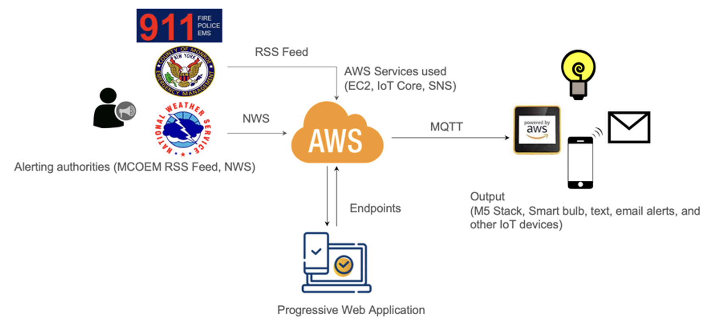

Figure 2: Architectural Diagram

**Testing and Refinement** (Objective 5)

A comprehensive testing process will be implemented to ensure the PWA responds accurately and delivers emergency alerts as intended. Initially, unit-level testing will be conducted to verify that all features function logically and without failures. This phase will validate backend services, data flow, alert rendering, device compatibility, and location-based delivery. The evaluation will employ usability testing techniques, including task-based observation, think-aloud protocols, and accessibility audits, guided by the Web Content Accessibility Guidelines (WCAG) and Section 508 standards.

Following technical validation, user testing will be conducted with members of the DHH community. This phase will evaluate whether the developed features are truly useful, accessible, and aligned with the community’s expectations. Key focus areas will include:

· Ease of use and navigation

· Customization and user control options

· Overall usability and accessibility of the platform

Feedback from the DHH users and other stakeholders will be carefully collected and analyzed. Based on this input, corrective actions and design improvements will be implemented in an iterative development cycle to ensure the platform evolves to effectively meet user needs.

**Analysis Report** (Objective 6)

User feedback will be systematically analyzed to continuously enhance both the system architecture and the overall platform based on users' real-world requirements and challenges. User experiences, observations, and suggestions will be documented systematically to identify areas for improvement and pinpoint areas of pain. In parallel, detailed analysis of alerts transmitted through the system will be conducted to evaluate the architecture's reliability, responsiveness, and durability. Combining qualitative user feedback with quantitative alert data, this dual approach will provide a holistic view of system performance. The collected data will be categorized and visualized using Tableau to identify trends, highlight inconsistencies, and inform data-driven decisions that guide iterative improvements.

**4.2 Limitations**

**•** The scope of this project is limited to building the PWA; it doesn’t create custom code for IoT devices.

• The custom IoT devices, such as the M5 Stack Core 2, will only be limited to testing the architecture flow.

• The proposed system will only operate for users in the United States, as the alerts are gathered at the Country level

**4.3 Deliverables**

The following deliverables will be made available as a result of the proposal execution:

· A fully functional progressive PWA for DHH individuals in the United States, offering personalized alerts and information on steps to take in times of emergency, conveniently.

· User-friendly UI for seamless interaction with the PWA

· Real-time analysis report on alerts received, including verification of accuracy and time delay with different alert recipient devices.

· Presentation in .ppt format summarizing project objectives, methodology, findings, and future recommendations.

**5 Project Timeline**

The Gantt chart outlines a Seven-month project to develop and deploy a PWA for DHH individuals in the United States. The project will begin in May 2025 and end in December 2025.

Table 1: Timeline depicting tasks and the time in weeks to finish the tasks.

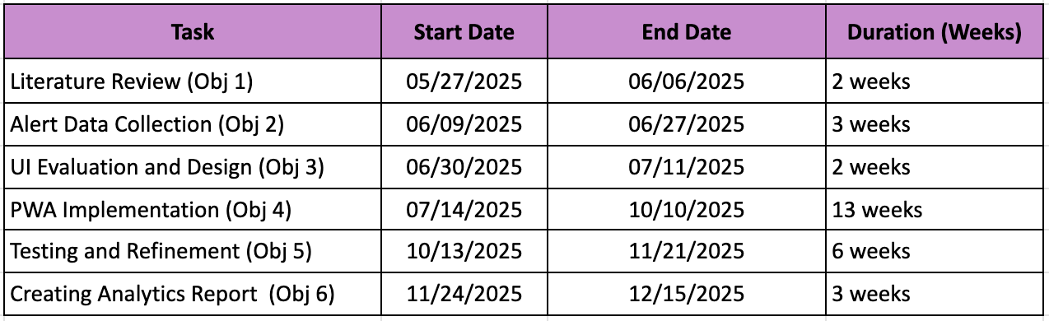

Table 2: Gantt chart of timeline to complete the project

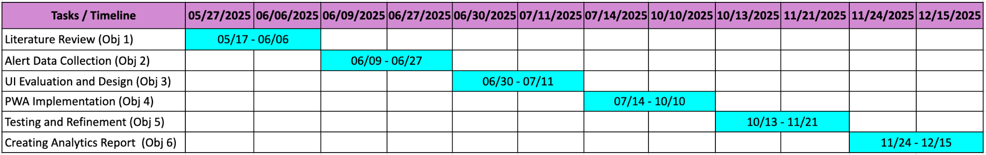

**6 Conclusion**

This proposal introduces an innovative PWA that revolutionizes emergency communication by creating a unified, accessible alert system for DHH communities. By aggregating alerts from Federal and state-level sources into a single customizable platform, the PWA delivers location-specific, real-time emergency information directly to users’ preferred devices, whether smartphones, tablets, or IoT-enabled home systems.

The PWA represents a transformative leap in emergency alert architecture, replacing fragmented, audio-dependent systems with a comprehensive one-stop platform designed around user needs. Its features, like adjustable alert radii, multilingual support for diverse populations, and cross-device compatibility, set a new standard for inclusive emergency preparedness. By prioritizing accessibility at every level, from interface design to notification delivery, the system will maintain the speed and reliability of traditional alerts while finally serving the full spectrum of community needs.

**References**

[1] Federal Emergency Management Agency. (2021). *Integrated Public Alert and Warning System (IPAWS)*. <https://www.fema.gov/emergency-managers/practitioners/integrated-public-alert-warning-system>

[2] Federal Emergency Management Agency. (2021). *Integrated*

*Public Alert and Warning System (IPAWS)*.<https://www.fema.gov/emergency-managers/practitioners/integrated-public-alert-warning-system>

[3] National Technical Institute for the Deaf. (2020). *Rochester and NTID: A hub for deaf culture and*

*education*. Rochester Institute of

Technology.<https://www.rit.edu/ntid/about-ntid>

[4] M. Di

Mauro, G. Nitti, R. Bruno, and G. Anastasi, “A Distributed Multi-Tier Emergency

Alerting System Exploiting Sensors-Based Event Detection to Support Smart City

Applications,” *Sensors*, vol. 20, no. 1, p. 170, 2020.

[5] R. López,

J. Cuenca, and A. Boukerche, “Recent Advances in Internet of Things Solutions

for Early Warning Systems: A Review,” *Sensors*, vol. 22, no. 6, p. 2124, 2022.

[6] D.

Thangavel, X. Ma, A. Valera, H. X. Tan, and C. K. Y. Tan, “Performance

Evaluation of MQTT and CoAP via a Common Middleware,” *2014 IEEE Ninth International Conference on*

*Intelligent Sensors, Sensor Networks and Information Processing (ISSNIP)*, Singapore, 2014, pp. 1–6.

[7] R. Abbas

et al., “From Inception to Innovation: A Comprehensive Review and Bibliometric

Analysis of IoT-Enabled Fire Safety Systems,” *Safety*, vol. 11, no. 2,

p. 41, 2024.

[8] H.

Al-Turjman and L. Mostarda, “A Survey on Security and Privacy in Edge-Enabled

IoT Frameworks,” *Future Generation*

*Computer Systems*, vol. 97, pp.

219–231, 2019.

[9] A. K.

Rath, K. P. Tripathy, and A. P. Pattnaik, “NFV and SDN-Based Distributed IoT

Gateway for Large-Scale Disaster Management,” *arXiv preprint arXiv:1808.06874*, 2018.

[10] Mitchell,

R. E., Young, T. A., Bachleda, B., & Karchmer, M. A. (2006). How many

people use ASL in the United States? *Sign*

*Language Studies, 6*(3), 306–335.<https://doi.org/10.1353/sls.2006.0019>

[11] National

Council on Disability. (2014). *Effective*

*communication for people with disabilities: Before, during, and after*

*emergencies*.<https://www.ncd.gov/publications/2014/05272014>

[12] National

Deaf Center. (n.d.). *How many deaf*

*people live in the United States?*

<https://nationaldeafcenter.org/faq/how-many-deaf-people-live-in-the-united-states/>

[13] Rochester

Institute of Technology. (n.d.). *Deaf*

*employment demographics*.<https://infoguides.rit.edu/deafemploy/demographics#:~:text=Of%20the%20approximately%201%2C155%2C000%20people,or%20hard%2Dof%2Dhearing>.

[14] Stanglmeier,

K., Vogel, L., Bernal, G., Khan, A., & Wang, H. (2022). Accessible

emergency alerts for Deaf and Hard of Hearing individuals: A systematic review.

*IEEE Access, 10*, 45672–45689.<https://doi.org/10.1109/ACCESS.2022.3174567>

[15] U.S.

Access Board. (2017). *Revised 508*

*standards and 255 guidelines*.<https://www.access-board.gov/ict/>

[16] U.S. Census Bureau. (2021). *American Community Survey (ACS)*. <https://www.census.gov/programs-surveys/acs> U.S. Department of Justice. (2010). *Americans with Disabilities Act Title II regulations*.<https://www.ada.gov/regs2010/titleII_2010/titleII_2010_regulations.htm>