Declaration Format below: Please Sign this form and upload the same with duly signed in the link provided for PAT Registration -2026 Batch

**Declaration**

I hereby acknowledge that I have read the regulations, guidelines, and rules of PAT completely and understand the same. I will abide by and follow the instructions of the Career Development Centre failing which I will be responsible for the consequences caused. I confirm my registration to PAT with the concern of my parent/guardian.

Name of the Student: Utkarsh Vyas

Roll No.: 22BCE8099

E-Mail ID: utkarsh.22bce8099@vitapstudent.ac.in

Branch: CSE specialization in AI and ML

Date:04-02-2025

Place: Amravati , Vijaywada

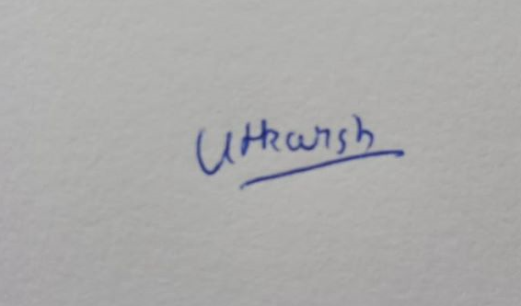

Signature of the Student