if the elements are not found by the general locators like id, class, name, etc. then XPath is used to find an element on the web page

## What is XPath in Selenium?

**XPath in Selenium** is an XML path used for navigation through the HTML structure of the page. It is a syntax or language for finding any element on a web page using XML path expression. XPath can be used for both HTML and XML documents to find the location of any element on a webpage using HTML DOM structure.

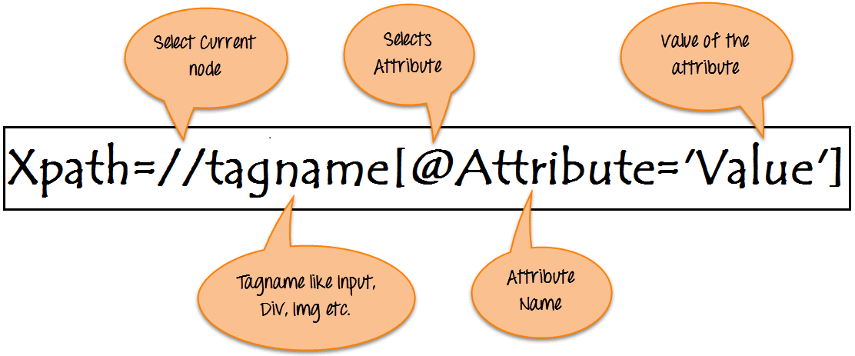

Xpath=//tagname[@attribute='value']

* **// :** Select current node.
* **Tagname:**Tagname of the particular node.
* **@:** Select attribute.
* **Attribute:** Attribute name of the node.
* **Value:** Value of the attribute.

## Types of X-path

There are two types of XPath:

**1) Absolute XPath**

**2) Relative XPath**