ACTIVE DIRECTORY HOMELAB
Day 1 — Preparing Windows Server 2022
Environment: VMware Workstation | OS: Windows Server 2022 Standard Evaluation

1. Objective
Prepare the Windows Server 2022 virtual machine for an Active Directory lab by opening Server Manager and starting the Add Roles and Features Wizard. The initial steps establish the installation method and identify the server that will receive the role.

2. Lab Environment
- Virtualization platform: VMware Workstation
- Operating system: Windows Server 2022 Standard Evaluation
- Management console: Server Manager
- Task: Begin installing the Active Directory Domain Services (AD DS) role

3. Procedure

Step 1 — Open Server Manager
Start the Windows Server virtual machine and open Server Manager. From the Dashboard, open the Manage menu and choose Add Roles and Features.
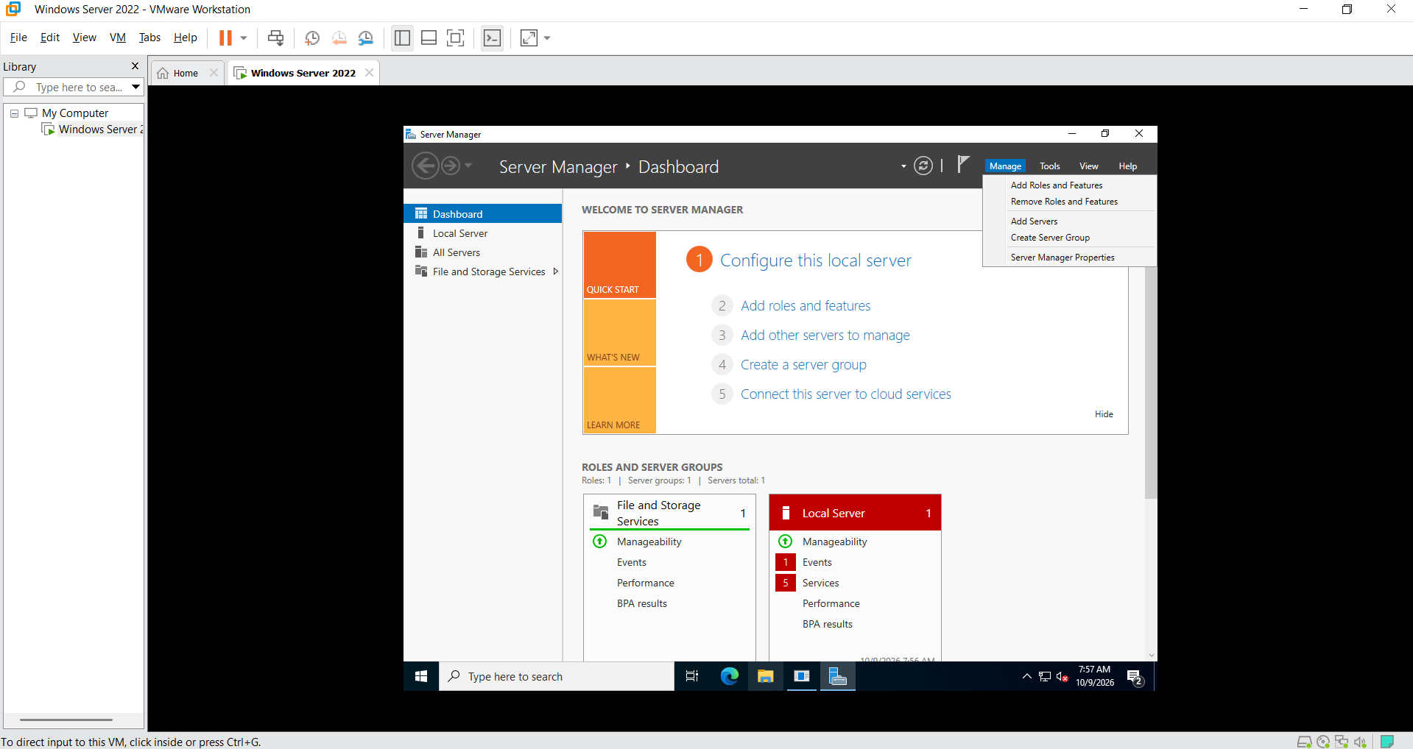
Screenshot 1. Server Manager dashboard before adding the Active Directory role.

Step 2 — Choose the installation type
In the Add Roles and Features Wizard, select Role-based or feature-based installation. This option is used to add server roles and features to a selected Windows Server instance. Remote Desktop Services installation is intended for a different deployment workflow.
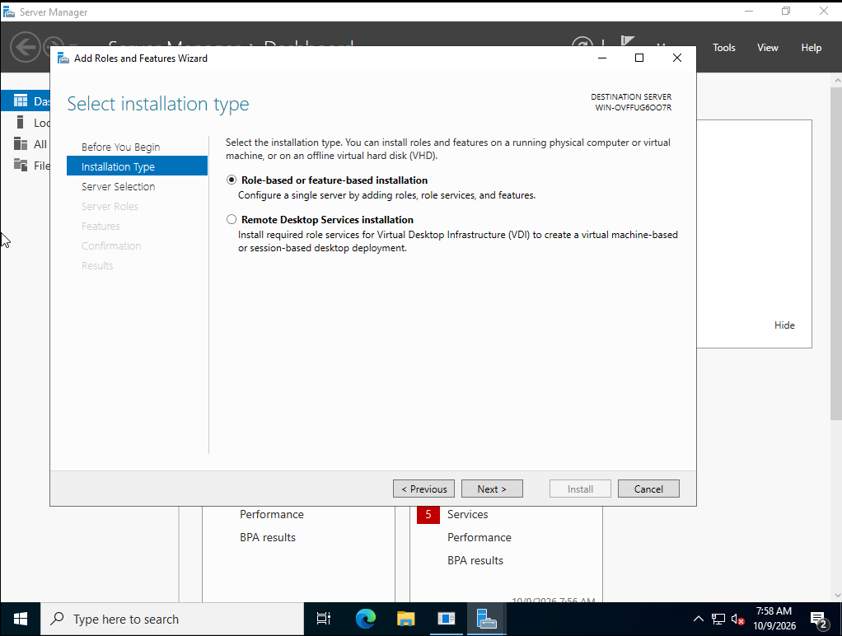
Screenshot 2. Add Roles and Features Wizard — Role-based or feature-based installation selected.

Step 3 — Select the destination server
Choose Select a server from the server pool, then select the local Windows Server 2022 machine shown in the list. Confirm that the intended server is highlighted before clicking Next.
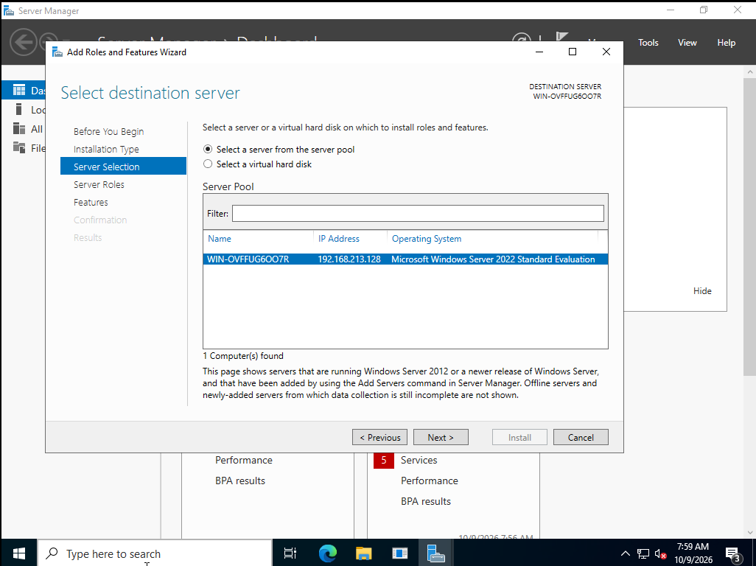
Screenshot 3. Destination server selected from the server pool.

4. Why these steps matter
- Server Manager provides a central interface for administering Windows Server roles and features.
- Role-based or feature-based installation is the standard path for adding AD DS to a server.
- Selecting the correct destination server helps prevent installing a role on the wrong machine.

5. Current Status and Next Steps
Completed in the screenshots: opened Server Manager, launched the Add Roles and Features Wizard, selected role-based or feature-based installation, and selected the destination server.
Next: proceed to Server Roles, select Active Directory Domain Services (AD DS), accept any required management tools when prompted, continue through the wizard, and install. After installation, promote the server to a domain controller by creating a new forest or joining an existing domain, depending on the lab design. Domain-controller promotion is a separate step from installing the role.

6. Key Takeaway
Day 1 focused on preparing the server and beginning the AD DS role installation workflow. The screenshots document the initial wizard stages; they do not yet confirm that AD DS was installed or that the server was promoted to a domain controller.

