ACTIVE DIRECTORY HOMELAB
Day 2 — Selecting Server Roles and Features
Environment: VMware Workstation | OS: Windows Server 2022 Standard Evaluation

1. Objective
Continue the Active Directory lab setup by selecting the necessary server roles (Active Directory Domain Services, DNS Server) and features using the Add Roles and Features Wizard in Windows Server 2022.

2. Lab Environment
Virtualization platform: VMware Workstation
Operating system: Windows Server 2022 Standard Evaluation
Management console: Server Manager
Task: Select AD DS, DNS, and related features for installation.

3. Procedure

Step 1 — Select Active Directory Domain Services
In the Add Roles and Features Wizard, navigate to the "Server Roles" section. Check the box for "Active Directory Domain Services" (AD DS).
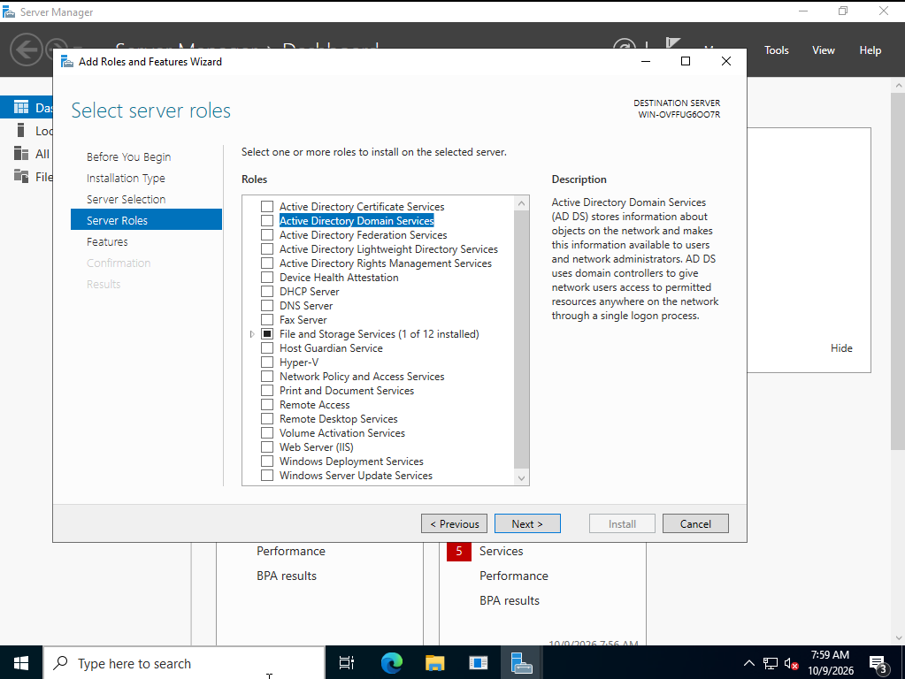
Screenshot: Select server roles - Active Directory Domain Services

Step 2 — Select Additional Required Roles
In addition to AD DS, select "DNS Server" and "Remote Access" from the roles list. DNS is a critical component for Active Directory environments to provide name resolution.
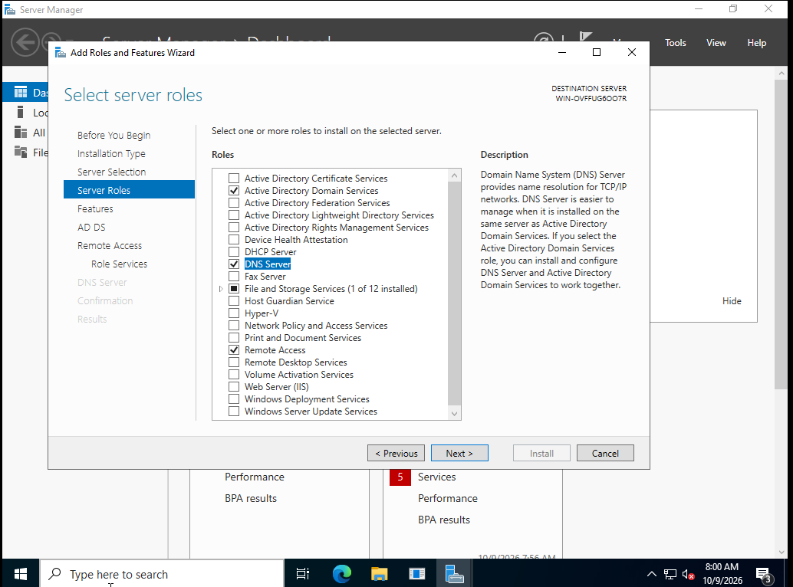
Screenshot: Select server roles - DNS Server and Remote Access

Step 3 — Select Features
Proceed to the "Features" section of the wizard. Ensure that "Group Policy Management" is selected, as this will be required for managing domain policies later.
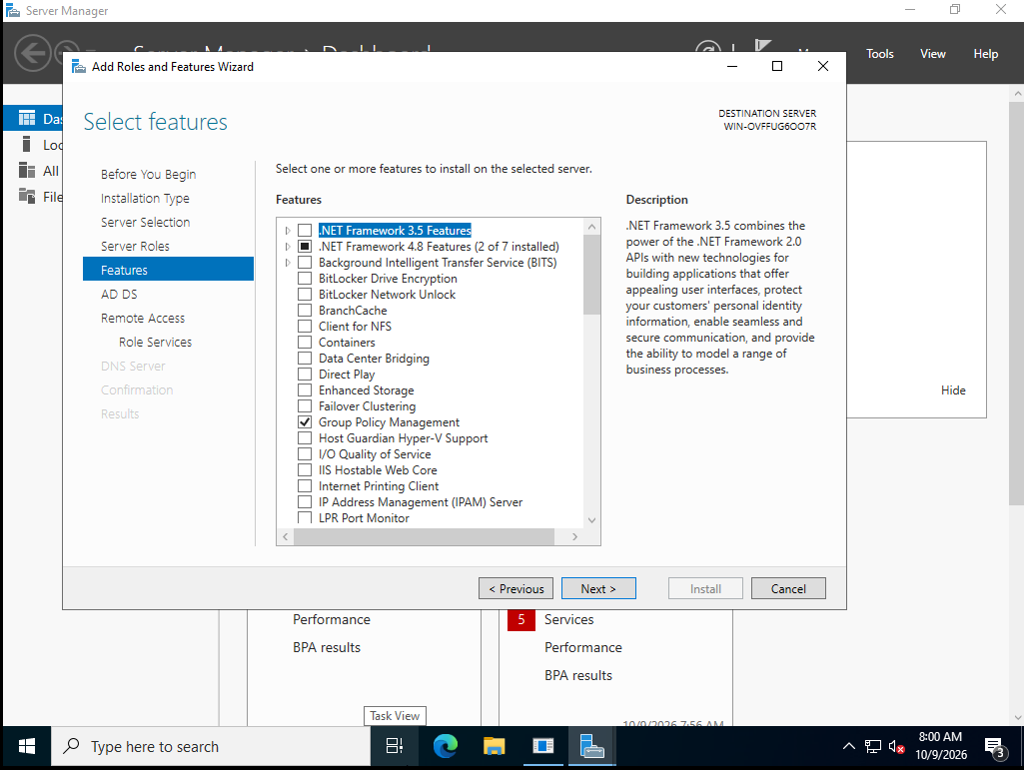
Screenshot: Select features - Group Policy Management

4. Why these steps matter
• Active Directory Domain Services (AD DS) is the core role that stores directory data and manages communication between users and domains.
• DNS Server is strictly required by Active Directory to locate controllers and resolve domain names.
• Group Policy Management allows administrators to manage configurations and security settings across the domain.

5. Current Status and Next Steps
Completed in the screenshots: Navigated through the Server Roles and Features screens, successfully selecting AD DS, DNS Server, Remote Access, and Group Policy Management.
Next: Confirm the selections and finalize the installation of the roles. Once installed, the final step will be to promote the server to a Domain Controller.

6. Key Takeaway
Day 2 focused on identifying and selecting the precise roles and features required for a functional domain controller. The installation combines AD DS and DNS to ensure network routing and identity management work seamlessly.

