**WEEK-2**

**AIM*: Installation of XAMPP Local-Server for Back-end support.***

**THEORY:**

***2.1: Installation Steps (XAMPP)***

***STEP-1:***

Open the Terminal

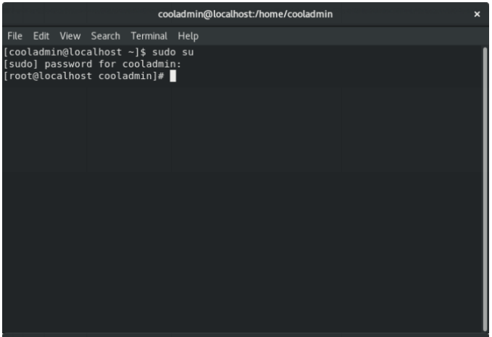

***STEP 2:***

Download the latest version of Xampp

Open up terminal and run the following commands

Download the latest version according to your system.

wget <https://sourceforge.net/projects/xampp/files/latest/download>

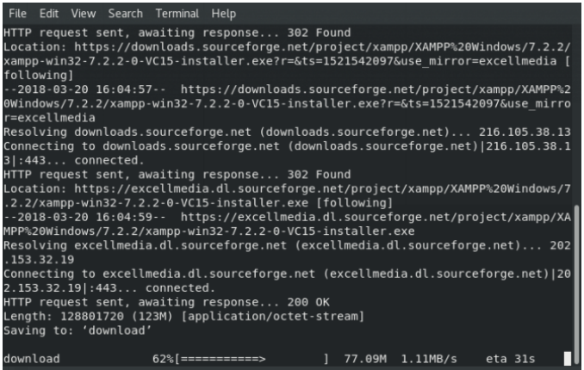

***STEP 3:***

Change the downloaded files permission to an executable and run the file

sudo chmod +x xampp-linux-x64-1.8.3-2-installer.run

sudo ./xampp-linux-x64-1.8.3-2-installer.run

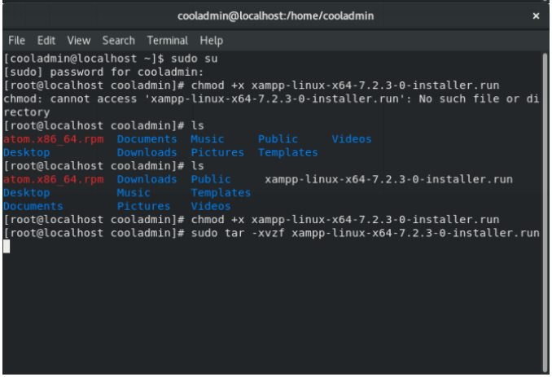

***STEP-4:***

An installation wizard will run. Complete the installation.

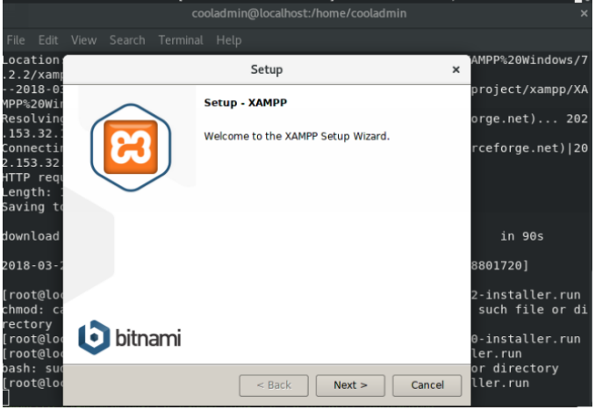

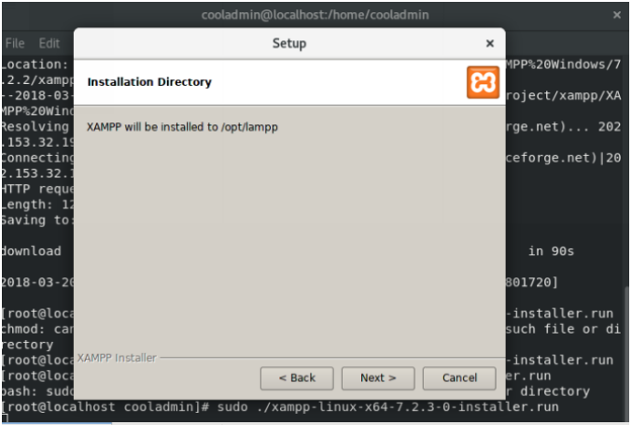

***STEP-5:***

If everything completes without any issue then Xampp Control Panel will run.

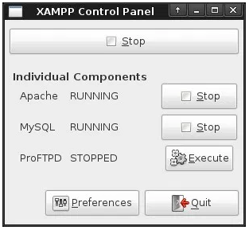

***STEP-6:***

Now visit official website for documentations and further information

