OS Lab No. 1 – Utkarsh Bajaj (180905460)

Ans 1) Program :

#include <sys/stat.h>

#include <sys/types.h>

#include <stdlib.h>

#include <stdio.h>

#include <string.h>

#include <unistd.h>

#include <fcntl.h>

int main(int argc, char const *argv[]){

int sfd;

if(argc != 3){

printf("Insuffient Number of args\n");

exit(1);

}

sfd = open(argv[1], O_RDONLY);

if(sfd == -1){

printf("Couldn't open file!");

exit(1);

}

char line[1024];

char ch;

int i = 0;

int line_no = 0;

while(read(sfd, &ch, sizeof(char)) > 0){

if(ch != '\n' || ch == EOF){

line[i++] = ch;

} else {

line[i] = '\0';

if(strstr(line, argv[2]) != NULL){

printf("Line %d:\t%s\n", line_no, line);

}

i = 0;

line_no++;

}

}

close(sfd);

return 0;

}

Input : File

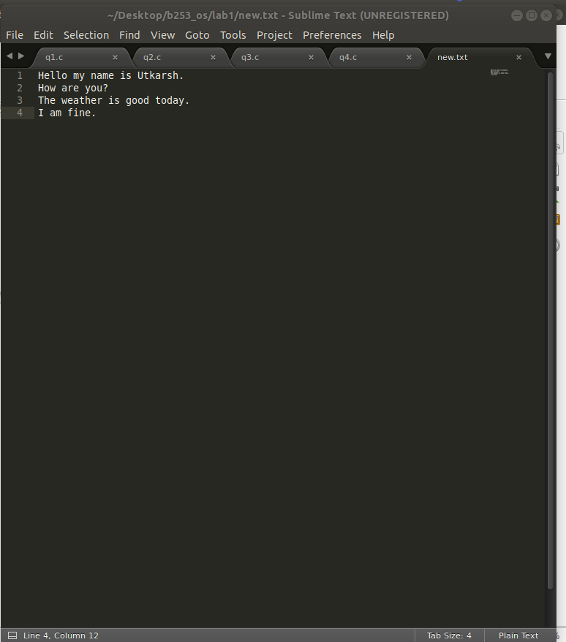

Output :

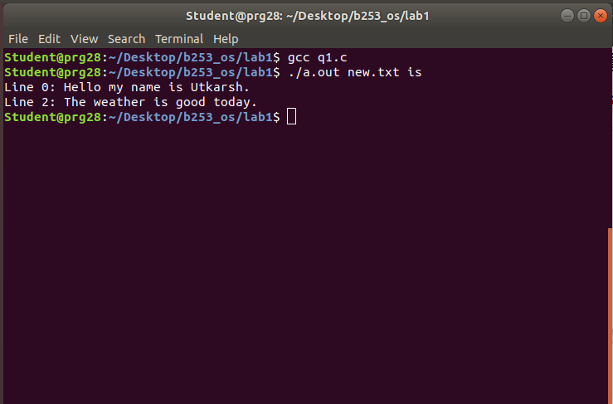

Ans 2) Program :

#include <sys/stat.h>

#include <sys/types.h>

#include <stdlib.h>

#include <stdio.h>

#include <string.h>

#include <unistd.h>

#include <fcntl.h>

int main(int argc, char const *argv[])

{

int sfd;

for(int i = 1; i < argc; i++){

sfd = open(argv[i], O_RDONLY);

int lncnt = 0;

if(sfd == -1){

printf("Error opening file\n");

exit(1);

}

char line[10005];

char ch;

int j = 0;

while(read(sfd, &ch, sizeof(char)) > 0){

if(ch == '\n'){

line[j++] = '\0';

printf("%s\n", line);

++lncnt;

if(lncnt % 20 == 0){

char c;

printf("Press a character to continue\n");

c = getchar();

}

j = 0;

} else {

line[j++] = ch;

}

}

close(sfd);

}

return 0;

}

Input File :

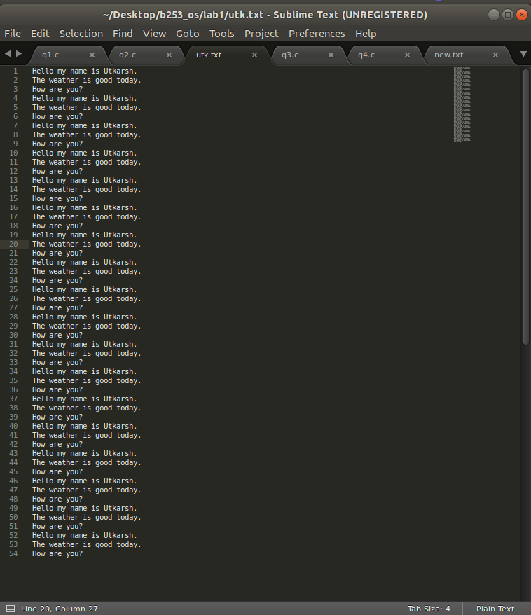

Output :

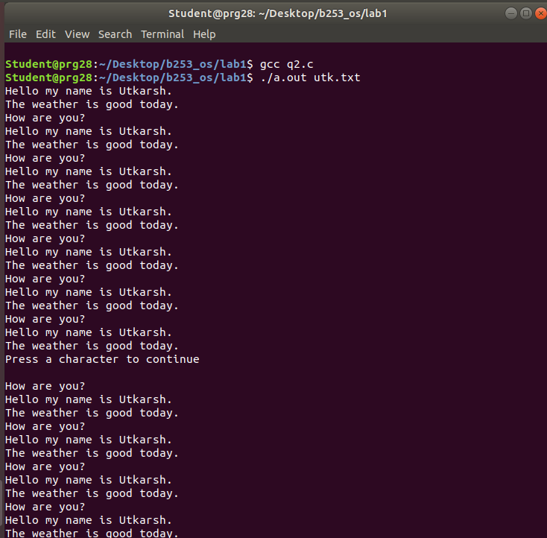

Ans 3) Program:

#include <sys/stat.h>

#include <sys/types.h>

#include <stdlib.h>

#include <stdio.h>

#include <string.h>

#include <unistd.h>

#include <fcntl.h>

int main()

{

int a = 40, errno;

char s[] = "utkarsh";

float b = 9.3;

char c = 'c';

printf("Integer D %d\n", a);

printf("Integer I %i\n", a);

printf("Octal I%o\n", a);

printf("Hexadecimal %x\n", a);

printf("Char %c\n", c);

printf("Float %f\n", b);

printf("Double Precsion %e\n", b);

printf("Double standard%g\n", b);

errno = open("hello.txt", O_RDONLY);

printf("\nError NO. : %m\n");

}

Output :

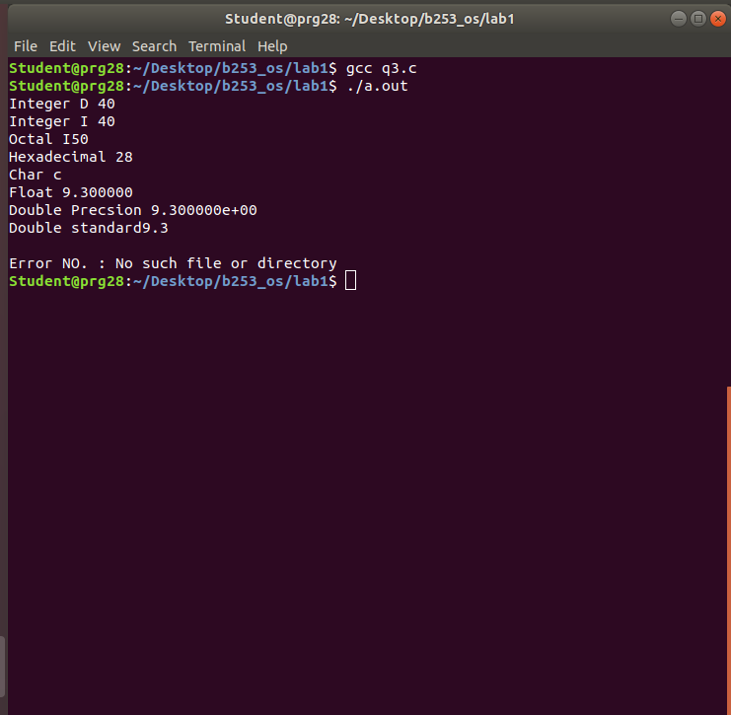

Ans 4) Program

#include <stdio.h>

int main(int argc, char const *argv[])

{

FILE *fa, *fb;

int ca;

fa = fopen("q4in.txt", "r");

if(fa == NULL){

printf("Cannot open file");

return 0;

}

fb = fopen("q4out.txt", "w");

ca = getc(fa);

while(ca != EOF){

putc(ca, fb);

ca = getc(fa);

}

fclose(fa);

fclose(fb);

return 0;

}

Input file :

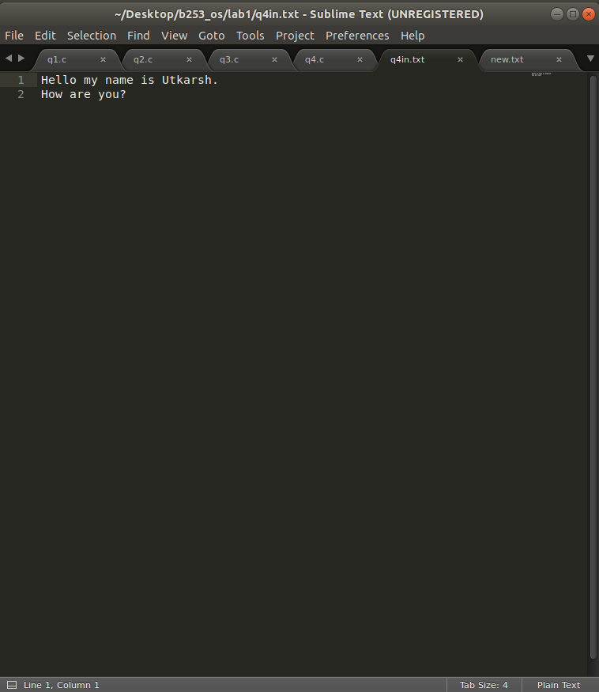

Output File :

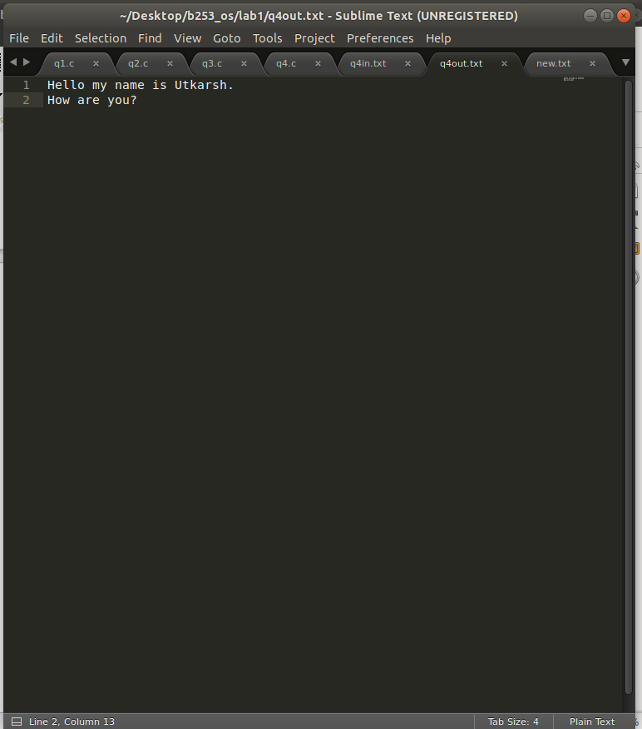

Execution :

