Lab 8 OS

Utkarsh Bajaj (180905460)

Ans 1) Program:

#include <stdlib.h>

#include <stdio.h>

#include <pthread.h>

#include <string.h>

void *thread_code(void* param)

{

int n = *((int*)param);

int arr[n];

arr[0] = 0;

arr[1] = 1;

for (int i = 2; i < n; i++)

arr[i] = arr[i - 2] + arr[i - 1];

int *sol = (int *)calloc(n, sizeof(int));

memcpy(sol, arr, sizeof(int) * n);

return sol;

}

void main()

{

int n;

printf("Enter no. of terms: ");

scanf("%d", &n);

void *arr;

pthread_t thread;

pthread_create(&thread, 0, &thread_code, (void*)&n);

printf("Thread created!\n");

pthread_join(thread, &arr);

int *arr2 = arr;

for (int i = 0; i < n; i++)

printf("%d ", (int)arr2[i]);

printf("\n");

}

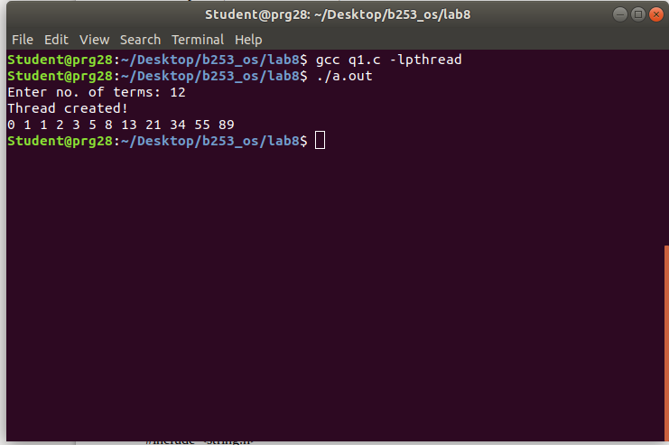

Answer 2)

Program:

#include <stdlib.h>

#include <stdio.h>

#include <pthread.h>

#include <string.h>

void* thread_code(void* n)

{

int sum = 0;

int limit = *((int*)n);

for (int i = 1; i <= limit; i++)

sum += i;

*((int*)n) = sum;

}

void main()

{

int n, num;

printf("Enter no. of elements: ");

scanf("%d", &n);

num = n;

pthread_t thread;

pthread_create(&thread, 0, &thread_code, (void*)&n);

pthread_join(thread, NULL);

printf("Sum of all non-negetive numbers from 1 to %d = %d\n", num, n);

}

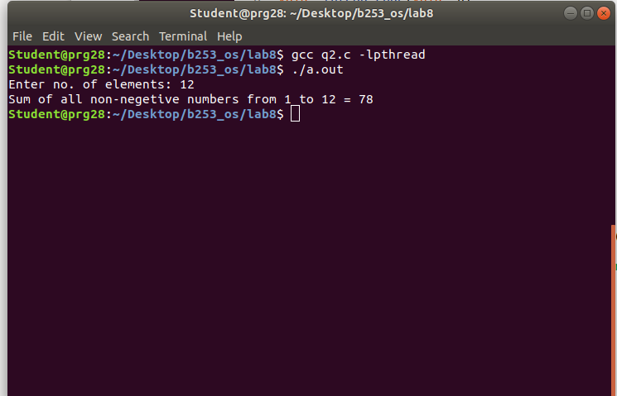

Answer 3) Program:

#include <stdlib.h>

#include <stdio.h>

#include <pthread.h>

#include <string.h>

void *prime(void* arr)

{

int n1 = *((int*)arr);

int n2 = *(((int*)(arr + sizeof(int))));

printf("Prime numbers: ");

for (int i = n1; i <= n2; i++)

{

int flag = 0;

for (int j = 2; j <= i / 2; j++)

{

if ((i % j) == 0)

{

flag = 1;

break;

}

}

if (flag == 0)

printf("%d ", i);

}

printf("\n");

}

int main()

{

int arr[2];

printf("Enter lower limit: ");

scanf("%d", &arr[0]);

printf("Enter upper limit: ");

scanf("%d", &arr[1]);

pthread_t thread;

pthread_create(&thread, 0, &prime, (void*)arr);

pthread_join(thread, NULL);

}

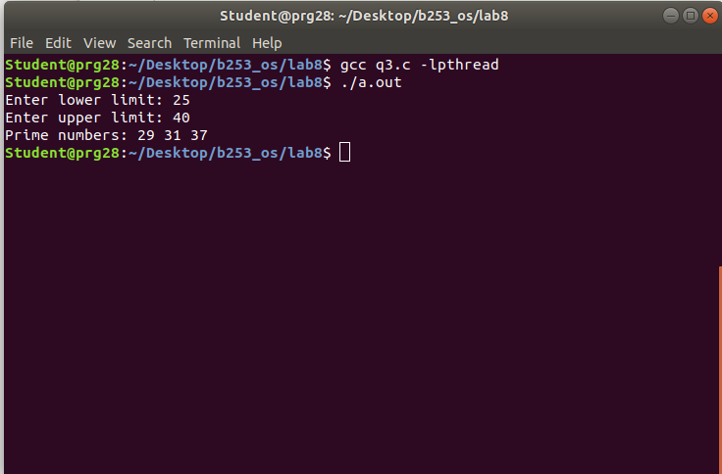

Answer 4) Program:

#include <stdlib.h>

#include <stdio.h>

#include <pthread.h>

#include <string.h>

void * even(void *brr)

{

int *arr = (int*)brr;

int size = arr[0];

int sum = 0;

for (int i = 1; i <= size; i++)

if (arr[i] % 2 == 0)

sum += arr[i];

return (void *) sum;

}

void * odd(void *brr)

{

int *arr = (int*)brr;

int size = arr[0];

int sum = 0;

for (int i = 1; i <= size; i++)

if (arr[i] % 2 != 0)

sum += arr[i];

return (void *) sum;

}

int main()

{

int n, e, o;

printf("Enter size of array: ");

scanf("%d", &n);

int arr[n + 1];

arr[0] = n;

printf("Enter elements:\n");

for (int i = 1; i <= n; i++)

scanf("%d", &arr[i]);

pthread_t t1, t2;

pthread_create(&t1, 0, &even, (void *)arr);

pthread_create(&t2, 0, &odd, (void *)arr);

pthread_join(t1, (void*) &e);

pthread_join(t2, (void*) &o);

printf("Sum of even numbers = %d\n", (int)e);

printf("Sum of odd numbers = %d\n", (int)o);

}

