HR Employee Attrition Analysis

Prepared By
Utkarsh Bisht

Role

Data Analyst

Dataset:
IBM HR Analytics Employee Attrition & Performance (Kaggle)

Tools Used:
Excel
Power Query
SQL
Power BI
GitHub
Visual Studio Code

Date:
July 2026

Business Overview
This project involves the analysis of the IBM HR Analytics Employee Attrition & Performance dataset to identify the key factors associated with employee attrition. Using Excel, Power Query, and SQL for data validation, cleaning, and analysis, along with Power BI for visualization, this project analyzes employee attrition across departments, age groups, income ranges, overtime, job satisfaction, and distance from home to understand which employee groups have higher attrition rates.

Business Problem
A fictional dataset represents an organization that needs to understand the factors contributing to employee attrition so that HR teams and organizational leaders can make informed decisions to improve employee retention.

Business Objectives
- Identify the key factors associated with employee attrition.
- Analyze attrition patterns across different employee groups.
- Identify departments and employee groups with relatively higher attrition rates.
- Provide recommendations based on insights to support employee retention.

Key Questions
- Which departments have the highest attrition rates?
- Which age groups are most likely to leave the organization?
- Does income level have an impact on employee attrition rates?
- Does job satisfaction have a relationship with employee attrition?
- Does overtime have an impact on employee attrition rates?
- Does distance from home have an impact on employee attrition rates?

Primary Stakeholders
- HR Department
- Organizational Leaders
- Managers
Dataset
Source - IBM HR Analytics Employee Attrition & Performance (Kaggle)
Link - https://www.kaggle.com/datasets/pavansubhasht/ibm-hr-analytics-attrition-dataset
Size - The employee data in this dataset is distributed across 35 columns.
Tools Used
- Excel – Initial data inspection and validation
- Power Query – Data cleaning and transformation
- SQL – Data validation, attrition metrics, and analysis
- Power BI – Dashboard development and visualization
- GitHub – Version control and portfolio hosting
- Visual Studio Code – SQL development and project documentation
Data Validation & Cleaning
- Row count verification
- Duplicate detection
- Missing value assessment
- Invalid value validation
Key Observations
- Total records: 1,470
- Employees attrited: 237
- Overall attrition rate: 16.12%
- Average monthly income: $6,503
- No duplicate employee records found.
- No NULL values detected in the validated columns.
- No invalid values found for Age, Monthly Income, or Distance from Home.
The dataset passed the validation checks and was considered suitable for analysis.

Business Analysis
- Attrition by department
- Attrition by age group
- Attrition by income range
- Attrition by job satisfaction
- Attrition by overtime
- Attrition by distance from home

Dashboard
The Power BI dashboard provides an overview of employee attrition using KPI cards, interactive filters, and visualizations across different employee and job-related factors.
The dashboard includes:
KPI Cards
- Average Income
- Total Employees
- Employees Attrited
- Attrition Rate
Interactive Filters
- Department
- Job Role
Visualizations
- Attrition Rate by Department
- Attrition Rate by Age Group
- Attrition Rate by Overtime
- Attrition Rate by Income Range
- Attrition Rate by Distance From Home
- Attrition Rate by Job Satisfaction
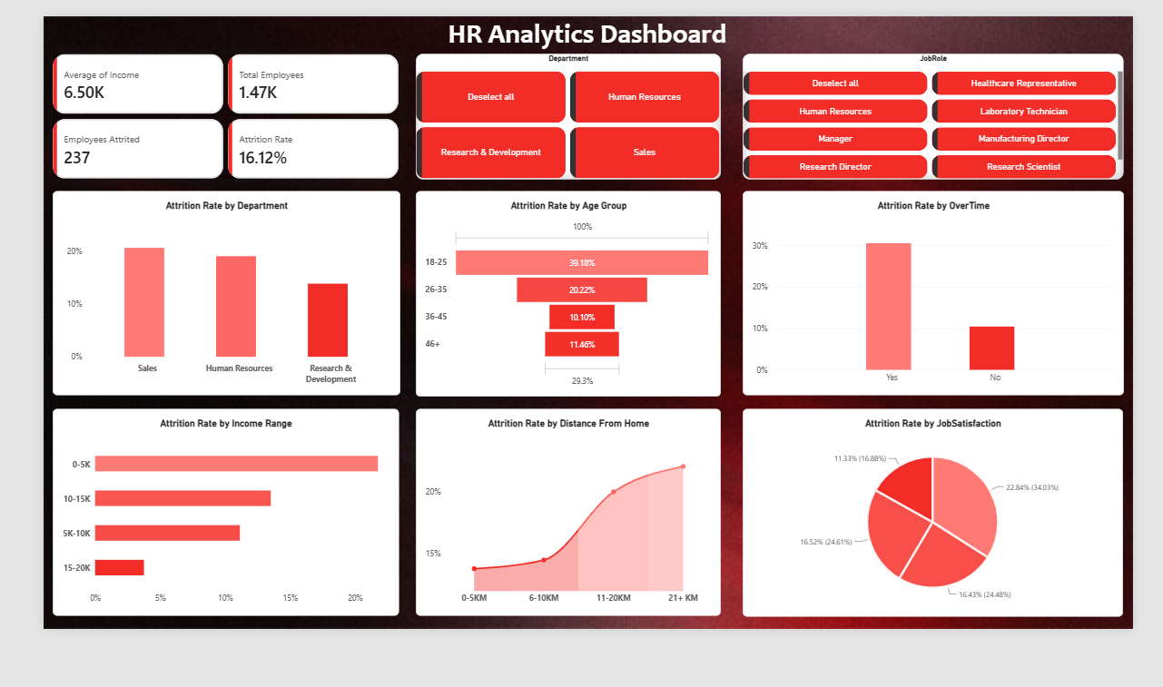
Key Findings
- Employees working overtime show a substantially higher attrition rate compared with employees who do not work overtime.
- Younger employees, particularly those aged 18–25, show the highest attrition rate among the analyzed age groups.
- Attrition varies across departments, with Sales showing the highest attrition rate among the three departments.
- Employees in the lowest income range show a relatively higher attrition rate compared with higher-income groups.
- Employees living farther from the workplace show higher attrition rates, with employees living 21+ KM away showing the highest attrition rate.
- Employees with lower job satisfaction levels show higher attrition rates, with the lowest job satisfaction group showing the highest attrition rate.

Business Recommendations
- HR should investigate workload and employee well-being among employees working overtime and consider workload management initiatives.
- Develop stronger career-development programs, mentorship, skill-building opportunities, and clear career progression for younger employees.
- Investigate high-attrition departments to identify department-specific issues such as workload, management, and compensation.
- Review compensation for lower-income employee groups and consider competitive pay, incentives, and growth opportunities.
- Consider flexible or hybrid work options and transportation support for employees with longer commuting distances.
- Conduct regular employee satisfaction surveys and address issues related to management, recognition, career growth, and workplace experience.

Prepared by: Utkarsh Bisht
Role: Data Analyst
Project Date: July 2026

