HR Employee Attrition Analysis

Prepared By
Utkarsh Bisht

Role - Data Analyst

Dataset:
IBM HR Analytics Employee Attrition & Performance (Kaggle)

Tools Used:
Excel
Google BigQuery (SQL)
Tableau
GitHub

Date:
August

Business Overview

This project involves analysis of *IBM HR Analytics Employee Attrition & Performance* to uncover the factors that lead to employee attrition along with the performance analysis of employees. Using SQL for data validation, cleaning and analysis along with Tableau for visualization, this project points out the leading factors behind attrition like *WHY* employees are leaving, which *department* and *job role* have higher attrition rate etc. It also involves analysing employee performance and evaluating the relationship between their performance and attrition , and whether low job satisfaction or low enviroment satisfaction is responsible for their attrition or whether any other factors contribute to attrition.

Business Problem

A fictional dataset is representing an organization which needs to uncover the factors that lead to employee attrition so that the hr and organization leaders can take decisons and improve the employee tenure

Business Objectives
- Uncover the factors that lead to employee attrition,
- Provide recommendations based on insights so that the HR and organizational leaders can take better decisions to improve the employee tenure
The goal is to generate actionable business insights that support revenue growth and improve the customer experience. Using SQL for data analysis and Tableau for visualization.

Key Questions
1. Which departments have highest attrition rates?
2. Which age groups are most likely to leave the organization?
3. Does the salary have any impact on employee attrition rates?
4. Does the job satisfaction level correlate with employee attrition?
5. Does the distance from home to office have any impact on employee attrition rates?
Primary Stakeholders
- HR Department
- Organizational Leaders
- Managers
Dataset
Source - IBM HR Analytics Employee Attrition & Performance (Kaggle)
Link - https://www.kaggle.com/datasets/pavansubhasht/ibm-hr-analytics-attrition-dataset
Size - The employee data in this dataset is distributed across 35 columns
Tools Used
- Google BigQuery – SQL querying, data validation, and analysis
- Tableau Public – Dashboard development and visualization
- GitHub – Version control and portfolio hosting
- Visual Studio Code – SQL development and project documentation

Data Validation & Cleaning

- Row count verification
- Duplicate detection
- Missing value assessment
- Invalid value validation

Key observations:
- Total records: 1,470
- No duplicate employee records found.
- No NULL values detected in the validated columns.
- No invalid values found for Age, Monthly Income, or Distance from Home.

Business Analysis

- Attribute by department
- Attribute by age group
- Attribute by monthly salary
- Attribute by job satisfaction
- Attribute by overtime
- Attribute by distance from home

Dashboard
The dashboard was built on Tableau & provides a complete overview of attrition across different department ,age, monthly income, job satisfaction and distance from home.

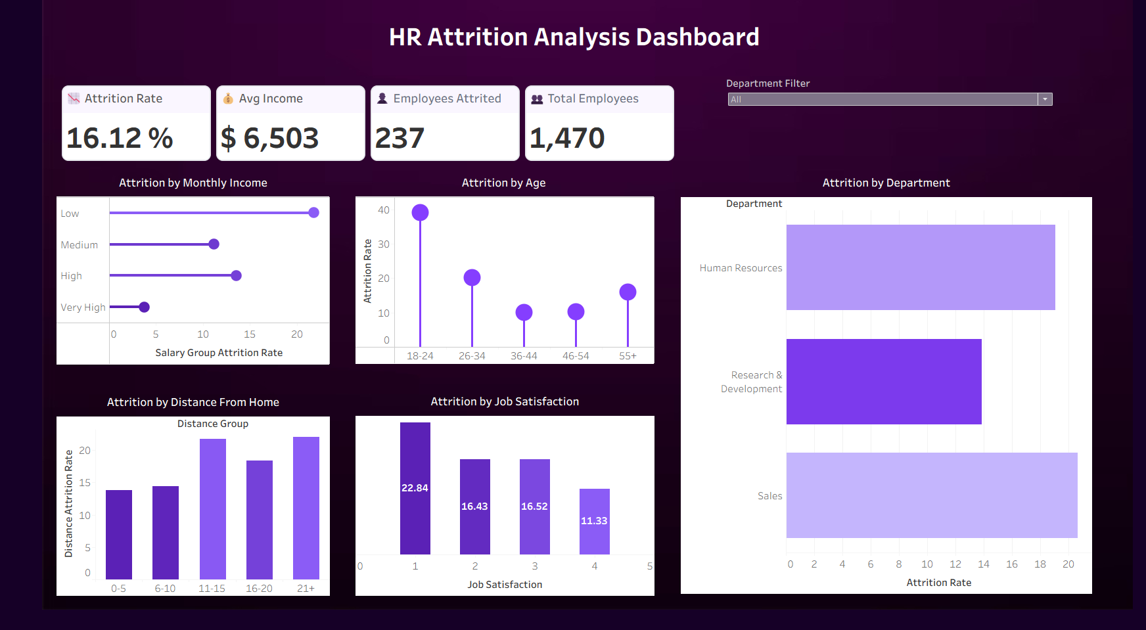

Includes,
KPI Cards
Total Employees, Average Salary, Attrition Rate, Total Employee Attrited

Graphs
- Attribute by department
- Attribute by age group
- Attribute by monthly salary
- Attribute by job satisfaction
- Attribute by distance from home
- Interactive department filter

Key Findings
- Lower job satisfaction is associated with higher employee attrition.
- Younger employees show relatively higher attrition.
- Employees living farther from the workplace show higher attrition.
- Lower-income employees show relatively higher attrition.
- Attrition varies across departments.

Business Recommendations
- Improve employee satisfaction through feedback, recognition, and career growth.
- Investigate high-attrition departments and their underlying causes.
- Provide career development and mentorship opportunities for younger employees.
- Consider flexible work options for employees with longer commutes.
- Review compensation for lower-income and high-attrition employee groups.

Prepared by: Utkarsh Bisht
Role: Data Analyst
Project Date: July 2026

