Psychological Analysis Using Social Media Tweets

# 

P. Renukadevi

Assistant Professor

(C. Tech Department)

SRM Institute of Science and Technology

Kattankulathur, Chennai, India

renukadp@srmist.edu.in

Utkarsh Gupta

(C. Tech Department)

SRM Institute of Science and Technology

Kattankulathur, Chennai, India

ug3189@srmist.edu.in

Kartik Singh

(C. Tech Department)

SRM Institute of Science and Technology

Kattankulathur, Chennai, India

ks9124@srmist.edu.in

***ABSTRACT*** –**The main goal of this study is to use social media platform to extract and analyse relevant data to understand the psychological aspects of depression through in-depth study of long short-term memory (LSTM) and convolutional neural networks (CNNs) for motor skills. Examining the tweets in more detail, focusing on language and temporal context. By examining the underlying dynamics within Twitter network, we aim to gain insights into the social processes that affect the concept of depression. This review aims to enhance the understanding of mental health professionals and decision makers in this area. The first phase of our method includes tweet tokenization followed by LSTM and CNN models for searching for important features. The primary goal of this project is to develop a system that can conduct psychological analysis and support psychotherapy. Our method achieves a classification accuracy of up to 99.02%, which enables the detection of changes in behavioural patterns.**

***Keywords:*** *Psychological analysis, Social media, Depression, Machine learning, NLP (Natural Language Processing), Data preprocessing*

1. **INTRODUCTION**

The digital media has proliferated across the globe to a considerable degree, therefore, there are notable shifts in the social lives of the people from the range of age groups in the world. Nowadays, the role of social media cannot be overemphasized because X (Twitter) alone, in India, has over 17 million users and is therefore a vital tool in understanding their behaviour and mental state. But as for the problem of mental health, it is being confronted with the scarcity of services and the high cost of the diagnosis and professionals say that the same approach should be used in India as well: the psychiatric patient should be monitored within closed environment and after that the treatment should be directed at the root cause. Through relying on subjective and non-objective stories, conveying only the perspectives of few patients, who may not represent the whole matter. In fact, patients changes of behaviour might not be detected at all and the wrong diagnoses are a direct consequence of that. Social media networks really provide the researchers the required field to study, and especially in the case of under-served remote populations with minimum medical facilities, they become the indispensable sources of data. Through investigation of the functioning of social media such as the X (Twitter), researchers can get the significant data on the nature of individual personality and his/her attitude towards the social events. While investigation by means of posts on people whose messages are connected with suicide or hate speech implies that social media could be a tool for the urgent response and assistance, the experts will see that social media platforms allow them to uncover users concerns and pains of the same kind with many mental health conditions. One recent study, for instance, revealed relationships between high social network site use and low self- rated mental health in children and teenagers who also report psychological distress. Hence, the research paper is focused on evaluation of risky behaviours which are categorized into several subgroups. Whether we talk about how people in the community dealing with mental illnesses or the case where the researchers or the policymakers handle social media inclusions, we have to be able to understand the differences of each status and address them adequately.

# LITERATURE SURVEY

"A Psychological Analysis of Depression Using Social Media (X (Twitter))" project literature review includes an academic review and comprehensive review of the literature on depression and social media, with a specific focus on X (Twitter) that requires research many majors to understand their motivations, strategies, and contributions to the field.

Abdullah Ikram, Mohit Kumar, and Geetika Munjal (IEEE, 2022) address the challenges of sentiment analysis on X (Twitter), including missing, sparse content data, and limited context by their method of data collection, preprocessing, selection, and classification using unigram + processing bigram.

Shreyas S. Korty, Suvarna G. Kankaraddy (IEEE) focus on disorder detection in X (Twitter) posts using NLP and machine learning techniques. Their methods include SVM, LR, LSTM-NLP, CNN+LSTM, DL+NLP, and Naive Bayes.

Shruti K. Kumar, Nandita Dinesh, and Nitha L. (IEEE, 2022) investigate distress detection in X (Twitter) tweets using different machine learning classifiers. Methods such as Naïve Bayes, decision tree, SVM, random forest, and CNN are used.

Alya Melati Putri, Kevin Vijaya Owen, and Albert Salomo (IEEE, 2022) investigate the accuracy of machine learning models for detecting harassment on social media. Their methods include Naive Bayes, SVM, KNN, LR, and LSVM.

Osman Ahmed and Jerry Chun-Wei Lin (IEEE, 2023) examine the impact of depression on social media and various modes of discovery. Their approach includes personal journaling, GAT, self-focus, and emotional vocabulary expansion.

Jai Nanavati and Unnati Patol (IEEE, 2023) propose a hybrid model to analyse depression issues through social media. Techniques such as hybrid perception are used.

Taken together, these studies provide valuable insights into the understanding of depression on X (Twitter) and other social media platforms. Methods and perspectives are offered that contribute to the advancement of research in this area. The findings open the way for further investigation and the development of effective strategies for identifying and managing depression in online contexts.

# PROPOSED WORK

The choice of LSTM (Long Short-Term Memory) & CNN (Convolutional Neural Network) model for the project "Psychological Analysis of Depression Using Social Media" is a strategic decision with several factors:

*Processing sequential data*: The data itself follows a sequential pattern, where tweets are sorted and delivered in a specific order. LSTMs are adept at processing sequential data, allowing long-term dependent capture. This is important for understanding the subtle language structure and emotional contagion associated with depression in tweets.

*Text analysis capabilities*: LSTMs are known to perform well in natural language processing tasks such as sentiment analysis. They have the ability to recognize emotional cues and verbal signs of depression. When combined with CNN for feature extraction from text, the model’s ability to extract meaningful information from tweets improves significantly.

*Integration of large amounts of data*: Social media data typically contains a variety of formats such as text, images, video, and interactivity. The LSTM + CNN model allows for the integration of multiple data sets, which can enhance deeper analysis and insights about depression on X (Twitter) by considering different data sources

*Understanding context*: LSTMs excel at capturing context, which is critical to understanding mental health discussions taking place on X (Twitter) and other social media platforms. The model can better see how conversations evolve over time, how users interact, and how emotional states change during conversations.

*Hierarchical feature learning*: CNNs are known for their ability to learn hierarchical representations of data, making them suitable for understanding complex patterns in X (Twitter) conversations This complements LSTM's ability to process dependent feature sequences, and to analyse a complete occurs in depression-related content on X (Twitter).

*Model flexibility and tuning*: The LSTM + CNN model provides flexibility in terms of architectural changes and hyperparameter tuning. These variables are important for optimizing the model's performance in psychological analysis of depression on X (Twitter), and allow for fine-tuning to achieve the desired results.

In summary, the LSTM+CNN model is a well-suited choice for the task, exploiting the strengths of both architectures to fully analyse sequential and textual features thereby providing insight.

**Data collection** from social media comments is vital in psychological analysis as it offers a vast and dynamic pool of real-time data reflecting diverse human emotions, behaviours, and thought patterns.

*Twint Configuration:* The dataset obtained by the special Twint tool presents a comprehensive collection of X (Twitter) statistics developed for analytics applications. It includes a wide range of content with metadata that extends from individual tweets to detailed user information. It covers key moments, capturing real-time conversations and sentiment around topics, making it incredibly valuable for tasks such as sentiment analysis and trend forecasting.

*Kaggle X (Twitter) Sentiment Dataset:* The dataset stands out as a widely used X (Twitter) data repository with a special focus on sentiment analysis. It contains labelled tweets categorized into positive, negative, and neutral sentiments, making them essential for sentiment analysis efforts. Spanning geography, the data structure incorporates complementary metadata, making it great for comprehensive analysis.

*Googlenews-vector-badnews300.bin.gz***:** The dataset is a valuable asset for natural language processing (NLP) efforts, providing pre-trained word vectors from a wide range of news articles They are represented 300-dimensionally vector space, this stored vocabulary contains linguistic semantics and syntactic nuances. In addition, it provides linguistic analyses such as morphosyntactic analysis and analysis of language development over time. Specifically, the GoogleNews-vectors-negative300.bin.gz dataset plays an important role in advanced NLP research by enhancing contextual and meaningful language models.

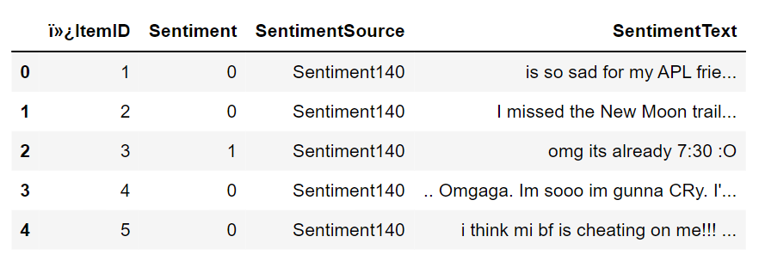

Fig. 1. Kaggle Dataset

**Tokenization** is an important step in natural language processing, which converts human-readable information into numerical form for machine learning algorithms. In this report, we detail the key steps in the tokenization process for effective text analysis and model training.

*Tokenizer Initialization and Parameter Tuning:* Tokenizer, an intermediate stage, is initialized with parameters such as num_words (set to 20,000) to extract simple words, increasing computational efficiency and model performance.

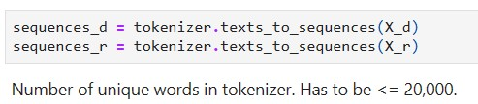

Fig. 2. Token Fitting

*Fitting of the tokenizer:* The tokenizer is fitted to various data types including depression and random tweets to capture the nuances and variations of the language, which are important for robust model training.

*Text sequences*: Tokenizer converts raw text into a sequence of numbers, facilitating machine learning model matching.

*Counting unique words*: By calculating the number of words (21,548 unique tokens), we measure the amount and diversity of the language in the dataset.

*Sequences are padding for consistency*: Padded sequences are set to a consistent long (140 words) by pad sequences, ensuring identical input data for machine learning models.

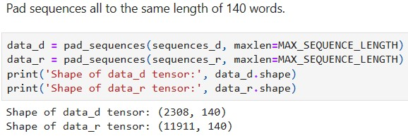

Fig. 3. Padding Sequence

In summary, tokenization is a key step in NLP, enabling machines to process and analyse human language intelligence, which is important for various tasks such as sentiment analysis and text classification.

**Data preprocessing** is crucial in psychological analysis using social media comments as it involves cleaning, organizing, and transforming raw data into a structured format suitable for analysis.

*Pre-trained Word2Vec Loading:* Integrating pre-trained Word2Vec models is an important step in natural language processing efforts, enabling the use of pre-stored vocabulary for different tasks This process requires an executed Word2Vec model file previously trained, usually stored in binary or text formats Once loaded, the model provides lexical vectors that capture semantic relations between words, which prove helpful in tasks such as text classification and sentiment analysis.

*Data Cleaning:* Tweet preprocessing is still a key step in NLP and text analysis, involving various techniques to clean up unstructured tweet text, followed by analysis or machine learning This process involves extracting URLs, image links, hashtags, and @ mentions using regular words. Emojis are removed or replaced, while letters and punctuation are removed to reduce noise and increase performance.

Ideally, lemmatization rather than stemming is adopted to ensure proper wording, and normalization procedures to handle contraction and text variation These preprocessing steps are applied systematically to each tweet in the data set to prepare the data for subsequent analysis or modelling efforts.

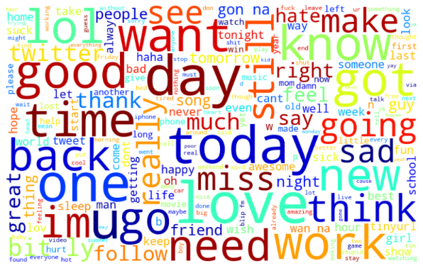

Fig. 4. General Embedded Matrix

**Embedding matrices** play an important role in machine learning models for natural language processing, acting as an important link between textual data and numerical representation. In this particular framework, an embedding matrix is ​​a two-dimensional structure where each row is a specific word meet To create this sorted matrix, the pre-trained Word2Vec instance is initialized using the KeyedVectors.load_word2vec_format function. When double stored, this model contains a pre-established vocabulary with many words derived from extensive text.

Then, the dimensions of the matrix are determined by the minimum value of MAX_NB_WORDS and the actual number of unique words in Tokenizer and nb_words and then an empty matrix of size (nb_words, 300), named embedding_matrix, is constructed. Through iteration over the words, the corresponding pre-trained word vector for each word is inserted into the embedding matrix if it is in the Word2Vec model and meets the MAX_NB_WORDS constraint.

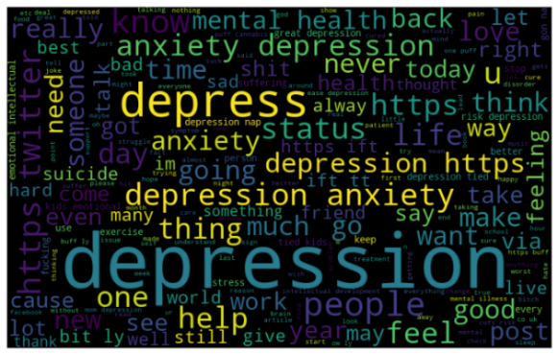

Fig. 5. Negative Embedded Matrix

This careful process generates an embedding matrix of vector representations of words, previously trained in a corpus sufficient to incorporate semantic and contextual information Serving as a foundational element to start the word embeddings layer of the neural network model, this matrix is ​​indispensable for the proper use and analysis of text

**Training and Testing** in psychological analysis using social media comments, employing LSTM and CNN models is pivotal for their ability to capture dependencies and spatial patterns within the data, respectively.

*Model architecture:* Model building is an important step aimed at developing an efficient algorithm that can classify tweets to identify symptoms of depression. This model works by taking an input sentence and producing an output, which represents the probability that the input tweet shows depression. The basic framework of the model combines Convolutional Neural Network (CNN) and short-term memory (LSTM) networks to take advantage of the robustness of both frameworks.

*Convolutional layer thickness:* After the embedding layer, the Convolutional Layer is introduced. CNNs are known for their ability to learn spatial structure, and excel in detecting structural patterns in ordinal data. A 1D convolutional layer with 32 filters and a kernel size of 3 is used, with the ReLU activation function. After convolution, a Max-Pooling level with a pool size of 2 is used to reduce the dimensionality of the data, focusing on salient features. In addition, a dropout layer with a dropout rate of 0.2 is combined to prevent overfitting.

*LSTM positioning:* After the convolutional layer, the LSTM layer is introduced. LSTMs specialize in capturing dependent sequences that are critical to understanding textual data as context. This LSTM layer with 300 units is connected to the output of the convolutional layer to learn from the structural model. Another dropout layer with a dropout rate of 0.2 is included to further prevent overfitting.

*Output layer available*: The model ends with a Dense layer that defines an output unit and a sigmoid activation function. This level predicts the probability that the input tweet shows depression, where the sigmoid function ensures that the output falls within the range [0, 1], can be defined as a probability in model building, compilation is performed to establish loss functions, optimization algorithms, and evaluation metrics. Binary cross-entropy acts as a chosen loss function suitable for binary classification tasks.

The model architecture including the layer structure and total parameter count is summarized using the model_summary function, and distinguishes between separable and non-separable parameters*.* To deal with overfitting, an Early Stopping procedure is used to ensure training efficiency. This mechanism checks the performance of the model during training, terminating the program if it loses or accuracy could not be improved within the specified number of times.

*Training program:* The model is trained for a specified number of periods, processing training data to modify internal parameters, reduce loss, and increase accuracy Set of training and validation data are provided to evaluate model performance, and trained using the model fit method for example, including the number of times, batch size, shuffling, the Early Stopping parameters are included.

1. **RESULT AND ANALYSIS**

In our investigation of psychological using social media tweets, we used a sequential sampling framework consisting of several layers: embedding layer, Conv1D layer, maximum pooling layer, dropout layer, and LSTM layer, dense layer and the design of this model included 6,428,733 patterns, where 428,733 patterns were separable and the remaining 6,000,000 patterns were identified as inseparable.

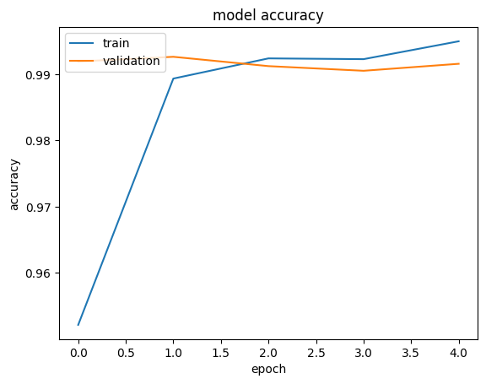

Fig. 6. Model Accuracy

The performance of our model was evaluated using precision, recall, F1-score, and ROC-AUC score metrics. These metrics were calculated for both positive (indicating depression) and negative (non-depression) groups. Our model demonstrated exceptional performance across all metrics, indicating its effectiveness in psychological using social media tweets.

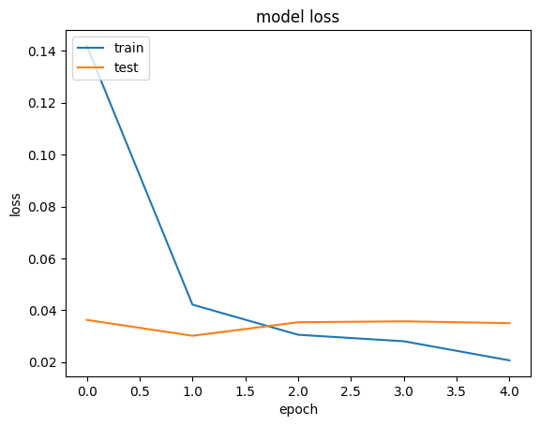

Fig. 7. Model Loss

For the positive category (reflecting depression), our model achieved an accuracy of 98.44%, which means that 98.44% of the cases classified as positive were indeed positive. The recall for the positive category was 95.45%, that is the model showed 95.45% of the actual positive cases. Furthermore, the F1-score representing the harmonic mean of precision and recall was calculated as 96.92% for the best class, indicating a balanced performance between accuracy and recall.

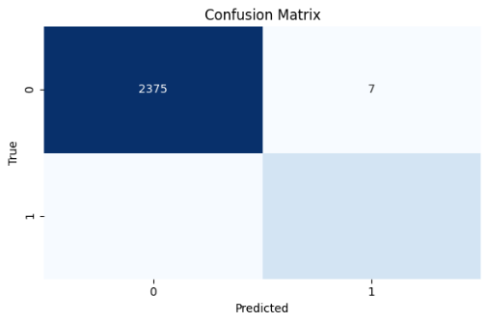

Fig. 8. Confusion Matrix

Furthermore, our model obtained a high ROC-AUC score of 97.58%, indicating that it can successfully discriminate between positive and negative cases. In summary, high specificity, recall, F1-score, and ROC-AUC scores of the model confirm its efficacy and reliability for detecting psychometric properties of depression in social media data.

## CONCLUSION

The aim of the research project was to scale up early detection of depression using social media data, which produced promising results. Social media platforms act as valuable insights into users mental states, enabling individuals to share thoughts, feelings and experiences outside of mental health support, insights from social media data finds applications in various sectors such as business marketing, helping companies understand customer sentiment and satisfaction LSTM has emerged as a powerful tool for managing broad data in depression research, capturing very subtle symptoms of depression, and demonstrating robust performance with both balanced and unbalanced data. Future research should focus on expanding mental health research beyond social media platforms, exploring new data sources and other machine learning techniques that can detect depressive symptoms in individuals who do not engage in social media.

1. **REFERENCES**
2. Xu, G., Meng, Y., Qiu, X., Yu, Z., & Wu, X. (2022). Sentiment analysis of comment texts based on BiLSTM. *Ieee Access*, *7*, 51522-51532.
3. Tammaro, A. M., Tomaiuolo, M., Mordonini, M., Pellegrino, M., & Demicelis, R. (2022). Building a Sentiment Analysis Model for Libraries: The CSBNO Consortium Approach. Italian Research Conference on Digital Library Management Systems.
4. Meng, W., Wei, Y., Liu, P., Zhu, Z., & Yin, H. (2019). Aspect based sentiment analysis with feature enhanced attention CNN-BiLSTM. *IEEE Access*, *7*, 167240167249.
5. Ikram, A., Kumar, M., & Munjal, G. (2022, January). X (Twitter) Sentiment Analysis using Machine Learning. In *2022 12th International Conference on Cloud Computing, Data Science & Engineering (Confluence)* (pp. 629-634). IEEE.
6. Kumar, S. K., Dinesh, N., & Nitha, L. (2022, May). Depression detection in X (Twitter) tweets using machine learning classifiers. In *2022 Second International Conference on Interdisciplinary Cyber Physical Systems (ICPS)* (pp. 81-86). IEEE.

1. Liaw, A. S., & Chua, H. N. (2022, September). Depression Detection on Social Media With User Network and Engagement Features Using Machine Learning Methods. In *2022 IEEE International Conference on Artificial Intelligence in Engineering and Technology (IICAIET)* (pp. 1-6). IEEE.
2. Kumar, S. K., Dinesh, N., & Nitha, L. (2022, May). Depression detection in X (Twitter) tweets using machine learning classifiers. In *2022 Second International Conference on Interdisciplinary Cyber Physical Systems (ICPS)* (pp. 81-86). IEEE.
3. Putri, A. M., Wijaya, K., Salomo, O. A., & Gunawan, A. A. S. (2022, November). A Review Paper: Accuracy of Machine Learning for Depression Detection in Social Media. In *2022 IEEE International Conference on Communication, Networks and Satellite (COMNETSAT)* (pp. 39-45). IEEE.
4. Williams, J., Comanescu, R., Radu, O., & Tian, L. (2018, July). Dnn multimodal fusion techniques for predicting video sentiment. In *Proceedings of grand challenge and workshop on human multimodal language (Challenge-HML)* (pp. 64-72).
5. Barbieri, F., Collados, J., Neves, L., & Espinosa-Anke, L. (2020). Tweeteval: Unified benchmark and comparative evaluation for tweet classification. *arXiv preprint arXiv:2010.12421*.