

bANK MANAGEMENT SYSTEM
PROJECT REPORT

SUBMITTED BY:
NAME: UTKARSH GUPTA
RESITRATION NO.: 26BCE10903
COURSE: Introduction to Problem Solving
SUBJECT CODE: CSE1021

SUBMITTED TO:
Faculty Name: Dr. Gunjan Ansari
Designation: Associate Professor
Department: SCOPE

Academic Session: 2026-27

2. Introduction
The Bank Management System is a console-based Python application that simulates basic banking activities. The program starts by accepting an account number and then verifies a four-digit PIN. After successful authentication, the customer receives a menu containing four operations: Check Balance, Withdraw Money, Deposit Money, and Exit.

- System Overview

A console-based Bank Management System prototype developed using Python to simulate core banking activities seamlessly.
- Core Banking Operations
Handles user authentication, real-time balance inquiries, fund deposits, and cash withdrawals securely.
- Modular Architecture
Separates database storage, operational logic, and automated unit testing for high reliability and easy maintenance.

3. Problem Statement
Basic banking tasks such as checking an account balance, depositing money, and withdrawing money require a clear sequence of validation and calculation. A simple software system can reduce manual calculation and provide consistent responses to common inputs.
Problem to be addressed: Build a Python program that can identify a customer using an account number and PIN and then perform basic balance-related operations while preventing invalid transactions.
The application must correctly handle both successful and unsuccessful situations. For example, an unknown account should not reach the banking menu, an incorrect PIN should stop authentication, a non-positive transaction amount should be rejected, and a withdrawal larger than the available balance should not change the account.
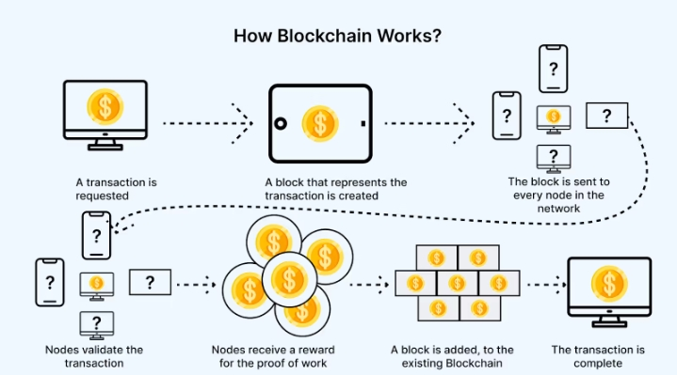
Expected outcome: A working menu-driven console application that performs the defined operations and displays understandable messages for each result.

Functional Requirements
The functional requirements below are directly mapped to the supplied Python code.
ID | Requirement | How the code implements it
FR-0  1 | Store account details | accounts dictionary stores PIN, balance and customer name.
FR-0  2 | Accept account number | input() reads the account number and strip() removes extra spaces.
FR-0  3 | Verify account | if acc_num in accounts checks whether the account exists.
FR-0  4 | Authenticate PIN | Entered PIN is compared with accounts[acc_num][0].
FR-0  5 | Display customer name | accounts[acc_num][2] is used after successful login.
FR-0  6 | Check balance | accounts[acc_num][1] is read and formatted as currency.
FR-0  7 | Withdraw money | Amount is validated and subtracted from the balance.
FR-0  8 | Deposit money | Positive amount is added to the balance.
FR-0  9 | Handle invalid menu | else branch displays an invalid-choice message.
FR-1  0 | Exit | Choice 4 breaks the while loop and prints a thank-you message.

5.Non-functional Requirements
Quality | Requirement for this project
Usability | Console messages and menu options should be clear and easy to follow.
Reliability | The system should not update the balance when a transaction fails validation.
Performance | Dictionary lookup and simple arithmetic operations should execute quickly.
Maintainability | The program uses a main() function and straightforward conditional logic.
Portability | The program should run wherever Python 3 is available.
Readability | Variable names such as acc_num, amount, choice and current_balance describe their purpose.
Data integrity | Withdrawal cannot exceed the current balance, and non-positive amounts are rejected.

6.System Architecture
The application follows a simple layered flow. The user communicates with the console interface, the main() function controls the program, authentication checks the account and PIN, and transaction logic reads or updates the account dictionary.
User
Console
Input
main()
Control
Authentication
Banking
Operations
accounts
Dictionary
Component | Responsibility
User / Console | Provides account number, PIN, menu choice and transaction amount.
main() | Controls the complete application flow.
Authentication | Checks account existence and PIN correctness.
Banking Menu | Presents four operations after successful login.
Transaction Logic | Checks amounts, balance and updates the account.
accounts Dictionary | Temporarily stores account data during program execution.

7.Design Diagrams

7.1Use Case Diagram
The customer is the main actor. After login, the customer can check balance, withdraw money, deposit money, or exit.
BANK MANAGEMENT SYSTEM
Login
Check Balance
Withdraw Money
Deposit Money
Exit
Customer

7.2Workflow Diagram
Start
Account
Exists?
PIN
Valid?
Menu
Process
Choice
Return to
Menu / Exit

7.3Seuence Diagram
The sequence below represents the interaction between the customer, console, program logic, and the account data.
Customer
Console
Bank Logic
Accounts
Enter account number
Check account
Enter PIN
Validate PIN
Select operation
Update / read balance

7.4Class / Component Diagram
User Input /
Console UI
main()
Control Logic
Authentication
Transaction
Logic
accounts
Dictionary

7.5ER Diagram / Data Model
The supplied project does not use a database. Therefore, the following is a conceptual data model showing the entities represented by the in-memory dictionary. The ACCOUNT entity is the actual structure used by the Python program.
ACCOUNT
AccountNumber (Key)
PIN
CustomerName
Balance
CUSTOMER
uses account
TRANSACTION
deposit/withdraw
1
:
1
1
: many*

Design Decisions & Rationale
Decision | Rationale
Dictionary for accounts | Account number can be used as a key for direct lookup.
List as account value | The small project keeps PIN, balance and name together in a compact structure.
main() function | Keeps the complete program flow organized in one main entry point.
while True menu | Allows multiple operations after one successful login until Exit is selected.
if / elif / else | Provides clear branching for menu choices and validation conditions.
In-memory storage | Suitable for a small educational prototype and avoids database setup.
Formatted currency output | Makes the balance easier to read using ■, commas and two decimal places.

Implementation Details
- Data Structure
  - Written in Python 3
  - account ={“100A”:[1234,150000.0, “Utkarsh”]}
- Conditional Validation
  - Logical check for amount> balance
  - Prevent invalid amount <=0
- Exception Management
  - Uses try-except Value Error blocks
  - Catches invalid string inputs

Screenshots / Results

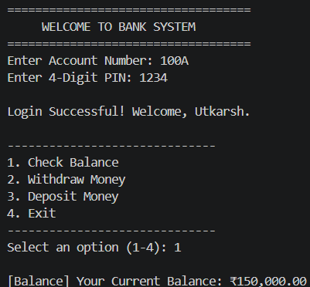
Result 1 — Successful login and menu Result 2 — Balance inquiry
===================================
WELCOME TO BANK SYSTEM
===================================
Enter Account Number: 100A
Enter 4-Digit PIN: **** Login Successful! Welcome, Utkarsh.
------------------------------
1.Check Balance
2.Withdraw Money
3.Deposit Money
4.Exit

Result 3 — Successful deposit / withdrawal Result 4 - Validation message
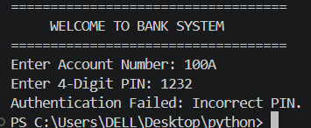
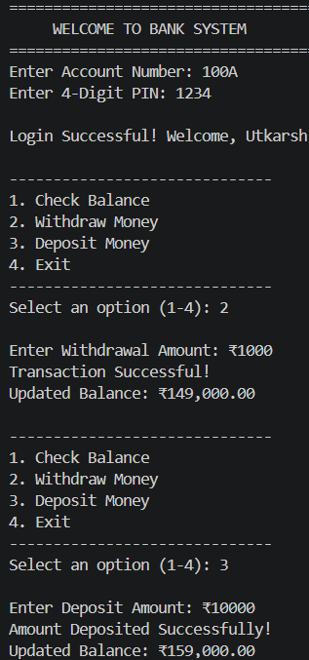

Testing Approach
Testing is performed by checking normal, boundary and invalid inputs. The expected result is based on the conditions present in the supplied source code.
Test ID | Scenario | Sample Input / Condition | Expected Result
TC-01 | Valid login | 100A + correct PIN | Login successful; menu displayed.
TC-02 | Unknown account | 999X | Account number not found.
TC-03 | Incorrect PIN | Existing account + wrong PIN | Authentication failed.
TC-04 | Check balance | Choice 1 | Current balance displayed.
TC-05 | Valid withdrawal | Amount within balance | Amount subtracted; updated balance shown.
TC-06 | Excess withdrawal | Amount > balance | Insufficient balance message; balance unchanged.
TC-07 | Zero  withdrawal/deposit | Amount = 0 | Amount must be greater than zero.
TC-08 | Negative amount | Amount < 0 | Amount must be greater than zero.
TC-09 | Valid deposit | Amount > 0 | Amount added; updated balance shown.
TC-10 | Invalid menu | Choice other than 1–4 | Invalid choice message.
TC-11 | Exit | Choice 4 | Thank-you message and loop ends.
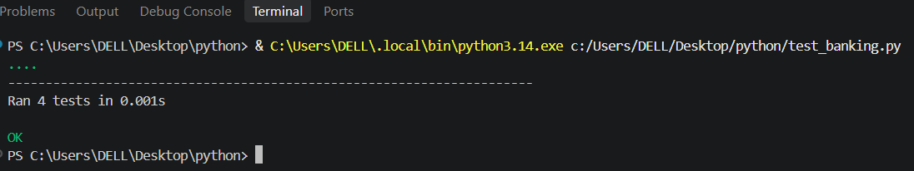

Challenges Faced
Challenge | How it is handled in the current code
Account validation | Checks acc_num in accounts before continuing.
PIN validation | Compares entered PIN with stored PIN.
Invalid amount | Rejects amounts less than or equal to zero.
Insufficient balance | Compares withdrawal amount with current balance.
Repeated operations | while True keeps the banking menu active.
Balance updates | Withdrawal subtracts; deposit adds directly to the stored balance.
Invalid menu option | Final else branch displays a clear error message.

Technical limitation noticed: The code converts the PIN using int() and transaction amounts using float().
Non-numeric input could therefore raise a Value Error. A future version should add try/except validation.

Learnings & Key Takeaways
This project connects basic Python syntax with a realistic application workflow.
- Dictionary: learned how key-value structures can represent account records.
- Lists: used to keep PIN, balance and name associated with each account.
- Functions: main() provides a clear entry point for the application.
- Conditions: if/elif/else controls authentication, menu choices and transaction validation.
- Loops: while True enables repeated banking operations.
- Input handling: input(), strip(), int() and float() convert user data into usable values.
- Formatted output: f-strings format the customer name and currency values.
- Problem solving: each banking operation is broken into validation, processing and result display.
Key takeaway: Even a small Python program can model a complete business process when the data, rules, and user flow are clearly defined.

Future Enhancements
Enhancement | Purpose
Database integration | Persist accounts and balances after the program closes.
Transaction history | Store deposits and withdrawals with date/time and amount.
Account creation | Allow new customers to register accounts.
Fund transfer | Allow transfers between valid accounts.
Secure PIN handling | Hash credentials and avoid displaying sensitive input.
Exception handling | Prevent crashes caused by non-numeric input.
GUI / Web interface | Replace console interaction with a graphical or browser interface.
Role-based access | Separate customer and administrator operations.
Receipt generation | Create a transaction receipt after successful operations.

15. References
Primary Reference
- Project Source Code: The core structure and logic of this Bank Management System are built using standard Python code provided for this project.
Technical References
- Python Data Structures: Used Python dictionaries (dict) and lists (list) to store account details, PINs, account balances, and user names.
- Control Flow & Loops: Applied while loops and if-else conditional statements for user authentication and menu navigation.
- Python Built-in Functions & Methods: Used standard input/output functions, string formatting methods (strip(), f-strings), and type casting (int(), float()).
- Time Module: Utilized Python’s built-in time module (time.sleep()) to add a processing animation effect during transactions.
- Exception Handling: Implemented try-except blocks to handle non-numeric user inputs and prevent program crashes.
Scope Note
- In-Memory Operations: This is a basic console-based Python project where data is stored temporarily in memory during runtime without external databases or file storage.
— End of Project Report —

