

A MODEL TO FIND THE EFFECT OF



WIND SPEED AND HUMIDITY ON



TEMPERATURE IN BASEL

**Introduction**

In this paper, we are trying to find a relationship between temperature as a dependent variable and humidity and wind speed as independent variables. The hourly data has been taken for the city of Basel, Switzerland, from 1 January 2008 to 1 December 2022.

Sample size = 44568

T= B0 + B1H + B2W + UI

T = Temperature H = Humidity W = Wind speed

# UNIT ROOT TESTS:

**Temperature:**

Interpretation: -

**∆tempt= ẟtemp(t-1)+Ʃ48i=1 γ1∆temp(t-i)+ut**

H0: Temp has a unit root

H1: Temp does not have a unit root P<0.05, which is significant.

Therefore, we do not accept H0. Tempt is stationary.

Temperature does not have a unit root, so the series follows I (0).

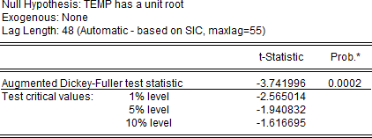

From the table below we can see that the temperature series has an intercept but no trend.



# Humidity:

Interpretation: -

H0: Humidity has a unit root

H1: Humidity does not have a unit root P<0.05, and it is significant.

Therefore, we do not accept H0. Humidity is stationary.

Humidity does not have a unit root, so the series follows I (0).

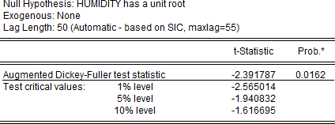

From the table below we can see that the humidity series has both intercept and trend.



# Wind Speed:

Interpretation: -

H0: Wind Speed has a unit root

H1: Wind Speed does not have a unit root P<0.05, which is significant.

Therefore, we do not accept H0. Wind Speed is stationary.

Wind Speed does not have a unit root, so the series follows I (0).

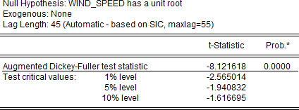

From the table below we can see that wind speed series has an intercept but no trend.



**OLS Regression**

After estimating the equation with temperature as the dependent variable and humidity and wind speed as independent variables, the following results were achieved.

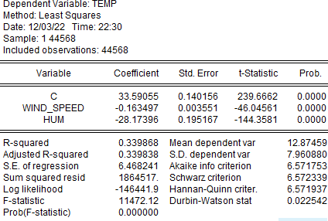

**Result**

From the above table, we infer that a 1 gram per meter cube increase in humidity will bring a 0.28-degree Celsius decrease in temperature. Similarly, a 1 km/hr increase in wind speed will result in a 0.16-degree Celsius decrease in temperature. R-squared is relatively low at 0.339868; hence it is not a good fit.

**Autocorrelation**

Looking at the Durbin-Watson stat in the above table we can say that this model has positive autocorrelation since 0.022<2.

**Heteroscedasticity**

The Breusch-Pagan-Godfrey test is done to check for heteroscedasticity. Here the null hypothesis is that this model does not have heteroscedasticity i.e. homoscedasticity. Since the p-value is less than 0.05, the t-stat is significant. Hence, we reject the null. This model has heteroscedasticity.

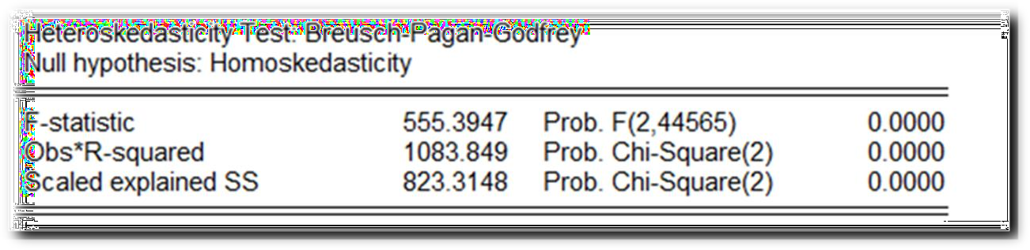

**Multicollinearity**

The Variance Inflation Factor is calculated to check for multicollinearity. From the table below we infer that the model does not have multicollinearity since VIF<10.

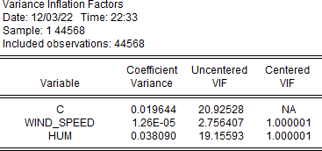

**Specification Error**

Ramsey’s RESET Test is done to check for specification errors. From the table we can infer that t-stat and f-stat are significant, i.e. P-value<0.05. Hence, there is a specification error in the model.

