**SOLVING FOR INDIA HACKATHON**

**Project Title:** Distributed Serverless Workflow for Stock Price Movement

**Project Description:** The Distributed Serverless Workflow for Stock Price Movement is a project aimed at developing a system that can efficiently track and analyse the movement of stock prices in real-time using a serverless architecture. Users will be able to configure the workflow to track specific stocks or markets, set alerts based on price thresholds, and receive notifications via various channels, including email or SMS. Overall, this project aims to provide a scalable, cost-effective, and reliable solution for tracking stock price movements, enabling users to make informed investment decisions in a timely manner.

**Project Theme:** Our project is based on the theme of “Fintech”.

**GitHub URL:** *https://github.com/utkarshhh1/stockify*

**Sample of Project:**

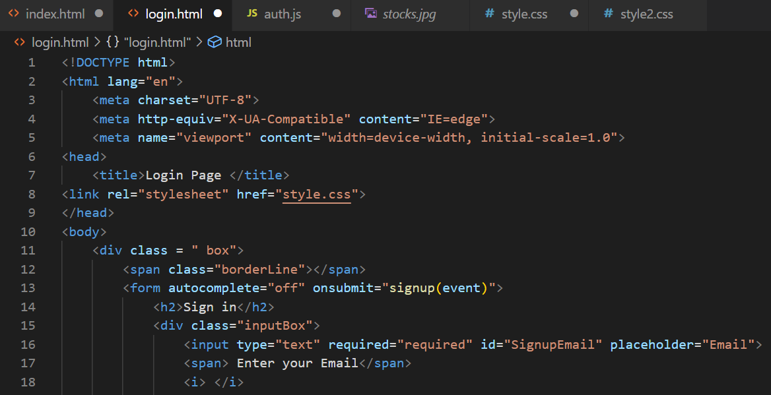

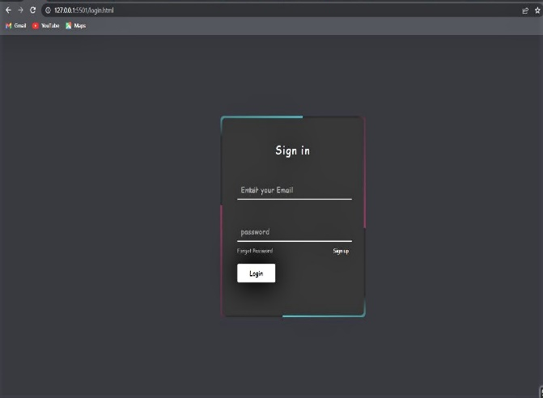

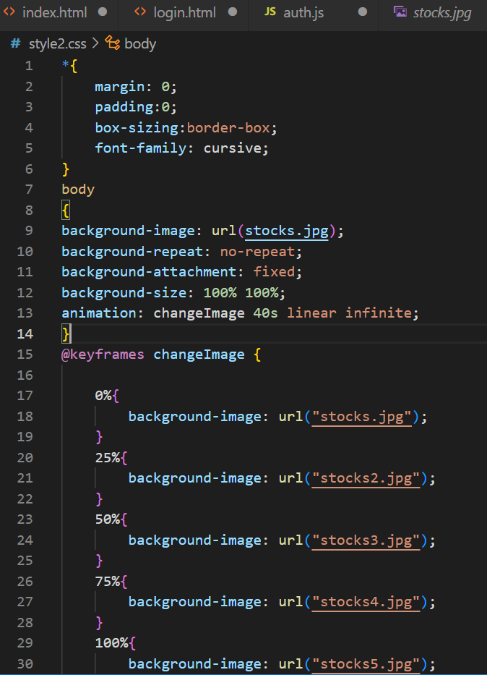

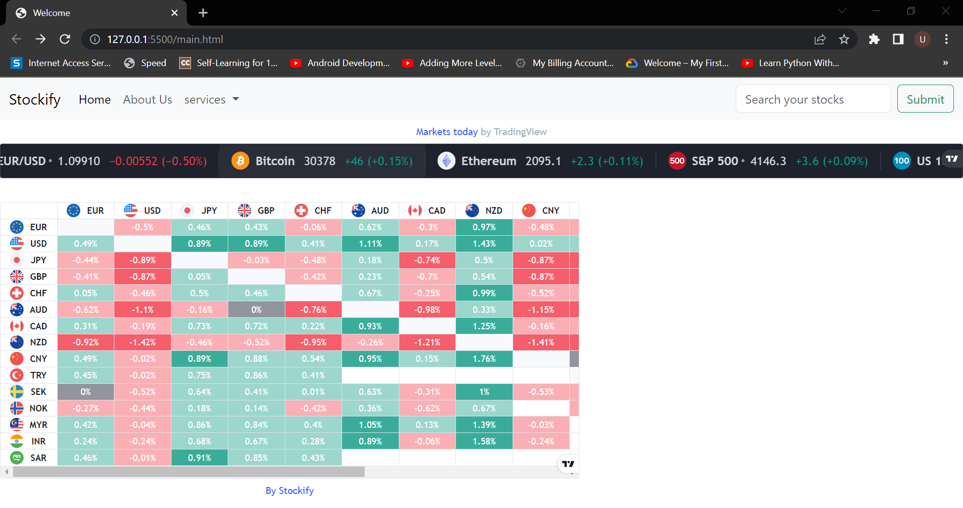

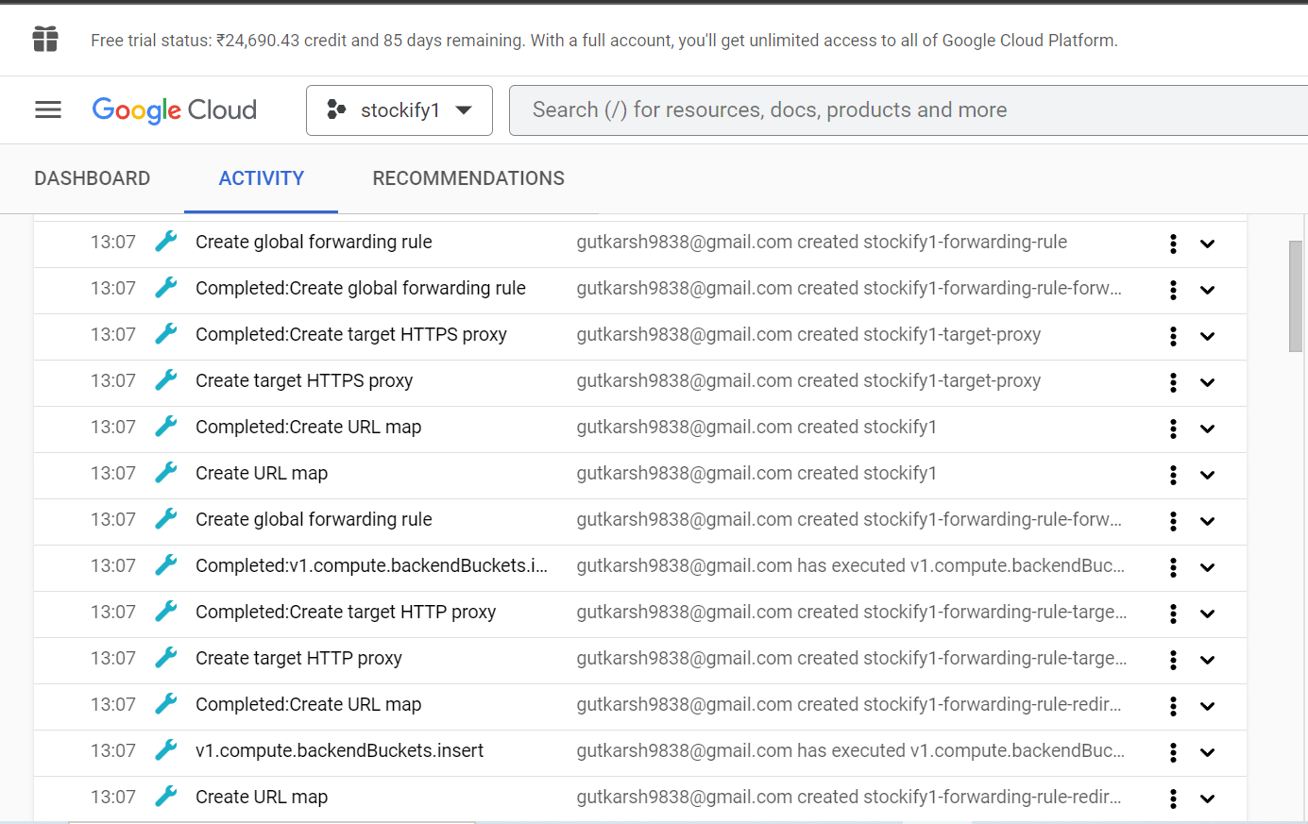

**Web App URL:** *www.stockify.com*

**Detailed Google Document of our Project:**

**Introduction**:

The stock market is a dynamic and complex system, with prices constantly fluctuating based on a variety of factors such as economic indicators, geopolitical events, and company news. As a result, traders and investors must constantly monitor the market and analyse data to make informed decisions about buying and selling stocks.

In recent years, serverless computing has emerged as a powerful technology for building scalable, fault-tolerant workflows that can handle large volumes of data. In this document, we will explore the use of a distributed serverless workflow for monitoring and analyzing stock price movements.

**Architecture**:

At a high level, the distributed serverless workflow for stock price movement consists of several components:

1. *Data Ingestion*: Raw stock price data is ingested into the workflow from various sources, such as stock market APIs or real-time news feeds.
2. *Data Processing*: The raw data is processed to extract relevant information such as price changes, trading volume, and news sentiment.
3. *Data Analysis*: The processed data is analysed using machine learning and statistical models to identify patterns and trends in stock price movements.
4. *Alerts and Notifications*: Based on the analysis results, alerts and notifications are generated to inform traders and investors of potential opportunities or risks.
5. *Visualization*: The analysis results are visualized using dashboards and charts to help traders and investors better understand market trends and make informed decisions.

Each of these components is implemented as a serverless function, which can be independently deployed and scaled as needed. The functions are orchestrated using a workflow management system such as Apache Airflow, which provides a high-level view of the workflow and allows for easy debugging and maintenance.

**Scalability and Fault-Tolerance:**

One of the key benefits of the serverless approach is its scalability and fault-tolerance. As the volume of data increases, additional serverless functions can be deployed to handle the load, without the need for manual intervention. Similarly, if a function fails due to a hardware or software issue, the workflow management system can automatically re-deploy the function on a different server, ensuring that the workflow continues to operate smoothly.

**Data Security:**

Since stock price data is highly sensitive and confidential, it is important to ensure that the workflow is secure and compliant with relevant regulations. This can be achieved through a combination of measures such as data encryption, access controls, and regular audits.

**Conclusion**:

A distributed serverless workflow for stock price movement offers a scalable, fault-tolerant, and cost-effective way to monitor and analyse stock price movements. By leveraging serverless computing technology and workflow management systems, traders and investors can quickly identify opportunities and risks in the market, and make informed decisions that can maximize their returns.

**Team Members:**

Team Leader : Utkarsh Gupta(Google Cloud Platform)

Member 1 : Utkarsh Upadhyay (Web Development)

Top of Form