Game Design Document

Fill up the following document

1. Write the title of your project.

Pest Remover

1. What is the goal of the game?

Kill all Pests.

1. Write a brief story of your game.

There is a man working for a pest control service.

His job is to get rid of as much as pests as possible in the given amount of time.

1. Which are the playing characters of this game?

* Playing characters are the ones who respond to the user based on the input from the user.
* Cars, monkeys, dinos, wizards, etc., are the playing characters in the game.

|  |  |  |
| --- | --- | --- |
| Number | Character Name | What can this character do? |
| 1 | Pest Killer | Kill Pest |
| 2 |  |  |
| 3 |  |  |
| 4 |  |  |
| 5 |  |  |
| 6 |  |  |
| 7 |  |  |
| 8 |  |  |

1. Which are the Non-Playing Characters of this game?

* Non-Playing characters are the ones that don't have an action or behavior when the user interacts with the game.
* Hurdles, stones, bananas, coins, etc., are non-playing characters in the game.

|  |  |  |
| --- | --- | --- |
| Number | Character Name | What can this character do? |
| 1 | Pest | Damage the Pest Killer |
| 2 |  |  |
| 3 |  |  |
| 4 |  |  |
| 5 |  |  |
| 6 |  |  |
| 7 |  |  |
| 8 |  |  |

Draw your imagination of this game. What does this game look like?

* Draw the game either on your computer or on paper.
* Add images of the game scenes to show each of the playing and non-playing characters at least once.

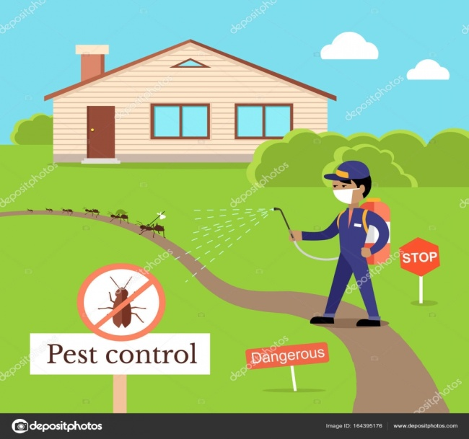

How do you plan to make your game engaging?

Players get to kill the pest but if you dont kill the pest it will start damaging the PC charecter.