Q1.  Print the first 10 natural numbers using for loop

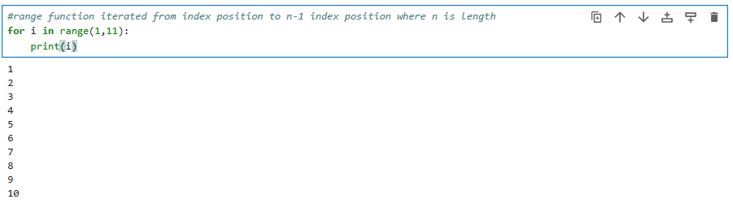

Q2. Python program to check if the given string is a palindrome

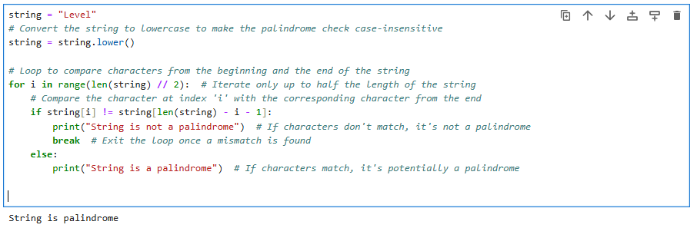

Q3.  Python program to check if a given number is an Armstrong number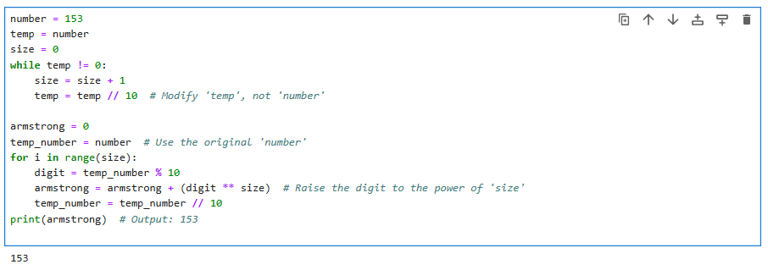

Q4. Python program to get the Fibonacci series between 0 to 50

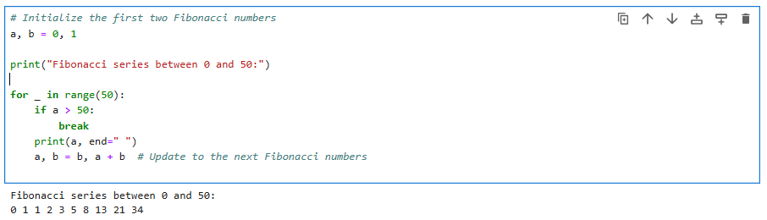

Q5. Python program to check the validity of password input by users

