Use the IF function to evaluate whether each product met its sales target.

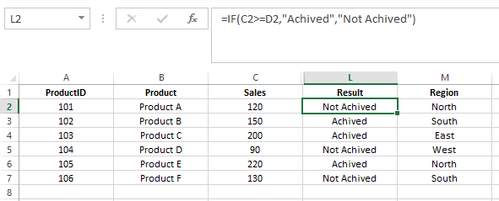

Use the IF function to determine if a product is eligible for a regional bonus. Products in the "North" region with sales over 200 are eligible.

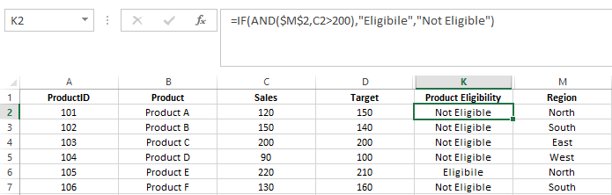

Use nested IF functions to assign a commission rate based on sales. Sales >= 200 get a 10% commission, sales >= 150 get a 7% commission, and others get a 5% commission.

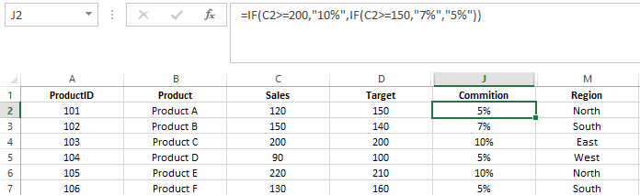

Use the IF function to calculate a bonus amount. If sales met or exceeded the target, the bonus is 10% of the sales; otherwise, it's 5%.

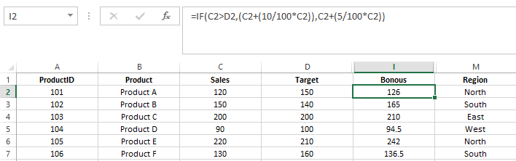

Use the IF function to categorize sales performance as "Excellent" (>=200), "Good" (>=150), or "Needs Improvement" (<150).

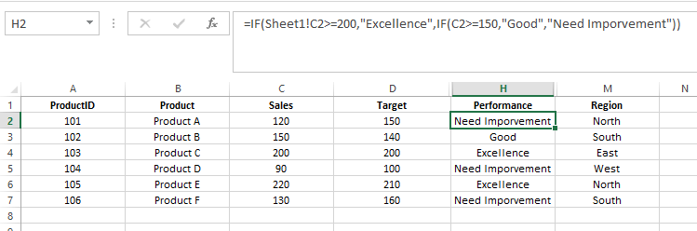

Use the IF function to assign a price tier based on the sales value. "High" for sales > 200, "Medium" for sales between 100 and 200, and "Low" for sales < 100.

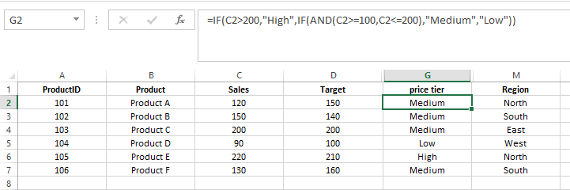

Use the IF function to calculate the year-end bonus. If sales >= 150 and region is "North", the bonus is $500, otherwise, it's $300.

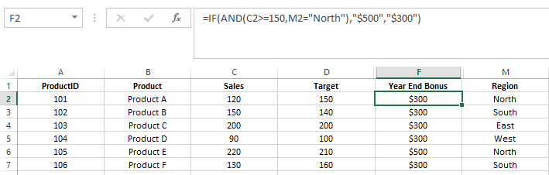

Use the IF function to mark high performers. A product is a high performer if its sales are in the top 25% of all sales.

