**Python Installation steps:**

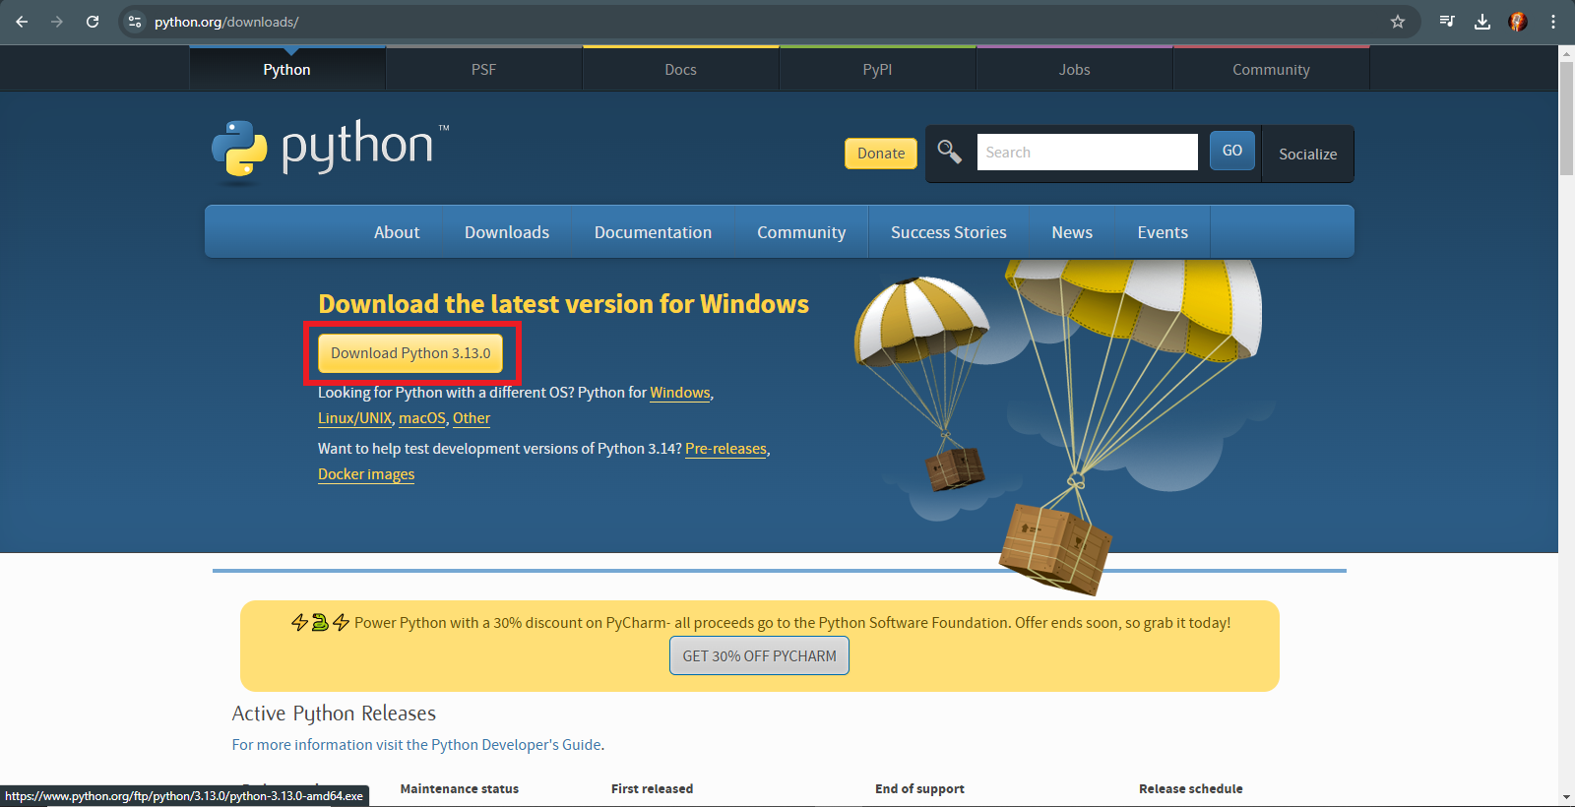

Click on download python. After clicking, the python would get downloaded in your system

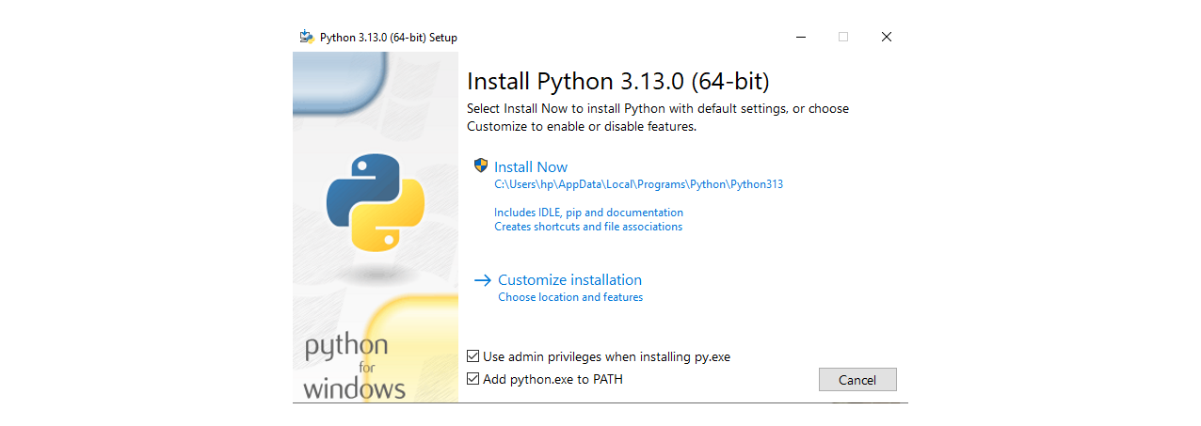

After downloading, the installation screen will be displayed ( It will automatically be displayed). In that screen click on **Add python.exe to Path** (by doing this the python’s path would automatically get added in Environment variables, after doing this we can run our python file from any disk or directory).

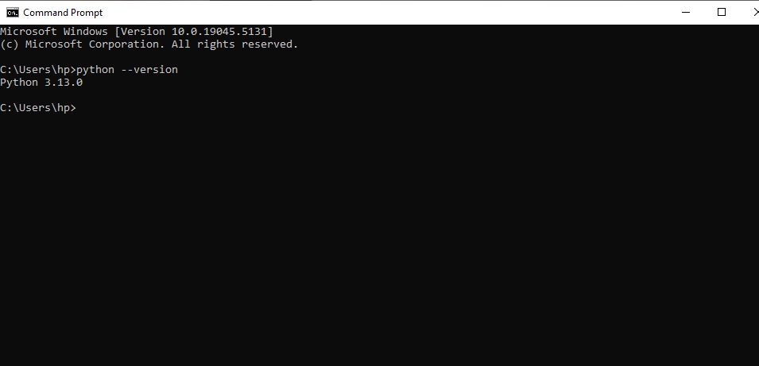

After installation, Open the command Prompt and run **python - - version.** If the version is visible means python is installed successfully.

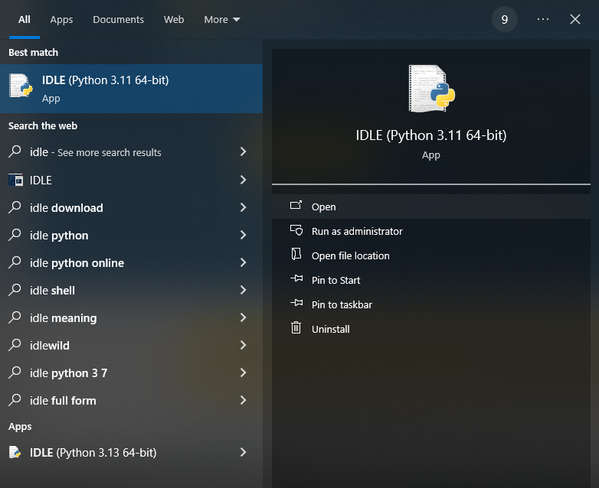

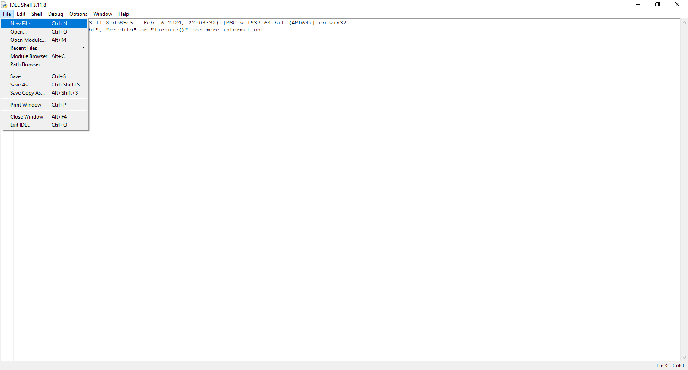

Open IDLE for writing programs. Click on create a new file (this will create new file) and save that file.

**Programs**

Q1. Print hello world

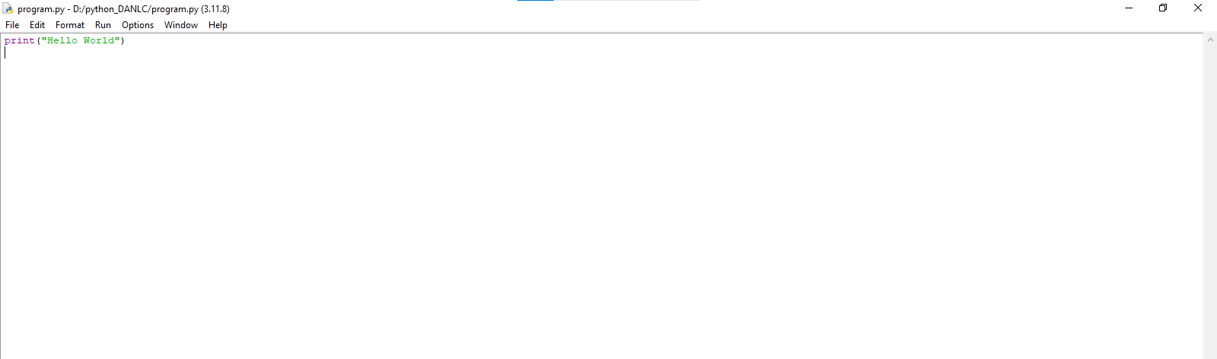

Q2. Describe local variable and global variable code

**Local Variable**:

* A local variable is declared inside a function or a block and is accessible only within that function or block.
* It cannot be accessed outside of its scope.

**Global Variable:**

* A **global variable** is declared outside of any function or block.
* It is accessible from anywhere in the program, unless shadowed by a local variable with the same name.

Q3. Write a code that describe Indentation error

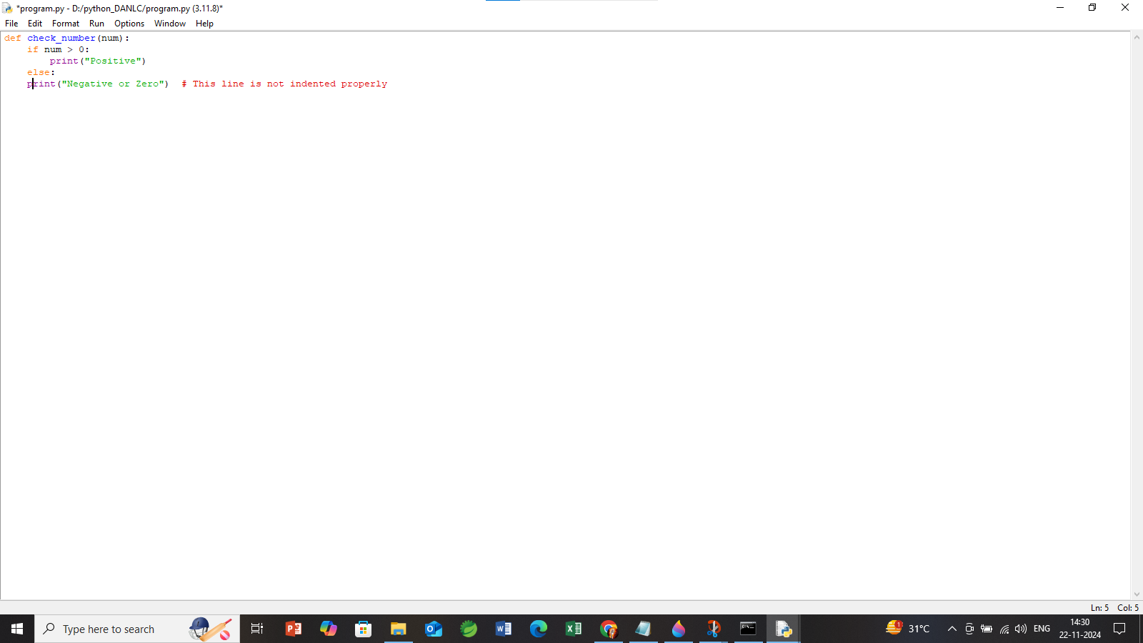

Q4. write a code that describe local and global variable with same name follows the roles

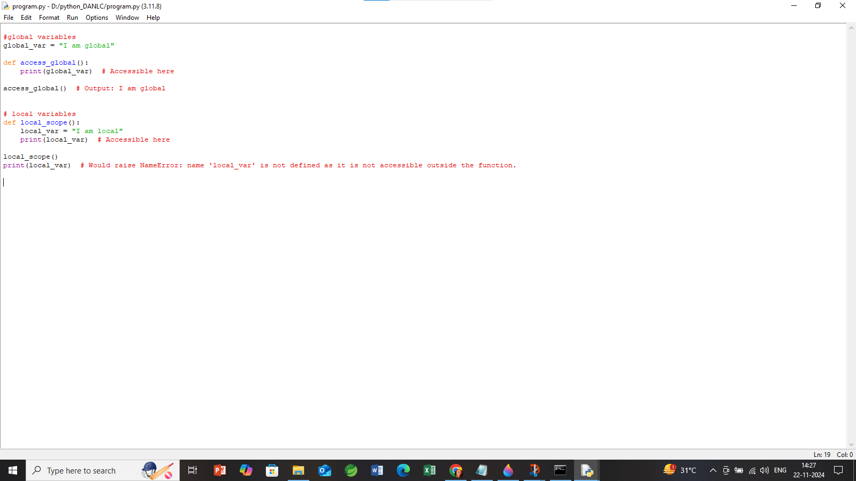

Q5. Write a code for string, int and float input. 