1. Write a Python program to Count all letters, digits, and special symbols from the given string

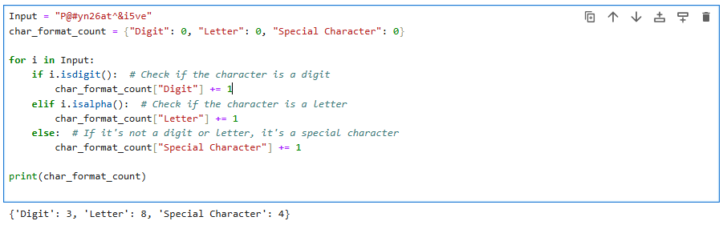

2. Write a Python program to remove duplicate characters of a given string.

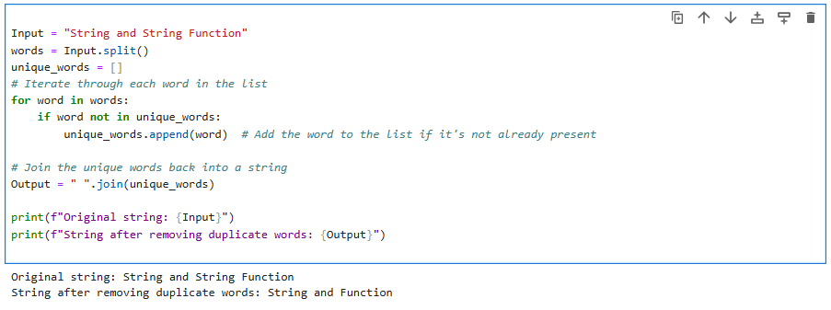

3. Write a Python program to count Uppercase, Lowercase, special character and numeric values in a given string

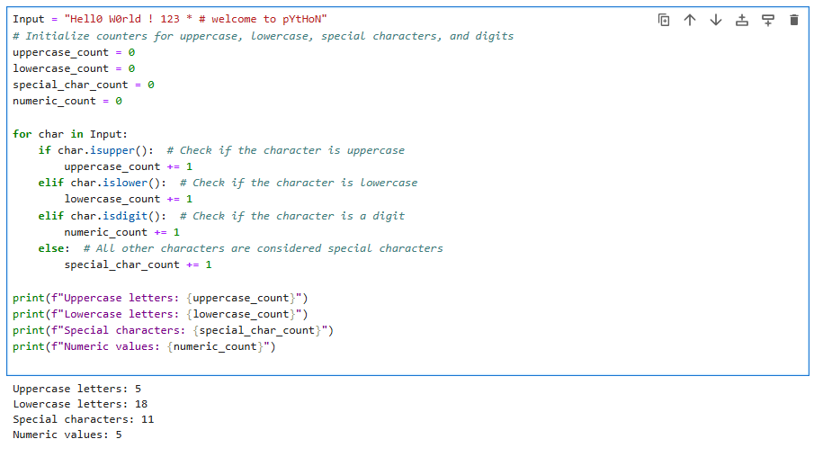

4. Write a Python Count vowels in a string

