SECURE DEVICE REGISTRATION AND INTELLIGENT ACCESS CONTROL SYSTEM
A Mini Project Report Submitted in the partial fulfillment of the requirements for the award of the degree of

BACHELOR OF TECHNOLOGY

In

DEPARTMENT OF COMPUTER SCIENCE AND INFORMATION TECHNOLOGY
By
Utkarsh Pankaj – 2420090138
Saru Dhanush – 2420090083
Rithish Rao – 2420030778

Under the Esteemed Guidance of

Dr. Venkateshwari Ketineni





K L (Deemed to be) University

DEPARTMENT OF COMPUTER SCIENCE AND INFORMATION TECHNOLOGY

DECLARATION

The Mini Project Report entitled “Secure Device Registration and Intelligent Access Control System” is a record of bona fide work carried out by Utkarsh Pankaj (2420090138), Saru Dhanush (2420090083), and Rithish Rao (2420030778), submitted in partial fulfilment of the requirements for the award of the B.Tech degree in Computer Science and Information Technology at K L (Deemed to be) University. The report describes the work completed by the team and has been prepared for academic submission.

Utkarsh Pankaj – 2420090138
Saru Dhanush – 2420090083
Rithish Rao – 2420030778

K L (Deemed to be) University

DEPARTMENT OF COMPUTER SCIENCE AND INFORMATION TECHNOLOGY
CERTIFICATE

This is to certify that the mini project report entitled “Secure Device Registration and Intelligent Access Control System” is a bona fide work carried out by Utkarsh Pankaj (2420090138), Saru Dhanush (2420090083), and Rithish Rao (2420030778), in partial fulfilment of the requirements for the award of the Bachelor of Technology degree during the academic year 2026–2027.

Signature of the Course Co-ordinator Signature of HOD

ACKNOWLEDGEMENT

We would like to express our sincere gratitude to everyone who supported us during the development of this project. Building the system helped us connect the concepts learned in SOA Programming and Microservices with a practical security problem.

We are especially thankful to our project guide, Dr. Venkateshwari Ketineni, for her guidance, feedback, and encouragement throughout the work. Her support helped us refine the project idea and focus on a clear, useful implementation.

We also thank the Department of Computer Science and Information Technology and KLH CSE Bowrampet Campus for providing the academic environment and resources needed to complete this project.

Finally, we thank our classmates, friends, and families for their encouragement and support. We acknowledge the documentation and open-source resources that helped us understand access control, device identification, web development, and security monitoring.

Utkarsh Pankaj – 2420090138
Saru Dhanush – 2420090083
Rithish Rao – 2420030778

TABLE OF CONTENTS

S.No. | Contents | Page no.
1. | Abstract | 6
2. | Introduction | 7
3. | Literature Survey | 8
4. | Problem Statement and Objectives | 10
5. | Hardware and Software Requirements | 11
6. | Implementation | 12
7. | Results & Discussion | 13
8. | Conclusion & Future Scope | 14
9. | References | 15

- ABSTRACT

The Secure Device Registration and Intelligent Access Control System is designed to make access decisions more aware of the device being used, not just the username and password. In many systems, a correct password can be enough to begin a session even when the request comes from an unfamiliar or revoked device. Our project addresses this gap by combining device registration, fingerprint generation, user authentication, risk evaluation, access decisions, and security-event monitoring in one workflow. A registered device is assigned a record and a fingerprint derived from available device attributes. When access is requested, the system checks the device status and evaluates contextual signals such as failed login attempts, request behaviour, and the sensitivity of the resource. The resulting risk level helps the access-control logic decide whether a request should be allowed or blocked. Important outcomes are recorded so that an administrator can review device status, recent events, risk information, and alerts through a central dashboard. The project is organised around the principles of Service-Oriented Architecture, where responsibilities are separated into modules and can communicate through APIs. The current application demonstrates the core user journey and security-monitoring interface; full production deployment would require all service integrations and persistence to be verified and hardened.
Team Name: Secure Access Team

Team Logo: KLH University logo on the report cover

Team Members:
- Utkarsh Pankaj – Team Lead / Integration (2420090138)
- Saru Dhanush – Development and Testing (2420090083)
- Rithish Rao – Development and Documentation (2420030778)

- INTRODUCTION

Digital services are used every day to access personal information, academic systems, business applications, and other protected resources. These services usually begin by checking a username and password. Although that is important, it does not always answer a second question: is the device making the request one that should be trusted?
For example, a valid account may be used from a new laptop, a shared computer, or a device that an administrator has already revoked. Repeated failed login attempts or unusual requests for sensitive resources can also be warning signs. If the system only checks credentials, these signals may be missed.
The Secure Device Registration and Intelligent Access Control System adds a device-aware layer to this process. Administrators can register devices and manage their status. When a user requests access, the system checks the device fingerprint, authentication result, risk factors, and applicable permissions. Based on these checks, it produces an Allow or Deny decision and records the outcome for review.
The project is also an application of Service-Oriented Architecture (SOA). Device management, authentication, risk evaluation, access control, suspicious-activity analysis, auditing, and notifications are separate responsibilities. Keeping these responsibilities modular makes the system easier to understand, test, and extend. This report describes the problem, related work, requirements, implementation approach, observed interface, results, and possible future improvements.

- LITERATURE SURVEY
Existing security approaches provide useful foundations for this project. The following sources were reviewed to understand device trust, access control, authentication, web security, and the technologies used to build the system.
1. NIST – Zero Trust Architecture (SP 800-207). The Zero Trust model recommends that access should not be granted simply because a user is inside a network. Users, devices, and the requested resource need to be evaluated before access is approved. This supports our decision to check device status and request context alongside authentication.
2. NIST – Digital Identity Guidelines (SP 800-63B). These guidelines discuss authentication, authenticators, and protecting access to digital services. They reinforce the importance of secure credential handling and careful authentication decisions. Our authentication component follows the same general principle of verifying identity before allowing protected actions.
3. OWASP – Access Control Cheat Sheet. OWASP recommends enforcing authorization on the server side and applying access rules consistently to protected resources. This is relevant to our role and resource checks, especially when a normal user attempts to reach an administrator-only function. The interface alone must never be responsible for enforcing access.
4. OWASP – Authentication Cheat Sheet. This guidance covers secure login practices, password handling, and protection against common authentication weaknesses. It informed the project's attention to failed-login tracking and the need to avoid storing plaintext passwords. Additional production hardening would include rate limiting and stronger session controls.
5. MDN – SubtleCrypto API. The Web Crypto API provides browser-supported cryptographic functions, including SHA-256 hashing. This is relevant to generating a deterministic fingerprint from selected attributes available to the browser. Browser attributes can change or be imitated, so a hash should be treated as a recognition signal rather than proof of hardware identity.
6. PostgreSQL Documentation. PostgreSQL provides relational storage for structured records and supports constraints and queries that help keep data consistent. It is suitable for records such as devices, access decisions, risk assessments, and audit events. The final deployment should verify that the dashboard reads its data from persistent records rather than only from sample values.
7. Spring Cloud Gateway Documentation. Spring Cloud Gateway describes a gateway approach for routing API requests to backend services and applying shared filters. This is relevant to the proposed SOA architecture, where the frontend can use a common entry point rather than addressing every service separately.
8. Spring Boot Documentation. Spring Boot supports the development of standalone Java applications and REST APIs with configurable application components. It is a suitable option for implementing independent services if the project is expanded from its current lightweight web application into separately deployed Java microservices.

- Problem Statement and Objectives

Problem Statement:
A password-based access system may accept valid credentials without adequately checking whether the requesting device is registered, trusted, or behaving suspiciously.

Problem Description:
The project combines device recognition, authentication, contextual risk scoring, and access policies so that suspicious requests can be denied and recorded for administrator review.
Objectives:
The project was initiated to demonstrate how device trust can strengthen ordinary user authentication.
The main objectives are to register and manage devices; generate and verify device fingerprints; authenticate users; evaluate risk using contextual factors; identify suspicious activity; apply Allow/Deny rules; keep audit records; and provide a central dashboard for reviewing security events.

- HARDWARE AND SOFTWARE REQUIREMENTS
Hardware Requirements:
- • Laptop or desktop computer with a modern multi-core processor
- • Minimum 8 GB RAM recommended for development and testing
- • Network connection for installing dependencies and testing APIs
Software Requirements:
- • Operating system: Windows, Linux, or macOS
- • Node.js and npm for the current web-server and JavaScript application
- • Modern web browser such as Chrome or Firefox
- • Visual Studio Code or another code editor
• Git for version control; Docker and Docker Compose where containerised execution is used
• For the planned expanded SOA deployment: Java 21, Spring Boot, PostgreSQL, API Gateway, and service discovery

- IMPLEMENTATION
- Frontend: HTML, CSS, and JavaScript provide the Security Command Center interface, navigation, dashboard cards, charts, device views, risk monitoring, alerts, audit logs, and access simulation.
- Backend: The current workspace uses a lightweight Node.js server to serve the web application and support its available routes. The project architecture is designed around separate SOA responsibilities; independent Java microservices and production database integrations should only be described as complete after they are present and tested in the deployed workspace.
- API Integration: Frontend actions should call backend endpoints for device operations, access checks, risk calculations, and audit events. Seeded demonstration records are acceptable for presentation, but the data should be clearly identified and should not be mistaken for live security telemetry.

1. Frontend (HTML, CSS, JavaScript):
- public/index.html: defines the page structure and dashboard sections.
- public/style.css: controls the dark security-dashboard theme, layout, cards, tables, and responsive styling.
- public/app.js: manages client-side navigation, dashboard rendering, charts, and interactions.
- Other files: package.json lists Node.js dependencies and scripts; test/access.test.js contains access-related tests; Dockerfile and docker-compose.yml support container-based execution where configured.
2. Backend and Service-Oriented Design:
- server.js: starts the Node.js web server and serves the frontend. It is the current application entry point.
The SOA design separates device registration, authentication, risk evaluation, access control, suspicious-activity detection, auditing, and notifications into logical responsibilities. A complete deployment should expose these through documented APIs and keep persistent data in the database.
- API Integration:
The intended request flow is: browser → server/API entry point → device and authentication checks → risk and access decision → audit event → dashboard update. Each stage should return a clear result and reason, and failures should be handled safely.

- RESULTS & DISCUSSION
Figure 1. Security Command Center dashboard. The screen brings device counts, access-request activity, risk distribution, recent security events, and open alerts into one view. The sample values shown in the prototype are illustrative and should be connected to verified backend/database records for a live deployment.
Figure 1: Dashboard interface used to review device and access security.
The sidebar provides access to Devices, Users, Access Simulator, Risk Monitor, Security Alerts, Audit Logs, Device Registration, Notifications, System Health, and Settings. These sections are intended to make the main security workflow easy to demonstrate during project evaluation.
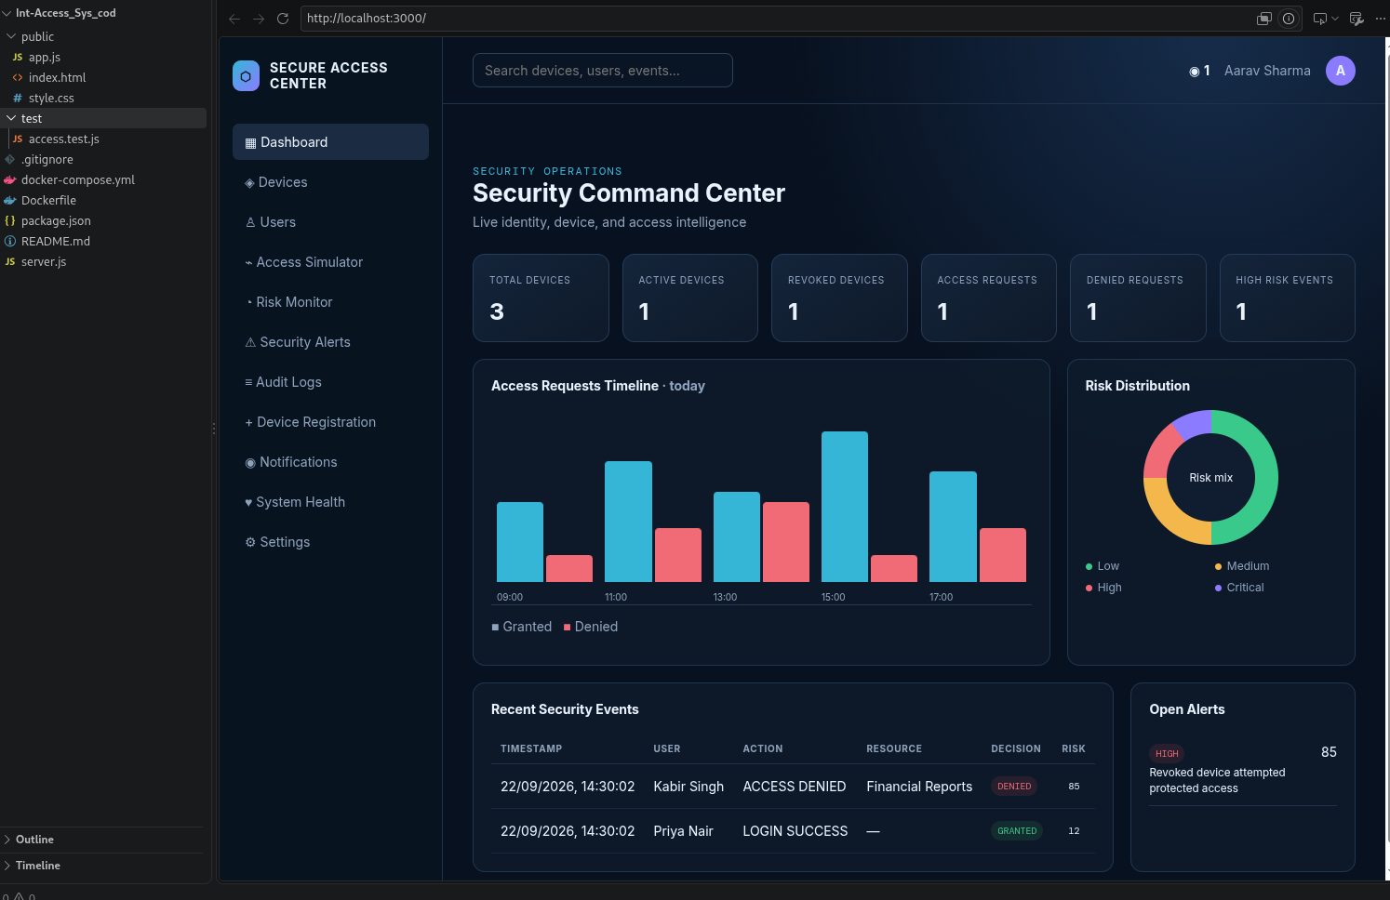

- CONCLUSION & FUTURE SCOPE
The project demonstrates the central idea of device-aware access control: a successful login should not be the only factor considered before a protected resource is opened. By combining device registration, fingerprint checking, risk evaluation, access rules, and audit visibility, the system provides a more informative way to review access requests. The dashboard presents the workflow in a form that is easy for users and administrators to understand. The project also helped the team understand how security responsibilities can be separated into services and connected through APIs. Before production use, all backend integrations, persistence, and enforcement rules must be tested end to end; dashboard appearance alone is not evidence of a complete secure deployment.

Future Scope:
Short term: connect every dashboard component to verified API responses, persist devices and audit events in a database, add input validation, role-based authorization, and stronger login-attempt protection.
Medium term: deploy device, authentication, risk, access-control, audit, and notification services independently; add service discovery and an API gateway; automate integration tests; and provide live dashboard updates through polling or server-sent events.
Long term: evaluate machine-learning anomaly detection using a suitable dataset, improve device re-enrolment when attributes change, add stronger device attestation where available, conduct a formal security review, and assess performance under higher request volumes.

- REFERENCES

1. NIST, Zero Trust Architecture, SP 800-207. https://csrc.nist.gov/pubs/sp/800/207/final
2. NIST, Digital Identity Guidelines: Authentication and Lifecycle Management, SP 800-63B. https://pages.nist.gov/800-63-3/sp800-63b.html
3. OWASP Foundation, Authorization Cheat Sheet. https://cheatsheetseries.owasp.org/cheatsheets/Authorization_Cheat_Sheet.html
4. OWASP Foundation, Authentication Cheat Sheet. https://cheatsheetseries.owasp.org/cheatsheets/Authentication_Cheat_Sheet.html
5. MDN Web Docs, SubtleCrypto. https://developer.mozilla.org/en-US/docs/Web/API/SubtleCrypto
6. PostgreSQL Global Development Group, PostgreSQL Documentation. https://www.postgresql.org/docs/
7. Spring, Spring Cloud Gateway Reference. https://docs.spring.io/spring-cloud-gateway/reference/
8. Spring, Spring Boot Reference Documentation. https://docs.spring.io/spring-boot/index.html
9. OWASP Foundation, Logging Cheat Sheet. https://cheatsheetseries.owasp.org/cheatsheets/Logging_Cheat_Sheet.html
10. OWASP Foundation, REST Security Cheat Sheet. https://cheatsheetseries.owasp.org/cheatsheets/REST_Security_Cheat_Sheet.html

