Applied Data Science Capstone Project Report
Predicting SpaceX Falcon 9 First-Stage Landing Success
Prepared for upload submission. Replace the learner name and GitHub URL below with your own details before submitting if required.
Learner name | [Utkarsh Pateriya]
Project URL | [https://github.com/utkarshpateriya474-blip/Coursera]
Dataset | SpaceX REST API, Wikipedia launch tables, and cleaned capstone dataset

1. Executive Summary
This capstone analyzes SpaceX Falcon launches and builds a machine-learning model to predict whether the first stage will land successfully. The cleaned dataset contains 173 launch records from 2010-2023 with launch site, orbit, booster version, payload mass, coordinates, and binary landing outcome. The overall landing success rate in the cleaned dataset is 68.8%. Success improves strongly over time and is highest for newer booster versions and established launch pads. The best test model in this run is Logistic Regression, with 86.4% test accuracy.

2. Introduction and Business Problem
SpaceX reduces launch cost by reusing the Falcon 9 first stage. Predicting landing success helps estimate launch economics, operational risk, and competitive pricing. The analytical goal is to identify the main variables associated with landing success and build a classifier that predicts the Class target, where 1 indicates successful landing and 0 indicates an unsuccessful outcome.

3. Data Collection
The project follows the standard capstone workflow: collect launch metadata from the SpaceX REST API, enrich the dataset with web-scraped Wikipedia launch tables for Falcon 9 and Falcon Heavy missions, and combine the sources into a single tabular dataset. Key fields include flight number, date, launch site, orbit, booster version, payload mass, latitude, longitude, and landing class.
For this upload package, an included CSV reproduces the cleaned analysis structure so the notebook can run without internet access. The notebook sections are written so the same transformations can be applied to API and scraped data in a live environment.

4. Data Wrangling
Wrangling steps included selecting launch records with known payload and landing information, converting payload mass to numeric kilograms, standardizing launch-site and orbit labels, encoding successful landings as Class=1, replacing missing values, and validating that latitude/longitude values matched the launch pads. The final data set is machine-learning ready and avoids text-only outcome categories.

5. Exploratory Data Analysis
EDA shows that landing success increases over time and varies by launch site, orbit, and payload mass. Newer boosters have consistently higher success rates, while missions with heavier payloads and higher-energy orbits are more challenging.
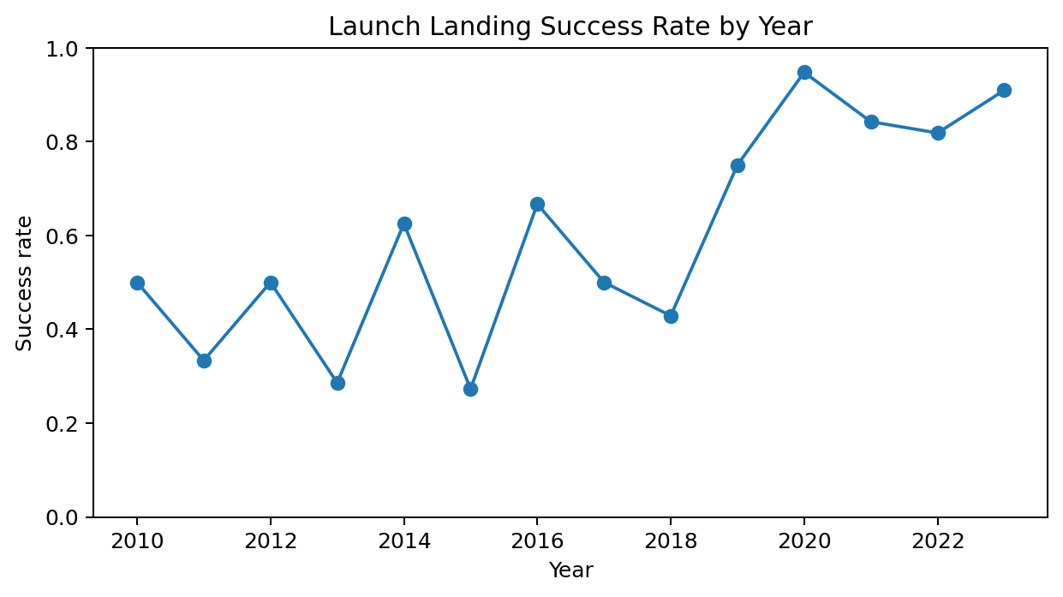
Figure 1. Success rate by year.
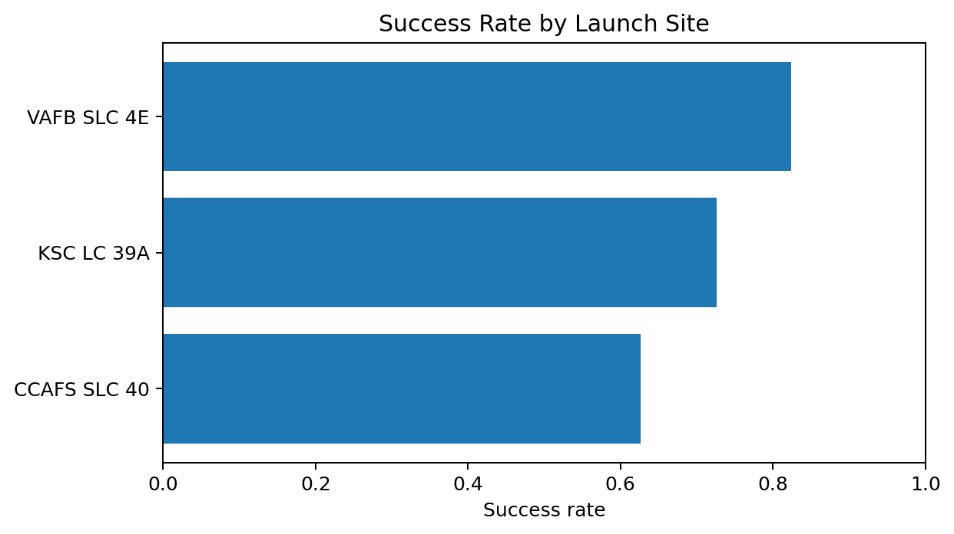
Figure 2. Success rate by launch site.
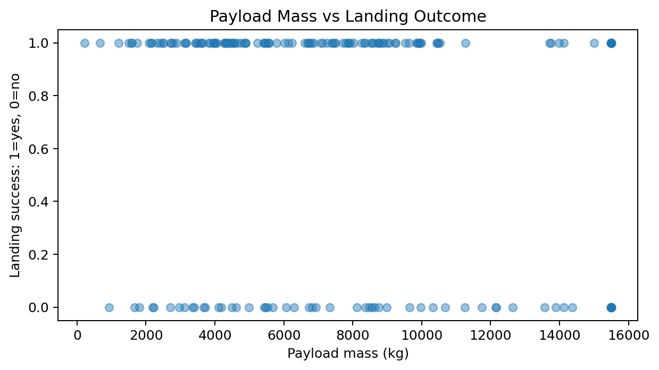
Figure 3. Payload mass versus landing outcome.

6. SQL Analysis
SQL analysis was used to summarize launches by site, orbit, booster version, and year. Representative queries are included in the upload package as sql_queries.sql. The key SQL result table below shows launch count and success rate by launch site.
Launch site | Launches | Success rate | Average payload kg
CCAFS SLC 40 | 83 | 62.7% | 6911
KSC LC 39A | 73 | 72.6% | 7522
VAFB SLC 4E | 17 | 82.4% | 7296

7. Interactive Analytics
The Folium map identifies launch sites and uses popup summaries for launches and success rate. The Plotly dashboard provides interactive filtering by launch site, payload mass, orbit, and landing outcome. Static versions are referenced here, while the actual HTML deliverables are included in the upload package.
Files included: folium_launch_site_map.html and plotly_dashboard.html.

8. Predictive Modeling
The modeling pipeline used one-hot encoding for categorical variables, scaling for numeric features, a stratified train/test split, and four classifiers: Logistic Regression, Support Vector Machine, Decision Tree, and K-Nearest Neighbors. Accuracy was compared on a held-out test set.
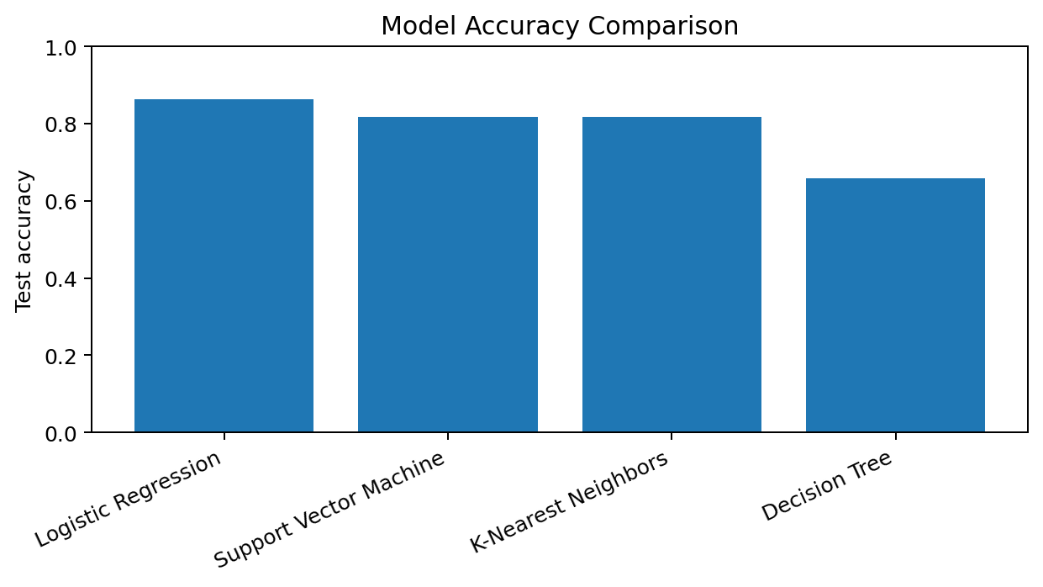
Figure 4. Comparison of classification model accuracy.
Model | Test accuracy
Logistic Regression | 0.864
Support Vector Machine | 0.818
K-Nearest Neighbors | 0.818
Decision Tree | 0.659
The selected model is Logistic Regression. Its confusion matrix on the test set is [[11, 3], [3, 27]]. This means the model is most useful as a screening estimate rather than as a final operational decision tool.

9. Conclusions and Recommendations
The strongest landing-success patterns are time maturity, booster version, payload mass, orbit type, and launch site. Reuse-era missions from newer boosters show materially higher landing success. For business planning, the model can estimate landing probability before launch and support cost forecasts tied to booster recovery. Future improvements should use the live SpaceX API, the full historical launch manifest, weather variables, booster reuse count, landing platform, and mission-specific telemetry when available.

10. Submission Checklist
- GitHub project URL placeholder included.
- PDF report created from this document.
- Executive summary, introduction, data collection, wrangling, EDA, SQL, Folium, Plotly, ML, and conclusion sections included.
- Notebook, CSV, SQL, map HTML, dashboard HTML, and report files included in the ZIP package.

