PYTHON PROJECT

Restaurant Billing System
[]> Raghu Rasoi : The Indian Cuisine <[]
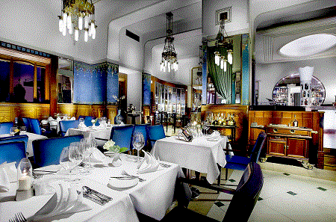
SUBMITTED TO:-- DR.MAHESH KUMAR
SUBMITTED BY:-- UTKARSH RAGHUVANSHI
ENROLLMENT NO:-- 161B256
BATCH:-- B-9(BZ)

Project Details:

It is basically and Restaurant Billing System developed using Python 2.17.The basic objective of this propject is to learn the basics of the Avanced Programming Language Python.

The aspects of the programming languge has been used in this project such has Tkinter,Databases,Message Box,loops etc.The project has been developed with the basic knowledge and there is a scope of development too.
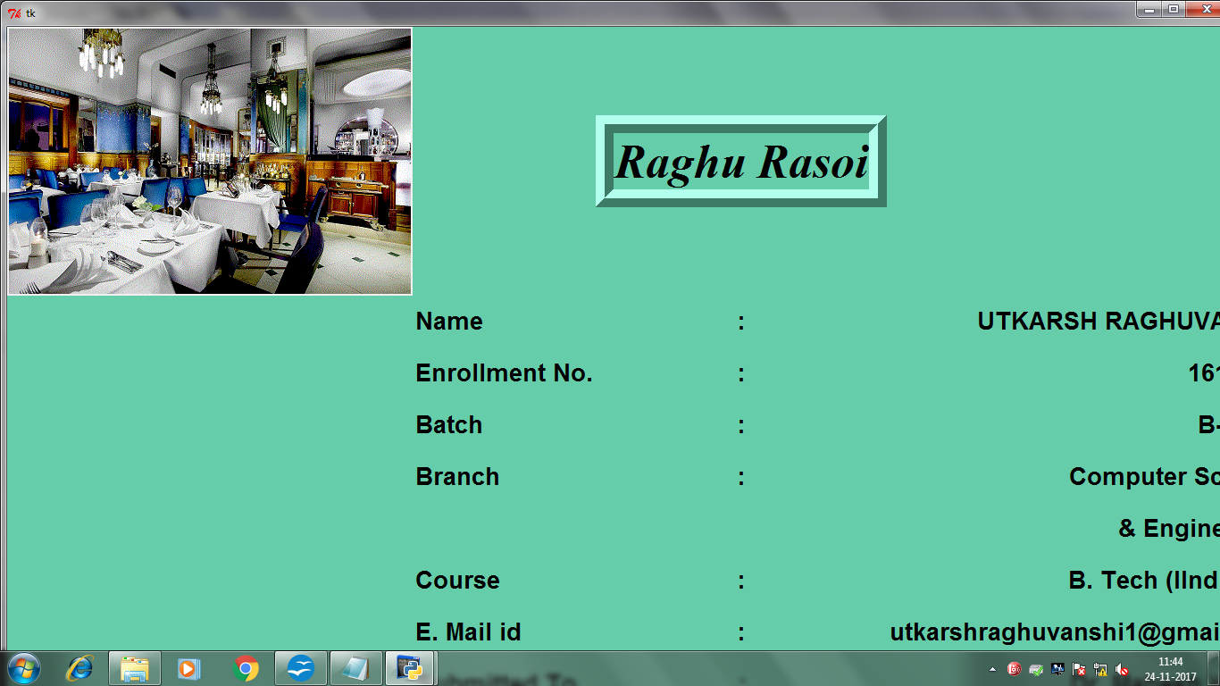
The very first window contains the Basic Details of the Customer such as Customer name,Customer Phone No and the Bill No. Its also asks from the customer for the choice of the food he/she wants to eat.

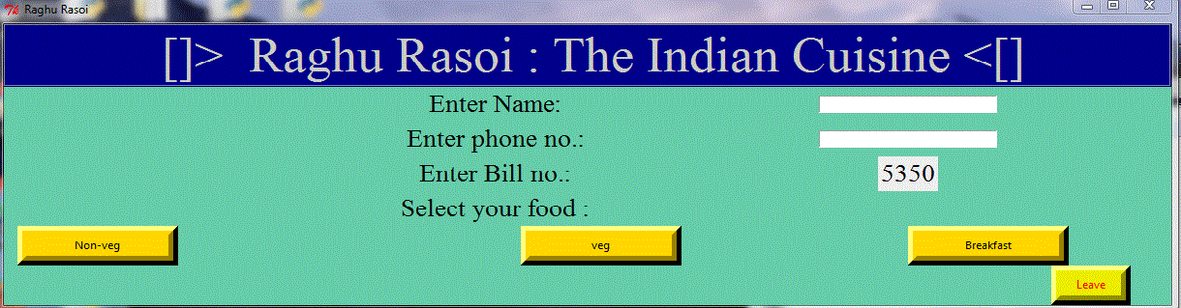
It contains three sections Veg,Non Veg, and breakfast. On the choice of the customer a new window appers which contain the choices of the food under that category and it asks the user to enter the quantity and once the user enter the quantity it multiplies the per plate cost of that food with the quantity and and the same for the multiple food items and the calculates the total bill for the customer and the GST is calculated on the food at the rate of 5%.

veg:--
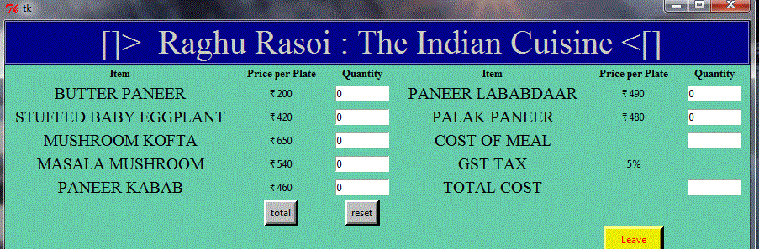
non veg:--

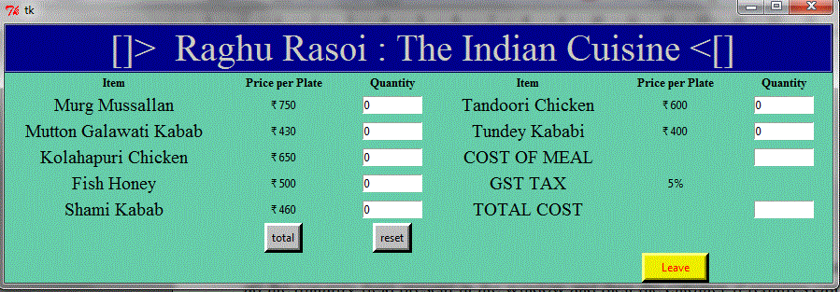

Breakfast:--

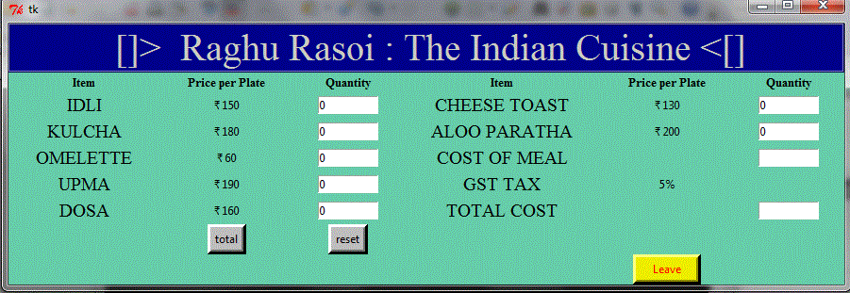

Once, the total bill is displayed on the screen then there is a reset button to clear all the qunatity field present in the window and then the cutomer if requires can leave the windowand then a message box.

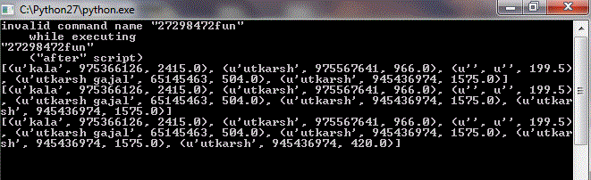

Finally The user comes to the main screen where the Customer Name,phone No, and the total bill gets stored in the database and then the user finally exits from the main window.
