STM32 ARM Cortex-M Development Board for Teaching and Prototyping

Submitted in partial fulfillment of the requirement for the award of Degree of Bachelor of Technology in Electronics and Telecommunication Discipline

Submitted To


SVKM’s NMIMS,
Mukesh Patel School of Technology Management & Engineering,
Shirpur Campus, Shirpur (M.H.)

Submitted by:
Utkarh Sethi – 70061114024
Shreyansh Sharma – 70061115057
Vivek Samtani – 70061115049

Under the Supervision of:

Prof. Shashikant Patil

Prof. Kiran Sanlunkhe

DEPARTMENT OF Electronics and Telecommunication
Mukesh Patel School of Technology Management & Engineering

SESSION: 2018-19

CERTIFICATE

This is to certify that the work embodies in this Project entitled “STM32 ARM Cortex-M Development Board” being submitted by

“Utkarsh Sethi” (70061114024)
“Vivek Samtani” (70061115049)
“Shreyansh Sharma” (70061115057)

for partial fulfillment of the requirement for the award of “Bachelor of Technology in Electronics and Telecommunication” discipline to “NMIMS, Mumbai (M.H.)” during the academic year 2017-18 is a record of bonafide piece of work, carried out by him under my supervision and guidance in the “Department of Electronics and Telecommunication”, MPSTME, Shirpur (M.H.).

APPROVED & SUPERVISED BY:

Prof. Shashikant Patil Prof. Shashikant Patil

Department of ExTC Department of ExTC

DEPARTMENT OF ELECTRONICS AND TELECOMMUNICATION
Mukesh Patel School of Technology Management & Engineering

CERTIFICATE OF APPROVAL

The Project entitled “STM32 ARM Cortex-M Development Board for Teaching and Prototyping” being submitted by:

“Utkarsh Sethi” (70061114024)
“Vivek Samtani” (70061115049)
“Shreyansh Sharma” (70061115057)

has been examined by us and is hereby approved for the award of degree “Bachelor of Technology in Electronics and Telecommunication Discipline”, for which it has been submitted. It is understood that by this approval the undersigned do not necessarily endorse or approve any statement made, opinion expressed or conclusion drawn therein, but approve the project only for the purpose for which it has been submitted.

(Internal Examiner) (External Examiner)
Date: Date:

`
DEPARTMENT OF ELECTRONICS AND TELECOMMUNICATION DEPARTMENT
Mukesh Patel School of Technology Management & Engineering

DECLARATION

We,

Utkarsh Sethi

Vivek Samtani

Shreyansh Sharma

The students of Bachelor of Technology in Electronics and Telecommunication discipline, Session: 2018-19, MPSTME, Shirpur Campus, hereby declare that the work presented in this Project entitled “STM32 ARM Cortex-M Development Board for Teaching and Prototyping” is the outcome of our work, is bonafide and correct to the best of our knowledge and this work has been carried out taking care of Engineering Ethics. The work presented does not infringe any patented work and has not been submitted to any other university or anywhere else for the award of any degree or any professional diploma.

Utkarsh Sethi -70061114024 Vivek Samtani - 70061115049
Shreyansh Sharma - 70061115057

Date:

DEPARTMENT OF ELECTRONICS AND TELECOMMUNICATION
Mukesh Patel School of Technology Management & Engineering

ACKNOWLEDGEMENT

After the completion of this Major Project work, words are not enough to express my feelings about all those who helped me to reach my goal; feeling above this is my indebtedness to The Almighty for providing me this moment in life.

It’s a great pleasure and moment of immense satisfaction for me to express my profound gratitude to Prof. Shashikant Patil, Extc Dept., MPSTME, Shirpur, Prof. Kiran Sanlunkhe, Extc Dept., MPSTME, Shirpur, whose constant encouragement enabled me to work enthusiastically. Their perpetual motivation, patience and excellent expertise in discussion during progress of the project work have benefited me to an extent, which is beyond expression. Their depth and breadth of knowledge of Electronics Engineering field made me realize that theoretical knowledge always helps to develop efficient operational software, which is a blend of all core subjects of the field. I am highly indebted to them for their invaluable guidance and ever-ready support in the successful completion of this project in time. Working under their guidance has been a fruitful and unforgettable experience.

We express my sincere thanks and gratitude to Dr. B.K. Mohanty, Head, Electronics and Telecommunication Department, MPSTME, Shirpur, for providing necessary infrastructure and help to complete the project work successfully.

We also extend my deepest gratitude to Dr. RS Gaud, Director, MPSTME, Shirpur Campus; Dr. Nikhlesh Kumar Sharma, Director of Engineering, MPSTME, Shirpur Campus and Dr. N. S. Choubey, Associate Dean, MPSTME, Shirpur Campus for providing all the necessary facilities and true encouraging environment to bring out the best of my endeavors.

We sincerely wish to express my grateful thanks to all members of the staff of computer engineering department and all those who have embedded me with technical knowledge of computer technology during various stages of B.Tech. Computer Engineering.

We would like to acknowledge all my friends, who have contributed directly or indirectly in this Major Project work.

The successful completion of a Major Project is generally not an individual effort. It is an outcome of the cumulative effort of a number of persons, each having their own importance to the objective. This section is a vote of thanks and gratitude towards all those persons who have directly or indirectly contributed in their own special way towards the completion of this project.

Utkarsh Sethi -70061114024 Vivek Samtani - 70061115049
Shreyansh Sharma - 70061115057
ABSTRACT

The STM32 Development board project aim to bring the tecchnological breakthroughs of ARM Core to the hands of undergraduate students. Demonstrating various interfaces like ADC, PWM, I2C,SPI. The goal of the project is to learn how these periferals work and impliment using ARM platform. The project will also focus on making sure students learn to interface hardware and not only software. ST Microcontrollers provides various resources to learn software design, these docs will work as reference material for the development board providing exposure on how to work with microcontrollers in the real world. The HAL pripheral library is used for softwaare delevopment with the board. Custom circuitary is to be designed and manufactured with everything needed to use these peripherals. On completion of project, future students wil have custom circuit board, laboratory assignments and an easy to understand user manual to get started with the hardware and firmware development. These deliverable will be expose university students to some of the latest microcontrollers used in the industry, replaing decades old technology used to teach in the classroom.

TABLE OF CONTENTS

1. Introduction
2. Survey
3. Desig Problem
4. Design Requirements
5. Challenges
6. Exisiting Products
7. Design Process
8. Current Progress
9. Future Work
10. References

TABLE OF FIGURES

1. Introduction
2. Survey
3. Desig Problem
4. Design Requirements
5. Challenges
6. Exisiting Products
7. Design Process
8. Current Progress
9. Future Work
10. References

ABBREVIATIONS
1. Introduction
2. Survey
3. Desig Problem
4. Design Requirements
5. Challenges
6. Exisiting Products
7. Design Process
8. Current Progress
9. Future Work
10. References

Introduction
The technology is advancing at an incredible rate, the electronics industry is advancing at an exponential rate. This makes it difficult for students to stay up to date, and leaves a gap in education for students in electrical and electronics departments. How are students supposed to learn everything if the course keep becoming outdated?

Microcontrollers were invented in the 1970s and revolutionised the world. After which the technology has advanced rapidly. Today most of the mainstream products are designed on 32bit systems leaving 8bit to supporting hardware like LCD controllers and driving actuators for the main system.

The STM32 aims to enhance the microcontroller course for undergraduate students by introducing the latest in the industry. The 8bit controllers used in courses are no longer very relevant and companies require you to be familiar with ARM ISA used in the industry.

The intent of the project is to create a development board to teach undergraduate students about embedded systems using the ARM architecture. The intended users are university students who are new to embedded domain, with little experience and introduce to them what is required to excel in todays embedded world.

The STMF103xx chip was selected keeping lot of parameters in mind, like availability of reference docs, availability of stocks, libraries and support. To help learn the various peripheral interfaces, the board is split into various modules/boards like basic input output module, serial communication module, LCD module, motor driver module, ADC module.

Although initially planed in earlier design to include various ports o the main board like pin out for SPI, I2C, USART, we decided not to put it on the main board and take a more minimal approach, and rather give the pain of figuring out pins to the user/student. This will force the student to go through the data sheets, and reference manuals, while at the same time making it easier to interpret with ports available as functional blocks instead of sequential blocks.

Survey
We collected feedback from various people working in the industry about what the expect form fresher’s in the industry, which revealed how the course focusing solely on 8bit controllers does not makes us ready to work in the industry. The major systems designed today are based on ARM and only sub tasks are assigned to the 8bit controllers.
When moving forwards to start making ARM based board we decided to solve a few other problems faced by students at the same time. We contacted out batch mates, juniors as well as seniors about dicciculties they had while learning microcontrollers from a practical stand point. We went ahead and contacted our acquintances belonging to other institues, including IITs if they have similar issues. A concensuos was reached and we found out that students learn how to understand and work with ASM, but when they have to move to making projects they can’t understand how to interface hardware as the kits used incolleges do not expose hardware interfacing, most of which do not even expose studetns to the choice of the pin number they would like to use.
Today 32bit micro controller based systems have started to cost less than their 8bit counter parts, due to various factors like mass production, easy availability, good documentiation, standardization of development tools faster lead and development cycle. The standardisation does no limit an organization to a particular manufacturer anymore, it is easier to switch between them, by chaning only manufacturer specific peripheral interfaces. The lead times have become shorter, due to very good support and documentation from the ARM based manufactures. Thus, making ARM industry leaders in almost all embedded doamins form cars, to microwaves.

Existing Products
Many products are on the market that are meant to provide simple introductions to advanced microcontrollers. The products that are on the market, however, tend to be specialized for one use, not general uses that are desirable for a teaching environment. Some of the products are:

1 - 8051 Development board:
8051 Development Board with inbuilt programmer.
On board Voltage Regulator with filters and operating voltage- 5V to 12V.
DB-9 connector to connect with the serial port of the computer(UART communication).
On Board IN-circuit programmer consisting AT89C2051 and MAX232.
11.0592 MHz Crystal Oscillator for clock pulsing.
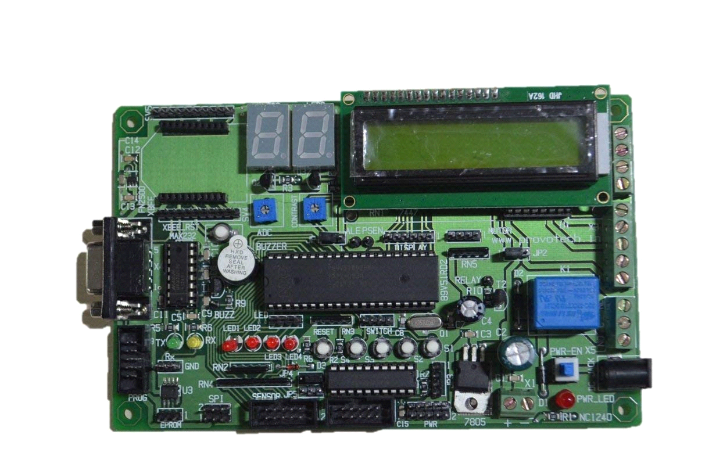
2 - ARM Cortex-M3 NXP LPC1768 Development Board
Architecture: cortex m3
Graphical lcd connectivity
3.2 Inch tft connectivity
Usb device and host connectivity options
Rs232 interface for uart0 and uart3
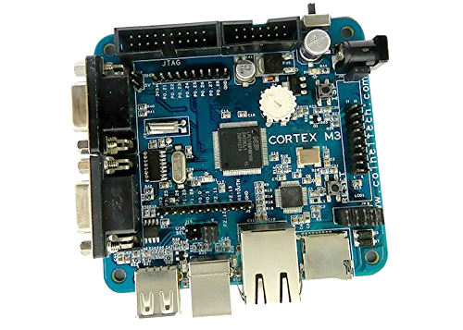
3- STM32 Nucleo-64 development board with STM32F103RB MCU
STM32 microcontroller in LQFP64 package
External SMPS to generate Vcore logic supply (only available on '-P' suffixed boards)
1 user LED shared with Arduino™
1 user and 1 reset push-buttons
32.768 kHz LSE crystal oscillator
Board expansion connectors:
Arduino™ Uno V34
ST morpho extension pin headers for full access to all STM32 I/Os
External SMPS experimentation dedicated connector (only available on '-P' suffixed boards)
Flexible power-supply options: ST-LINK USB VBUS or external sources
On-board ST-LINK/V2-1 debugger/programmer with USB re-enumeration capability. Three different interfaces supported on USB: mass storage, Virtual COM port and debug port
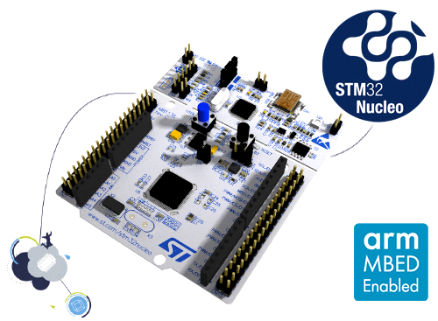
In 8051 development boards hardware interfacing is very difficult as pins cannot be interfaced externally
Other ARM development boards are quite expensive
8051 require external peripherals while ARM has INBUILT peripherals
8051 consumes more power than ARM and hence over a period of time ARM can be more cost efficient

Our closest competetors are Nucleo boards but even they lack the flexibility to interface between peripheral devices, fucussing on familiarising firmware development, while hardware interfacing is just as importatnt to learn as a student.

PROBLEM DEFINITION

Problem

This project aim to make range of circuit boards which will function together as a development board introducing microcontrollers for teaching environment. The board will be degined with flexibility and inddependance in mind and not try to force a person’s workflow in a particular manner. The board will not limit to specific functions and allow easy expansion and general purpose use by giving bread board easy model, allowing the complete capability to user.
Every user has different levels of experience, some new students will come with no prior knowledge and some with existing experience. The board should help both the audience, by not being intimidating and also not limiting the experienced community.

The primary goal of the project is to provide an easy to use system for introducing the world of embedded to under graduate students. In addition user manuals and reference material to learn features of these latest micro controllers, to help move beyond the course syllabus.

DESIGN

Design Requirements
Since the development board is primarily being used as a teaching tool, the system will eed to be easily usable by students with varied experience skill levels. A baseline is :
- Create cystom PCBs which will have to be interfaced by studetns
- Have easy breadboarding capability
- Ability to use the system with little to none external components, while still having the flecibility to use them
- Provide device drivers for various peripherals

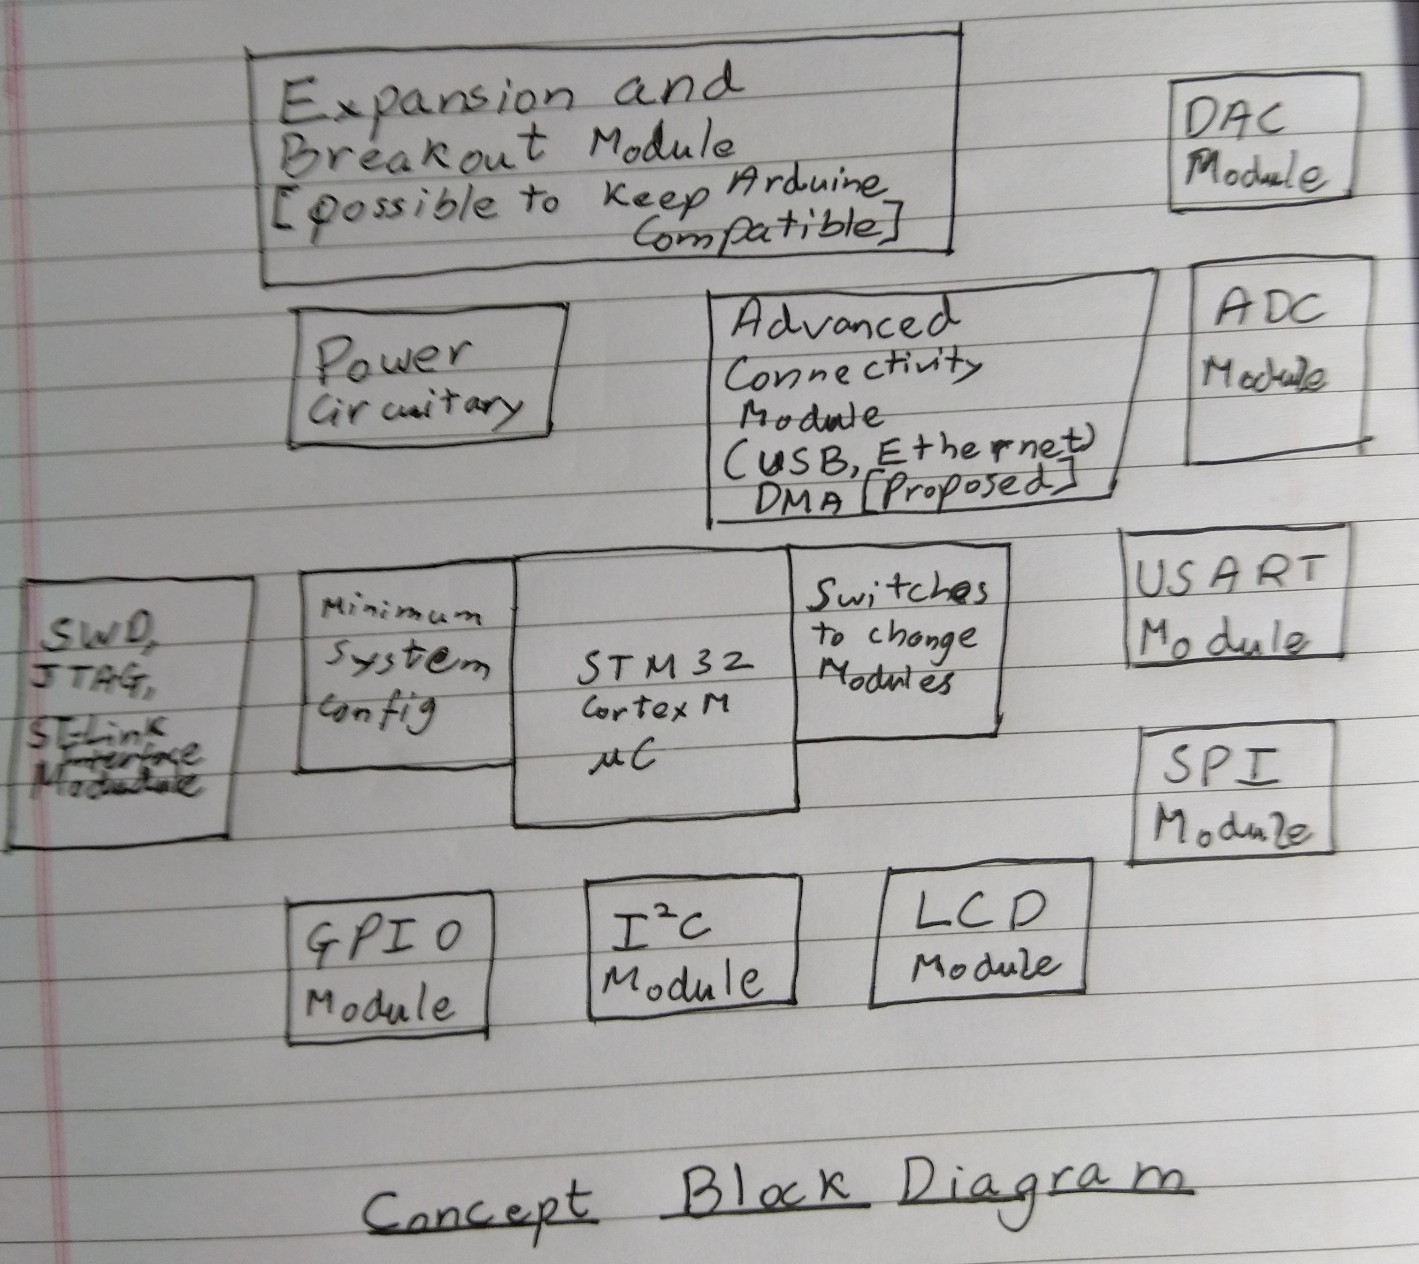
The Board is meant to be explorataryy and open source, eaving scope for updating and expansion in the future.
To implement multiple methods exsist:
- One single board with all components
- Multiple stackable boards
- Multiple modular boards
Each method has its own advantages and disadvantages, after careful evaluation and discussion, we dicided modular boards would be the best way to proceed.

Due to having limited time, these features may change over time, and future improvements may take place in the list.

The designing started with experimenting with various arm boards on the market, cominantly on the STM Discovery line of evaluation boards. The discovery line includes onboard debugger and power supply. We started with going through various interfaces of the microcontroller:

Serial Peripheral Interface (SPI)
It is a synchronous serial communication interface specification used for short distance communication. We can communicate in full duplex mode using a master-slave architecture with a single master . The SPI bus is intended for high speed, on board initialization of device peripherals.

USART (Universal Synchronous/Asynchronous Receiver/Transmitter)
It is a microchip that facilitates communication through a computer's serial port using the RS-232 protocol. It is a type of serial interface device primarily used to support synchronous protocols. The data format and transmission speeds are configurable.

Pulse Width Modulation (PWM)
Using digital means we can produce different analog signals. We can use it to control the power supplied to electrical devices like DC motors, valves, pumps, hydraulics and other mechanical parts.

Analog-to-digital converter (ADC, A/D, or A-to-D)
It is a system that converts analog signals into digital signals. like the sound entering a microphone or light entering a camera which would be processed further and converted into digital format. These are majorly implemented as integrated circuits (ic’s). it may also provide an isolated feature that converts input analog voltage or current into

I²C (Inter-Integrated Circuit)
It is a synchronous, multi-master, multi-slave, packet switched, single-ended, serial computer bus . It is widely used for attaching lower-speed peripheral ICs to processors and microcontrollers in short-distance, intra-board communication.

LCD Screen

The chosen LCD screen uses either I2C or a parallel interface to write the data. Though the parallel interface allows for faster data rates, saves microcontroller pins for other functions. As it is using different drivers so the code can be used to drive a wide variety of screens, varying in both resolution and size.
Before we used 8 pins of the microcontroller to drive the lcd but not through the help of PCF8754 we can use 2 pins to drive upto 8 lcds at the same time. And we can also run different types of LCDs at the same time with the least pins usability.

Basic Input and Output Board
The basic input and output board was created to make using switches and LEDs easy while still providing a large number of them to the students. This board would have the following features:
• LEDs
• Switches
• Seven segment displays
• Seven segment display driver

Design Process

Initially, we’re going to focus on just the microcontroller itself so we can more easily understand the design process without getting overwhelmed with circuit complexity.
Design process broken down into three fundamental steps:
STEP 1 – System Design
STEP 2 – Schematic Circuit Design
STEP 3 – PCB Layout Design

System Design and Block Diagram
A block diagram includes a block for each core function, the interconnections between the various blocks, specified communication protocols, and any known voltage levels (input supply voltage, battery voltage, etc.)
Once all of the components have been selected and the required supply voltages are known we like to add the supply voltages to the block diagram. Including the supply voltage for each functional block it allows you to easily identify all of the supply voltages you’ll need as well as any level shifters. 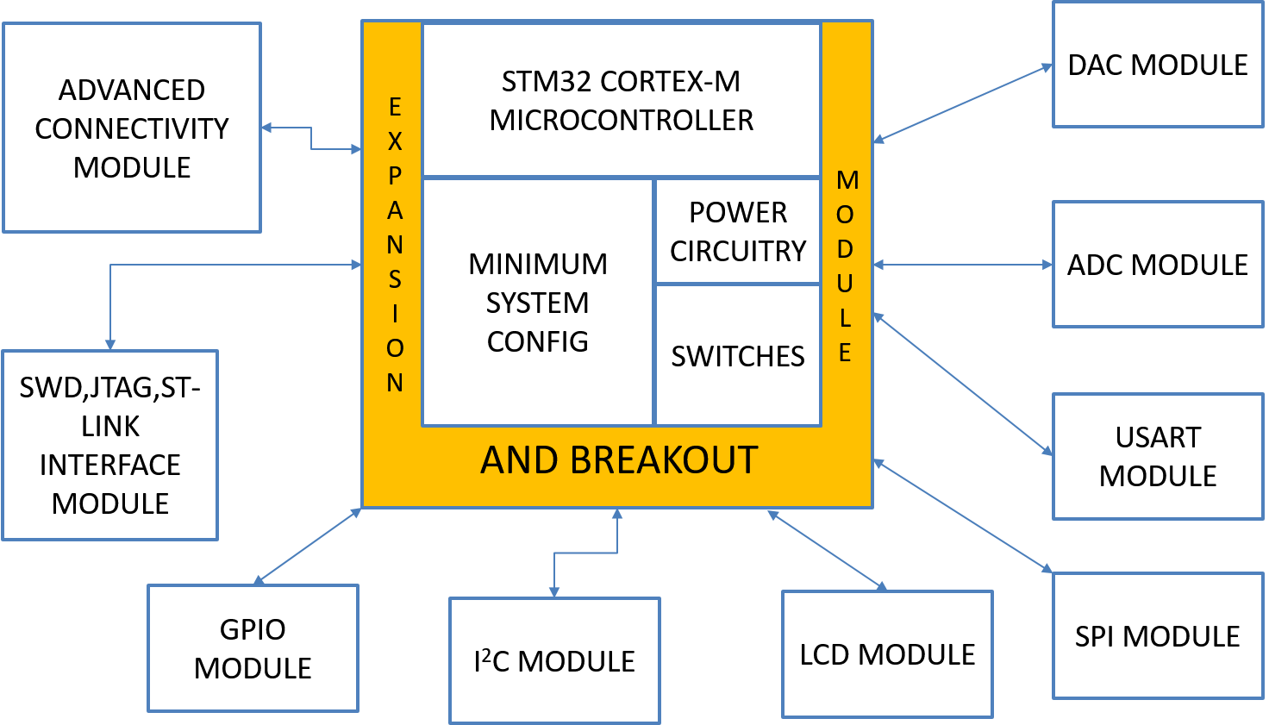

Now that we have a block diagram we can better understand the necessary requirements for the microcontroller. Until you’ve mapped out everything that will connect to the microcontroller it’s impossible to select the appropriate microcontroller.

Select Microcontroller

When selecting a microcontroller (or just about any electronic component) I like to use an electronics distributor’s website like Newark.com. Doing so allows you to easily compare various options based on a variety of specifications, pricing, and availability. It’s also an easy way to quickly access the component’s datasheet.

The ARM Cortex-M is a 32-bit architecture that is fantastic choice for more computationally intensive tasks compared to what is available from older 8 bit microcontrollers such as the 8051, PIC, and AVR cores.

One of the biggest advantages of Arm Cortex-M processors is their low price for the level of performance you get. In fact, even if an 8-bit microcontroller is sufficient for your application you should still consider a 32-bit Cortex-M microcontroller.
There are Cortex-M microcontrollers available with very comparable pricing to some of the older 8-bit chips. Basing your design on a 32-bit microcontroller gives you more room to grow should you want to add additional features in the future
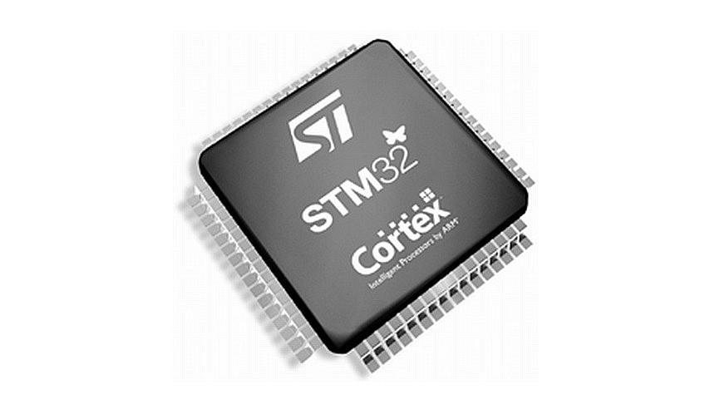

Schematic Circuit Design

Now that we have selected the microcontroller it’s time to design the schematic circuit diagram.
There are dozens of PCB tools available but we had access to Altium Designer 17 as a friend owned a copy and, when it comes to ease of use, and performance Altium Designer is hard to beat.

The first step in designing a schematic is to place all of the key components. For this initial design this includes the microcontroller chip, a voltage regulator, reset circuitry and a programming connector.

For more complex designs it usually makes more sense to completely design each sub-circuit first, then merge them all together

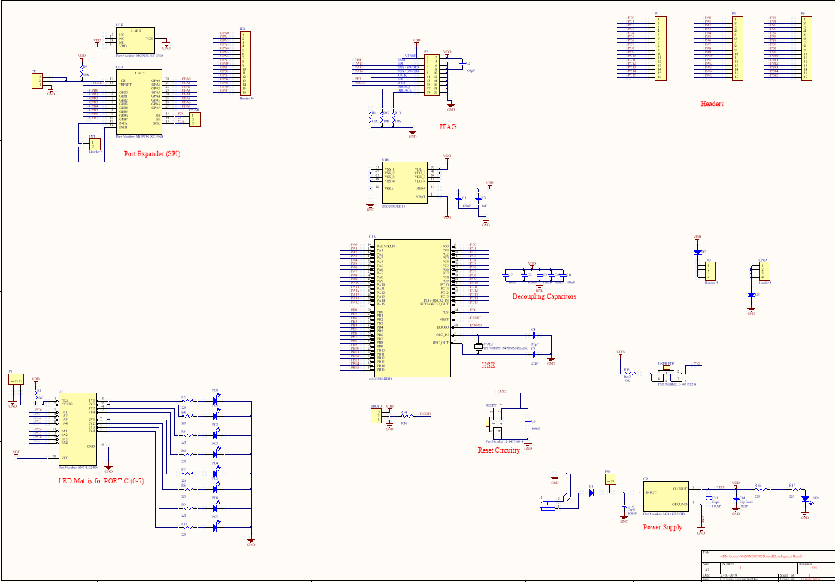

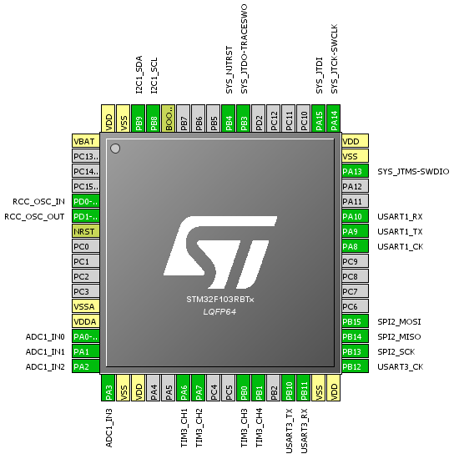
Pinout of STM32f103RxT6 LQFP64

PCB Design

Component Placement
Although all of the components have been inserted, it’s our job to determine exactly where each component is placed on the PCB.
Most PCB design software packages include an auto-placement feature that places components with the goal of minimizing routing lengths. But it’s almost always necessary to manually place the components in the best layout.

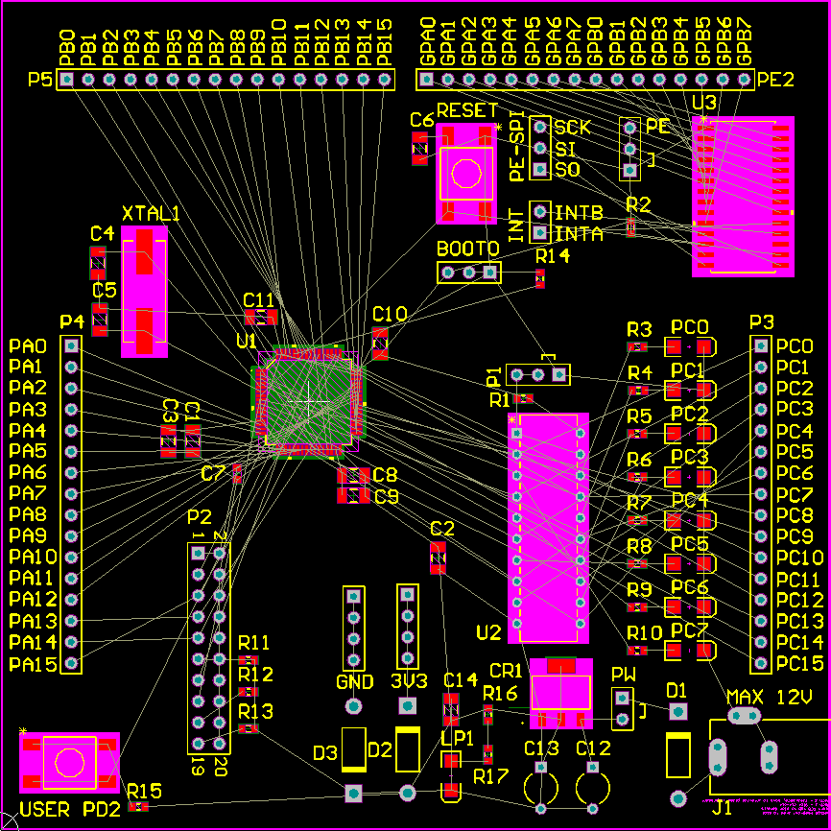

PCB Layer Stack
A printed circuit board is made up of stacked layers. Conducting layers are separated by insulating layers. The minimum number of conducting layers is two. This means the top layer and the bottom layer can be used for routing signals, and these two layers are separated by an internal insulating layer.
The number of conducting layers is always an even number, so you can have a board with 2,4,6,8,10,12 conducting layers. Most designs will require 4-6 layers, and more advanced designs may require 8 or more layers.

For our purpose we will be using only 2 layers due to manufacturing and cost contraints.

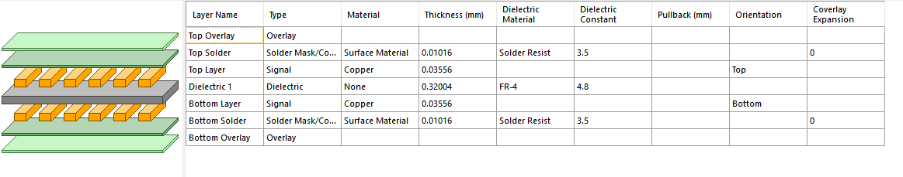
PCB Layer Stack

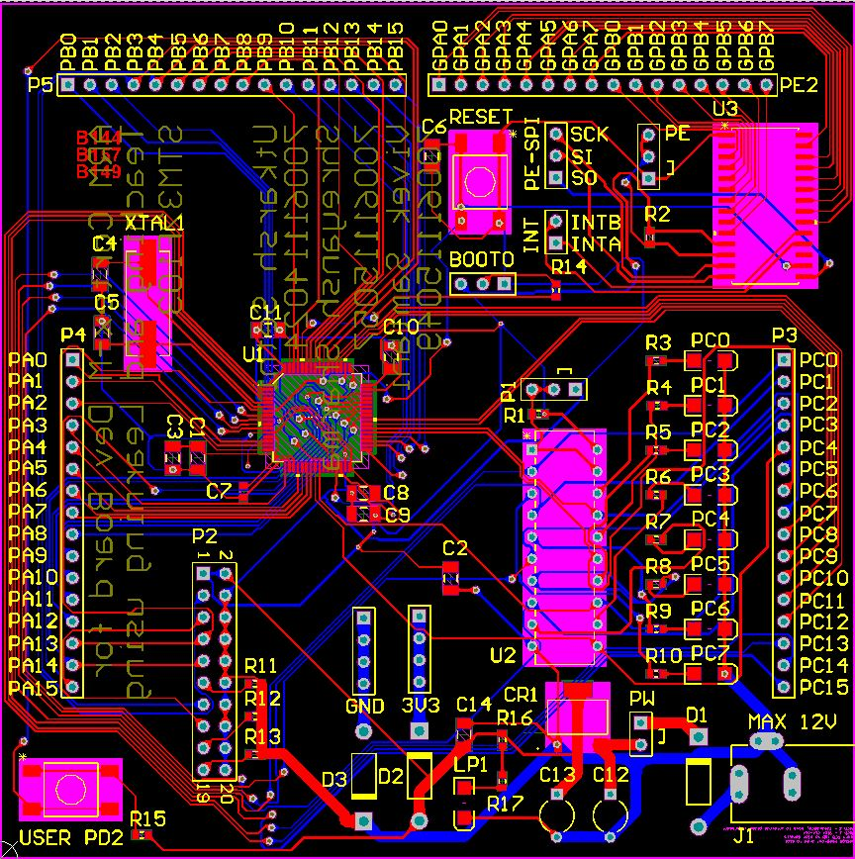

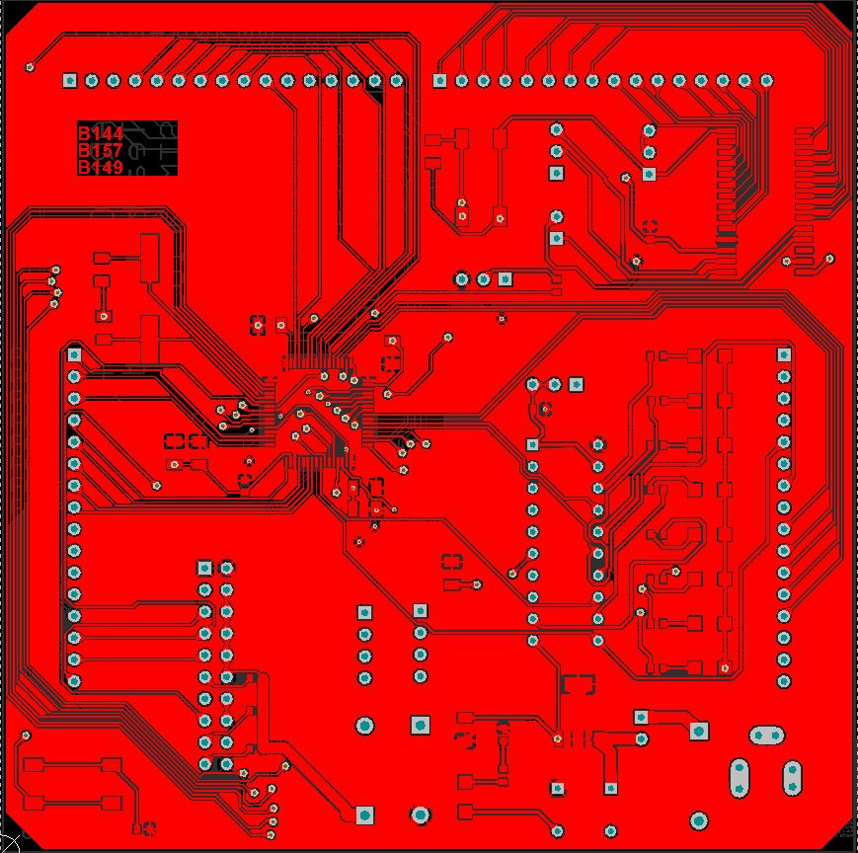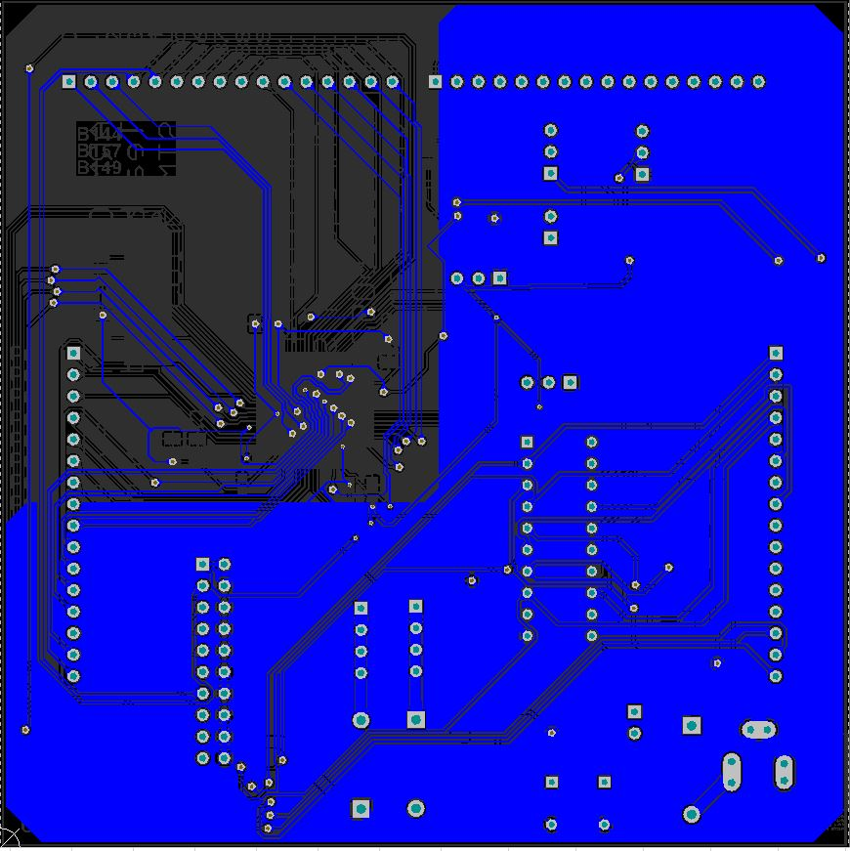

PCB after Routing

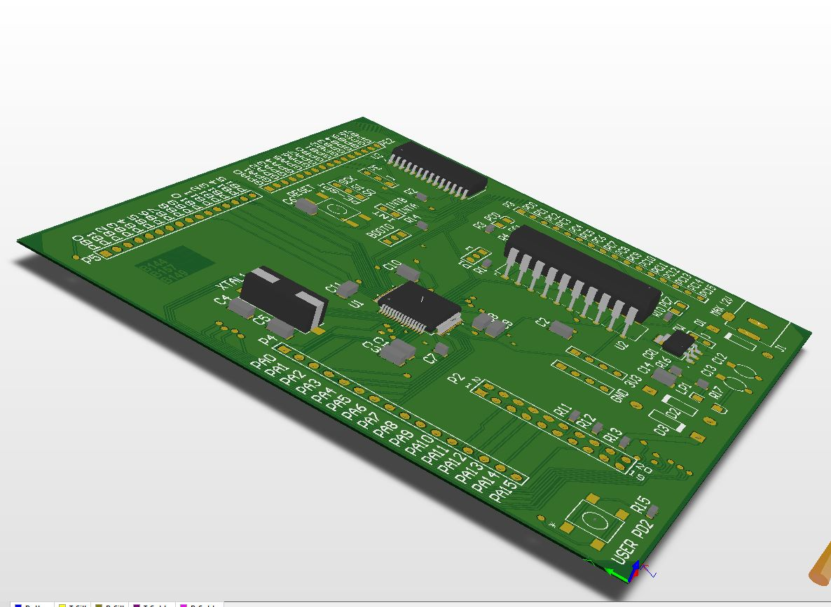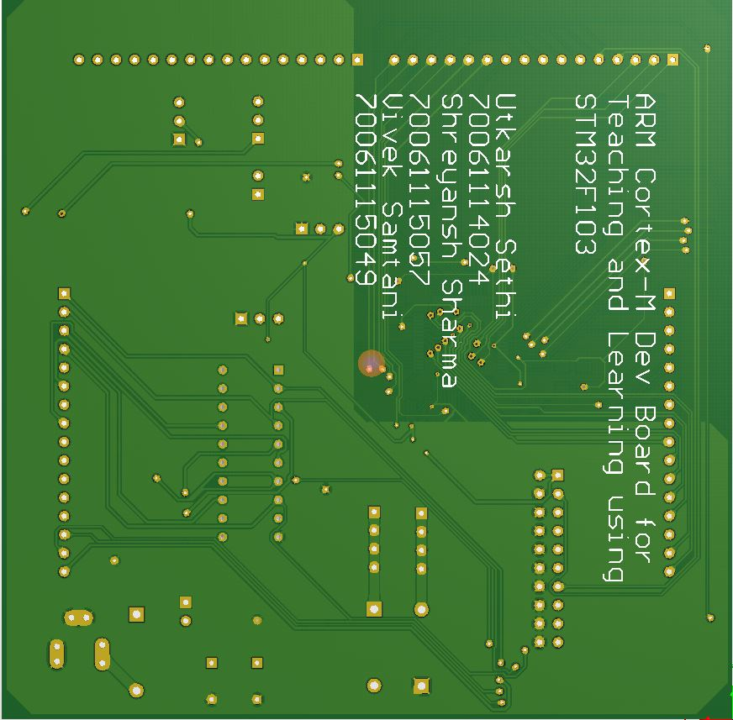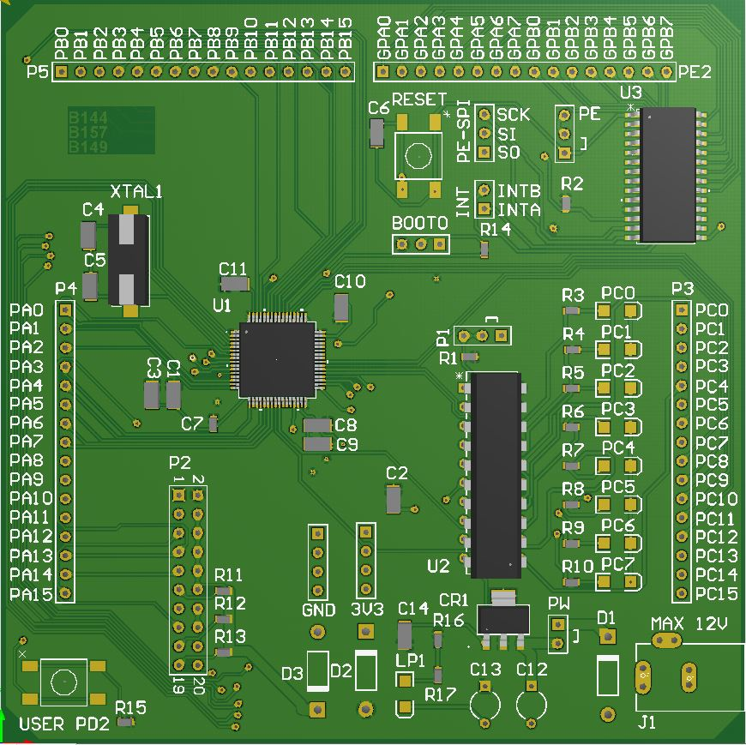

PCB FINISHED

Implimetation

Initially we faced problem while interfacing different components with 8051 microcontroller and hence we did numerous experiments and we never got to know the debugging process behind the operation inside the microcontroller

Different modules and ICs which were used were never clear to us
We were often just running the programs which were pre-defined

Major problem faced with us was that we never really found a way out of this difficult loop of doubts and accordingly we shared our problems with teachers and seniors , we realized they are facing the same problem
We even consulted professors from outside our campus and different students from other colleges

Hence we decided to implement a development board to study debugging and interfacing in a more efficient way while understanding the operations separately

Initially selecting the IC was another hectic problem we faced
There were way too many microcontrollers out there in the market and hence we selected STM 32F103R8T6

STM32 is a family of 32-bit microcontroller integrated circuits by STMicroelectronics. The STM32 chips are grouped into related series that are based around the same 32-bit ARM processor core, such as the Cortex-M7F, Cortex-M4F, Cortex-M3, Cortex-M0+, or Cortex-M0. Internally, each microcontroller consists of the processor core, static RAM, flash memory, debugging interface, and various peripherals

We selected Cortex M3 series because it was convenient and easy to understand and routing was easy for us

Features of M3 are as follows
Core  - ARM® 32-bit Cortex®-M3 CPU (120MHz max) with Adaptive real-time accelerator (ART Accelerator™ allowing 0-wait state execution performance from Flash memory, MPU, 150 DMIPS/1.25 DMIPS/MHz (Dhrystone 2.1)  Memories  - Up to 1Mbyte of Flash memory  - 512bytes of OTP memory  - Up to 128 + 4Kbytes of SRAM  - Flexible static memory controller that supports Compact Flash, SRAM, PSRAM, NOR and NAND memories  - LCD parallel interface, 8080/6800 modes  Clock, reset and supply management  - From 1.8 to 3.6V application supply+I/Os  - POR, PDR, PVD and BOR  - 4 to 26MHz crystal oscillator  - Internal 16MHz factory-trimmed RC  - 32kHz oscillator for RTC with calibration  - Internal 32kHz RC with calibration  Low-power modes  - Sleep, Stop and Standby modes  - V_{BAT} supply for RTC, 20 × 32 bit backup registers, and optional 4 KB backup SRAM  Up to 17 timers  - Up to twelve 16-bit and two 32-bit timers, up to 120MHz, each with up to 4 IC/OC/PWM or pulse counter and quadrature (incremental) encoder input | Up to 140 I/O ports with interrupt capability  - Up to 136 fast I/Os up to 60MHz  - Up to 138 5V-tolerant I/Os  Up to 15 communication interfaces  - Up to 3 × I²C interfaces (SMBus/PMBus)  - Up to 4 USARTs and 2 UARTs (7.5Mbit/s, ISO 7816 interface, LIN, IrDA, modem ctrl)  - Up to 3 SPIs (30Mbit/s), 2 with muxed I²S to achieve audio class accuracy via audio PLL or external PLL  - 2 × CAN interfaces (2.0B Active)  - SDIO interface  Advanced connectivity  - USB 2.0 full-speed device/host/OTG controller with on-chip PHY  - USB 2.0 high-speed/full-speed device/host/OTG controller with dedicated DMA, on-chip full-speed PHY and ULPI  - 10/100 Ethernet MAC with dedicated DMA: supports IEEE 1588v2 hardware, MII/RMII  Cryptographic acceleration  - Hardware acceleration for AES 128, 192, 256, Triple DES, HASH (MD5, SHA-1)  - Analog true random number generator

We used Altium Designer 17
To design the routing and connections we used Altium Designer 17 which is user friendly Altium has helped a wide range of companies succeed in designing next-generation electronic products and systems.
It is :
Easy
Powerful
Modern
One of the most tangible benefits is the ability to create very accurate 3D models of the PCB assembly and export that as an industry standard format so that we know when we produce the PCB that it will fit the mechanical chassis the first time
My favorite thing about Altium Designer is the integrated approach to PCB design and schematic capture. The ease-of-use is excellent.
Altium provides unified electronics design solution with schematic capture

We made our own libraries and datasheets according to the interfacing of our STM32 micro controller and hence we used
STM32CubeProgrammer to know the pin numbers for interfacing every needed exercise in the lab manual
After this we started to work on the schematic

We used Keil uVision5 MDK
Keil® MDK is the most comprehensive software development solution for Arm®-based microcontrollers and includes all components that you need to create, build, and debug embedded applications MDK-Core is based on µVision (Windows only) with leading support for Cortex-M devices including the new Armv8-M architecture.
MDK includes two Arm C/C++ Compilers with assembler, linker, and highly optimize run-time libraries that are tailored for optimum code size and performance.

Kiel was used to make example code for demonstration purpose. It is also used for debugging of the Board over JTAG/SWD.

Demonstration Example Code:
/**
******************************************************************************
* @file : main.c
* @brief : Main program body
******************************************************************************
** This notice applies to any and all portions of this file
* that are not between comment pairs USER CODE BEGIN and
* USER CODE END. Other portions of this file, whether
* inserted by the user or by software development tools
* are owned by their respective copyright owners.
*
* COPYRIGHT(c) 2019 STMicroelectronics
*
* Redistribution and use in source and binary forms, with or without modification,
* are permitted provided that the following conditions are met:
* 1. Redistributions of source code must retain the above copyright notice,
* this list of conditions and the following disclaimer.
* 2. Redistributions in binary form must reproduce the above copyright notice,
* this list of conditions and the following disclaimer in the documentation
* and/or other materials provided with the distribution.
* 3. Neither the name of STMicroelectronics nor the names of its contributors
* may be used to endorse or promote products derived from this software
* without specific prior written permission.
*
* THIS SOFTWARE IS PROVIDED BY THE COPYRIGHT HOLDERS AND CONTRIBUTORS "AS IS"
* AND ANY EXPRESS OR IMPLIED WARRANTIES, INCLUDING, BUT NOT LIMITED TO, THE
* IMPLIED WARRANTIES OF MERCHANTABILITY AND FITNESS FOR A PARTICULAR PURPOSE ARE
* DISCLAIMED. IN NO EVENT SHALL THE COPYRIGHT HOLDER OR CONTRIBUTORS BE LIABLE
* FOR ANY DIRECT, INDIRECT, INCIDENTAL, SPECIAL, EXEMPLARY, OR CONSEQUENTIAL
* DAMAGES (INCLUDING, BUT NOT LIMITED TO, PROCUREMENT OF SUBSTITUTE GOODS OR
* SERVICES; LOSS OF USE, DATA, OR PROFITS; OR BUSINESS INTERRUPTION) HOWEVER
* CAUSED AND ON ANY THEORY OF LIABILITY, WHETHER IN CONTRACT, STRICT LIABILITY,
* OR TORT (INCLUDING NEGLIGENCE OR OTHERWISE) ARISING IN ANY WAY OUT OF THE USE
* OF THIS SOFTWARE, EVEN IF ADVISED OF THE POSSIBILITY OF SUCH DAMAGE.
*
******************************************************************************
*/
/* Includes ------------------------------------------------------------------*/
#include "main.h"
#include "stm32f1xx_hal.h"
#include "stdlib.h"
#include "stdbool.h"

/* USER CODE BEGIN Includes */

/* USER CODE END Includes */

/* Private variables ---------------------------------------------------------*/

/* USER CODE BEGIN PV */
/* Private variables ---------------------------------------------------------*/

/* USER CODE END PV */

/* Private function prototypes -----------------------------------------------*/
void SystemClock_Config(void);
static void MX_GPIO_Init(void);

/* USER CODE BEGIN PFP */
/* Private function prototypes -----------------------------------------------*/

/* USER CODE END PFP */

/* USER CODE BEGIN 0 */

int delay = 200;

void EXTI2_IRQHandler(void)
{
/* USER CODE BEGIN EXTI2_IRQn 0 */

if( __HAL_GPIO_EXTI_GET_FLAG(GPIO_PIN_2)){

int delay = rand() % (2000 - 10 + 1 ) + 10;

}
/* USER CODE END EXTI2_IRQn 0 */
HAL_GPIO_EXTI_IRQHandler(GPIO_PIN_2);
/* USER CODE BEGIN EXTI2_IRQn 1 */

/* USER CODE END EXTI2_IRQn 1 */
}

/* USER CODE END 0 */

/**
* @brief The application entry point.
*
* @retval None
*/
int main(void)
{
/* USER CODE BEGIN 1 */

/* USER CODE END 1 */

/* MCU Configuration----------------------------------------------------------*/

/* Reset of all peripherals, Initializes the Flash interface and the Systick. */
HAL_Init();

/* USER CODE BEGIN Init */

/* USER CODE END Init */

/* Configure the system clock */
SystemClock_Config();

/* USER CODE BEGIN SysInit */

/* USER CODE END SysInit */

/* Initialize all configured peripherals */
MX_GPIO_Init();
/* USER CODE BEGIN 2 */

/* USER CODE END 2 */

/* Infinite loop */
/* USER CODE BEGIN WHILE */
bool toggle = 0;
while (1)
{

/* USER CODE END WHILE */

/* USER CODE BEGIN 3 */
for(int pin=0; pin < 8; pin++){
if(toggle == 1){
GPIOC->BSRR = (1<<pin);
toggle = 0;
}
else {
GPIOC->BSRR = (0<<pin);
toggle = 1;
}
HAL_Delay(delay);
}

}
/* USER CODE END 3 */

}

/**
* @brief System Clock Configuration
* @retval None
*/
void SystemClock_Config(void)
{

RCC_OscInitTypeDef RCC_OscInitStruct;
RCC_ClkInitTypeDef RCC_ClkInitStruct;

/**Initializes the CPU, AHB and APB busses clocks
*/
RCC_OscInitStruct.OscillatorType = RCC_OSCILLATORTYPE_HSI;
RCC_OscInitStruct.HSIState = RCC_HSI_ON;
RCC_OscInitStruct.HSICalibrationValue = 16;
RCC_OscInitStruct.PLL.PLLState = RCC_PLL_NONE;
if (HAL_RCC_OscConfig(&RCC_OscInitStruct) != HAL_OK)
{
_Error_Handler(__FILE__, __LINE__);
}

/**Initializes the CPU, AHB and APB busses clocks
*/
RCC_ClkInitStruct.ClockType = RCC_CLOCKTYPE_HCLK|RCC_CLOCKTYPE_SYSCLK
|RCC_CLOCKTYPE_PCLK1|RCC_CLOCKTYPE_PCLK2;
RCC_ClkInitStruct.SYSCLKSource = RCC_SYSCLKSOURCE_HSI;
RCC_ClkInitStruct.AHBCLKDivider = RCC_SYSCLK_DIV1;
RCC_ClkInitStruct.APB1CLKDivider = RCC_HCLK_DIV1;
RCC_ClkInitStruct.APB2CLKDivider = RCC_HCLK_DIV1;

if (HAL_RCC_ClockConfig(&RCC_ClkInitStruct, FLASH_LATENCY_0) != HAL_OK)
{
_Error_Handler(__FILE__, __LINE__);
}

/**Configure the Systick interrupt time
*/
HAL_SYSTICK_Config(HAL_RCC_GetHCLKFreq()/1000);

/**Configure the Systick
*/
HAL_SYSTICK_CLKSourceConfig(SYSTICK_CLKSOURCE_HCLK);

/* SysTick_IRQn interrupt configuration */
HAL_NVIC_SetPriority(SysTick_IRQn, 0, 0);
}

/** Configure pins as
* Analog
* Input
* Output
* EVENT_OUT
* EXTI
*/
static void MX_GPIO_Init(void)
{

GPIO_InitTypeDef GPIO_InitStruct;

/* GPIO Ports Clock Enable */
__HAL_RCC_GPIOD_CLK_ENABLE();
__HAL_RCC_GPIOC_CLK_ENABLE();
__HAL_RCC_GPIOA_CLK_ENABLE();

/*Configure GPIO pin Output Level */
HAL_GPIO_WritePin(GPIOC, GPIO_PIN_0|GPIO_PIN_1|GPIO_PIN_2|GPIO_PIN_3
|GPIO_PIN_4|GPIO_PIN_5|GPIO_PIN_6|GPIO_PIN_7, GPIO_PIN_RESET);

/*Configure GPIO pins : PC0 PC1 PC2 PC3
PC4 PC5 PC6 PC7 */
GPIO_InitStruct.Pin = GPIO_PIN_0|GPIO_PIN_1|GPIO_PIN_2|GPIO_PIN_3
|GPIO_PIN_4|GPIO_PIN_5|GPIO_PIN_6|GPIO_PIN_7;
GPIO_InitStruct.Mode = GPIO_MODE_OUTPUT_PP;
GPIO_InitStruct.Pull = GPIO_NOPULL;
GPIO_InitStruct.Speed = GPIO_SPEED_FREQ_LOW;
HAL_GPIO_Init(GPIOC, &GPIO_InitStruct);

/*Configure GPIO pin : PD2 */
GPIO_InitStruct.Pin = GPIO_PIN_2;
GPIO_InitStruct.Mode = GPIO_MODE_IT_FALLING;
GPIO_InitStruct.Pull = GPIO_PULLUP;
HAL_GPIO_Init(GPIOD, &GPIO_InitStruct);

/* EXTI interrupt init*/
HAL_NVIC_SetPriority(EXTI2_IRQn, 0, 0);
HAL_NVIC_EnableIRQ(EXTI2_IRQn);

}

/* USER CODE BEGIN 4 */

/* USER CODE END 4 */

/**
* @brief This function is executed in case of error occurrence.
* @param file: The file name as string.
* @param line: The line in file as a number.
* @retval None
*/
void _Error_Handler(char *file, int line)
{
/* USER CODE BEGIN Error_Handler_Debug */
/* User can add his own implementation to report the HAL error return state */
while(1)
{
}
/* USER CODE END Error_Handler_Debug */
}

#ifdef USE_FULL_ASSERT
/**
* @brief Reports the name of the source file and the source line number
* where the assert_param error has occurred.
* @param file: pointer to the source file name
* @param line: assert_param error line source number
* @retval None
*/
void assert_failed(uint8_t* file, uint32_t line)
{
/* USER CODE BEGIN 6 */
/* User can add his own implementation to report the file name and line number,
tex: printf("Wrong parameters value: file %s on line %d\r\n", file, line) */
/* USER CODE END 6 */
}
#endif /* USE_FULL_ASSERT */

/**
* @}
*/

/**
* @}
*/

/************************ (C) COPYRIGHT STMicroelectronics *****END OF FILE****/

CONCLUSION

Challenges
- ARM is complex architecture and will be difficult to introduce to beginners.
- The documentation provided with latest processors is thousands of pages and often cannot be completed in 15labs, so it has to be provided in a concise manner.
- Advanced protocols like usb/Ethernet cannot be covered
- New µCs / ICs cannot be placed on breadboard which make them intimidating

Learning
- We learnt about various steps involved in a commertial PCB design
- We learnt softwares like Altium Designer, Kiel uVison MDK 5
- Routing a 2layer board

Future Scope
- More side boards could be built, to support and demonstrate other protocols like USB, USART, I2C, DAC

References
- Whiteway, Alexander Keith . “PIC32 DEVELOPMENT for ECE4760” Electrical and Computer Engineering Projects: Masters of Engineering , May. 2015, people.ece.cornell.edu/land/courses/eceprojectsland/STUDENTPROJ/2014to2015/akw62/akw62_report_201505180311.pdf.
- Ross, Michael David. “PIC32 DEVELOPMENT BOARD.” Electrical and Computer Engineering Projects: Masters of Engineering , Jan. 2014, people.ece.cornell.edu/land/courses/eceprojectsland/STUDENTPROJ/2013to2014/mdr87/mdr87_report_201312201016.pdf.
- Mahbub , Syed Tahmid Mahbub, “Comparing the PIC32MX250F128B and Atmel AT91SAM3X8E for teaching” Electrical and Computer Engineering Projects: Masters of Engineering , Dec. 2013, people.ece.cornell.edu/land/courses/eceprojectsland/STUDENTPROJ/2013to2014/sm893/Independent%20Study%20Paper%20Final.pdf
- ST-Microcontrollers, UM0986 User manual, ”Developing your STM32VLDISCOVERY application using the MDK-ARM software ”.
- ST-Microcontrollers, UM1523 User manual, ” Getting started with software and firmware environments for the STM32F0DISCOVERY kit ”.
- ST-Microcontrollers, UM1725 User Manual, ” Description of STM32F4 HAL and LL drivers ”.
- ST-Microcontrollers, AN4488 Application note, ” Getting started with STM32F4xxxx MCU hardware development ”.
- ST-Microcontrollers, PM0214 Programming manual, ” STM32F3 Series, STM32F4 Series, STM32L4 Series and STM32L4+ Series Cortex®-M4 programming manual ”.
- ST-Microcontrollers, RM0090 Reference manual, ” STM32F405/415, STM32F407/417, STM32F427/437 and STM32F429/439 advanced Arm®-based 32-bit MCUs ”.
- ST-Microcontrollers, STM32F405xx STM32F407xx Data Sheet, ” ARM Cortex-M4 32b MCU+FPU, 210DMIPS, up to 1MB Flash/192+4KB RAM, USB OTG HS/FS, Ethernet, 17 TIMs, 3 ADCs, 15 comm. interfaces & camera ”.
- ST-Microcontrollers, STM32F407VG, https://my.st.com/content/my_st_com/en/products/microcontrollers/stm32-32-bit-arm-cortex-mcus/stm32-high-performance-mcus/stm32f4-series/stm32f407-417/stm32f407vg.html#design-scroll .
- Various Other Open source Projects related to STM32 and other µCs.

