**LED Space Impact**

**Abstract:**

It is going to be a game where a spaceship has to dodge and finish off space invaders moving towards it at increasing speeds. It is to be made on a set of LED matrices. It draws inspiration from the old mobile game “Space Impact”. The space invaders will move horizontally towards the spaceship. The space ship would be given powers to move vertically and fire bullets back at the invaders. The longer a player can survive and the more number of invaders it shoots, the more points he/she gets. Lots of variations and increasing levels of difficulties can be introduced in the game to make it more interesting. We’ll use the Krypton board and a Verilog code to implement this idea.

# Introduction

It’s the very popular old mobile phone game, where our spaceship, on the left edge of the screen moves past all the invaders charging towards it. We plan to use four to six, 8x8 LED matrices and make specific LEDs glow to represent the Spaceship and invaders and the bullets fired by them, in distinguished shapes. The speed of the invaders moving towards the spaceship will increase with time and they’ll appear at discrete vertical levels randomly. They’ll move towards the spaceship to crash into it and the player will try to dodge or shoot them to score more points, which we can display using Seven-segment display units. We can make the computer play the game as well. And to increase difficulty we can allow vertical movement of invaders as well and we can also make them fire bullets at the spaceship.

# Project description

**2.1 Project goal:**

The goal is to make an enjoyable game. The major challenges we can have is synchronizing the motion of invaders and spaceship over all the LED matrices we use, as we are going to use more than one 8x8 LED matrix. All the LED matrices would be coded appropriately and we’ll have to identify when a bullet hits an invader and when an invader crashes into the spaceship and then change scores accordingly. Also if we want an entirely computer controlled game, we have to code the spaceship appropriately so that it can dodge and/or shoot the invaders properly. We’ll have to identify the position of each object on the LED module and then write appropriate codes in case they interact.

## Technical Design

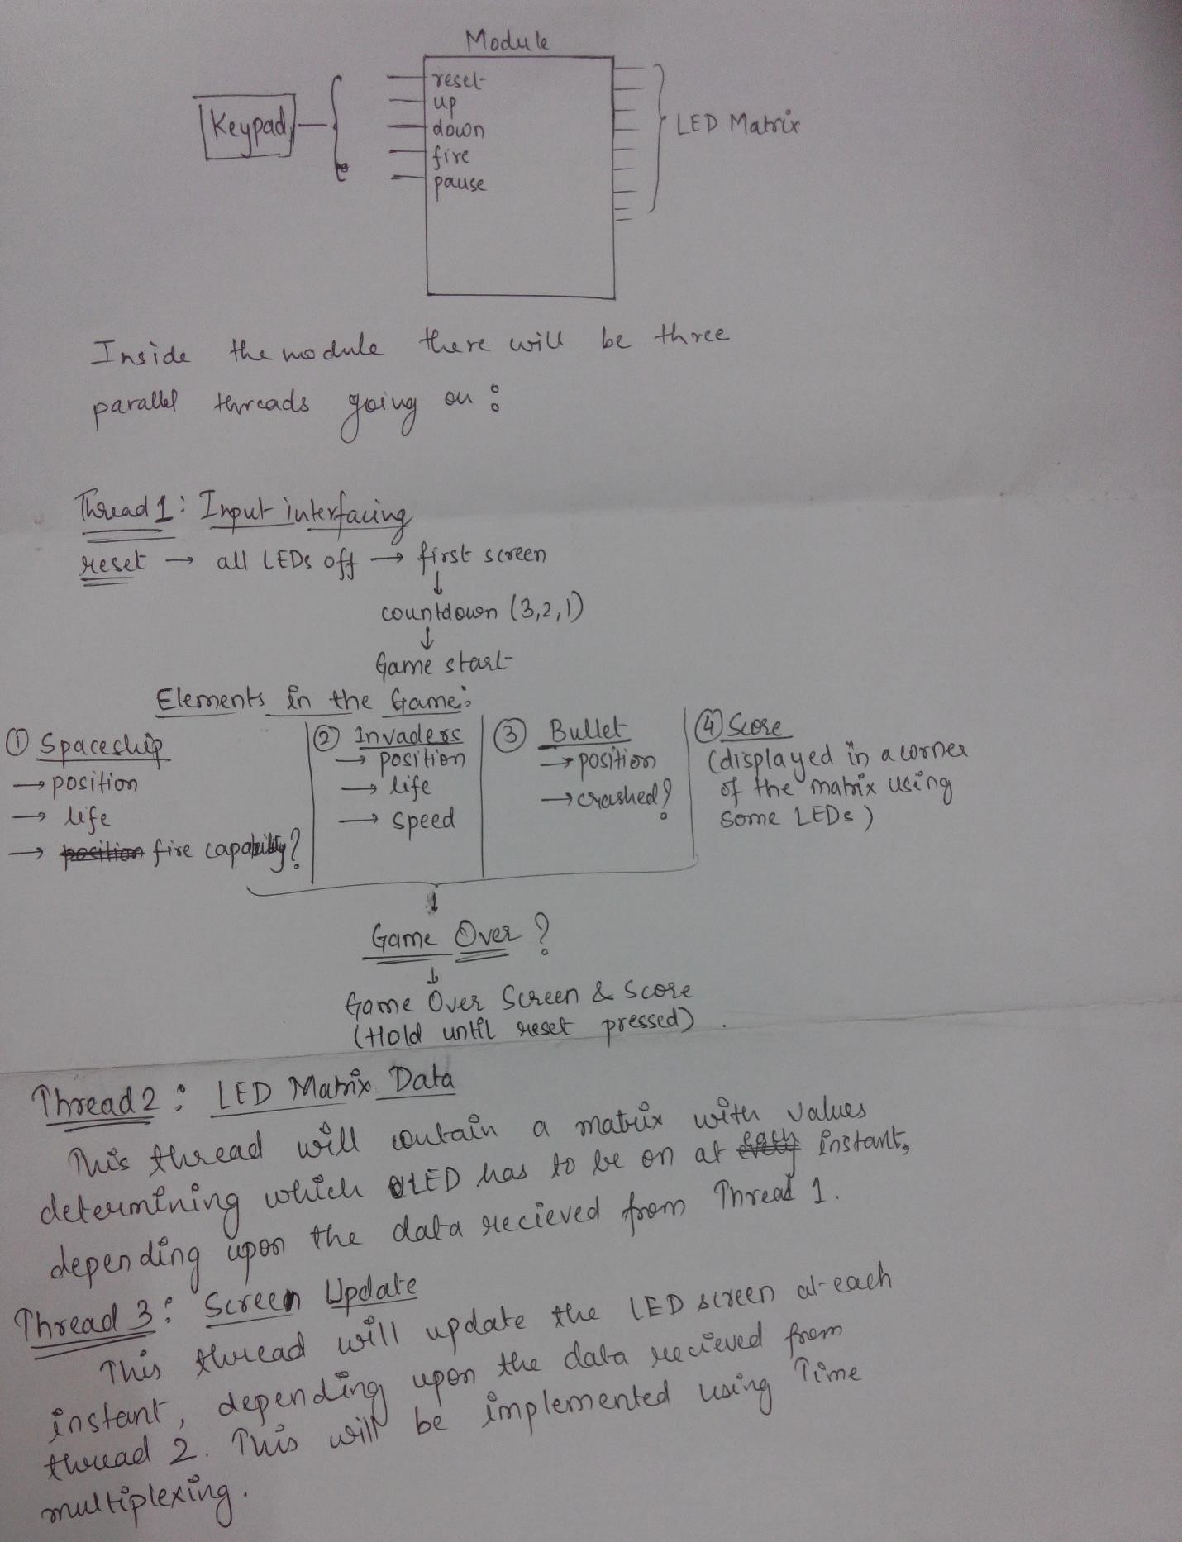

### System-level overview

### Performance validation

If we are able to control the spaceship and invaders well and if we are able to fire bullets, identify crashes and increase points well, we’ll consider our project successful.

# Project plan

The coding will take most of our time. Then we’ll have to arrange and synchronise the working of all the LED matrices we are going to use. We plan to complete our coding in one third of a time and the finish circuit design and integration and the next third of the time and then test our complete project in the last third.

**Milestone 1:** Complete Verilog code

**Milestone 2:** Design Circuit

**Milestone 3**: Assemble circuit

**Milestone 4:** Complete testing and Debugging

# GANTT CHART

|  |  |  |  |
| --- | --- | --- | --- |
| **Task Name** | **Due Date** | **Will be done by** | **Remark** |
| 1. **Writing Code** |  |  |  |
| **1.1 Thread 1** | 10 March | Both |  |
| **1.2 Thread 2** | 6 March | Ashish |  |
| **1.3 Thread 3** | 8 March | Utkarsh |  |
| **1.4 Final Compilation** | 17 March | Ashish |  |
| **2. Circuit Design** | 18 March | Utkarsh |  |
| **3. Assembling Circuit** |  |  |  |
| **3.1 Procuring Hardware** | 19 March | Both |  |
| **3.2 Keypad Interfacing** | 19 March | Ashish |  |
| **3.3 LED Matrix Interfacing** | 20 March | Both |  |
| **3.4 Final Circuit Integration** | 24 March | Utkarsh |  |
| **4. Testing and Debugging** |  |  |  |
| **4.1 Code testing, debugging and simulation** | 27 March | Ashish |  |
| **4.2 Circuit testing and debugging** | 30 March | Utkarsh |  |

**4. Project Implementation:**

I don’t think we’ll need any major instruments except for the ones needed to hook up the LED matrices with the Krypton boards and the controlling keys. Hardware we’ll need:

1. 4 to 6 LED Matrices
2. Krypton Board
3. Connectors for LED Matrices