Supporting evidence snapshot before the 120-user follow-up. Use HW6-Utkarsh-Sharma.docx as the updated submission; see vertical-512-120-summary.md for the completed follow-up and teardown limitation.

Homework 6: Scalability
Utkarsh Sharma · CS6650 · Code: github.com/utkarshsharma19/Building-Scalable-Systems-CS6650/tree/main/hw06

Setup
I added GET /products/search?q= to my HW5 Go service. It stores 100,000 products in a sync.Map. Each search starts at a random product, checks exactly 100 (name and category, case-insensitive), and returns at most 20. Every response has an X-Products-Checked: 100 header, and my Grafana panel showed an average of exactly 100 checks per search in every test. The service ran on ECS Fargate (256 CPU, 512 MB). Locust (FastHttpUser, 2 workers, 0–10 ms wait) ran on my laptop. Grafana scraped the ECS tasks directly, and Terraform also built a CloudWatch dashboard.

Part II: Finding the breaking point
A single search returned in 44 ms end to end (Fig 1). Almost all of that is the network from my laptop to Oregon: the server itself took about 0.25 ms.
Test | Throughput | p50 / p95 / p99 | CPU | Failures
5 users, 2 min | 161 req/s | 23 / 35 / 53 ms | ~25% | 0
20 users, 3 min | 520 req/s | 31 / 43 / 94 ms | ~62% | 0
60 users, 3 min (extra) | 1,056 req/s | 38 / 90 / 200 ms | ~99% | 0

What happened. 20 users did not break the service. Each user spends about 40 ms per request waiting on the network, so 20 users can only send about 500 requests per second, which the task handled at 62% CPU. So I added a 60-user test. If the server had kept up, 60 users would have sent about 1,400 req/s. Instead throughput stopped at about 1,050 req/s, CPU hit 99–100%, and p95 latency went from 35 to 90 ms (Fig 2). Memory stayed flat at about 10% (50–70 MB) the whole time because the products are loaded at startup. CPU is the resource that hits the limit first.
Optimize or scale? Each request still checked 100 products, with server-side search p95 about 0.25 ms. At 256 CPU units, throughput was 1,056 req/s, client p95 was 90 ms, and CPU was about 99%. The completed 60-user, 512-CPU-unit run delivered 1,487.6 req/s with p95 52 ms, p99 96 ms, and zero failures in 267,708 requests: 41% more throughput and 42% lower p95. CloudWatch averaged about 72–75% CPU in the steady full-load minutes. CPU therefore had headroom; network latency or the fixed user count may constrain throughput, but this does not establish a network ceiling. A 120-user run would test the new ceiling. A bigger task still leaves a single point of failure.
Using CloudWatch to decide. CPU at 62% for 520 req/s and 100% at about 1,050 req/s means one task handles about 1,000 req/s at most. At a 70% target that is about 700 req/s per task, which tells me how many tasks to run for a given load.
HW5 dashboard vs CloudWatch (Fig 3). They agree on the shape: both show the load steps at the same times, and Grafana's per-task process CPU matches CloudWatch CPU. Grafana showed things CloudWatch could not: request rate, 0% errors, and 100 products checked per search. CloudWatch showed something my app metrics missed. My server-side p95 stayed around 0.25 ms even at 99% CPU, while users saw p95 go from 35 to 90 ms. The waiting happens before my handler starts its timer (requests queue for CPU time), so the app's own duration metric looked healthy while users were waiting longer. CPU at 99% was the clearer warning. CloudWatch is slower though: 1-minute points with a delay, while Grafana updates every 5 s. Takeaway: watch CPU together with latency measured from the client or load balancer, not just inside the handler.

Part III: Horizontal scaling
Components. The ALB is the single public entry point and spreads requests across healthy tasks. The target group is the list of task IPs and their health (/health every 30 s, healthy after 2 passes). ECS adds and removes tasks from it, and the ALB only sends traffic to healthy ones. Auto scaling watches average CPU through CloudWatch alarms and changes the service's desired task count (target 70%, 2–4 tasks, 300 s cooldowns). ECS then starts or stops tasks to match.
Core test: the 60-user load that broke Part II, for 20 minutes through the ALB. Result: 1.68 million requests, 0 failures, about 1,450 req/s, p50 33 ms, p95 60 ms, p99 140 ms (Part II: 1,056 req/s, p95 90, p99 200). The ALB split traffic evenly (717 vs 716 req/s per task), but CPU was 59% on one task and 89% on the other for the same work, probably because they ran on different hardware. Average CPU was about 74%, above the 70% target. Load started at 06:16:40, desired count went from 2 to 3 at 06:22:53, and the new task was healthy at 06:23:33. That is about 7 minutes from load to new capacity, because the alarm needs 3 one-minute points above 70% plus CloudWatch's delay. After that, average CPU dropped below 70%, so it stayed at 3 tasks. Response times stayed flat through the scaling event (Fig 4–5).
Resilience: I stopped one task at 06:25:32. Its target went to draining, the ALB stopped sending it requests, and ECS started a replacement. It was back to 3 healthy targets about 1 minute later. Locust recorded 0 failed requests (Fig 6).
CPU vs request metrics for scaling. In the spike test, ALB target response time (p95) went from about 1 ms to 65 ms in the first minute of the spike, and requests per target jumped at the same moment. The CPU alarm fired about 6 minutes later. My app metrics would have been worse than CPU: handler p95 only moved from 290 to 450 µs, and requests in flight stayed at 0–1 because each request finishes in microseconds. I would pick ALB request count per target, with a target of about 700 req/s per task (from the Part II ceiling). Every request here costs the same CPU, so request count measures load directly, and it is available as soon as traffic arrives. I would not use latency as the main trigger because it includes network time and is noisy.
Horizontal vs vertical. A bigger task is simpler but has a size limit and is still a single point of failure. More tasks scale further and survive failures, at the cost of an ALB, slower reaction (~7 min) and no shared state between tasks.

Exploration (stress tests)
- Sudden spike (10 → 80 → 10 users, 7 minutes at 80, default policy): the 2 tasks ran at 90–97% CPU and ALB p95 was about 65 ms. Scale-out happened at 06:55:53, and the new task was ready at 06:56:44, just after the spike ended at 06:56:04. Auto scaling was too late to help. There were no failures because the service slows down instead of failing. Afterwards 3 tasks sat at about 18% CPU for over 10 minutes without scaling in, because the scale-in alarm needs 15 minutes below 63% (Fig 7). My prediction: CPU-based scaling cannot handle spikes shorter than about 7 minutes. For known spikes, raise the minimum task count or use scheduled scaling.
- Gradual ramp with a 50% target and 60 s cooldowns (10 → 80 users, +10 every 2 minutes): it scaled 2→3 at 07:24:10 and 3→4 at 07:27:10, only 3 minutes apart because of the short cooldown. It reached 4 tasks while load was still rising and served about 2,000 req/s at 80 users with p95 61 ms. A lower target scales earlier and leaves headroom but runs more tasks. A 90% target would scale late and run hot (predicted, not tested).
- Stopping 3 of 4 tasks at 80 users (07:29:11): one task carried all traffic until ECS replaced the other three. All 4 were healthy again by 07:30:18 (67 s). Run total: 1.6 million requests, 0 failures, with a short latency bump (Fig 8).
- All health checks failing (target group pointed at /health-broken, 20 users): both targets became unhealthy within about 50 s. When no target is healthy, the ALB "fails open" and sends traffic to all of them, so Locust saw 0 failures. But ECS treats failed ALB health checks as failed tasks. It replaced both tasks (08:21:15), the new ones also failed, and it replaced them again (08:22:19) (Fig 9–10). It recovered about 1 minute after I fixed the path. Lesson: a wrong health check can keep restarting a healthy service, and if a replacement round ever leaves no registered targets, users get errors.
Summary. The bottleneck was CPU, and more tasks (not code changes) fixed it. Across all Part III runs, about 4.4 million requests went through the ALB with 0 failed requests. CPU-based auto scaling works for slow load changes but reacts in about 7 minutes. For fast spikes it needs a faster signal (request count) or spare capacity kept running.

Figures

Fig 1. Single search on ECS: 200 OK, X-Products-Checked: 100, 44 ms total.
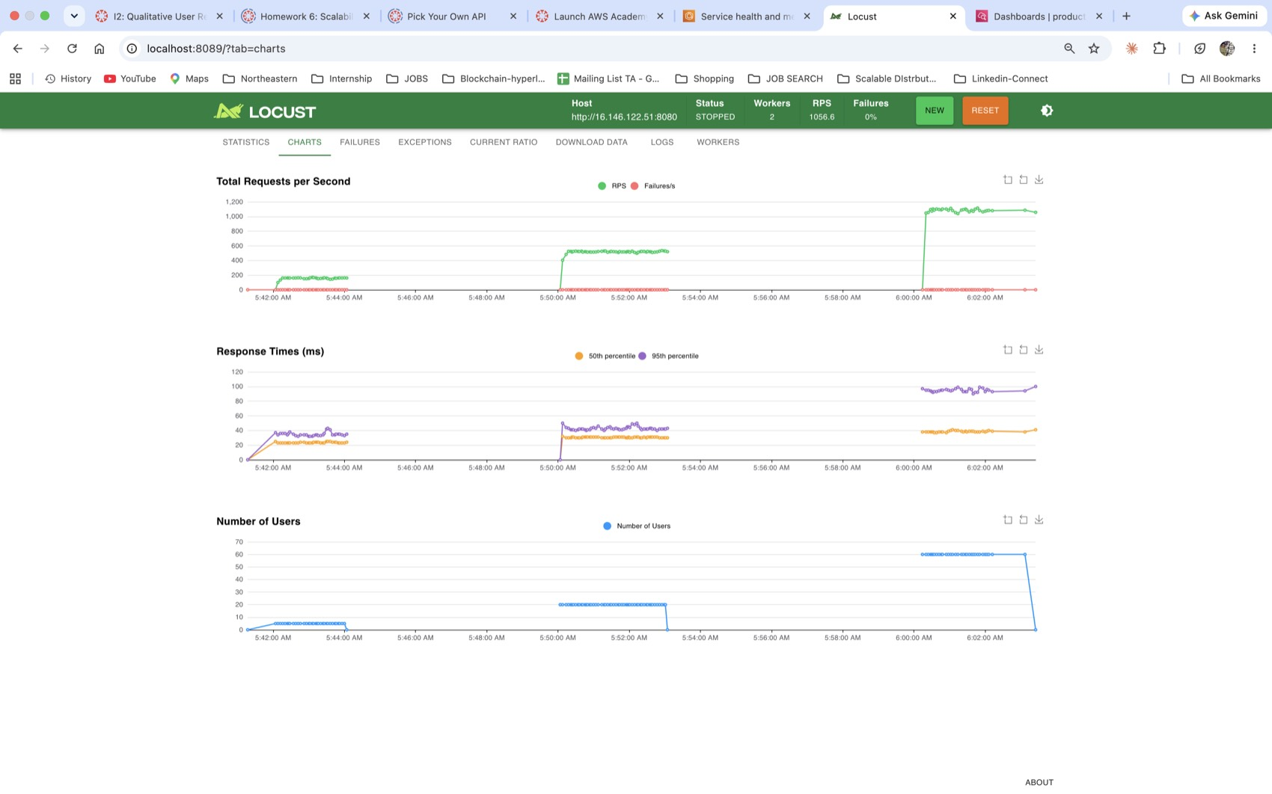
Fig 2. Part II Locust: 5, 20 and 60 users. Throughput levels off at ~1,050 req/s with 60 users and p95 rises.
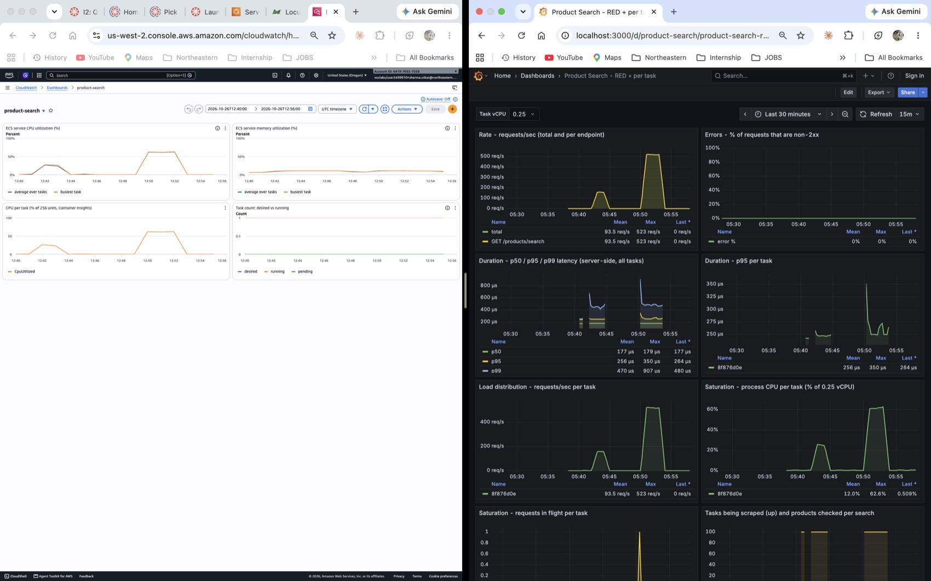
Fig 3. CloudWatch (left) and my Grafana dashboard (right) during the same Part II tests.
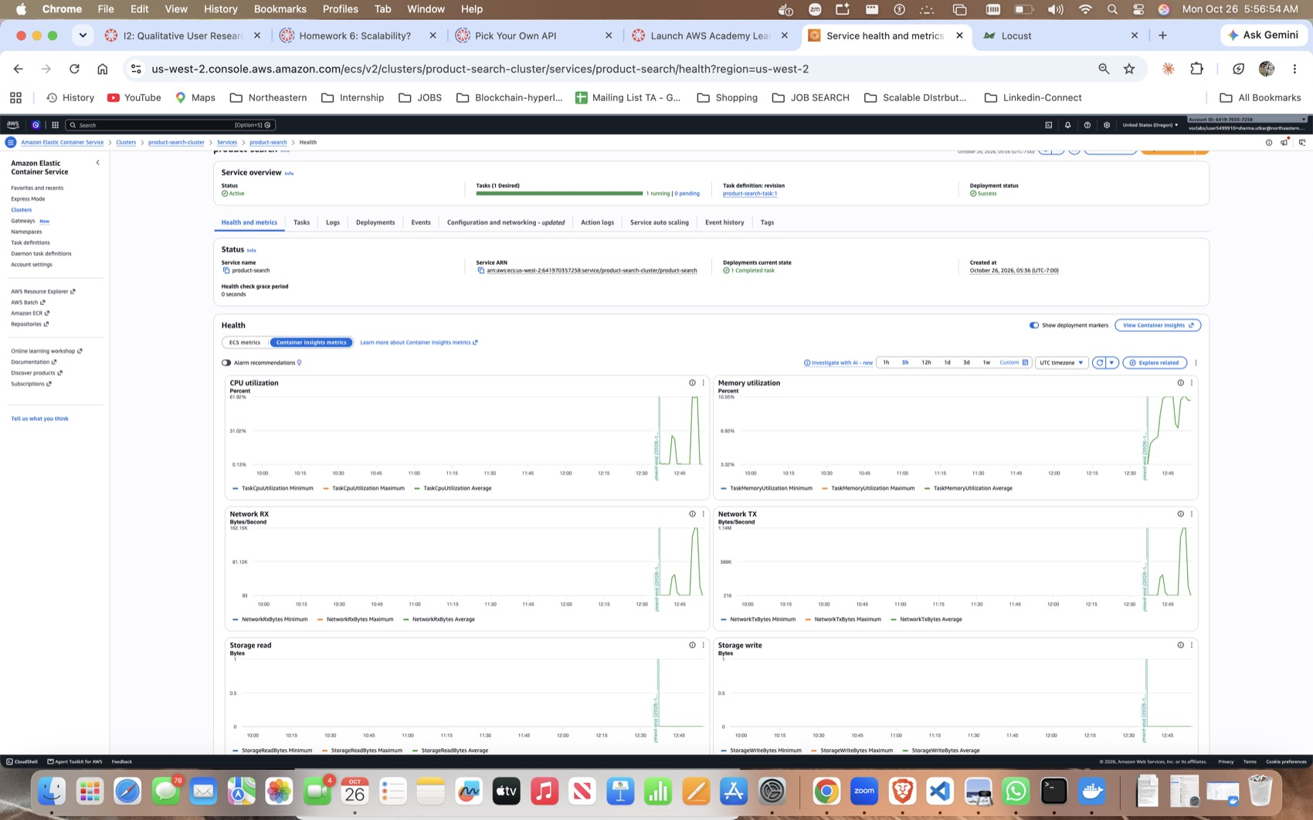
Fig 3b. ECS service metrics: CPU spikes with load, memory stays flat.
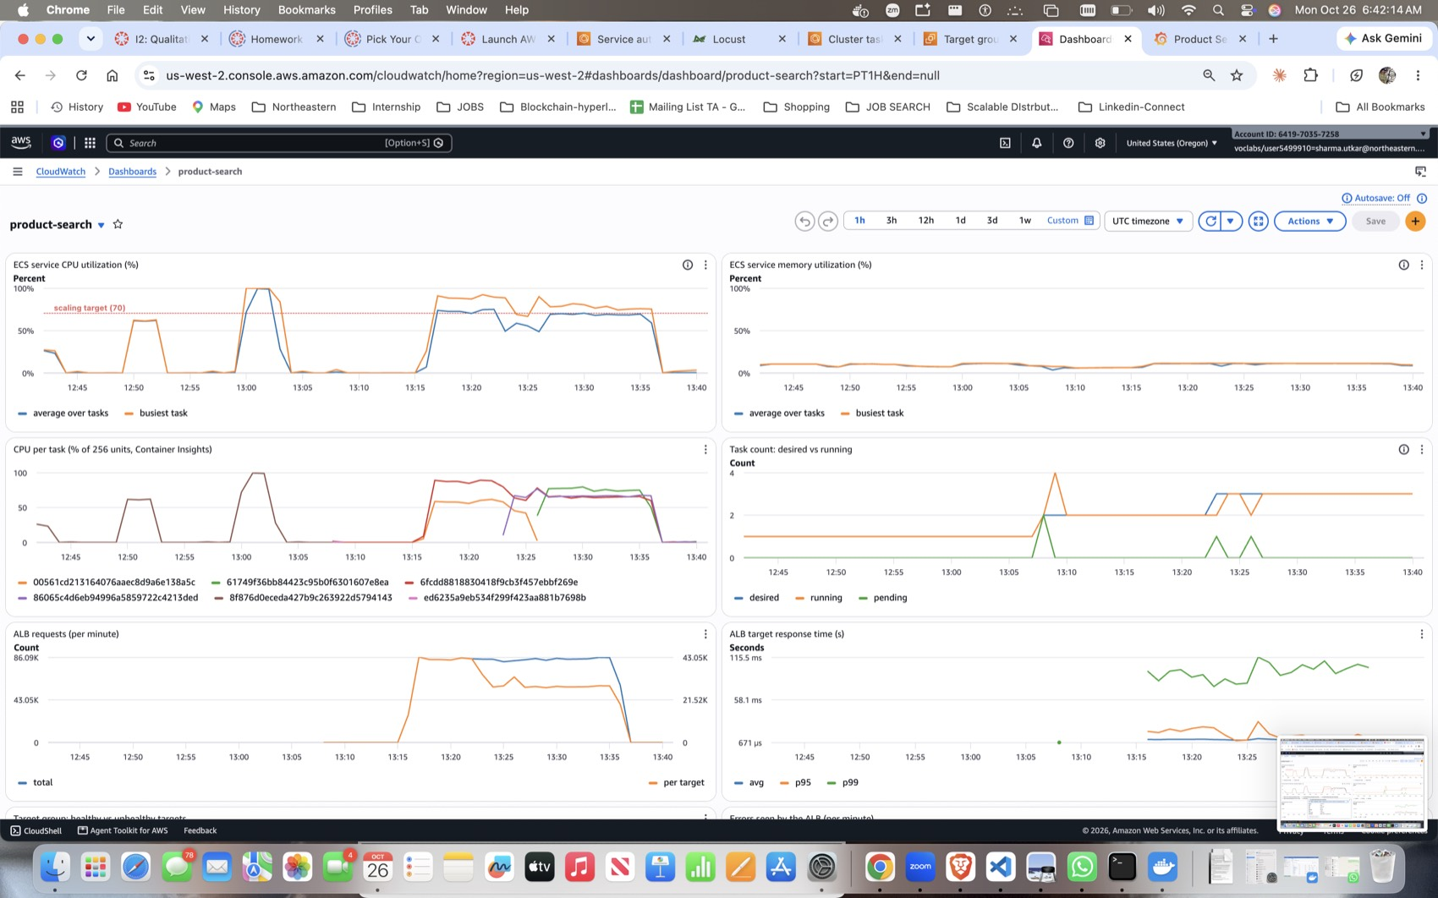
Fig 4. Part III CloudWatch: CPU around the 70% line, per-task CPU, desired vs running tasks (2 → 3), ALB requests and response time.
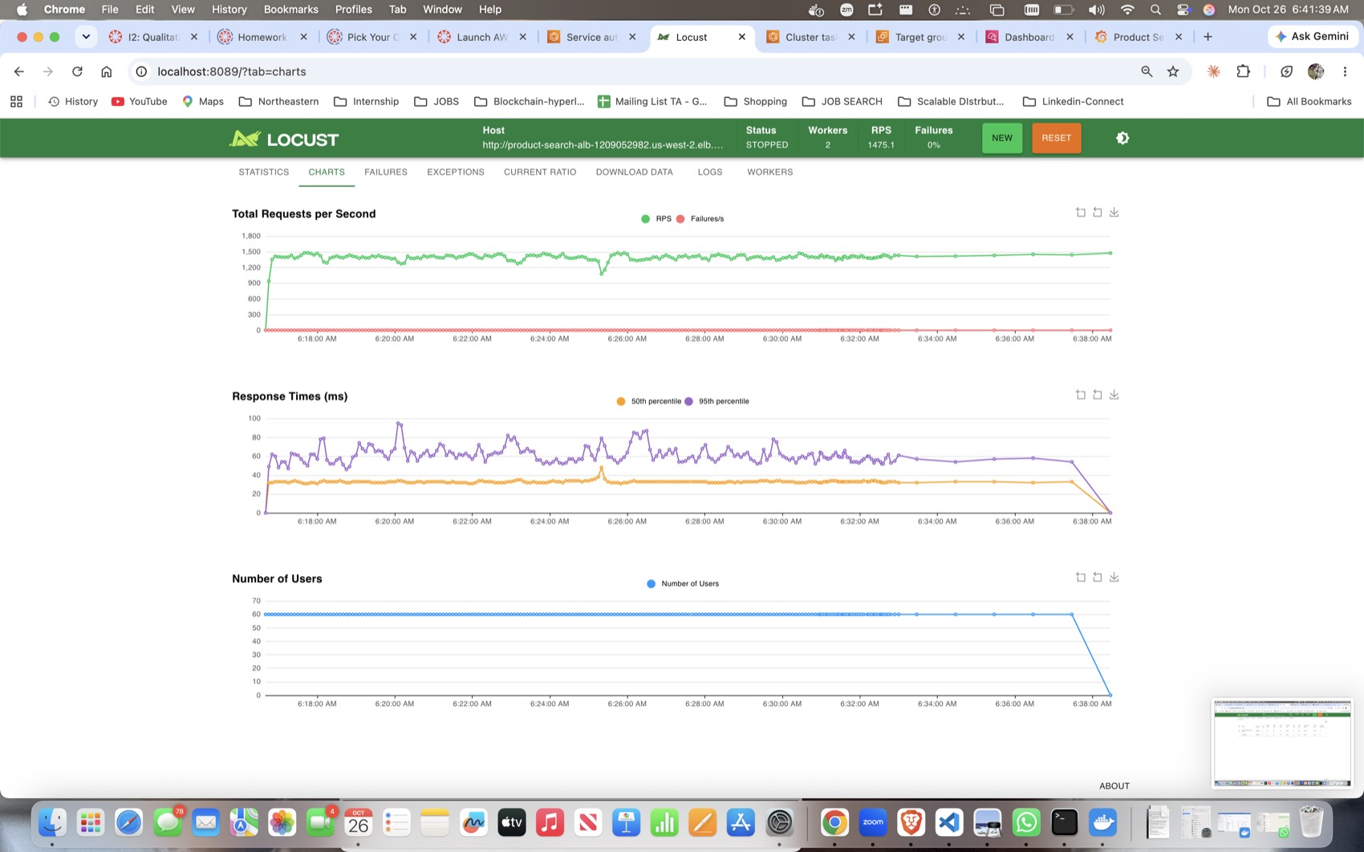
Fig 5. Core test (60 users, 20 min, through the ALB): ~1,450 req/s, flat latency, 0 failures, including the task stop at 06:25.
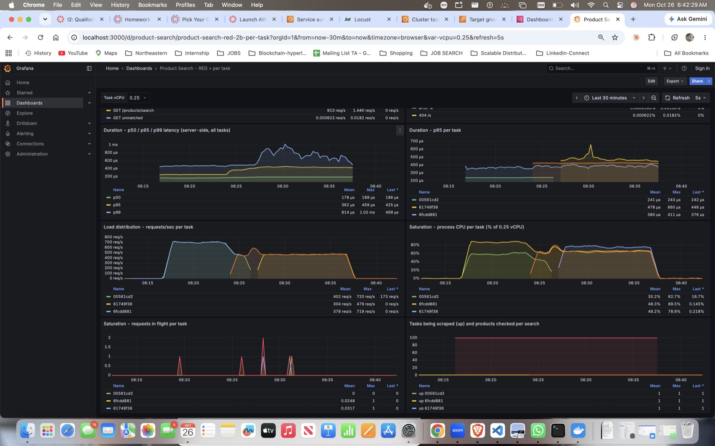
Fig 5b. Grafana per task: even request split across tasks, uneven CPU, and the stopped task's line ending.
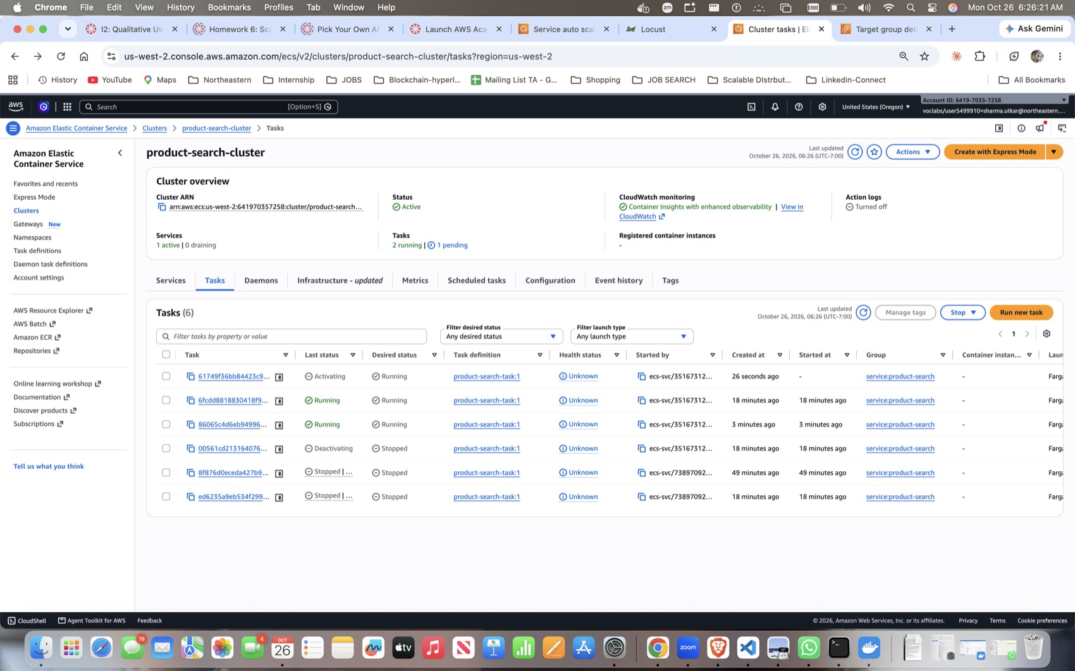
Fig 6. Resilience: the stopped task is deactivating while ECS starts a replacement.
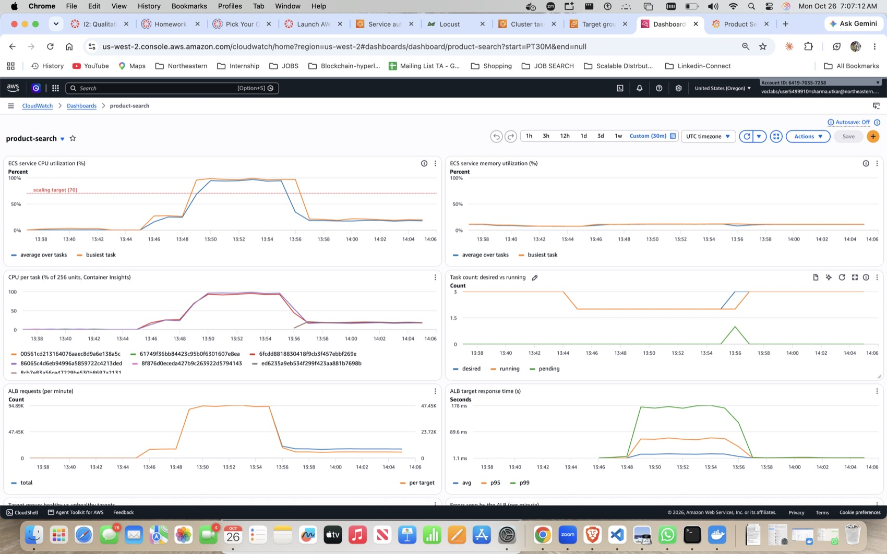
Fig 7. Spike test: CPU near 100% for the whole spike; the third task only arrives as the spike ends.
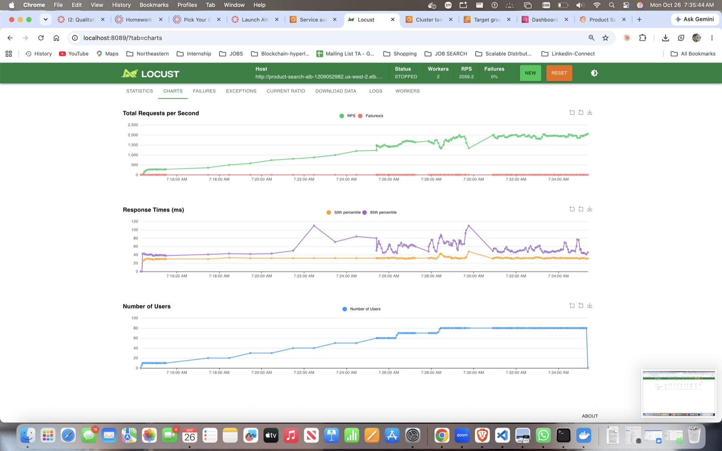
Fig 8. Ramp test with a 50% target: throughput grows to ~2,000 req/s; small bump when 3 of 4 tasks were stopped at 07:29, 0 failures.
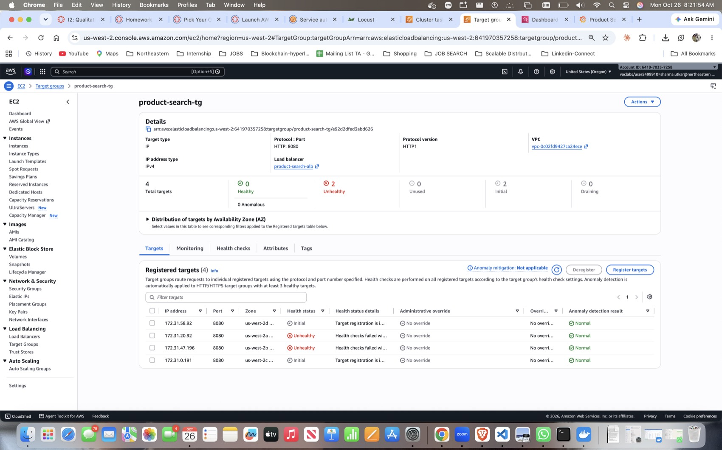
Fig 9. Broken health check: the old targets are unhealthy and the replacements are still in "initial".
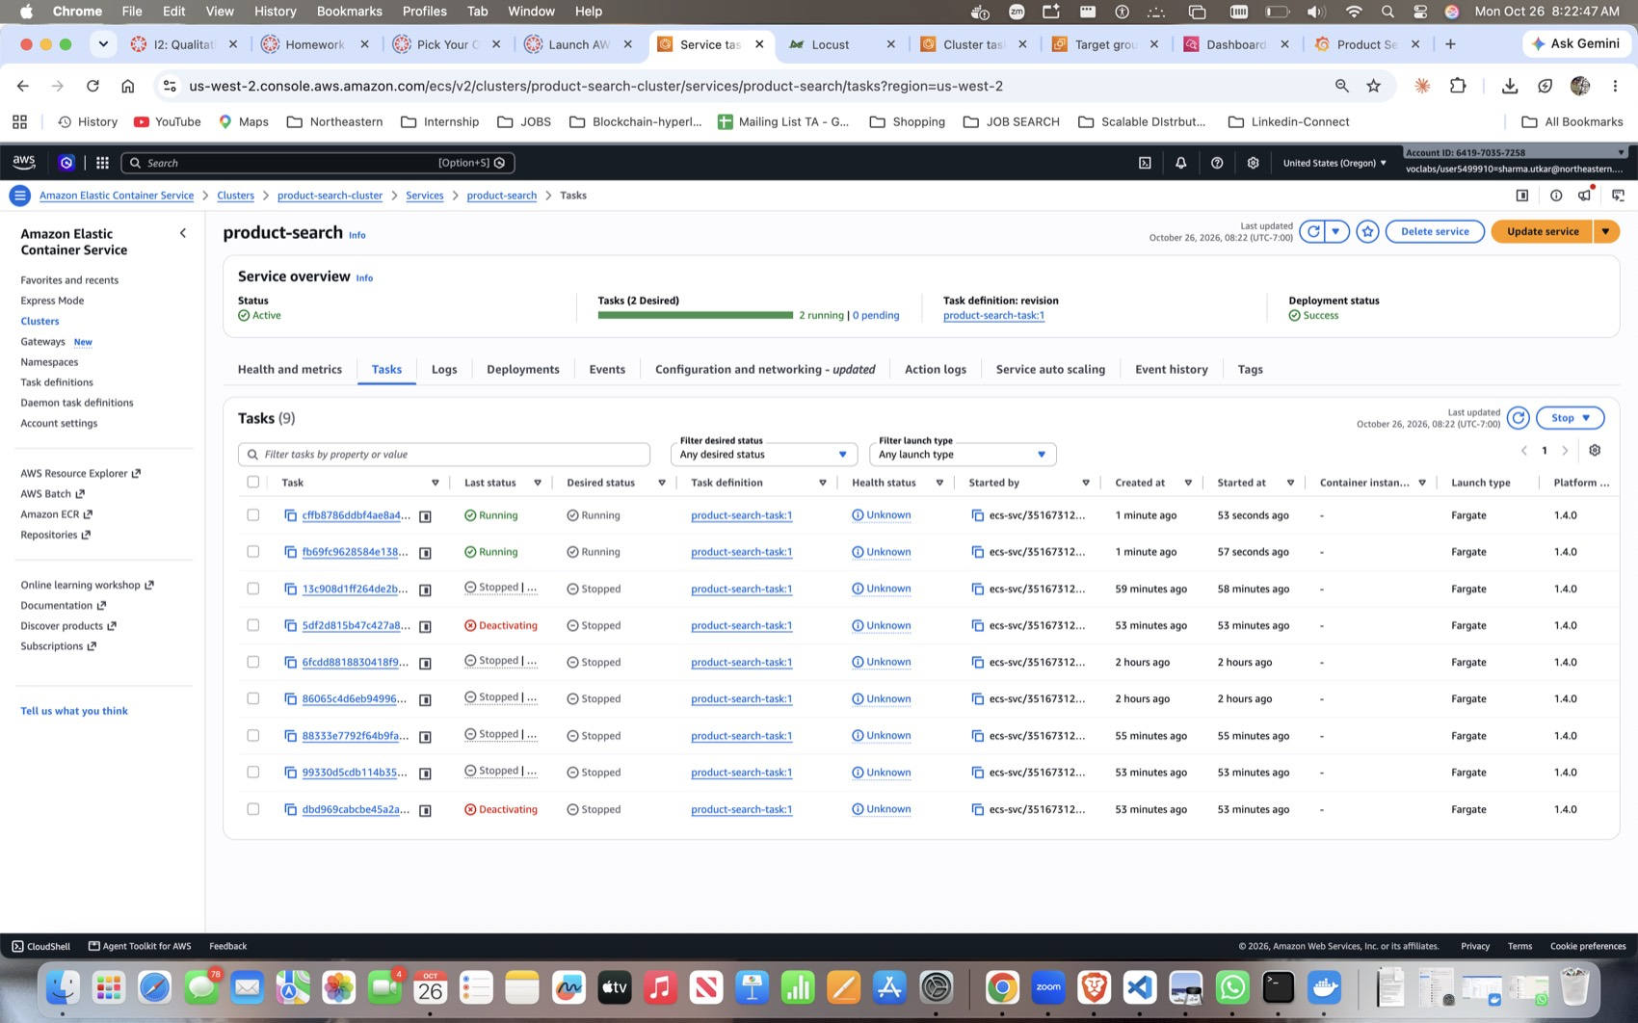
Fig 10. ECS replacing tasks again and again because of the failed health checks.
All 61 screenshots and the scaling log CSV are in the repo under hw06/screenshots/ and hw06/results/.

