CERBERUS
Today AI Passport controls what an AI may know about you.
Cerberus controls what an AI may do for you.
Human-owned delegation context for autonomous agents acting on production systems.
AI Passport Ideathon · Egoist Machines
Team: Cerberus Track: Agents Lane: Build (working prototype + architecture)

1. The idea in one screen
Maya is on call for a GPU cluster. In her AI Passport she owns an Operational Delegation context category, such as approved action classes, maintenance windows, maximum lease length, and when to escalate. Her Cerberus app receives a scoped Context Pass to that category. When the agent proposes draining rack 4, Portcullis combines Maya's current delegation context with current enterprise entitlement, agent-delegation policy, and live safety state. No valid Context Pass or no valid intersection means no production change. AI Passport records which context Cerberus read, Portcullis records the authorization decision, and Maya can revoke context access at any time.
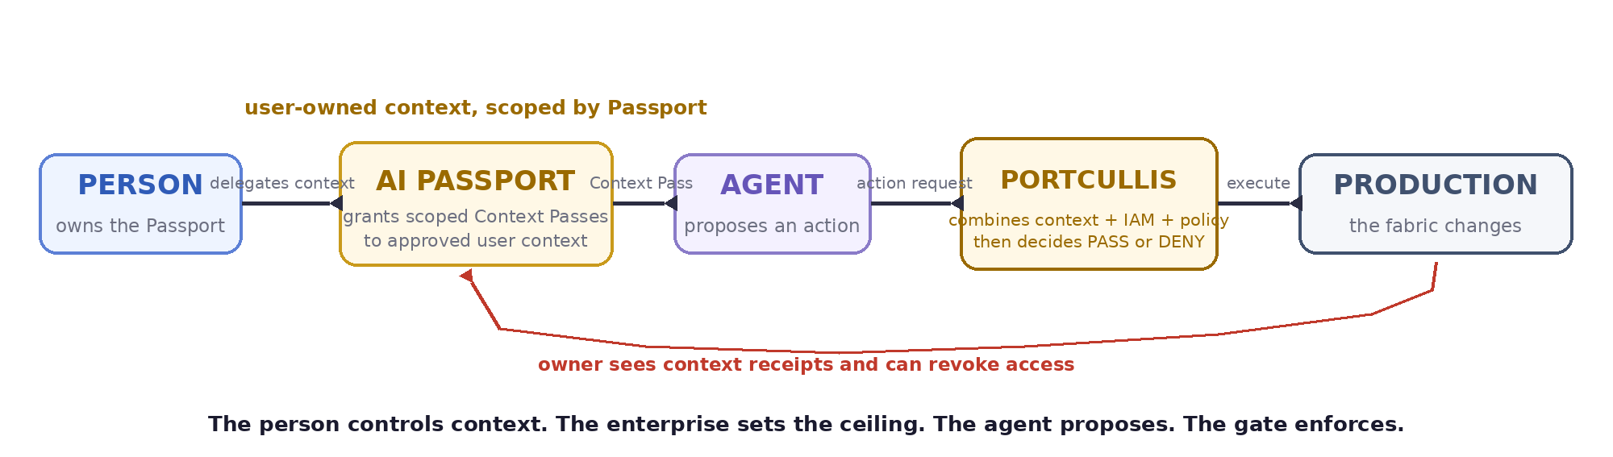
Figure 1. The person controls context. The enterprise sets the ceiling. The agent proposes. The gate enforces.

2. The problem
Agents are moving from advising humans to acting on infrastructure: provisioning fabrics, draining racks, and pushing switch configuration. The pull to automate this is real. But platform authorization alone does not express the user-controlled context that should govern how an agent acts, and today there are only two blunt options.
- Standing platform credentials give too much. The platform hands the agent broad, always-on access. One confident wrong inference and the blast radius is an entire leaf-spine fabric. Ungated agents do not remove that risk. They automate it.
- Human-in-every-loop gives too little. Approve every action by hand and the blast radius shrinks, but so does the reason to deploy the agent. You have rebuilt the specialist bottleneck and added latency.
Both answer what the platform will let the agent do. The missing layer is the person-owned context that says how the agent should act on their behalf, inside whatever authority the enterprise currently permits.

3. Who is affected
- Primary. The human operator who owns the Passport: network and platform engineers on SONiC-based leaf-spine fabrics at GPU-cloud providers, hyperscalers, and large enterprises. They carry the risk today and are paged when a bad change ripples across the spine.
- Secondary. Anyone delegating irreversible actions to an agent on production systems: deployment, database, and financial operations. Infrastructure is the sharpest instance of the same pattern.
- Tertiary. Orchestration and IAM vendors that can consume a standard user-owned context layer instead of inventing another per-agent preference and profile store.

4. The core insight
The platform defines the maximum authority a person holds. AI Passport lets the person own the operational context that governs how an agent may act for them. Portcullis turns that context into an execution decision without treating AI Passport as enterprise IAM.
Effective execution authority is an intersection, not a declaration:
effective execution authority = request ∩ delegation context ∩ current entitlement ∩ agent-policy
Maya cannot create enterprise authority by writing something into her Passport. If her Operational Delegation context permits rack maintenance and her current IAM entitlement covers racks 1 to 8, Portcullis can consider a request to drain rack 4. If her context allows an action that IAM or enterprise agent policy forbids, the intersection is empty and the gate denies. The enterprise keeps security sovereignty; the person keeps delegation sovereignty.
A privilege Maya may exercise by hand is not automatically one she may delegate to a machine. The enterprise separately marks which privileges are delegatable to autonomous agents, so spine.configure can remain human-only while rack.drain is agent-delegatable.

The trust bridge: context access is not execution authority
A valid AI Passport Context Pass is not production authority. Portcullis treats it only as proof that Maya chose to share a specific context category with Cerberus. At execution it validates the Passport issuer and current Pass status, binds the Passport owner to an enterprise identity, reads the current delegation context, and intersects the request with current enterprise entitlement and current agent-delegation policy. A Context Pass can never create enterprise rights, and cached context is never treated as a permanent grant.

Cerberus complements IAM, it does not replace it
Cerberus deliberately invents no new token cryptography. OAuth, SPIFFE, and OPA can remain the enterprise enforcement substrate. AI Passport adds a different primitive: user-owned memory and context with scoped access, revocation, an approval inbox, and receipts. Cerberus requests access only to Maya's Operational Delegation context, and Portcullis uses that context as one input to enterprise authorization. The novelty is not the wire format. It is making user-owned context actionable without turning that context into enterprise authority.

Consent is at the context and access boundary, not every action
Maya approves what enters her Operational Delegation context and which app may read that category. Suggested changes can land in the AI Passport inbox for approval before they become memory. Each context read produces an AI Passport receipt. Each production attempt produces a separate Portcullis authorization receipt. Maya stays in control without approving every action by hand.
Today AI Passport decides what an app may know about you. Cerberus shows how that user-owned context can govern what an agent may do for you.

5. Why infrastructure agents are the right proving ground
The contest asks where AI Passport is used best, against Creative, Identity, and Work. Infrastructure wins the argument on three grounds.
- Irreversibility. A bad recommendation is annoying; a bad autonomous infrastructure action is an outage. Delegation here has immediate, measurable value.
- Clean scope. Infrastructure authority maps naturally to actions × resources × time, which makes scoped delegation testable rather than philosophical.
- Transferability. If the primitive holds for production infrastructure, the same pattern extends to deployment, database, and financial agents. Infrastructure is the proving ground, not the ceiling of the idea.

6. Architecture
The detailed model separates context access from execution authorization. AI Passport owns the user-controlled context and grants Cerberus scoped access to it. Portcullis is the only path to production and derives execution authority from that context plus current enterprise identity, policy, and safety state.
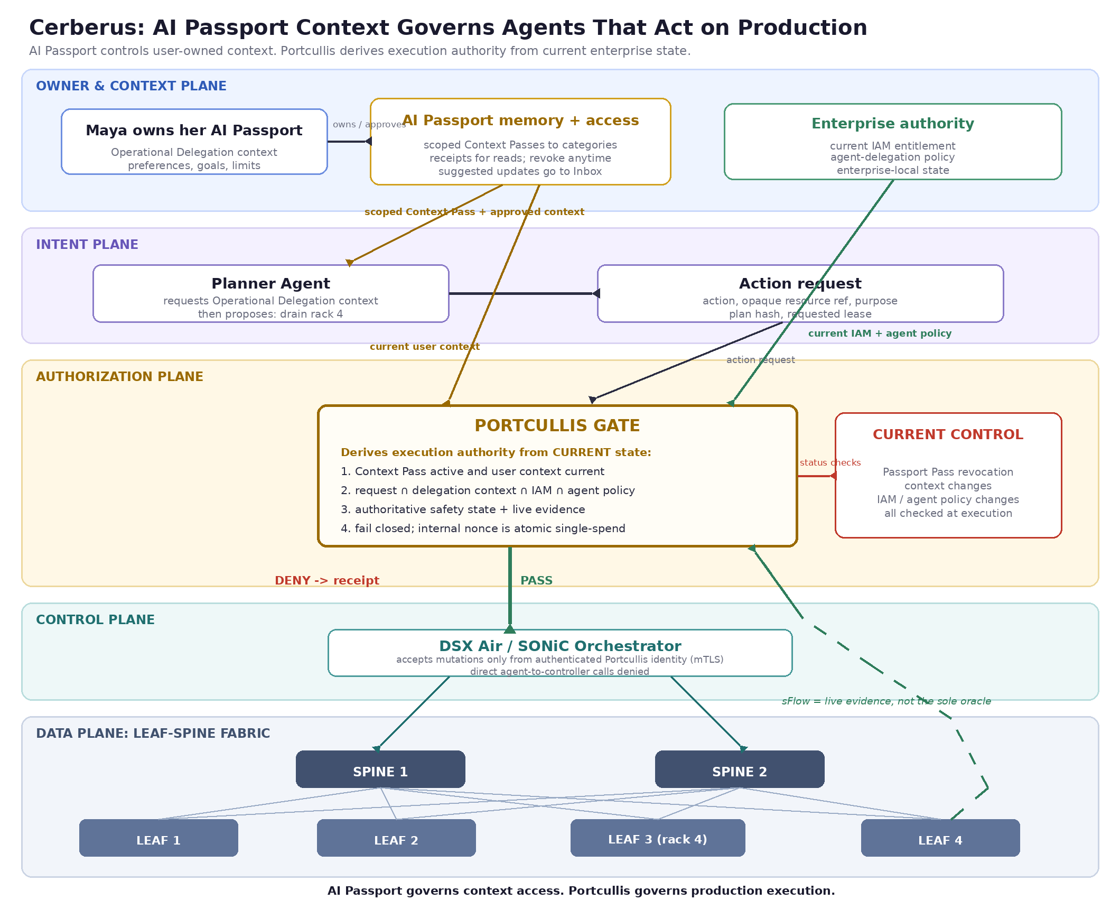
Figure 2. AI Passport governs scoped access to user context. Portcullis derives effective execution authority from request, current delegation context, current entitlement, and enterprise agent policy.

The chokepoint is enforced, not just declared
The orchestrator accepts mutation requests only from the authenticated Portcullis workload identity, over mTLS and service policy. Direct agent-to-controller execution is denied at the network and service layer. That is what actually makes the gate the single chokepoint, rather than a diagram convention.

Fail-closed, current-state, single-spend
Portcullis has three execution guarantees: current-state authorization, atomic single-spend, and fail-closed verification. It checks current Context Pass status, current delegation context, current entitlement, current agent-delegation policy, and authoritative safety state at execution. Before a permitted mutation, it atomically consumes an internal execution nonce so concurrent gateway replicas cannot double-spend the same authorization. If any required input cannot be verified, the action is denied.

Telemetry is evidence, not oracle
The sFlow MCP server provides live evidence. The gate combines it with authoritative operational state from the controller or scheduler before making a safety decision.

7. From context to execution
- Set the context. Maya stores Operational Delegation preferences in AI Passport, such as approved action classes, lease limits, maintenance windows, and escalation rules. New suggested memories require her approval before they are saved.
- Request context. The Cerberus app requests a scoped AI Passport Context Pass to the Operational Delegation category, not a production capability.
- Grant access. AI Passport grants revocable access only to the approved context category and records what Cerberus reads and when. The Pass carries no enterprise entitlement or production resource identifiers.
- Derive authority. The agent proposes an action. Portcullis validates the current Context Pass, reads the current delegation context, and intersects the request with current IAM entitlement and enterprise agent-delegation policy. It also checks authoritative safety state plus live evidence and fails closed if any input is unavailable.
- Execute or deny. If the intersection and safety checks pass, Portcullis atomically consumes an internal single-use execution nonce and calls the orchestrator under its authenticated workload identity. A DENY never touches the controller.
- Receipts. AI Passport records the context access receipt. Portcullis records the authorization decision. The two can be linked with an opaque correlation id without exporting enterprise audit detail.
- Revoke or update. Maya can revoke Cerberus's Context Pass or change her delegation context at any time. The enterprise can change entitlement or agent policy independently. The next execution sees current state. Nothing claims to reverse an action that already completed.

8. Submission field answers
Context, permission, proof, access. Context is Maya's user-owned Operational Delegation memory: action preferences, limits, windows, and escalation rules. AI Passport access is a scoped Context Pass to that category. Production permission is not stored in the Passport; Portcullis derives it from the current intersection of request, user context, IAM entitlement, enterprise agent policy, and safety state. Proof includes Passport Pass validity and read receipts, owner-to-IAM binding, current enterprise checks, and the Portcullis authorization receipt.
Who controls access. The person controls what context exists in AI Passport, what Cerberus may read, and can revoke that access at any time. The enterprise controls the maximum authority through IAM and separately decides what may be delegated to agents. Portcullis enforces both boundaries.
What can be revoked or changed. Maya can revoke the Cerberus Context Pass, remove or change delegation context, or reject suggested updates in the AI Passport inbox. The enterprise can change IAM entitlement and agent policy. Portcullis checks current state at execution, so revoked context access or reduced enterprise rights blocks the next action. Completed actions are not claimed to be reversible.
Risks and misuse concerns.
- Authority confusion. An AI Passport Context Pass is never treated as a production capability. User context cannot mint enterprise rights; Portcullis derives execution authority only from the current intersection with enterprise IAM and agent policy.
- Context Pass theft and execution replay. Context Passes are scoped to the Cerberus app and approved categories, with short validity and server-side revocation. Portcullis checks current Pass status before using context. Execution replay is a separate problem, prevented by atomically consuming an internal single-use nonce before mutation.
- Gate bypass. The orchestrator accepts mutations only from the authenticated Portcullis identity over mTLS; direct agent-to-controller calls are denied by service policy.
- Fail-closed. If Passport Pass status, current delegation context, current entitlement, enterprise agent policy, revocation, or authoritative safety state cannot be verified, Portcullis denies. There is no fail-open path.
- Trusting telemetry as truth. Live flow data is evidence, combined with authoritative controller and scheduler state before a safety decision.
- Privacy and the enterprise boundary. AI Passport holds user-controlled operational preferences, not raw telemetry, corporate identity, topology, or production resource identifiers. Enterprise targets and permissions are resolved inside Portcullis. AI Passport receipts show which context category Cerberus read and when, while the execution receipt keeps sensitive decision detail enterprise-side behind opaque ids and cryptographic digests.

9. How this maps to the judging criteria
- User Control. The person owns the Operational Delegation context, approves new memory before it is saved, grants or revokes Cerberus access to the category, and sees receipts for context reads. The enterprise still sets the security ceiling, so user control does not become self-issued authority.
- Privacy and Risk. The AI Passport Pass exposes only the approved context category. Corporate identity, topology, telemetry, and enterprise entitlements stay enterprise-side. Portcullis evaluates current state, fails closed, and uses an atomic single-use execution nonce before mutation.
- Clear AI Passport Use. AI Passport remains exactly what Egoist is building: a user-owned memory and context layer with scoped Passes, revocation, inbox approval, and receipts. Cerberus adds an Agents use case by making that user-owned context one governed input to production authorization, not a replacement for IAM.

10. What a first deployment moves
- Blast radius: bounded by the intersection of user context, current entitlement, enterprise agent policy, and the requested action.
- Revocation: user-held; revoking Cerberus's Context Pass or changing delegation context is reflected on the next execution check.
- Data in AI Passport: minimal; user-controlled operational preferences only, with no raw telemetry, topology, or enterprise entitlement data.
- Accountability: linked receipts; AI Passport records what context Cerberus read, and Portcullis records what production decision it made.

11. V1: what we build Monday morning
Deliberately small, so it is a product waiting to be built rather than an architecture waiting to be admired:
- One network operator and one maintenance agent.
- One Operational Delegation context category in AI Passport and one scoped Context Pass for Cerberus.
- One operation: rack.drain, on one rack.
- One Portcullis endpoint: validate current Context Pass, read current delegation context, check IAM and agent policy, evaluate safety state, atomically consume the execution nonce, and fail closed.
- One authoritative-state check (mocked or real) plus sFlow evidence.
- One AI Passport context-access receipt and one Portcullis authorization receipt stream.
The demo is 90 seconds: Maya approves Operational Delegation context, Cerberus receives a scoped Context Pass, and the agent proposes draining rack 4 while the rack is unsafe. Portcullis DENYs with a receipt. Conditions change and the next proposal PASSes under current IAM, policy, context, and state. Maya then revokes Cerberus's Context Pass, and the next run DENYs because the app can no longer access the governing context. A working logical-path prototype of this flow accompanies the submission.

12. Feasibility
A working logical-path prototype accompanies this submission: a mock AI Passport context store and Context Pass, a mock IAM and agent-policy source, Portcullis current-state checks, mock authoritative safety state, linked receipts, and revoke. The telemetry dependency is real: a working sFlow MCP server exposes fabric flow data to an agent as a callable tool. The architecture also builds on SONiC orchestration patterns, so intent-to-validated-config is grounded rather than hypothetical. Cerberus uses AI Passport for what it is designed to do, user-owned context with controlled access, and turns that context into a governed input to autonomous action.

Appendix A. AI Passport Context Pass schema (illustrative)
Valid JSON. This Pass grants Cerberus access to a user-owned context category. It carries no enterprise permission, topology, or production target.
{
"pass_id": "ctxpass_7f3a9c",
"issuer": "passport-authority:egoist",
"owner_ref": "passport_user_72af",
"app": "cerberus",
"categories": ["operational_delegation"],
"purpose": "govern autonomous infrastructure actions",
"audience": "cerberus",
"issued_at": "2026-08-12T15:40:00Z",
"expires_at": "2026-08-12T16:10:00Z",
"revocation_check": "live",
"receipt_on_read": true
}

Appendix B. Worked example
Operational Delegation context, approved by Maya: rack maintenance is an allowed action class during approved maintenance windows, maximum lease is 30 minutes, and anything outside policy should escalate to her. This context contains no rack identifier or enterprise entitlement.
- Cerberus requests a scoped AI Passport Context Pass to Maya's Operational Delegation category. AI Passport grants access and records a receipt when Cerberus reads it.
- The agent proposes draining rack 4. Portcullis validates that the Context Pass is still active, reads Maya's current delegation context, binds her to the enterprise identity, and checks current IAM entitlement plus enterprise agent-delegation policy. Rack 4 is within her entitlement and rack.drain is agent-delegatable.
- Portcullis then checks authoritative state from the scheduler and live evidence from sFlow. The scheduler is not yet safe and sFlow shows active traffic, so the safety condition fails.
- DENY. Nothing reaches a switch. AI Passport has already recorded the context read, and Portcullis returns a separate authorization receipt explaining why the action was denied.
- Ten minutes later the scheduler reports safe and flows reach zero. The agent proposes the action again. Portcullis re-reads current context, re-checks IAM and policy, atomically consumes an internal execution nonce, and PASSes the request to the orchestrator. Maya then revokes Cerberus's Context Pass. The next proposal fails closed because the governing context can no longer be accessed.
The person controls context. The enterprise sets the ceiling. The agent proposes. The gate enforces.

