CERBERUS
Today AI Passport controls what an AI may know about you.
Cerberus controls what an AI may do for you.
Human-owned delegation for autonomous agents acting on production systems.
AI Passport Ideathon · Egoist Machines
Team: Cerberus Track: Agents Lane: Build (working prototype + architecture)

1. The idea in one screen
Maya is on call for a GPU cluster. Tonight she authorizes her maintenance agent to drain racks during the maintenance window, for at most 30 minutes per operation, and only within the racks her platform rights already cover. Later the agent proposes draining rack 4. Her AI Passport delegates exactly that one operation; the Portcullis gate verifies the Pass, its issuer, and the live state. No valid delegation, no production change. She sees a receipt for every authorization decision and can revoke in one click.
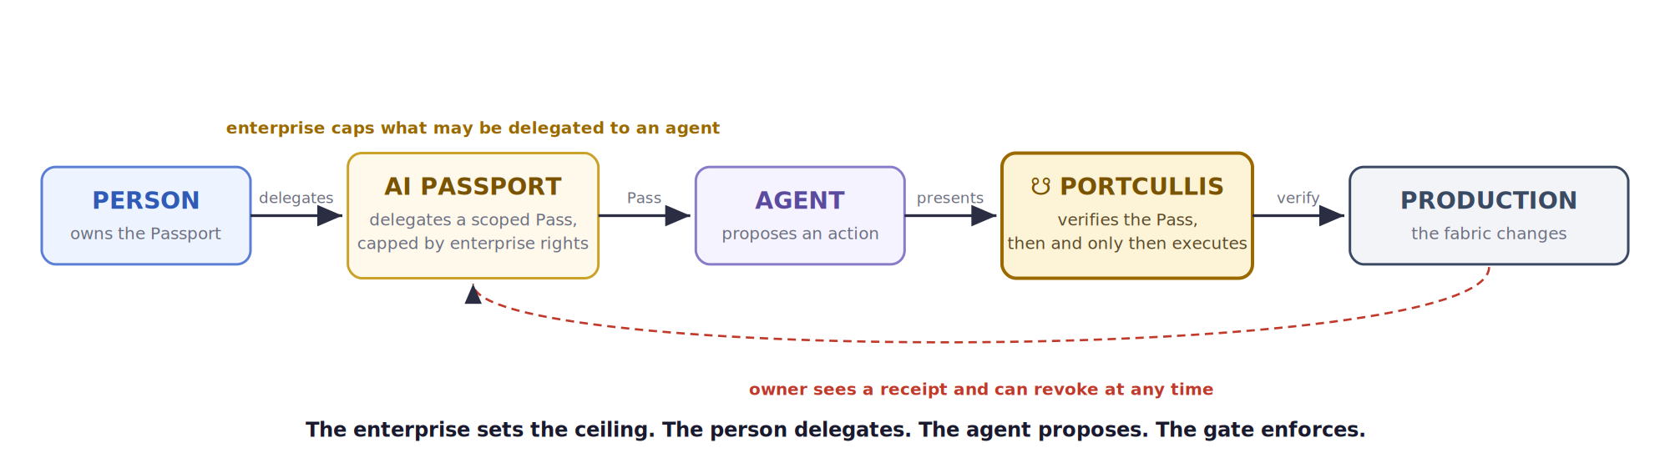
Figure 1. The enterprise sets the ceiling. The person delegates within it. The agent proposes. The gate enforces.

2. The problem
Agents are moving from advising humans to acting on infrastructure: provisioning fabrics, draining racks, pushing switch configuration. The pull to automate this is real. But agents have arrived with platform authorization and no user-controlled delegation layer, and today there are only two options, both of which fail.
- Standing platform credentials give too much. The platform hands the agent broad, always-on access. One confident wrong inference and the blast radius is an entire leaf-spine fabric. Ungated agents do not remove that risk. They automate it.
- Human-in-every-loop gives too little. Approve every action by hand and the blast radius shrinks, but so does the reason to deploy the agent. You have rebuilt the specialist bottleneck and added latency.
Both answer what the platform will let the agent do. The missing question is what the person has chosen to delegate, out of what they are themselves permitted to do.

3. Who is affected
- Primary. The human operator who owns the Passport: network and platform engineers on SONiC-based leaf-spine fabrics at GPU-cloud providers, hyperscalers, and large enterprises. They carry the risk today and are paged when a bad change ripples across the spine.
- Secondary. Anyone delegating irreversible actions to an agent on production systems: deployment, database, and financial operations. Infrastructure is the sharpest instance of the same pattern.
- Tertiary. Orchestration and IAM vendors that would rather verify one user-owned delegation layer on top of existing entitlements than manage a sprawl of per-agent credentials.

4. The core insight
The platform defines the maximum authority a person holds. AI Passport lets the person decide how much of that authority to lend an agent.
Effective agent authority is an intersection, not a declaration:
effective Pass = request ∩ delegation ∩ entitlement ∩ agent-policy
Maya cannot grant her agent rights she does not have herself, no matter what she writes in her Passport. If she delegates “drain rack 4” and her IAM entitlement covers racks 1 to 8, the effective Pass is “drain rack 4.” If she delegates “reconfigure every spine” and her entitlement does not cover it, the intersection is empty and the gate denies. The enterprise keeps security sovereignty; the person keeps delegation sovereignty.
A privilege Maya may exercise by hand is not automatically one she may delegate to a machine. The enterprise separately marks which privileges are delegatable to autonomous agents at all, so spine.configure can be human-only while rack.drain is agent-delegatable. The canonical rule, used throughout, is effective authority = request ∩ delegation ∩ current entitlement ∩ agent-delegation policy.

Why the gate trusts a Pass: the trust bridge
A valid signature is not enough. For the Portcullis to trust a Pass it must (1) recognize the issuing Passport authority, (2) bind the Passport’s owner to a real enterprise identity, and (3) confirm the requested scope survives intersection with that identity’s entitlements. A perfectly signed Pass for “delete production” from an unrecognized issuer, or from an owner without the entitlement, fails at the bridge. The cryptography does not begin halfway through the problem. Each of these is evaluated against current state at execution, not the values asserted when the Pass was minted: current entitlement, current agent-delegation policy, and current envelope and revocation. A signed Pass is never a stale snapshot of authority. The Passport carries only Maya’s delegation; the gate derives the effective authority by intersecting it with current entitlement and agent-delegation policy, because those enterprise facts live inside the boundary and are resolved gateway-side.

Cerberus complements IAM, it does not replace it
Cerberus proposes no new token cryptography. OAuth, SPIFFE, and OPA remain the enforcement substrate and can carry the Pass and enforce the ceiling. What AI Passport adds is a governance layer existing IAM does not naturally express: of everything I am authorized to do, what am I choosing to let this agent do for me, with what context, revocation, and receipts. Could OAuth implement the token underneath? Potentially yes. The novel primitive is user-owned, portable delegation layered over enterprise entitlements, not the wire format. Cerberus stands on top of IAM.

Consent is at the envelope, not every action
Consent happens once, when the person creates or modifies the delegation envelope. Every action after that produces an authorization decision and a receipt, not a fresh human approval. That is what keeps the person in control without putting them back in the loop.
Today AI Passport decides what an app may know about you. Cerberus adds what an agent may do for you.

5. Why infrastructure agents are the right proving ground
The contest asks where AI Passport is used best, against Creative, Identity, and Work. Infrastructure wins the argument on three grounds.
- Irreversibility. A bad recommendation is annoying; a bad autonomous infrastructure action is an outage. Delegation here has immediate, measurable value.
- Clean scope. Infrastructure authority maps naturally to actions × resources × time, which makes scoped delegation testable rather than philosophical.
- Transferability. If the primitive holds for production infrastructure, the same pattern extends to deployment, database, and financial agents. Infrastructure is the proving ground, not the ceiling of the idea.

6. Architecture
The detailed model adds the ceiling and the trust bridge to the delegation flow. The owner delegates from the top, capped by enterprise entitlement. Intent flows down. Every irreversible action passes through the Portcullis, which is the only path to the execution layer.
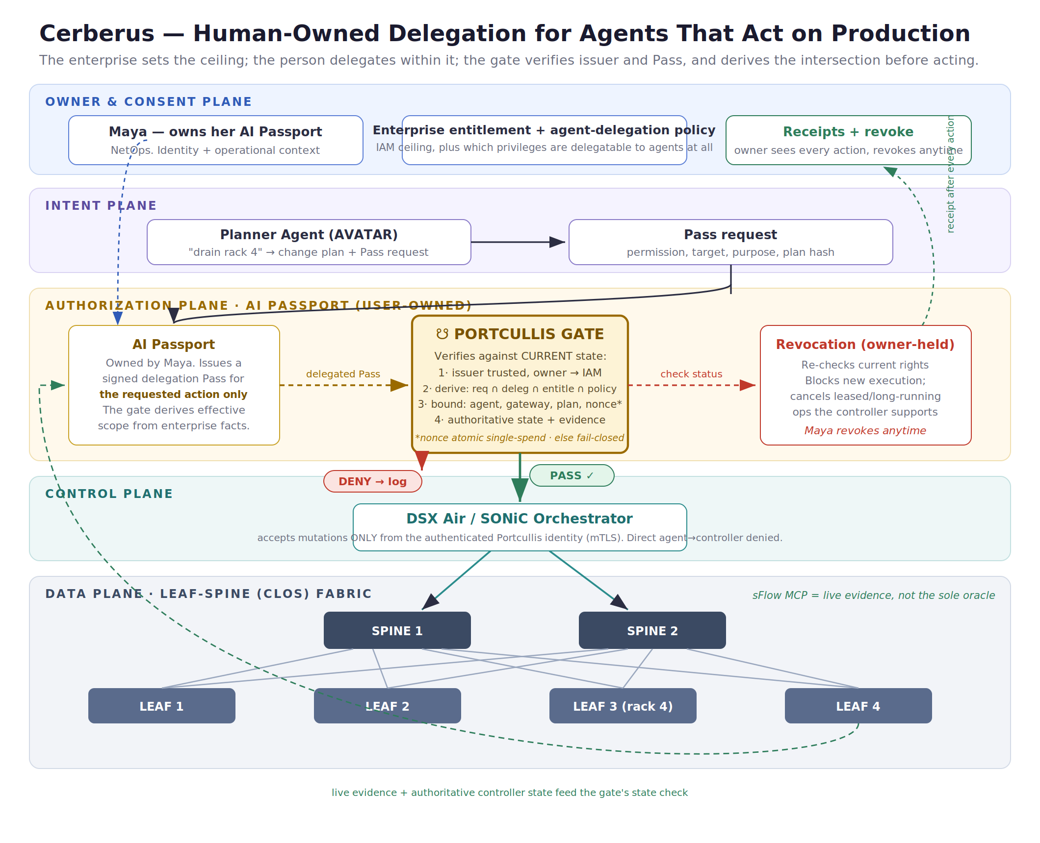
Figure 2. The Passport carries the person’s delegation. The gate derives effective authority = request ∩ delegation ∩ current entitlement ∩ agent-policy, and the orchestrator accepts mutations only from the authenticated Portcullis identity.

The chokepoint is enforced, not just declared
The orchestrator accepts mutation requests only from the authenticated Portcullis workload identity, over mTLS and service policy. Direct agent-to-controller execution is denied at the network and service layer. That is what actually makes the gate the single chokepoint, rather than a diagram convention.

Fail-closed, current-state, single-spend
Portcullis has three execution guarantees: current-state authorization, atomic single-spend, and fail-closed verification. It evaluates current entitlement, current agent-delegation policy, and current envelope and revocation at execution, so authority that changed since minting is caught. The nonce is atomically checked and consumed before execution, preventing concurrent double-spend across gateway replicas. And if issuer trust, current entitlement, revocation state, enterprise policy, or authoritative safety state cannot be verified, the action is denied.

Telemetry is evidence, not oracle
The sFlow MCP server provides live evidence. The gate combines it with authoritative operational state from the controller or scheduler before making a safety decision.

7. The Pass lifecycle
- Set the envelope. The owner consents once to a standing, scoped, revocable delegation envelope (permitted actions, targets, windows, lease length), never exceeding their own entitlements.
- Request. The agent proposes a change plan and requests a Pass for one action.
- Issue. The AI Passport mints a signed delegation Pass for the requested action, carrying Maya’s delegation only, bound to this agent, gateway, plan hash, nonce, and expiry. It embeds no enterprise entitlement or policy.
- Verify. The Portcullis derives the effective authority at execution by intersecting the request and delegation with current entitlement and current agent-delegation policy, then checks issuer trust and owner identity, the binding, authoritative state plus evidence, and that the nonce is fresh and unrevoked. It fails closed if any input cannot be verified.
- Execute or deny. PASS routes to the orchestrator. A DENY ends that attempt; the nonce is spent.
- Receipt. Every authorization decision, PASS or DENY, returns a receipt to the owner, holding signed decision metadata and hashes.
- Re-request or revoke. If state later changes, the agent requests a fresh Pass with a new nonce. At any time the owner can revoke or tighten the envelope; new execution is blocked and leases cancel where the orchestrator supports it.

8. Submission field answers
Context, permission, proof, access. Context is the delegated operational context the owner chose to share, plus target, action, and window. Permission is what the gate derives at execution: request intersected with delegation, current entitlement, and agent-delegation policy. Proof is issuer trust, owner-to-IAM binding, and binding of the Pass to a specific agent, gateway, plan hash, nonce, and expiry. Access gates the execution path, not data reads.
Who controls access. The enterprise sets the ceiling through IAM and separately marks which privileges are delegatable to agents at all. Within that, the person owns the Passport and the delegation envelope, and can revoke or narrow at any time. The agent can never self-escalate or exceed the ceiling.
What can be revoked or changed. The owner can revoke a Pass or tighten the envelope instantly. Checked at execution and never cached, revocation blocks new execution and cancels leased operations where the orchestrator supports it. It does not claim to reverse an action that already completed.
Risks and misuse concerns.
- Authority forgery. A user cannot mint authority by writing it into their Passport; the gate intersects every Pass with enterprise entitlement, so out-of-ceiling scope is denied.
- Pass theft, repurposing, replay. Binding to one agent, gateway, and plan hash prevents repurposing a stolen Pass into another action. Replay is prevented separately: the nonce is atomically checked and consumed before execution, so the same Pass cannot be spent twice, even across concurrent gateway replicas.
- Gate bypass. The orchestrator accepts mutations only from the authenticated Portcullis identity over mTLS; direct agent-to-controller calls are denied by service policy.
- Fail-closed. If issuer trust, current entitlement, enterprise policy, revocation, or authoritative safety state cannot be verified, the gate denies. There is no fail-open path.
- Trusting telemetry as truth. Live flow data is evidence, combined with authoritative controller and scheduler state before a safety decision.
- Privacy and the enterprise boundary. Sensitive identity, entitlements, resource identifiers, and raw telemetry stay enterprise-side. The Pass carries a minimal delegation claim with opaque references, an enterprise subject id, a resource reference, and an entitlement attestation hash, which the gateway resolves and intersects with current entitlement and policy. The user-owned receipt holds an opaque receipt id, the decision, and a cryptographic digest, so sensitive audit detail stays enterprise-side while the owner still gets proof.

9. How this maps to the judging criteria
- User Control. The person owns the Passport and sets the envelope inside their entitlements, revokes anytime, and receives a receipt for every authorization decision. The agent acts inside a boundary the person defined, capped by the ceiling and agent-delegation policy the enterprise defined.
- Privacy and Risk. The Pass carries a minimal claim with opaque references, so corporate identity, resource identifiers, and topology stay enterprise-side. Live state is evaluated then discarded; only signed decision hashes are kept. Blast radius is bounded by the intersection, the nonce is single-spend, and the gate fails closed.
- Clear AI Passport Use. Not a replacement for IAM. The delegation is user-owned and portable, while the enterprise’s authority stays enterprise-side; it carries user context and produces consent and receipts. Cerberus extends AI Passport from “what an AI may know about me” to “what an AI may do for me.”

10. What a first deployment moves
- Blast radius: bounded by the intersection of delegation and entitlement.
- Revocation: owner-held, near-immediate; leases cancel on revoke.
- Data in the Pass: minimal; no raw telemetry retained, only signed metadata and hashes.
- Accountability: receipted; every authorization decision returns a receipt to the owner.

11. V1: what we build Monday morning
Deliberately small, so it is a product waiting to be built rather than an architecture waiting to be admired:
- One network operator and one maintenance agent.
- One delegation envelope, capped by one IAM entitlement set.
- One operation: rack.drain, on one rack.
- One Portcullis endpoint: issuer trust, intersection check, atomic single-spend nonce, fail-closed.
- One authoritative-state check (mocked or real) plus sFlow evidence.
- One revoke button and one receipt stream.
The demo is 90 seconds: run the agent while the rack is unsafe (DENY, with a receipt explaining why), let conditions change, watch the agent request a fresh Pass and PASS, then press revoke and watch the next run DENY. A working logical-path prototype of exactly this ships with this submission.

12. Feasibility
A working logical-path prototype accompanies this submission: envelope, Pass issuance, the intersection and trust checks, Portcullis verification, mock authoritative state, receipts, and revoke. The telemetry dependency is real: a working sFlow MCP server exposes fabric flow data to an agent as a callable tool. The architecture builds on patterns already validated with SONiC orchestration and MCP-based telemetry, so intent-to-validated-config is grounded rather than hypothetical. Cerberus is the user-owned delegation layer that work has been missing, expressed in Egoist’s Passport primitive.

Appendix A. Delegated Pass schema (illustrative)
Valid JSON. The Pass carries only Maya’s delegation with opaque references (enterprise_subject, resource_ref, entitlement_ref, enterprise_policy_ref); Portcullis resolves them and derives the effective scope at execution, so identity, entitlements, resource identifiers, and telemetry stay enterprise-side.
{
"pass_id": "pass_7f3a9c",
"issuer": "passport-authority:egoist",
"enterprise_subject": "ent_sub_72af",
"delegate": "cerberus-agent-12",
"requested_scope": { "action": "rack.drain", "resource_ref": "resource_83af" },
"delegated_scope": { "action": "rack.drain", "window": "maintenance" },
"entitlement_ref": "iam-attestation:9c2f/v14",
"enterprise_policy_ref": "agent-delegation-policy:v6",
"effective_scope_resolution": "derived-by-portcullis-at-execution",
"purpose": "scheduled-maintenance",
"issued_at": "2026-08-12T15:40:00Z",
"expires_at": "2026-08-12T16:10:00Z",
"lease_seconds": 1800,
"audience": "portcullis-gateway",
"change_plan_hash": "8f29a1c4",
"nonce": "b3d9f0a2",
"conditions": [
{ "authoritative": "scheduler.resource_ref.drained_safe",
"evidence": "sflow.resource_ref.active_flows_zero" }
],
"evaluation": "current-state-at-execution",
"nonce_semantics": "atomic-check-and-spend",
"on_failure": "deny",
"revocation": { "holder": "owner", "check": "at-execution", "leases": "cancelable" },
"receipt": { "id": "opaque", "to": "owner",
"keeps": ["decision","policy_hash","plan_hash","state_assertion","evidence_digest","ts"] }
}

Appendix B. Worked example
Envelope (consented once by Maya): her agent may drain racks during her maintenance window, in leases up to 30 minutes, within her entitlement of racks 1 to 8.
- The agent proposes a plan and requests a Pass: action=drain, target=rack:4.
- Maya’s AI Passport mints delegation Pass A for the request, carrying her delegation only, bound to the agent, gateway, plan hash, a fresh nonce, and a 30-minute expiry.
- The Portcullis derives effective authority at execution: it intersects the request and delegation with Maya’s current entitlement (racks 1-8) and agent-delegation policy (rack.drain is agent-delegatable; spine ops are not). Rack 4 clears all three. It then checks issuer trust, owner identity, and binding, and combines authoritative state (scheduler: rack4.drained_safe) with live evidence (sFlow: active_flows). The scheduler is not yet safe and sFlow shows 3 active flows.
- DENY. Nothing reaches a switch. Pass A’s attempt is over and its nonce is spent. Maya sees a receipt explaining why (live traffic), not just “no.”
- Ten minutes later the scheduler reports safe and flows reach zero. The agent submits the plan again; the AI Passport issues delegation Pass B with a new nonce. The Portcullis re-derives the effective authority and authorizes it. PASS. The orchestrator drains rack 4 via the Portcullis identity, and a receipt returns to Maya. She could have revoked at any point, cancelling the lease.
The enterprise sets the ceiling. The person delegates. The agent proposes. The gate enforces.

