CERBERUS
AI Passport as the human-to-agent delegation layer
AI Passport Ideathon · Egoist Machines
Team: Cerberus Track: Agents Lane: Concept (with reference architecture and Pass schema)
In myth, Cerberus guards a gate that only the authorized may pass. Cerberus lets a person, not a platform, decide what an autonomous agent may do on their behalf: a scoped, revocable Pass delegated from the person’s own AI Passport, enforced at a single deterministic gate.

1. Short summary
AI Passport becomes the human-owned delegation layer between people and the autonomous agents that act for them. Today AI Passport governs what an AI may know about you. Cerberus extends it to what an AI may do on your behalf. A network engineer owns her AI Passport. When her agent proposes an irreversible change, the Passport issues a narrow, single-use Pass that states exactly what the agent may do, on which target, for how long, and for what purpose. A deterministic gate verifies that delegation against authoritative live state before anything reaches a switch, every action returns a receipt to the owner, and the owner can revoke at any time. Infrastructure agents are the best first home for this, because it is the domain where getting delegation wrong is measured in outages.

2. The problem
Agents are crossing a line in datacenter operations. They are moving from advising humans to acting on infrastructure: provisioning fabrics, draining racks, pushing switch configuration, reallocating capacity. The pull to automate this work is real. But agents have arrived with their authorization owned by the wrong party.
Today an infrastructure agent has two options, and both fail.
- Standing platform credentials give too much. The platform hands the agent broad, always-on access. One confident wrong inference, a hallucinated interface or a mis-scoped drain, and the blast radius is an entire leaf-spine fabric. Misconfiguration already ranks among the top causes of major outages. Ungated agents do not remove that risk. They automate it.
- Human-in-every-loop gives too little. Gate every action behind manual approval and the blast radius shrinks, but so does the reason to deploy the agent. You have rebuilt the specialist bottleneck and added latency.
Both options answer the wrong question. They ask what the platform will let the agent do. The right question is what the person has chosen to delegate.

3. Who is affected
- Primary. The human operator who owns the Passport: network and platform engineers on SONiC-based leaf-spine fabrics at GPU-cloud providers, hyperscalers, and large enterprises. They carry the risk today and are paged when a bad change ripples across the spine. Cerberus puts the delegation decision in their hands.
- Secondary. Any person delegating irreversible actions to an agent on production systems: databases, deployment pipelines, financial operations. Infrastructure is the sharpest instance of the same pattern, so the primitive travels outward.
- Tertiary. Orchestration and telemetry vendors that would rather verify one user-owned delegation standard than issue and manage per-agent platform credentials.

4. The core insight
Authorization is the missing layer for infrastructure agents, and its rightful owner is the person, not the platform.
A platform-issued workload credential (SPIFFE, a scoped OAuth token, an OPA policy) is option one from the problem above: standing authority the platform grants the agent. AI Passport is categorically different in who holds it and what it carries. It is owned by the person. It carries the user-controlled context and the specific authority the person has chosen to delegate. Every use produces a consent decision and a receipt the person can inspect and revoke. Cerberus does not reinvent IAM for agents. It moves the authority decision to where Egoist already puts it: the person.
Today AI Passport decides what an app may know about you. Cerberus adds what an agent may do for you.

Delegation is standing, not a click on every action
If the person had to approve each action by hand, this would just rebuild the human-in-every-loop bottleneck. It does not. The owner sets one standing, scoped, revocable envelope: “my agent may drain racks during my approved maintenance window, in leases of up to 30 minutes.” Inside that envelope the Passport issues per-action Passes automatically, each one narrow and receipted. Outside it, the agent is denied. The person stays in control without staying in the loop.

5. Architecture: planes, one gate, one owner
Cerberus separates concerns into planes. The owner delegates from the top. Intent flows down. Every irreversible action passes through a single chokepoint, the Portcullis gate, which verifies the delegated Pass before anything reaches a switch.
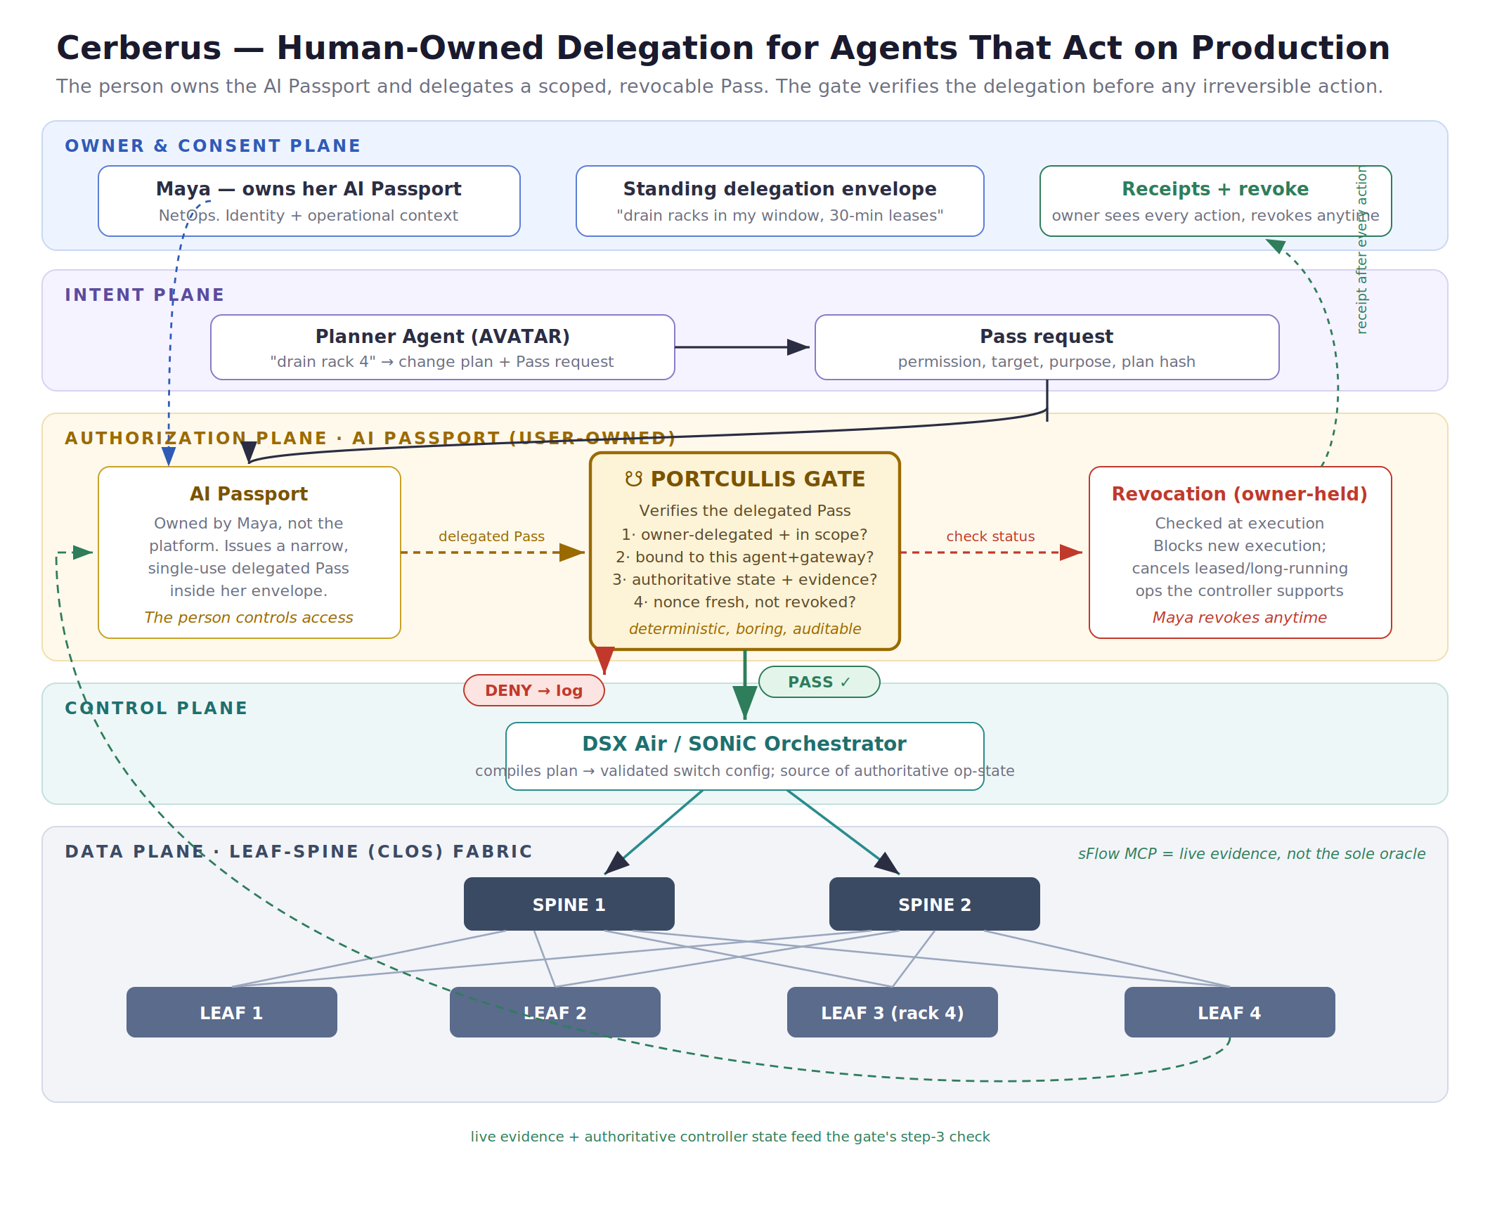
Figure 1. The person owns the AI Passport and sets a delegation envelope. The agent requests a Pass; the Portcullis verifies it against authoritative state; the owner receives a receipt and can revoke.

Owner and Consent Plane
The person owns the AI Passport. They set a standing delegation envelope, they see a receipt for every action, and they hold revocation. This plane is what makes the system user-controlled rather than platform-controlled.

Intent Plane
The Planner Agent turns natural-language intent (“drain rack 4”) into a change plan and a Pass request naming the permission, target, purpose, and a hash of the exact plan. The agent produces a proposal and a request, never a command.

Authorization Plane, where AI Passport lives
- AI Passport (user-owned). Owned by the person. Within the envelope they set, it issues a narrow, single-use delegated Pass. The person controls access; the agent can never widen it.
- The Portcullis Gate. Before any irreversible action the gate runs deterministic checks: is the action owner-delegated and in scope, is the Pass bound to this agent and this gateway and this change-plan hash, does authoritative state plus live evidence satisfy the conditions, is the nonce fresh and the Pass unrevoked. The planning can be probabilistic and clever. The authorization is boring, auditable, and non-negotiable by design.
- Revocation (owner-held). Checked at execution and never cached. Revocation blocks any new execution and cancels leased or long-running operations wherever the orchestrator supports cancellation or renewable leases.

Control Plane
Only a PASS reaches the DSX Air and SONiC orchestrator, which compiles the approved plan into validated switch configuration and is the source of authoritative operational state. A DENY never touches a switch. It is logged with the reason and the Pass it failed against.

Data Plane, the fabric itself
The physical leaf-spine (Clos) fabric: spine switches interconnecting leaf switches, with GPU racks on the leaves. This is what “drain rack 4” reaches into, and why the blast radius of an ungated mistake is large.

Observability, as evidence not oracle
An sFlow MCP server exposes live fabric telemetry. It is treated as supporting evidence, not the authoritative safety oracle. The gate combines it with authoritative operational state from the controller or workload scheduler, so a networking reviewer cannot poke a hole through a demo that trusts flow counts alone.

6. The Pass lifecycle
- Set the envelope. The owner defines a standing, scoped, revocable delegation envelope once (permitted actions, targets, windows, lease length).
- Request. The agent proposes a change plan and requests a Pass for one action within the envelope.
- Issue. The AI Passport mints a narrow, single-use Pass bound to this agent, gateway, change-plan hash, nonce, and expiry.
- Verify. The Portcullis runs the deterministic checks: owner-delegated and in scope, correctly bound, authoritative state plus evidence, nonce fresh and unrevoked.
- Execute or deny. PASS routes to the orchestrator. DENY is logged and never executed.
- Receipt. Every action returns a receipt to the owner, bound to the Pass and issuer, for full forensic replay.
- Revoke or narrow. At any moment the owner can revoke or tighten the envelope. New execution is blocked and leased operations cancel where the orchestrator supports it.

7. Submission field answers
Context, permission, proof, access. Context is the delegated operational context the owner chose to share, plus the target, action, and window. Permission is a single scoped grant issued inside the owner’s envelope, default-deny everywhere else. Proof is the owner’s delegation plus binding to a specific agent, gateway, change-plan hash, nonce, and expiry, with an audit receipt. Access gates the execution path, not merely data reads.
Who controls access. The person owns the AI Passport and sets the delegation envelope. The agent requests; the Passport issues inside the envelope; the person can revoke or narrow at any time. Authority lives with the human, not the platform, and the agent can never self-escalate.
What can be revoked or changed. The owner can revoke a Pass or tighten the envelope instantly. Because status is checked at execution and never cached, revocation blocks new execution and cancels leased or long-running operations wherever the orchestrator supports cancellation. It does not claim to reverse an action that already completed.
Risks and misuse concerns.
- Pass theft or replay. Signing alone does not stop replay, since a stolen signed token is still signed. Each Pass is bound to one agent instance, one gateway audience, one change-plan hash, a nonce, and a short expiry, so a Pass for “drain rack 4” cannot be replayed or reshaped into “reconfigure spine 1.”
- Over-broad envelopes. Default-deny plus least-privilege envelope templates keep delegations tight.
- Gate bypass. The Portcullis must be the only path to the execution layer, enforced architecturally with no side channels.
- Trusting telemetry as truth. Live flow data is evidence, combined with authoritative controller and scheduler state before a safety decision.
- Accountability gaps. Every action returns a receipt bound to a Pass and issuer for forensic replay.

8. How this maps to the judging criteria
The rubric scores three things. Cerberus is built to answer each one directly.
- User Control. The person owns the Passport and sets the envelope. They revoke anytime and receive a receipt for every action. The agent operates inside a boundary the person defined, never one the platform granted it.
- Privacy and Risk. The Pass is data-minimized: it carries only the delegated context and permission for one action. Live infrastructure state is evaluated at execution and discarded; only the authorization receipt is retained. Blast radius is bounded by the Pass, and replay is prevented by binding.
- Clear AI Passport Use. This is not platform IAM. The authority is user-owned and portable, carries user-controlled context, and produces consent and receipts. Cerberus extends AI Passport from “what an AI may know about me” to “what an AI may do for me.”

9. What a first deployment moves
- Blast radius: bounded. An agent can affect only what its Pass names.
- Revocation: owner-held, near-immediate. Checked at execution; leased operations cancel on revoke.
- Data in the Pass: minimal. Only delegated context; no raw telemetry retained.
- Accountability: receipted. Every action returns a receipt to the owner.

10. Feasibility
The hardest dependency already exists. A working sFlow MCP telemetry server exposes real fabric flow data to an agent as a callable tool. The architecture builds on implementation patterns already validated with SONiC orchestration and MCP-based telemetry, so natural-language intent to validated switch configuration is grounded rather than hypothetical. Cerberus is the user-owned delegation layer that work has been missing, expressed in Egoist’s Passport primitive.

Appendix A. Delegated Pass schema (illustrative)
{
"pass_id": "pass_7f3a9c",
"owner": "user:maya (NetOps, Production)",
"delegate": "cerberus-agent-12",
"issued_from_envelope": "env_rack_maintenance",
"permission": ["rack.drain"],
"target": ["rack:4", "leaf:leaf-3"],
"purpose": "scheduled-maintenance",
"issued_at": "2026-08-12T15:40:00Z",
"expires_at": "2026-08-12T16:10:00Z", // 30-min lease
"audience": "portcullis-gateway", // where it may be spent
"change_plan_hash": "8f29...", // this plan only
"nonce": "b3d9...", // single use
"conditions": [
{ "authoritative": "scheduler:rack4.drained_safe == true",
"evidence": "sflow-mcp:rack4.active_flows == 0" }
],
"revocation": { "holder": "owner", "check": "at-execution", "leases": "cancelable" },
"receipt": { "to": "owner", "on": "every-action" },
"data_minimization": "delegated context only; no raw telemetry stored"
}

Appendix B. Worked example
Envelope (set once by Maya): her agent may drain racks during her maintenance window, in leases up to 30 minutes.
- The Planner Agent proposes a plan and requests a Pass: action=drain, target=rack:4, purpose=maintenance.
- Maya’s AI Passport confirms this falls inside her envelope and issues Pass psp_7f3a9c, bound to the agent, the gateway, the plan hash, a nonce, and a 30-minute expiry.
- The Portcullis verifies: owner-delegated and in scope, correctly bound, unrevoked. Then step 3 combines authoritative state (scheduler: rack4.drained_safe) with live evidence (sFlow: active_flows). The scheduler is not yet safe and sFlow shows 3 active flows. The condition fails.
- DENY. The drain never reaches the orchestrator. Maya sees a receipt explaining why (live traffic), not just “no.”
- Ten minutes later the scheduler reports safe and flows reach zero. The same Pass passes step 3. PASS. The orchestrator drains rack 4, and a receipt is returned to Maya, bound to psp_7f3a9c. She could have revoked at any point, cancelling the lease.
The person delegates. The agent acts inside the boundary. The gate enforces it.

