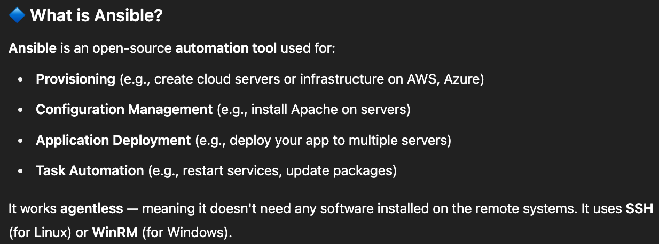



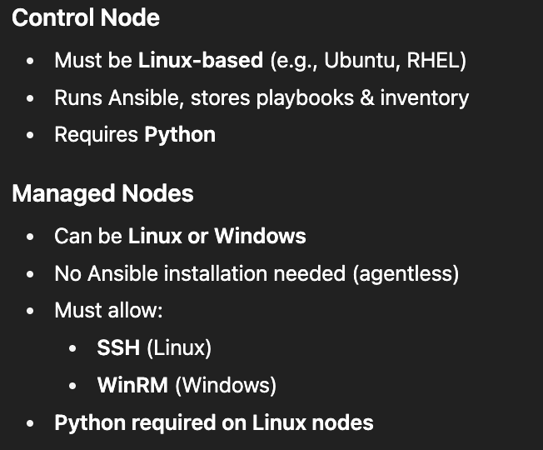

**Ansible passwordless authentication**

It means allowing the control node to connect to managed nodes without asking for a password each time. This is done using SSH key-based authentication for Linux hosts (and WinRM with certificates for Windows).

1. From control node where ansible is installed, use .pem file to SSH into your instances  
   ssh -i ~/Downloads/your-key.pem ubuntu@<ec2-public-ip>
2. Create Ansible Inventory File (inventory.ini). This file lists all your managed nodes (the EC2 instances) with details for Ansible to connect.

[webservers]

server1 ansible_host=13.220.85.175 ansible_user=ubuntu ansible_ssh_private_key_file=~/Downloads/your-key.pem ansible_ssh_common_args='-o StrictHostKeyChecking=no'

server2 ansible_host=3.91.154.60 ansible_user=ubuntu ansible_ssh_private_key_file=~/Downloads/your-key.pem ansible_ssh_common_args='-o StrictHostKeyChecking=no'

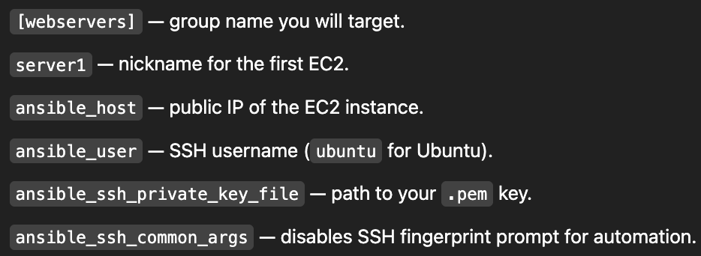

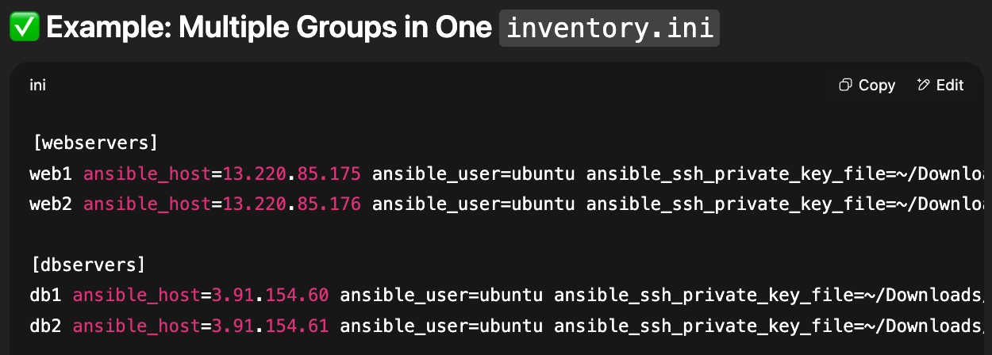

1. Run below adhoc command to test ansible can connect to all nodes.

ansible -i inventory.ini webservers -m ping

