**Virtual Machine vs Container**

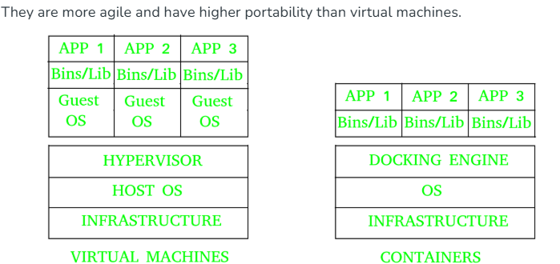

**How containers are logically isolated?**

1. Each container has its own filesystem so one can’t see other’s files.
2. Each have their own process so that one container can’t see other container processes.
3. Each container gets own private IP and hostname. Public IP is common i.e. host IP for external communication.
4. Each container runs its processes in its own ControlGroup which control how much resources a container can use so that other containers are not affected. (ControlGroup is a feature of linux kernel which controls limit of resources that processes can use)

**Architecture**

