**Components of linux OS**

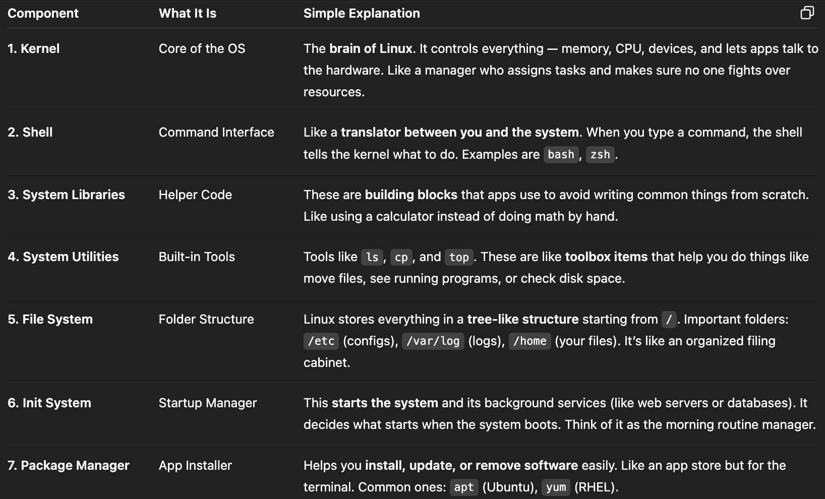

**Folder structure at root**

/sbin (system binaries)- contains command files required by administrator. like adduser, mount a file system, reboot system

/bin- contains command files required by all users like cp,ls,r,cat,mkdir

/lib- used by kernel  
  
/boot- contains files needed to restart the system.

/usr- contains most of the installed softwares and it’s files documents. It’s like ProgramFiles in windows

/srv- It stores data that your server shares with others.

/opt- used to store third-party software or manually installed applications. Every user should manually install 3rd party software here only.

/mnt- Used by system admin to temporarily access external devices or partitions by mounting them into the file system

/var- /var/log stores log files of system, services, applications. (basically all logs)

/home- Stores personal files for each normal user, which are user specific like /home/Ishan/scripts , /home/Ishan/Documents

/etc- stores all configuration files for system (hostname) and major applications. If you install a tool like Apache, Docker, or MySQL, their configs typically live in /etc

/tmp- stores cache and temporary data. emptied on reboot.

/run- stores runtime data of processes like processID, sockets docker.sock

**Linux prompt**  
  
user@hostname:directory_symbol

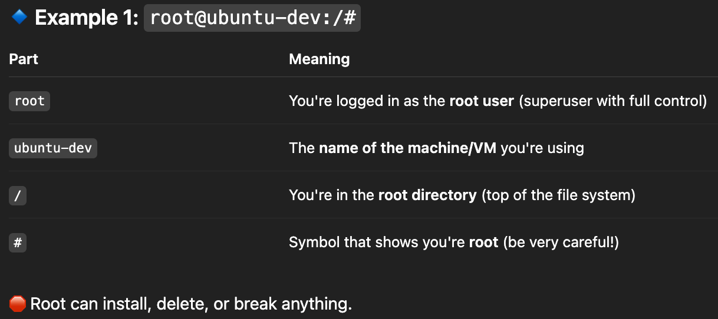

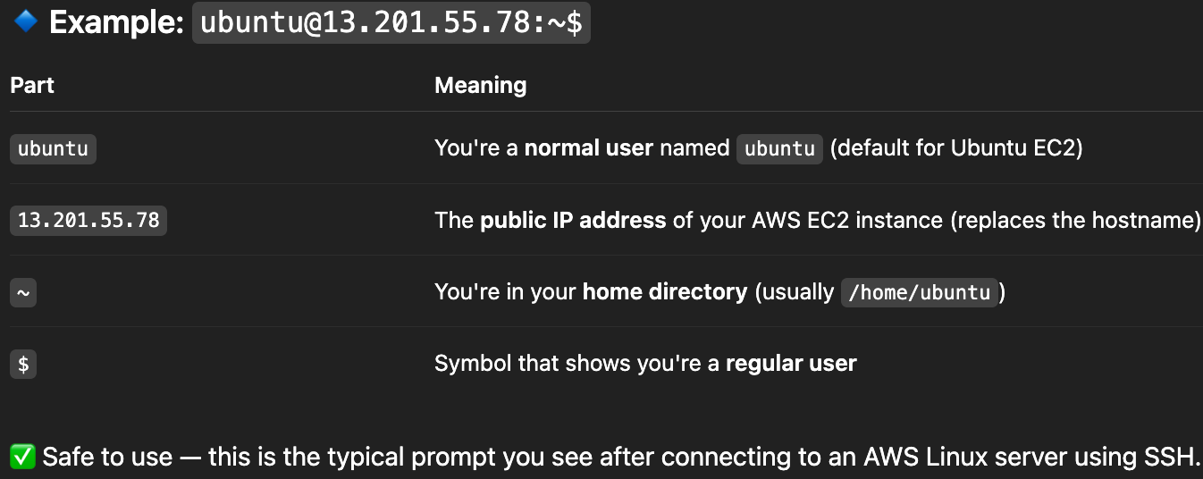

touch <file>- create empty file

vi <file>- opens the file in text editor, if not created then create and opens.

cat <file>- to show content of the file

man <command>- tells what that command does and available flags like “man ls”

pwd- print working directory

mkdir- make directory

top- shows all the details abt process and thread on system like TaskManagr. Used to monitor node health.

* apt is the default package manager of linux- /etc/apt. It creates a dependency tree for required package and install all necessary dependencies.

* The line #!/bin/bash at the **top of a shell script** is called a **shebang. It means run the shell script in bash.**

****chmod command** (change mode)**

**- 3 type of user we set permission for - user (u), group (g), others (o). User means owner of file.**

**- 3 types of access- read, write, execute**

