Archit Garg, Rohit Jhunjhunwala, Karamveer Choudhary, Utkarsh Srivastava

Abstract

This document proposes a high level description on displaying contextual ads to android platform

SmartAds: Bringing Contextual Ads to Mobile Apps

Contextual advertising on android platform

Table of Contents

1 Introduction to the problem and proposed solution: 2

2 Current state of the arts in the related areas: 2

3 High level description: 2

4 Plan of the research activities for the rest of the semester 3

4.1 Designing a resource friendly framework: 3

4.2 Display better targeted advertisements to the user using machine learning techniques: 3

5 References: 3

# Introduction to the problem and proposed solution:

Mobile ad market is one of the prominent ad spaces which is yet to see the boom. Despite the huge demand for apps and market for mobiles, in 2011, advertisers spent less than 1% of their overall advertising budget for mobile advertising; in contrast, they spent 16% for Web advertising. One of the main key reasons for this is, irrelevancy in mobile ads shown on apps.

For traditional web applications, the problem of ad relevancy is addressed in part, by Contextual advertising, wherein the ads displayed one the page are based on content of page. The fact that a web page can be crawled by a bot and indexed offline whereas it’s not so trivial to do the same in case of mobile app. Some ad systems do try to use the metadata of a mobile app to increase the relevancy but this model doesn’t scale much. There is a need for a new model which extracts data dynamically from the application and fetches relevant ads. The system needs to take care of network and memory overhead in phones.

Keeping all these facts in mind, a frameworks, called SmartAds is introduced. It is a client-server based model which dynamically scrapes data from mobile app and sends the information to the server. We will be implementing this framework on Android platform as part of this project.

# Current state of the arts in the related areas:

Contextual advertising as a whole concept and its place in mobile devices is closely related to this project. Contextual advertising is targeted advertising for ads displayed on websites or media such as mobile phones and tablets. For example, if a user goes to a sports website and sees ads on related sport jerseys, then it is a form of contextual advertising. This kind of advertising has had a huge impact in web because web pages can be easily crawled and indexed. However, for mobiles, contextual advertising has its own challenges.

The current solution of 'Smart Ads' tries to solve some of the issues like fetching the content of mobile applications dynamically while taking care of user's privacy. This solution implements a binary framework to capture user's gestures like swipe and touch to navigate various pages of the application. For every action, logs are created and application content is collected. Using this content, relevant ads are served to the user. The framework ensures that only the hash of each word is received from the application. On the server side, only the hash of certain keywords is indexed and it rejects any irrelevant or private information it receives (in hashed form), thus ensuring user privacy. However, this solution is compatible with Windows applications only. We plan to extend it for Android application which have a much larger user base. To implement it, we would need to develop our own framework which would handle the above mentioned points.

# High level description:

The high level description consists of a parsing component, middleware and indexing component, and a client side framework that will be integrated with the android applications. This framework extracts keywords from the application and sends hashed words as query to the middleware. The middleware then reverse maps the hashed words to the actual words it has in its database while discarding others, thus ensuring privacy to the users. The middleware queries the solr server using the actual words and pulls the most relevant ads to display on the client side framework. The parsing component does a onetime activity. It parses a set of ads and sends them to Solr for indexing. Below given diagram depicts the high level design explained above:

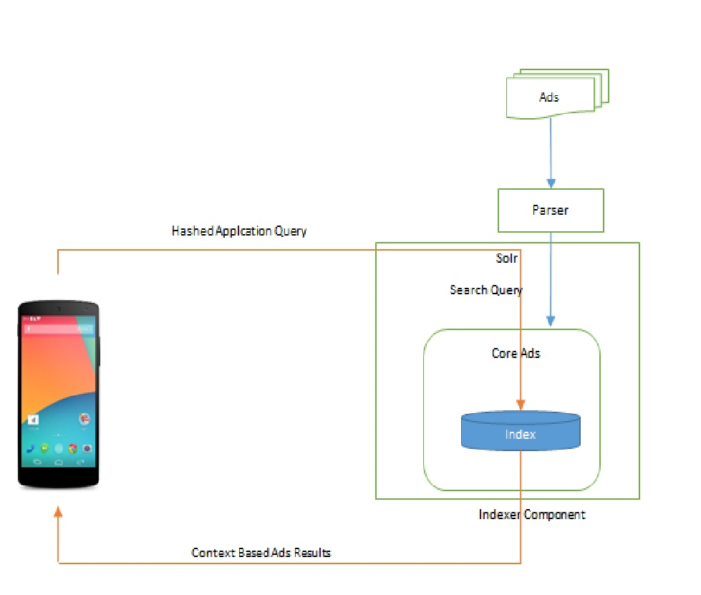

Figure 1 : High level design diagram

# Plan of the research activities for the rest of the semester

## Designing a resource friendly framework:

We need to design a client framework that can be integrated with existing applications with minimal change in existing application code. Also the framework should use minimal resources in terms of network usage, memory usage and battery consumption.

## Display better targeted advertisements to the user using machine learning techniques:

We will be researching on different types of techniques that can be used e.g. we can work on algorithms for text classification that can scan through the texts and analyze the context and relation between them to determine which one of the ads would be the most relevant one to display.

# References:

[Smart Ads ­ Bringing Contextual Ads to Mobile Apps](http://www.cse.buffalo.edu/~lusu/cse721/papers/SmartAds%20Bringing%20Contextual%20Ads%20to%20Mobile%20Apps.pdf)