

Mini Project Report -

Master of Computer Application – General
Semester – I

Sub : Front-End Frameworks and Technologies

Mini Project--Mini Project-08(JavaScript Grade Calculator)

By
Name: Utkarsh Tiwari
Reg no.: PROV/ASAC/MCA/7/26/049

Faculty Name: VEERA RAGHAV K

Faculty Signature: _______________
Department of Computer Application
Alliance University

INDEX

FIG NO | NAME OF TABLE | PG NO
1 | INTRODUCTION | 1
2 | INPUT CODE | 2-21
3 | OUTPUT CODE | 7
4 | CONCLUSION | 8

INTRODUCTION

Introduction

The College Events Website is a web-based platform designed to provide students and faculty with information about various events organized by the college. It helps users easily view upcoming events, event details, dates, venues, and other important information.

The website is developed using HTML and CSS to create a simple, attractive, and user-friendly interface. It can include different sections such as Home, About, Events, Gallery, and Contact.

The main purpose of this project is to make college event information easily accessible and to

INPUT CODE

<!DOCTYPE html>
<html>
<head>
<title>Grade Calculator</title>

<style>
body {
font-family: Arial;
background-color: lightblue;

text-align: center;
padding: 50px;
background-image: url('https://encrypted-tbn0.gstatic.com/images?q=tbn:ANd9GcQZ3R0RP63LmWnvNLe4AoEKTFocQvNHbDHylc9YyFaZQA&s=10');
background-repeat: no-repeat;
background-size: cover;
background-position: center;
background-attachment: fixed;
}

.box {
background-color: rgb(141, 63, 98);
width: 350px;
margin: auto;
padding-top: 100px;
border-radius: 100%;
margin-top:270px;
height: 400px;
width: 500px;
font-size: x-large;
}

input {
padding: 10px;
width: 80%;
margin: 10px;
font-size: large;
padding-bottom: 15px;
}

button {
margin-top: 20px;
padding: 20px 20px;
background-color: orange;
color: white;
border: none;
border-radius: 5px;
cursor: pointer;
font-size: larger;
}

#result {
margin-top: 20px;
font-size: 20px;
font-weight: bold;
}
</style>
</head>

<body>

<div class="box">
<h1>Grade Calculator</h1>

<input type="number" id="marks" placeholder="Enter your marks">

<br>

<button onclick="calculateGrade()">Calculate Grade</button>

<div id="result"></div>
</div>

<script>
function calculateGrade() {

let marks = Number(document.getElementById("marks").value);
let grade;

if (marks >= 90 && marks <= 100) {
grade = "A+";
}
else if (marks >= 80) {
grade = "A";
}
else if (marks >= 70) {
grade = "B";
}
else if (marks >= 60) {
grade = "C";
}
else if (marks >= 50) {
grade = "D";
}
else if (marks >= 0) {
grade = "F";
}
else {
grade = "Invalid Marks";
}

document.getElementById("result").innerHTML =
"Your Grade is: " + grade;
}
</script>

</body>
</html>

OUTPUT CODE

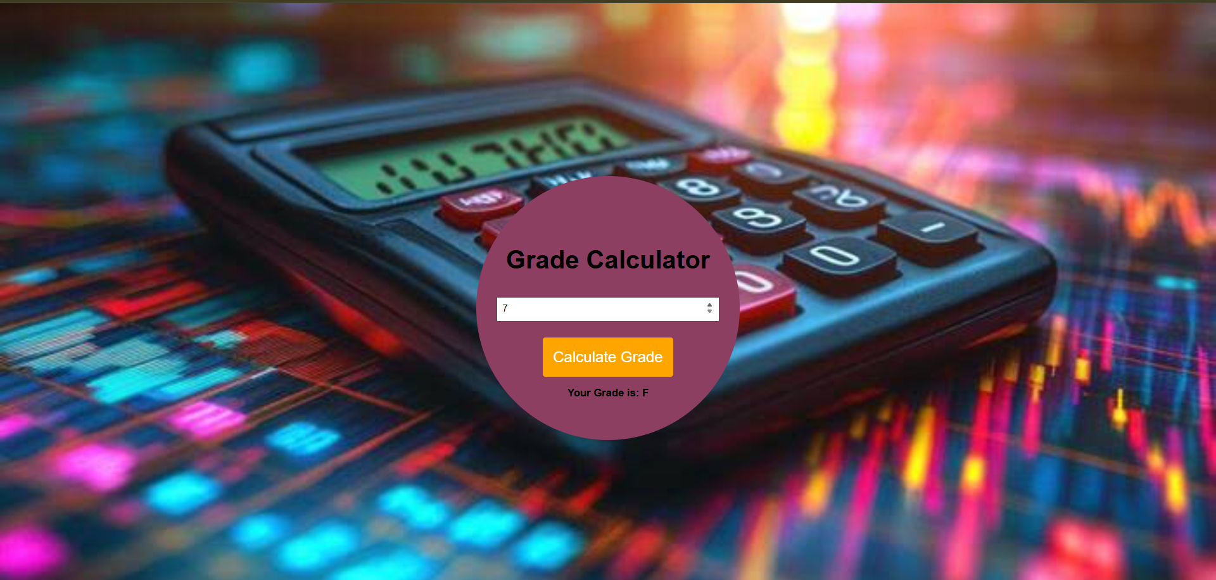

CONCLUSION

The College Events Website provides a simple and effective way to display and share information about college events. It helps students and faculty easily find details such as event names, dates, venues, and other important information.

This project helped us understand the practical use of HTML and CSS in creating a structured, attractive, and user-friendly website. In the future, the website can be improved by adding features such as online event registration, event notifications, login systems, and an admin panel.

