Project Prezoom

Requirements Document

Domain Model:

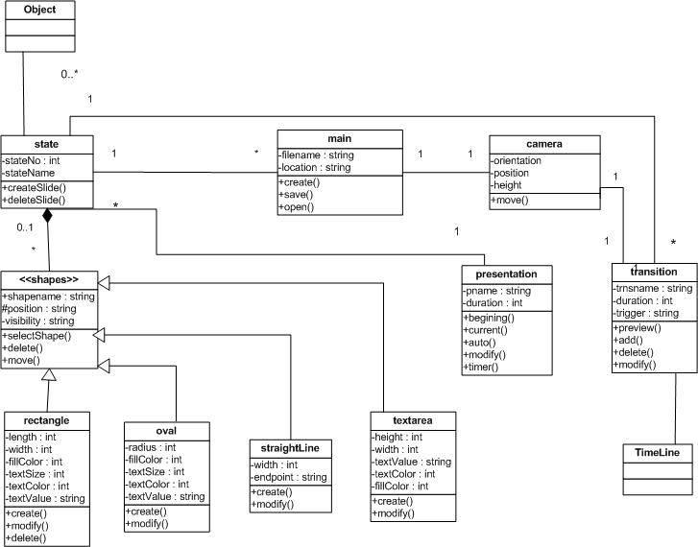

Lexicon:

|  |  |  |  |
| --- | --- | --- | --- |
| **FIELD NAME** | **DATA TYPE** | **DESCRIPTION** | |
| **Dashboard** | character | Data dashboard that displays key performance indicators pertaining to specific projects. | |
| **SelectNewProject( )** | character | It makes the user to create a new project.User can create new presentation. | |
| **ImportORNewProject: boolean** | String | User can create new presentation. Import is often used for importing parts of files, program settings. | |
| **ImportFile( )** | Character | To import a file, a program must be able to recognize and decode a file format other than its own. Again, this is a capability that must be built into the program.  EXAMPLE: function generally classified as an import is to read an image directly into a document from a scanner or camera. | |
| **LoadfileFromCloud( )** | Character | It will load the file from the cloud server. | |
| **Getdatafromfile( )** | varchar | By using this command I can use another computer with access to the same Drive, I have to re-link the data from the new computer to the same file. I even changed the names of the multiple computers to the same name, so they have the same "filepath". It will retrieve the all the data from the file. | |
| **"File has been loaded as presentation form": Message** | string | The file will be open and we can view in the presentation.The data will be in a PPT format. | |
| **AddObject( )** | Character | The user can add one or more object according to their needs.And the user can delete,change or they can perform some operation with the object.  Example:Oval,square, etc. | |
| **SetObjectColor( )** | String | The user can add the colour to the object like red,blue etc. | |
| **DeleteObject( )** | Character | This command is to delete the object. | |
| **SetObjectPosition( )** | Integer | The user can set the position for the object like they can place in right,left etc anywhere in the Presentation area. | |
| **SetHorizontalSize( )** | Integer | This command is to Customizing your horizontal command will enable you to enhance the appearance of your presentation.  Example: The horizontal size is displayed with the height set to 6. Notice how the height increases when the SIZE value is increased. | |
| **SetVerticleSize( )** | Integer | This command is to Customizing your vertical command will enable you to enhance the appearance of your presentation.  Example: The vertical size is displayed with the height set to 3. Notice how the height increases when the SIZE value is increased. | |
| **SetDepth( )** | Interger | When you add depth it helps to create a sense of place and draw the viewer into your images. To show a three-dimensional subject in a two-dimensional frame. | |
| **SetVisibility( )** | Character | It is mainly for to hide and to show the information.Two  option are Show() and Hide() functions. For example some object have visibility state and this functions is used to change it. | |
| **SetOrientation( )** | Character | The screenOrientation is the attribute of activity element. The orientation of presentation activity can be portrait, landscape, sensor, unspecified etc. Your screen will always display in Landscape mode, when you rotate your device, no changes will apply for the current activity | |
| **SetObjectTriggerState( )** | Character | To display a state in the presentation based upon the user’s interaction with the content, you'll need to add a trigger state. | |
| **SetObjectTriggerTime( )** | Integer | This command is to set a timer for the Trigger function so that the scripted event will be activated in that particular mentioned time in the presentation. | |
| **SetCameraFocus( )** | Character | It allow you to focus the any part in the presentation.You can zoom in or zoom out the particular portion . | |
| **SetCameraMovement( )** | Character | This command will control the camera movement in the presentation. | |
| **EditTextMessage( )** | Character | This command will allows you to create or edit your text message in the presentation. | |
| **SetTextSize( )** | Integer | This command will allows you to change the size of your text Example:size:6,8,12,16 etc. | |
| **SetTextColor( )** | Character | This command will allows you to change the color your text color like red ,green,blue etc. | |
| **SetTextFont( )** | Character | This command will allows you to change the font of the text. message.Example:Times new Roman etc. | |
| **SaveState( )** | Character | This command will save the each operation in each state .This command will save the changes of the state. | |
| **SaveOnDesktop( )** | varchar | This command will helps us to save the file on the desktop. | |
| **SavePresentationOnDesktop( )** | varchar | This command will helps to save the presentation on the desktop. | |
| **Presentation Has been Saved: Message** | varchar | This command will give the message for saving the presentation. | |
| **SaveOnCloud( )** | varchar | This command will save the file on the cloud.It will store it in cloud server. | |
| **SavePresentation( )** | varchar | This command will save the presentation.It will save the future work and current work. | |
| **DeleteObject( )** | Character | This command will delete the object.It will delete the object from the presentation. | |
| **Presentation phase** |
| **LoadfileFromCloud( )** | varchar | It will load the file from the cloud server**.** | |
| **Loadfile()** | varchar | It will load the file for the user from the saved document for the presenter.If the loading is done it will go to view state. | |
| **PresentView()** | varchar | This command will help us to view the presentation ,  The right to left transition is used when you push a view controller. the animated parameter in the presentViewController method doesn't really matter in this case of custom transition. | |
| **LoadPresentationForm()** | varchar | This command will retrive the presentation from the server. | |
| **LoadPresentationView()** | varchar | This command will retrieve the file from this command(LoadPresentationForm()) and it will load the presentation to view. | |
| **StartTransition()** | varchar | This command will helps to start the transition.At first presentation will be in state 0. | |
| **ChangeState()** | varchar | This command will helps to change the state. At first presentation will be in state 0. Whenever a trigger will become true (time exceed, user press button etc.), state will be change to 1. |
| **NextPage()** | Character | This command will helps to move the presentation to the nest page or upcoming page.  Camera angle will change slide and object will move to different positions set in development phase. | |
| **ClosePresentation()** | varchar | This command will close the presentation when the presentation ends. | |

**Iteration 1: (Due 16th Nov, 2020)**

1. **Container**
2. **Object and properties**
3. **States**
4. **Attributes**
5. **Features:**

* **Save**
* **Load**
* **Edit**

1. **Edit Mode**
2. **Transition**

**Iteration 2: (Due 30th Nov, 2020)**

1. **Timeline**
2. **Camera**
3. **Project**

* **Bug review**
* **Testing**