**Specification Document**

**1. Use Case Diagrams**

**  
  
2. State Diagram  
  
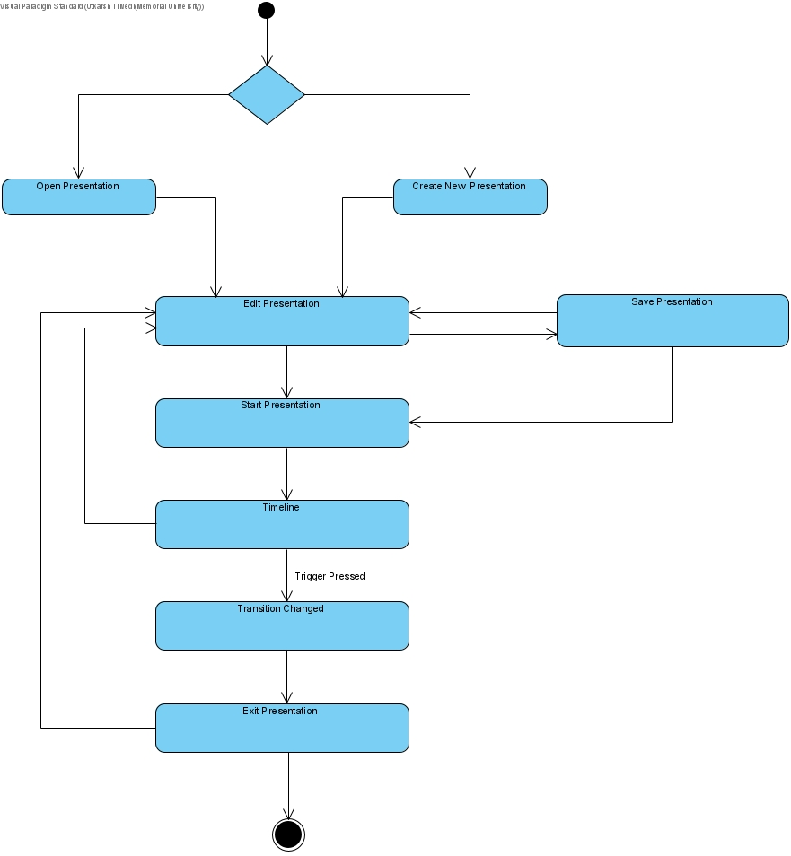**

**3. Use Cases**

**Presentation Development**

**Start**

Subject: Prezoom

Requirement address: T1

Actors involved: Presentation developer

Precondition: The system will start a new system.

Typical flow : The system will prompts the user whether to start or open a presentation or edit it.

**Create new project**

Subject: Prezoom

Requirement address: T2

Actors involved: Presentation developer

Precondition: The system will ask to create new presentation.

Typical flow : The system will allow the user to create new presentation with the new slide or the user can start doing the presentation with the existing file.

**Open**

Subject: Prezoom

Requirement address: T2

Actors involved: Presentation developer

Precondition: The system will ask the developer to open the existing file from the system.

Typical flow : The system will allow the user to open a presentation which is stored in the system.

**Edit Presentation**

**Colour**

Subject: Prezoom

Requirement address: T5

Actors involved: Editor

Precondition:. Change colour,Apply color,Remove color

Typical flow : Editor can change the colour like red,blue etc and they can apply color to different shapes ,text or slide etc., from drop down menu.

**Fill colour**

Subject: Prezoom

Requirement address: T5

Actors involved: Editor

Precondition:. Change colour,Apply color,Remove color

Typical flow : Editor can apply Fill color option to the particular shape or particular slide etc., from drop down menu.

**Font style**

Subject: Prezoom

Requirement address: T3

Actors involved: Editor

Precondition:. Change font style

Typical flow : Editor can change font style lie Times new roman,calibri,Abai,Arial etc.In each an every slide from drop down menu.

**Font size**

Subject: Prezoom

Requirement address: T3

Actors involved: Editor

Precondition: modify time duration

Typical flow : The Editor can change the size of the text like 12,16,18 etc., from drop down menu.

**Shapes**

Subject: Prezoom

Requirement address: T9,T10

Actors involved: Editor

Precondition: change or Add shapes

Typical flow : The Editor can change ,draw or add the shapes like circle,rectangle,line,oval etc to the slide.

**Time Duration**

Subject: Prezoom

Requirement address: T13

Actors involved: Editor

Precondition: modify time duration

Typical flow : The Editor can set or change the time duration.

**Delete Option**

Subject: Prezoom

Requirement address: T10,T4

Actors involved: Editor

Precondition: Delete state,object

Typical flow : The Editor can Delete the state

**Move Option**

Subject: Prezoom

Requirement address: T11

Actors involved: Editor

Precondition: Modify

Typical flow : The Editor can move the shapes from one place to another place in the slide by clicking move option.

**Add state**

Subject: Prezoom

Requirement address: T9

Actors involved: Editor

Precondition: Add state

Typical flow : The Editor can add the state

**Save Option**

Subject: Prezoom

Requirement address: T15

Actors involved: Editor

Precondition: Save

Typical flow : Edit the presentation can save the presention

**Undo option:**

Subject: Prezoom

Requirement address:

Actors involved: Editor

Precondition: Undo

Typical flow : Editor can use undo option to reverse some operation.

Example :If the editor drawn the cirlce first and then he drawn ellipse and then he decided no to have ellipse he can click undo to erase the ellipse from the presentation.

**Redo option:**

Subject: Prezoom

Requirement address:

Actors involved: Editor

Precondition: Redo

Typical flow : Editor can use redo option to get back some operation that editor has done.

Example :If the editor drawn the cirlce first and then he drawn ellipse ,if he deleted the ellipse mistakenly he or she can click the redo option to get back the ellipse shape.

**Text box :**

Subject: Prezoom

Requirement address:

Actors involved: Editor

Precondition: Text box

Typical flow : Editor can use test box option to write some text in the presentation slide or inside some shapes.

**Add state option :**

Subject: Prezoom

Requirement address:

Actors involved: Editor

Precondition: add slide

Typical flow : Editor can use add slide option to add one or more slide in the presentation by clicking the add slide option.

**View Option**

Subject: Prezoom

Requirement address:

Actors involved: Editor

Precondition: Text box

Typical flow : Editor can use test box option to write some text in the presentation slide or inside some shapes.

**Pop_up menu :**

Subject: Prezoom

Requirement address:

Actors involved: Editor

Precondition: Text box

Typical flow : Editor can use pop up menu option , so that user can arrange , get dtatils about the shape , add color and delete for to edit the presentation.

**Exit Option**

Subject: Prezoom

Requirement address: T6

Actors involved: Editor

Precondition: Exit

Typical flow : Editor can Exit the presentation after they finished the presentation.

**Presentation Phase**

**Slide movement,Timeline**

Subject: Prezoom

Requirement address: T16,T17,T18,T19

Actors involved: Presenter

Precondition: move First,Last,Backward,Forward

Typical flow : During presentation the présenter can move the presentation from last, first forward, backward using timeline.

**Presentation menu**

Subject: Prezoom

Requirement address:T20

Actors involved: Presenter

Precondition: auto presentation

Typical flow : The présenter can also enable presentation using the Presentation menu.

**Transition option**

Subject: Prezoom

Requirement address:T20,T25

Actors involved: Presenter

Precondition: Transitions

Typical flow : The présenter do transition operation,the user can change the circle to elliose or other shapes during the presentation.

**Camera movement**

Subject: Prezoom

Requirement address:T22

Actors involved: Presenter

Precondition: camera moves left or right.

Typical flow : The présenter can move the camera to the left or the right.

**Orientation**

Subject: Prezoom

Requirement address:T24

Actors involved: Presenter

Precondition: Change Orientation

Typical flow :The présenter can modify the orientation,vertical or horizontal, of the camera.

**4. Wireframe Diagrams  
  
5. Sequence Diagrams  
  
**