#*GRIDFS PYTHON CODE:

#!/usr/bin/python

# Solution 1 for image.show() not working

# sudo apt-get install imagemagick

# Solution 2 for image.show() now working

# I run Python 2.7 on Linux Mint and when calling Image.show()

# nothing happens. On my system, the default viewer is

# Image Viewer", which is called "eog" in bash. My Python

# thinks that I # use something else maybe "xv". So, open a terminal and run

# sudo gedit /usr/lib/python2.7/dist-packages/PIL/ImageShow.py

# Search for "xv" and replace it with "eog".

# Save the file and Image.show() works fine (for debugging purposes).

from PIL import Image

from pymongo import MongoClient

import gridfs

#Set up the database to store and retrieve image

client = MongoClient()

data_base = client.ImgDB

imageFile = raw_input("Enter the name of the image to be stored (on pwd) : ")

data = open(imageFile,"rb")

gfs = gridfs.GridFS(data_base)

theImage = data.read()

stored_image = gfs.put(theImage,filename=imageFile)

out = gfs.get(stored_image).read()

retrievedImageFile=raw_input("Enter name of the container for the retrieved image : ")

output= open(retrievedImageFile,"w+")

output.write(out)

output.close()

Image.open(retrievedImageFile).show()

#*GRIDFS PYTHON OUTPUT:

MONGO DATABASE

> show databases

ImgDB 0.000GB

blog_site 0.000GB

blogsite3 0.000GB

local 0.000GB

sneha 0.000GB

subhash 0.000GB

test 0.000GB

viraj 0.000GB

> use ImgDB

switched to db ImgDB

> show collections

fs.chunks

fs.files

> db.fs.files.findOne()

{

"_id" : ObjectId("57ecb0c95749c010ee5faa8e"),

"chunkSize" : 261120,

"filename" : "Nature.jpg",

"length" : 10565,

"uploadDate" : ISODate("2016-09-29T06:12:25.643Z"),

"md5" : "b11cd5ff4b89940d52ca6f756d9175da"

}

>

Output:

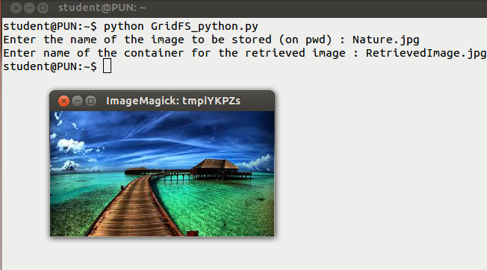

Original Image : Nature.jpg



Retrieved Image : RetrievedImage.jpg

