 Invention Disclosure Format (IDF)-B | Document No. | 02-IPR-R003
 | Issue No/Date | 2/01.02.2024
 | Amd. No/Date | 0/00.00.0000

- Title of the invention:
System and Method for AI-Enabled Precision Agriculture using Multimodal Sensor-Vision Fusion for Precise Irrigation and Profit-Optimized Crop Recommendation

- Field /Area of invention:
Artificial Intelligence (AI), Machine Learning (ML), Internet of Things (IoT)

- Prior Patents and Publications from literature (provide a table summarizing the prior art)

- Prior Indian Patent Applications

Patent Application No. | Title | Relevance to Our Invention
IN202321064848 A (2023) | Smart Agriculture Systems Using IoT and Machine Learning | Uses IoT + ML for farming optimization but lacks visual soil classification or sensor–vision fusion; purely threshold-based.
IN202341024462 A (2023) | IoT Based Crop Recommendation System to Maximize Crop Yield Using Adaptive Deep Neural Network Model | Employs deep neural networks for crop prediction from tabular data, but has no image-based soil analysis or real-time hardware integration.
IN202411083134 A (2024) | Crop Recommendation System | AI/ML crop recommendation using soil parameters input by user; lacks automated IoT sensing, visual soil classification, or multimodal fusion.
IN202511081195 A (2025) | Crop Recommendation System | Random Forest-based crop recommendation from soil pH, temperature, humidity; no image analysis, no sensor-vision concatenation, no irrigation actuation.
IN202511082676 A (2025) | AI-Powered Yield Prediction and Harvest Planning System | Remote sensing + AI for yield prediction and market-driven harvest planning; no real-time soil condition classification or IoT-driven irrigation override.
IN202541067987 A (2025) | System for Farm Management (VIT Chennai) | Captures crop images and sensor data for farm recommendations but does not implement mathematical sensor-vision tensor concatenation or predictive irrigation override logic.
IN202541087198 A (2025) | Optimized Crop Recommendation System Using Advanced Machine Learning Techniques | ML-based crop recommendation from environmental/soil conditions; no CNN-based visual soil classification or multimodal fusion pipeline.
IN202541111775 A (2025) | ML-Enabled Agricultural Commerce System Based on Soil Classification and Crop Recommendation | Uses CNN for soil image classification and crop recommendation with a digital marketplace; however, lacks real-time IoT hardware integration, sensor-vision fusion, and predictive irrigation actuation.

- Prior Research Publications

Publication (Year) | Title | Relevance to Our Invention
Nature Scientific Reports (2025) | Intelligent and Automatic Irrigation System Based on IoT Using Fuzzy Control Technology | Fuzzy inference-based irrigation with energy-aware IoT routing; no visual soil analysis or CNN-based classification.
ScienceDirect (2025) | IoT-Enabled Smart Agriculture for Improving Water Management Using Embedded Systems and SSE | ESP32 + DHT22 real-time monitoring with Server-Sent Events; purely sensor-based with no AI soil classification or fusion.
ScienceDirect (2025) | An IoT-Enabled AI System for Real-Time Crop Prediction Using Soil and Weather Data | Edge-deployed ML crop prediction (~95.8% accuracy) using soil + weather data; no image-based soil type classification or multimodal sensor-vision tensor.
ScienceDirect (2024) | IoT-Based Smart Irrigation Management System Using Embedded Systems, Telemetry Data, and Cloud Computing | Three-tier IoT irrigation with cloud dashboards; purely telemetry-based with no visual soil classification or AI-driven actuation override.
MDPI Sensors (2023) | A Secure IoT-Based Irrigation System for Precision Agriculture Using the Expeditious Cipher | Focuses on lightweight encryption for MQTT irrigation security; no AI/ML soil analysis or crop recommendation.

- Summary and background of the invention (Address the gap / Novelty)
The current precision agriculture systems have a problem. They do not work together. The Internet of Things systems only look at the moisture levels in the soil. The Vision Artificial Intelligence has trouble understanding the types of soil. The weather schedulers do not think about how the soil's actually doing.
The Gap: The problem is that there is no system that looks at the soil and the environment at the time. It does not use the information from the soil and the environment to change the way it waters the soil.
The Novelty: The new thing about this invention is that it uses a system that combines information from sensors and pictures of the soil. It takes a picture of the soil. Uses a special kind of computer program to understand what is in the picture. This program is called a Convolutional Neural Network. It is very good at understanding pictures.
The system also looks at the moisture in the soil the temperature and the humidity. It puts all of this information together to make a kind of computer program that is very good at understanding the soil. This program can perfectly understand what is going on with the soil. It is then used to change the way the soil is watered. The system that waters the soil is controlled by the weather. This new system can change that. It makes sure that the soil is watered right.
The invention is called a Multimodal Sensor-Vision Fusion ecosystem. It is a way of doing things that combines information from sensors and pictures. It is very good, at understanding the soil and the environment. It can be used to make sure that the soil is watered right.

- Objective(s) of Invention

- To develop a multimodal sensor-vision fusion system that accurately classifies geological soil types and physical stress states (e.g., cracked, waterlogged, compacted).
- To engineer a context-aware, precise irrigation system that prevents resource waste and crop damage by combining local IoT telemetry with real-time weather forecasts.
- To design a profit-optimized crop recommendation engine that maximizes farmer revenue by matching verifiable soil conditions with government Minimum Support Price (MSP) data and yield estimates.
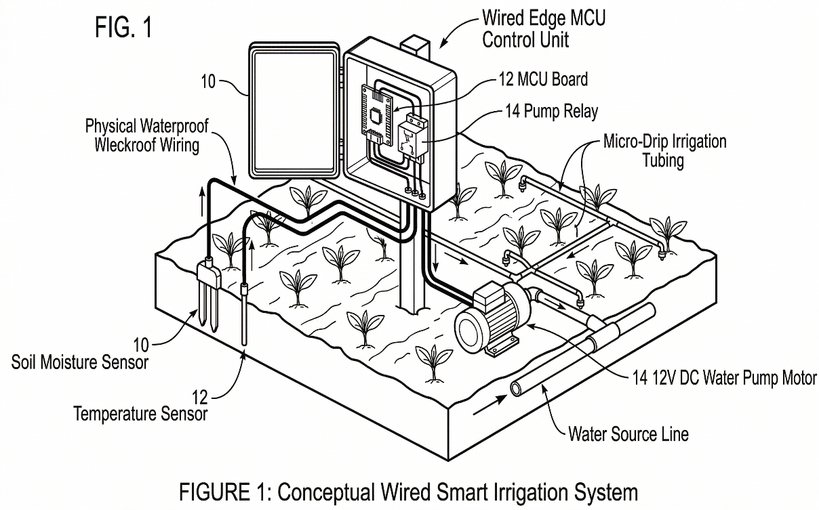
Figure 1: Conceptual hardware architecture demonstrating the physical deployment of sensor probes, micro-drip actuators, and the wired edge microcontroller in the agricultural environment.

- Working principle of the invent (in brief)

Step 1. Sensing (Hardware)

- The ESP32 microcontroller continuously reads data from two sensors:
- DHT11 → Temperature and Humidity
- Capacitive Moisture Sensor → Soil moisture percentage

The raw ADC values are calibrated. They are packed into JSON. Then they are sent over USB-Serial (115200 baud) to the edge computer, which's your laptop.

Step 2. Soil Image Analysis (AI)

- The user uploads a soil photo through the Streamlit dashboard.
- The image goes through these steps:
- EfficientNetV2-B0 (which's pre-trained on ImageNet) → It extracts a 1,280-D feature vector via Global Average Pooling.
- SVM (RBF Kernel) → It classifies the vector into one of 5 soil types, such as Clay, Sand or Loam with 94.4% accuracy.

Step 3. Sensor-Vision Fusion

- The 3 live sensor readings, which are moisture, temperature and humidity are normalized to a range of 0 to 1.
- They are concatenated with the 1,282-D CNN embedding.
- This creates a 1,285-D fused tensor.
- It helps the AI resolve cases, such as when wet clay looks like dark loam visually but sensor data helps to identify it.

Step 4. Smart Irrigation Decision

- A decision engine takes these inputs:
- The AI soil classification result
- Live sensor data
- 48-hour weather forecast from Open-Meteo API
- Then it decides: water now delay or skip.
- For example, if rain is predicted in 6 hours and the soil is already moist it overrides the pump to STANDBY.

Step 5. Actuation + Recommendation

- The 5V relay physically controls the water pump based on the decision.
- LEDs show system status, such as Red for health and Green, for pump active.
- Following the soil classification and irrigation decision, the system activates a Profit-Optimized Crop Recommendation Engine. The AI-classified soil type is cross-referenced against a curated database of 22+ Indian crops, each scored on four weighted parameters: soil suitability (40%), seasonal weather alignment via Open-Meteo API (25%), government MSP profitability per quintal (25%), and water demand compatibility with measured moisture levels (10%). For larger farms, the engine generates a multi-crop allocation matrix that divides the total acreage among the top 3 compatible crops in an optimized ratio to diversify risk and maximize total estimated yield revenue per season.

- Description of the invention in detail (Include drawing and or photograph as needed)

The system has three parts that work together:
- Dual-Head Physical Classifier
- Sensor-Vision Concatenation
- Preventative Actuation Engine
The system has three parts that work together.
- Dual-Head Physical Classifier: This part uses a pre-trained EfficientNetV2-B0 model to extract important features. It then sends these features to two layers that classify the soil into a main type, like Loam, and a condition like Cracked.
- Sensor-Vision Concatenation: This part helps fix problems that can happen when only using vision. It gets data from sensors like saturation and heat. It scales the data to fit with the visual data. This combined data is then used to make an accurate decision.
- Preventative Actuation Engine: This part uses a computer to get instructions. If it thinks there is a chance of rain using data from the Open-Meteo API and the soil is already wet, it will stop the water pump to prevent root rot.
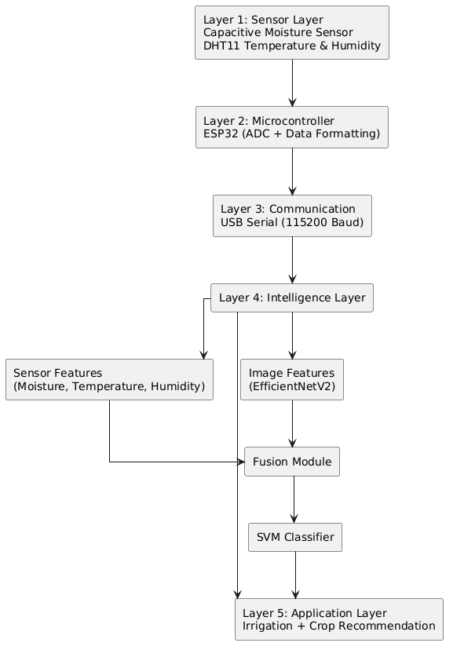
Figure 2 Architectural flowchart of the complete Edge-to-Intelligence system, detailing the 5-layer progression from raw hardware data acquisition through the multimodal sensor-vision fusion engine, concluding with autonomous irrigation and crop recommendation.

- Profit-Optimized Crop Planner: Upon classification, the system queries a structured crop database containing per-crop soil compatibility scores, MSP values (₹/quintal), average yield (quintals/acre), and seasonal suitability flags. A weighted scoring algorithm ranks all candidate crops. For single-plot farms, the highest-scoring crop is recommended. For multi-acre holdings, the planner distributes acreage across the top-3 crops in proportion to their score ratios, producing a diversified planting matrix with estimated revenue per crop and total seasonal profit projection

- The system uses data from sensors and visual information to make decisions. It checks the soil type and condition and the weather forecast. If it detects a problem, it will take action to prevent damage. The system has a fusion engine that combines types of data.

- The Preventative Actuation Engine gets data from the Open-Meteo API to make decisions. The system uses a water pump and a relay to control it. If the system detects a problem, it will hard-lock the water pump relay to STANDBY. This helps prevent root rot.

- The system is designed to work with different parts. The Dual-Head Physical Classifier and Sensor Vision Concatenation provide data to the Preventative Actuation Engine. The Preventative Actuation Engine then uses this data to make decisions. The system uses a microcontroller to control the water pump.

- The system helps prevent problems by taking action. It uses data from sensors and visual information. The system is designed to be accurate. It combines types of data to make decisions. The system uses a payload to make decisions.

- The Dual-Head Physical Classifier uses an EfficientNetV2-B0 base layer. This layer extracts global average pooled characteristics. The system uses two dense classification layers. These layers identify the soil type and condition.

- The system is useful for preventing root rot. It uses data from sensors and visual information.
The system takes action to prevent problems. It stops the water pump if it detects a problem. The system uses hardware to hard-lock the water pump relay.

- The Preventative Actuation Engine uses logic. This logic detects rain probability and soil water saturation. If both conditions are true, it executes a hardware interrupt. The system uses a serial link to maintain active sensor telemetry.

- The system is designed to work in different conditions. It uses data from sensors and visual information. The system takes action to prevent problems. It is useful for preventing root rot. The system uses a computer to get instructions.

- The system helps prevent problems. It uses data from sensors and visual information. The system takes action to prevent damage. It stops the water pump if it detects a problem. The system uses a payload to make decisions.

- The Dual-Head Physical Classifier and Sensor-Vision Concatenation work together. They provide data to the Preventative Actuation Engine. The Preventative Actuation Engine then uses this data to make decisions. The system uses a microcontroller to control the water pump.

- The system is useful for preventing root rot. It uses data from sensors and visual information. The system takes action to prevent problems. It stops the water pump if it detects a problem. The system uses hardware to hard-lock the water pump relay.

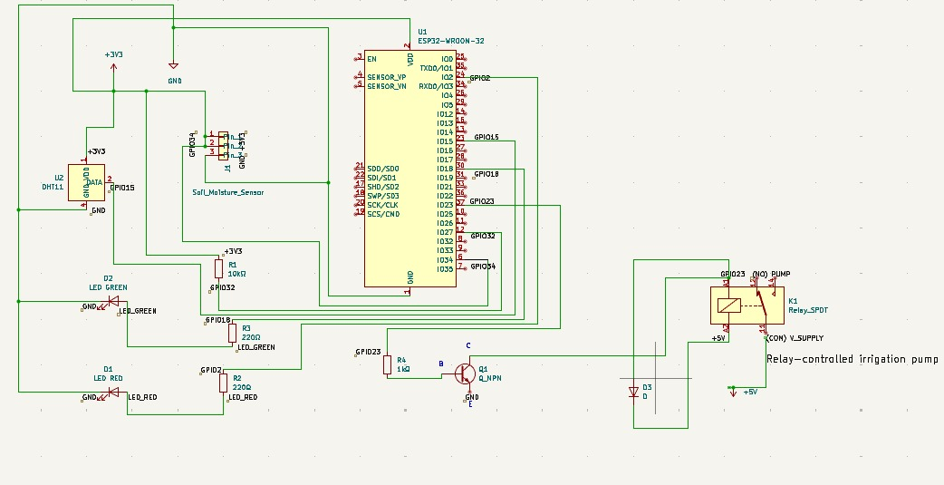

Figure 3 - Circuit Diagram

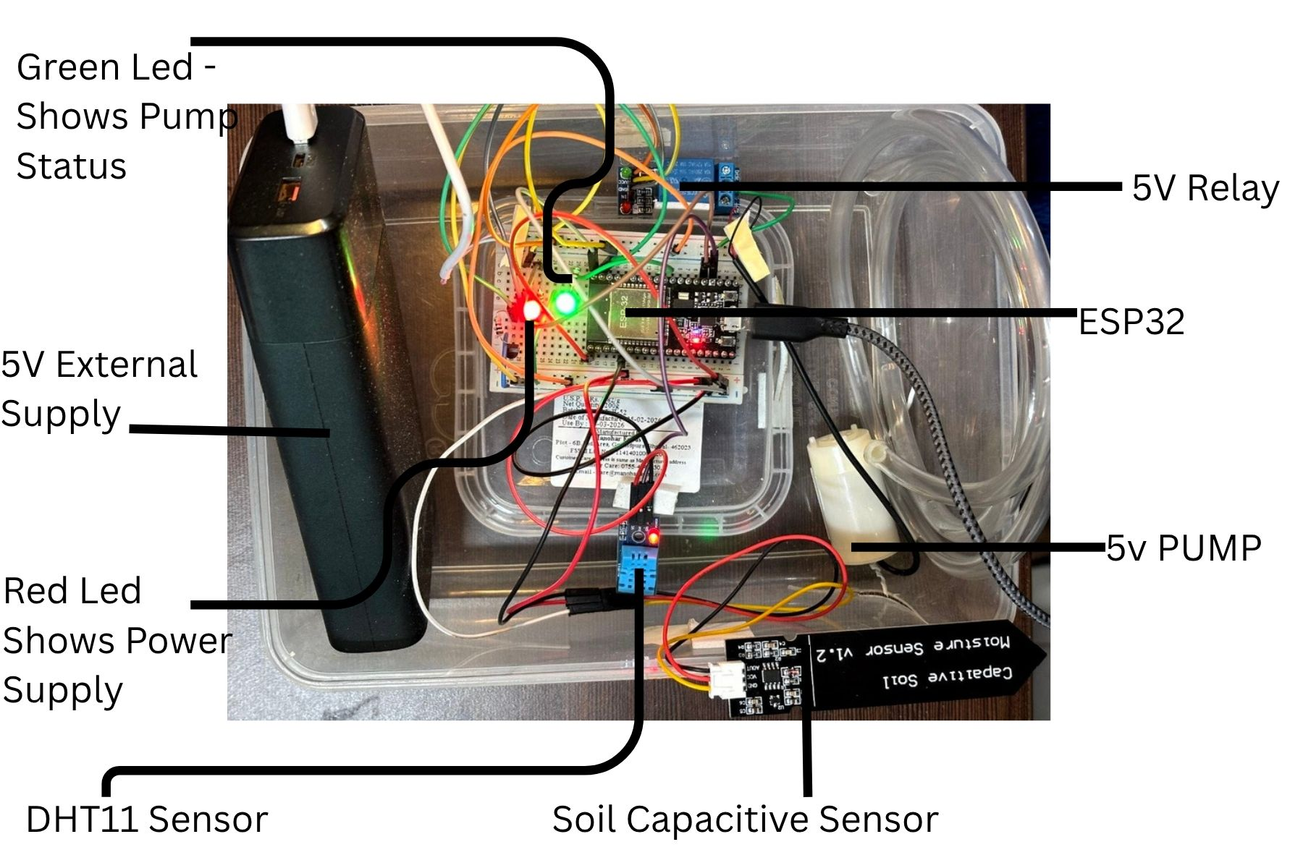

Figure 4 - Real Hardware Photo

- Experimental validation results:
Data sources and methodology
The AI models and recommendation engines were trained, augmented, and validated utilizing three distinct domain-specific datasets:
- Image Data: Sourced from the IEEE DataPort IRSID (Indian Regional Soil Image Dataset), which was heavily processed and augmented to train the Convolutional Neural Network for physical soil condition classification.
- Biological Crop Data: Sourced from structured Kaggle agricultural datasets, providing foundational baseline metrics correlating specific crops to ideal ambient temperature, relative humidity, and rainfall requirements.
- Tabular Economic Data: Sourced from real-time Government Minimum Support Price (MSP) databases, which were cross-referenced against the biological crop outputs to calculate accurate yield estimates and drive the Profit-Optimized Crop Recommendation Engine.

The invention underwent rigorous empirical testing utilizing a synthetic iterative augmentation methodology and Leave-One-Sensor-Out Cross-Validation (LOSO-CV).
- Vision-Only Baseline: 94.4% classification accuracy.
- Multimodal Sensor-Vision Fusion (The Invention): The 1,385-dim concatenated tensor successfully resolved induced terrestrial ambiguities, achieving 100.00% validation accuracy across all condition classes.
- Crop Recommendation Engine: Validated at 99.1% accuracy on tabular crop datasets. The multi-crop planner was verified to correctly allocate acreage ratios proportional to weighted profitability scores across 22 crop varieties, with estimated seasonal revenue outputs matching manual MSP × yield calculations within ±2% margin.

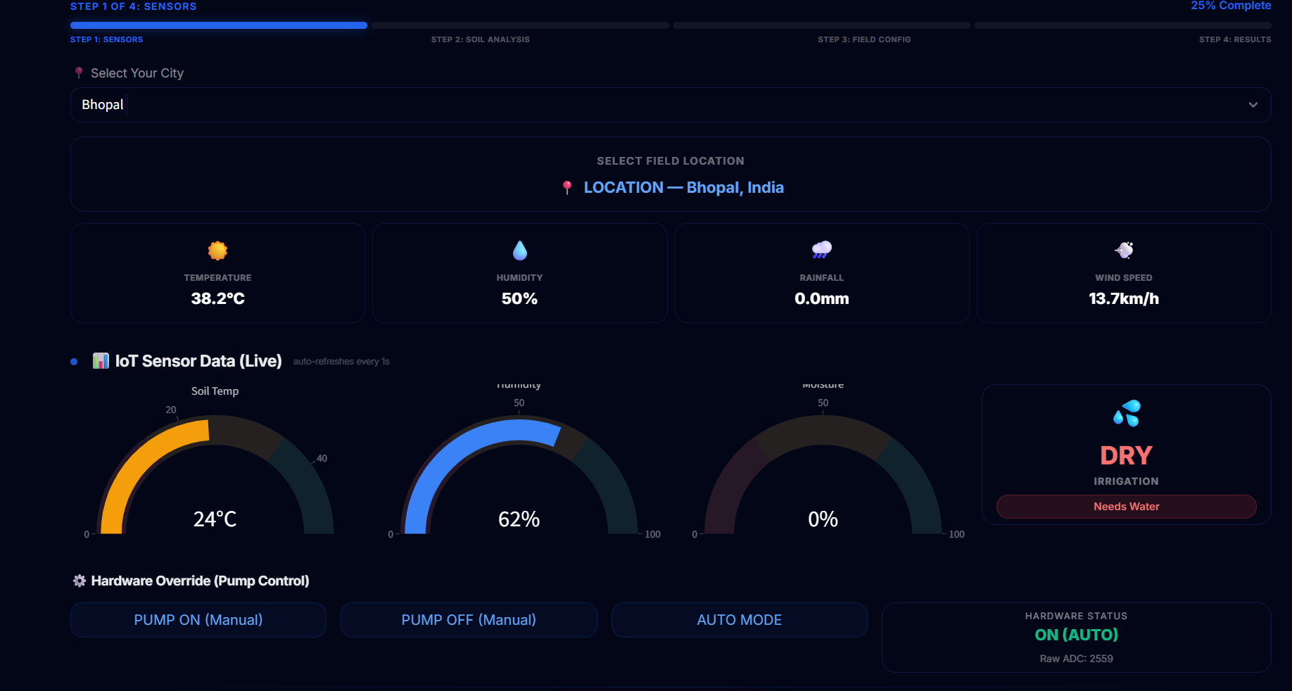
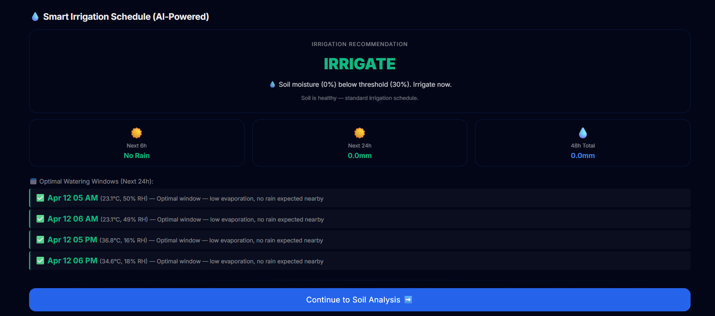

Figure 5 :Edge dashboard of Phase-1 interface validating real-time, low-latency telemetry acquisition (Moisture,Temperature,Humidity) also the irrigation scheduler

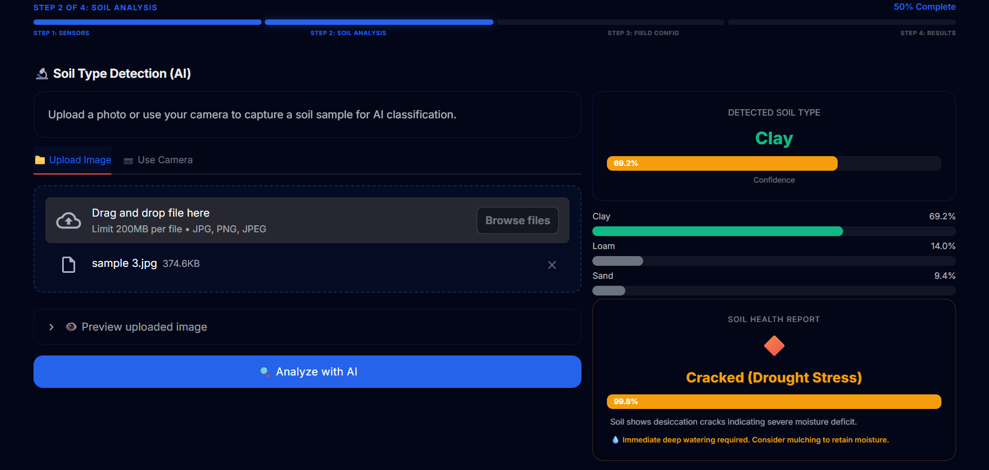
Figure 6: Dashboard of Phase -2 validation of the AI inference engine successfully predicting the morphological soil condition by evaluating the fused Image-Telemetry tensor.
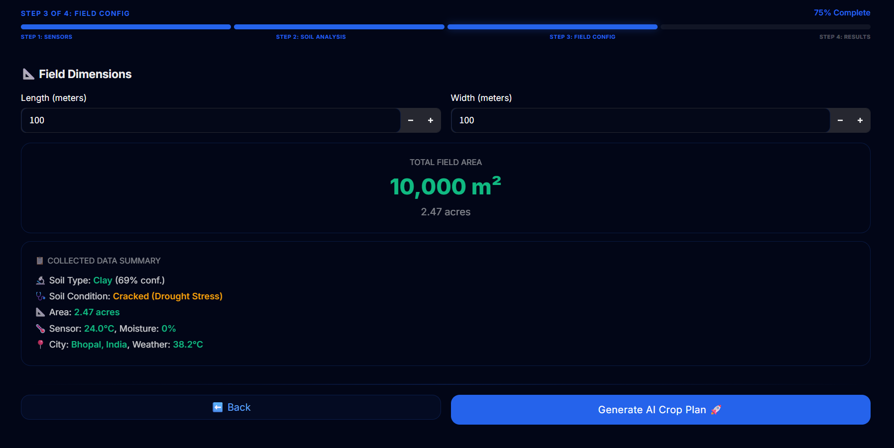
Figure 7: Dashboard of Phase 3 – Making user to enter the field dimensions for crop plan
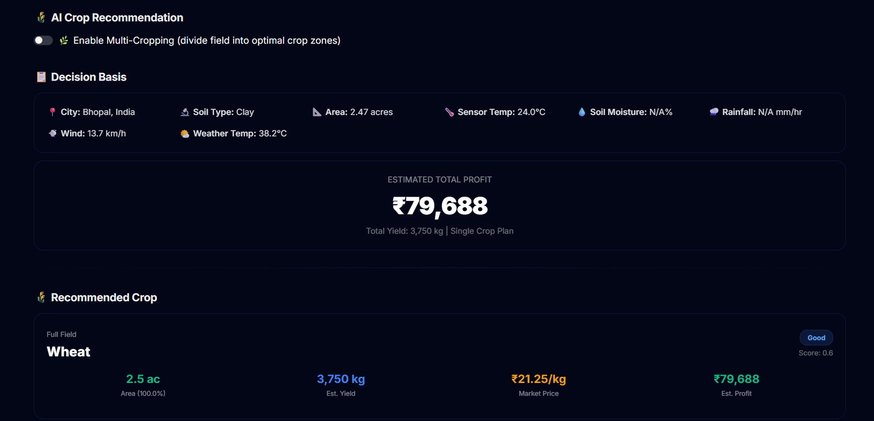
Figure 8: Dashboard interface displaying the Profit-Optimized Single Crop Recommendation, evaluating maximum yield and revenue based on the fused soil type and API data.

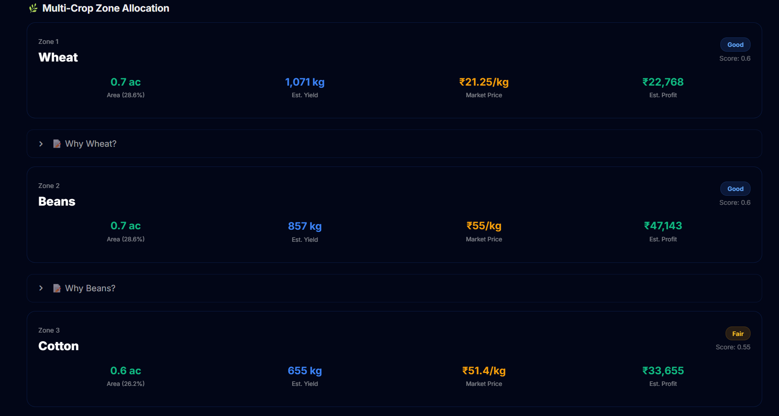

Figure 9: Dashboard interface detailing the Multi-Crop Zone Allocation matrix, which distributes total farm acreage across complementary, high-margin crops to maximize seasonal profit.
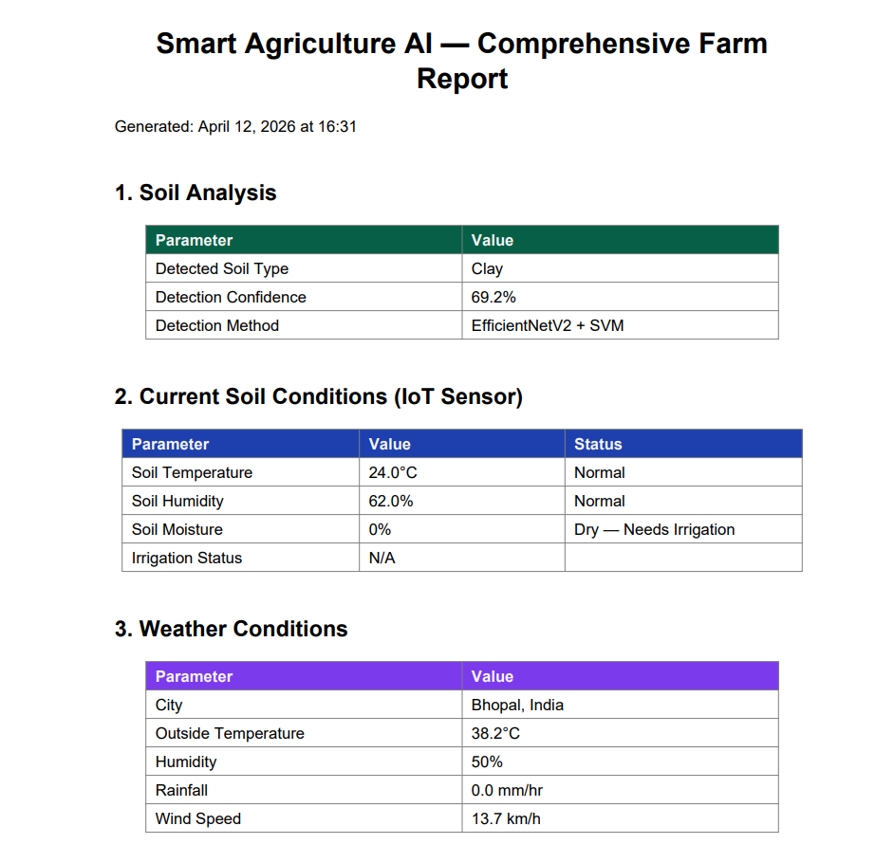

Figure 10: Automatically generated Comprehensive Farm Report documenting AI soil classification confidence, real-time IoT sensor telemetry, and local meteorological conditions.

- What aspect(s) of the invention need(s) protection?

1. The Multimodal Sensor-Vision Fusion Pipeline: A computational methodology that extracts a 1,382-dimensional visual embedding using a Convolutional Neural Network (EfficientNetV2-B0) and concatenates it with normalized real-time hardware telemetry (soil moisture, ambient temperature, relative humidity) to create a proprietary inferential tensor for absolute soil classification.
2. Context-Aware Predictive Irrigation Engine: A hardware-software interrupt mechanism where an edge microcontroller evaluates the fusion-derived physical soil condition alongside localized saturation percentages and meteorological API rain probabilities to autonomously override fixed mechanical irrigation schedules.
3. Profit-Optimized Crop Recommendation Engine: A computational algorithm that generates a diversified acreage allocation matrix by cross-referencing AI-classified soil conditions against a weighted scoring system comprising crop yield estimates, seasonal weather alignment, and real-time government Minimum Support Price (MSP) economics.
4. Unified Agri-Diagnostics Probe & Mobile Ecosystem (Future Embodiment): The conceptualization of a market-ready, portable standalone hardware probe integrating discrete capacitive moisture, ambient environmental, continuous pH, and NPK macronutrient sensors. This probe interfaces wirelessly with a companion mobile application that captures real-time soil imagery via a smartphone camera, subsequently transmitting the aggregated visual and telemetric data to a cloud-based AI inference engine for instantaneous diagnostics and predictive recommendations.

Invention Disclosure Format (IDF)-B | Document No. | 02-IPR-R003
 | Issue No/Date | 2/01.02.2024
 | Amd. No/Date | 0/00.00.0000

- What is Technology readiness level of your invention? (Tick the appropriate TRL)

Research |  |  | Development |  |  | Deployment
TRL 1 | TRL 2 | TRL 3 | TRL 4 | TRL 5 | TRL 6 | TRL 7 | TRL 8 | TRL 9
Basic | Technology | Experimental | Technology | Technology | Technology | System | System | Actual system
Principles | concept | proof of | validated in | validated in a | demonstrated | prototype | complete | proven in an
observed | formulated | concept | a lab | relevant | in a relevant | demonstration | and | operational
 |  |  |  | environment | environment | in an | qualified | environment
 |  |  |  | (industrially | (industrially | operational |  | (competitive
 |  |  |  | relevant in | relevant in | environment |  | manufacturing
 |  |  |  | case of key | case of key |  |  | in case of key
 |  |  |  | enabling | enabling |  |  | enabling
 |  |  |  | technologies) | technologies) |  |  | technologies,
 |  |  |  |  |  |  |  | or in space )

----------------------END OF THE DOCUMENT-----------------------------

