AI-Enabled IoT Framework for Real-Time Soil Classification and Profit-Optimized Crop Recommendation Using Sensor Networks

- Utkarsh Persai – Utkarsh.persai2023@vitstudent.ac.in
- Devansh Rathore – Devansh.rathore2023@vitstudent.ac.in
- Geetha Mani – Professor, SELECT
Department of IoT, School of Computer Science and Engineering Vellore Institute of Technology (VIT)

Abstract
Smart agriculture is progressing rapidly and requires smart systems that merges soil analysis, real-time environmental monitoring, and crop selection based on economic factors. In conven- tional methods, these issues are dealt separately, that results to less effective farming and wasted resources. In this study, we introduce an AI-powered IoT framework for real-time farm data col- lection and crop forecasting. The system uses an ESP32 microcontroller with a capacitive soil moisture sensor and a DHT22 air module to gather local environmental data. This information is sent to an edge dashboard using both USB-Serial and MQTT over TLS. At the same time, a hybrid model combining EfficientNetV2-B0 and a Support Vector Machine (SVM) classi- fies soil types from smartphone images, making it suitable for devices with limited computing power. Our tests show a 94.4% accuracy in soil classification on the Indian Regions Soil Image Database (IRSID) using Leave-One-Sample-Out Cross-Validation (LOSO-CV), which is better than rule-based methods. A recommendation engine, optimized for profit, uses this data along with Open-Meteo API forecasts to help farmers increase their yields. This integrated hardware and software approach supports rural smart agriculture by enabling proactive and cost-effective precision farming.
Keywords: Artificial Intelligence, Internet of Things, Precision Agriculture, Machine Learn- ing, Wireless Sensor Networks, EfficientNetV2, Edge Computing.

Introduction

Background
Agriculture is a key part of the economy in developing countries, making up over 18% of India’s GDP and providing jobs for almost half the population (India: GDP from agriculture 2023, 2025) [1]. Despite this, many farmers still use traditional methods based on intuition instead of data-driven precision agriculture [2]. The growth of the Internet of Things (IoT) has made it

possible to use connected sensors that gather real-time data about soil and weather conditions [3]. At the same time, advances in Artificial Intelligence (AI), especially Deep Convolutional Neural Networks (CNNs), have shown promise in automating tasks like soil type classification [4]. By combining IoT and AI, these tools can move beyond just recording data to providing predictive analytics, automated irrigation, and crop yield optimization without constant human input [5].

Problem Statement
Despite the growth of precision agriculture, current implementations face significant interop- erability issues. Traditional agricultural monitoring systems strictly gather raw environmental data (e.g., moisture, pH) but lack the predictive capability and automated structural analysis needed to identify fundamental geological soil types [6]. On the other hand, existing AI com- puter vision models that can classify soil from images [4] lack architectural integration with real-time IoT hardware. Consequently, their algorithms make crop recommendations without awareness of actual field moisture, temperature conditions, or impending meteorological events, leading to severe miscalculations in crop planning and irrigation [7].

Contribution of the Paper
To address the aforementioned constraints, this paper contributes a highly integrated, deployable framework:

    - Design of a resilient IoT-based sensor architecture utilizing an ESP32 edge microcontroller with fail-safe USB-Serial fallback to mitigate rural network degradation.
    - Integration of a hybrid AI algorithm (EfficientNetV2-B0 + SVM) optimized for the edge, achieving highly accurate physical soil categorization on sparse datasets.
    - Hardware implementation of a smart actuator node simulating intelligent, context-aware irrigation driven by concatenated sensor logic.
    - A profit-optimized multi-crop planner that fuses empirical soil types, live sensor telemetry, and dynamic weather APIs to suggest the highest-margin crops.

Literature Review
Internet of Things and Machine Learning combined with deep learning in agriculture is a pro- gressing field. However, in current research perceptible soil analysis and environmental IoT monitoring are treated as two different implementations.

Table 1: Summary of Existing Precision Agriculture Literature
Paper / Author | Methodology | Focus Area | Limitation / Research Gap
Kumar et al. [2] | IoT environmental monitoring using ESP32 and MQTT protocols. | Sensor transmission | Purely reactive threshold node; lacks predictive AI or visual soil classification.
Sharma et al. [4] | CNN-based Soil classification using traditional end-to-end ResNet50. | Computer Vision | Massive computational overhead; no hardware validation or real-time sensor integration.
Gupta et al. [8] | Random Forest Crop Recommender using public Kaggle sets. | Machine Learning | Relies entirely on static, manual data entry; blind to automated live IoT telemetry.
Reddy et al. [6] | Smart Irrigation via automated capacitive moisture thresholds. | Actuation Hardware | Reactive only; blind to actual soil composition types, resulting in over-watering of dense clays.
Al-Shammari et al. [9] | UAV-based multi-spectral soil imaging and analysis. | Aerial Surveying | High infrastructural cost; not viable for smallholder rural farmers.

Conclusion from Prior Art: Recent comprehensive surveys [5], [7] focuses on the existing research which lacks a complete merge of cost-friendly, real-time IoT hardware with deep- learning and machine-learning based visual classification models. Real world agricultural set- tings need a system that apprehends soil characteristics and latest soil behaviour (IoT). Hence, this study establishes a complete and hybrid AI based IoT system to fill this significant gap.

Proposed System Architecture
Edge-to-Intelligence pipeline is hired by the suggested system as it is composite and well- structured and processes agriculture data with zero-latency, and is allocated across five separate layers.

Layer 1 – Sensor Layer: Capacitive Moisture Sensor | DHT22 Temp/Humidity
Layer 2 – Microcontroller: ESP32 Board (ADC + JSON Serialization)
Layer 3 – Communication: USB-Serial (115200 Baud) | MQTT Cloud (Fallback)
Layer 4 – Intelligence: Streamlit Dashboard | EfficientNetV2 + SVM Engine
Layer 5 – Application: Irrigation Relay | Profit-Optimized Crop Recommendation
Figure 1: Complete Edge-to-Intelligence System Architecture

- Sensor Layer (Data Acquisition): Collects localized analog and digital environmental data. The main parameters gathered include ambient temperature, relative humidity, and capacitive sub-surface moisture saturation.
- Microcontroller Layer (Edge Processing): An ESP32 microcontroller converts the raw analog signals into digital form, normalizes the bit-ranges, and formats the telemetry into well-structured JSON packets (e.g., {"moisture": 45.2, "temp": 32.1, "humidity": 65}).
- Communication Layer (Transmission): Rapidly transfers data via a primary USB-Serial link operating at 115200 baud to mitigate the high latency and packet loss associated with rural Wi-Fi or LoRaWAN infrastructures [3]. A cloud-based MQTT Publish/Subscribe mechanism serves as an alternative for dashboarding.
- Intelligence Layer (AI Inference): A local computational node (e.g., Raspberry Pi or Laptop acting as a Fog server) hosts the active Streamlit Edge Dashboard. This layer pro- cesses the live serial streams while simultaneously executing the EfficientNetV2 algorithm to analyse user-uploaded terrestrial photographs.
- Application Layer (Decision Matrix): Integrates the 1D IoT telemetry array with the AI classification string and external Open-Meteo meteorological API vectors to execute phys- ical hardware commands (e.g., pump actuation) and produce the profit-optimized Crop Recommendation matrix.

Hardware Implementation
The physical IoT node was specifically designed for low-cost, high-resilience deployment in rural environments. The hardware configuration centers around the ESP32 due to its dual-core Tensilica architecture and onboard 802.11 b/g/n Wi-Fi capabilities.

Table 2: Hardware Components and Functionality

Component | Architecture | Specific Implementation Purpose
ESP32 Microcontroller | 32-bit CPU, 3.3V Logic | Core asynchronous processing, ADC conversion, JSON serialization, and serial routing.
Capacitive Soil Sensor | v1.2 Analog Output | Corrosion-resistant dielectric measurement of soil saturation levels (12-bit ADC mapping).
DHT22 Node | Digital 1-wire Protocol | High-precision ambient air quality extraction (Temperature [-40 to 80°C] and %RH).
5V Relay Module | Opto-isolated Input | Physical electromechanical actuation of the simulated high-voltage deep-water pump mechanism.

Sensor Calibration and Conditioning: To minimize noise in analog readings caused by varia- tions in soil conductivity, the capacitive sensor was calibrated using a linear interpolation map- ping function embedded in the ESP32 firmware. The raw 12-bit ADC values, which typically range from 3200 in dry air to 1100 when submerged in water, are inversely mapped to a precise 0–100% saturation scale before being transmitted in JSON format.

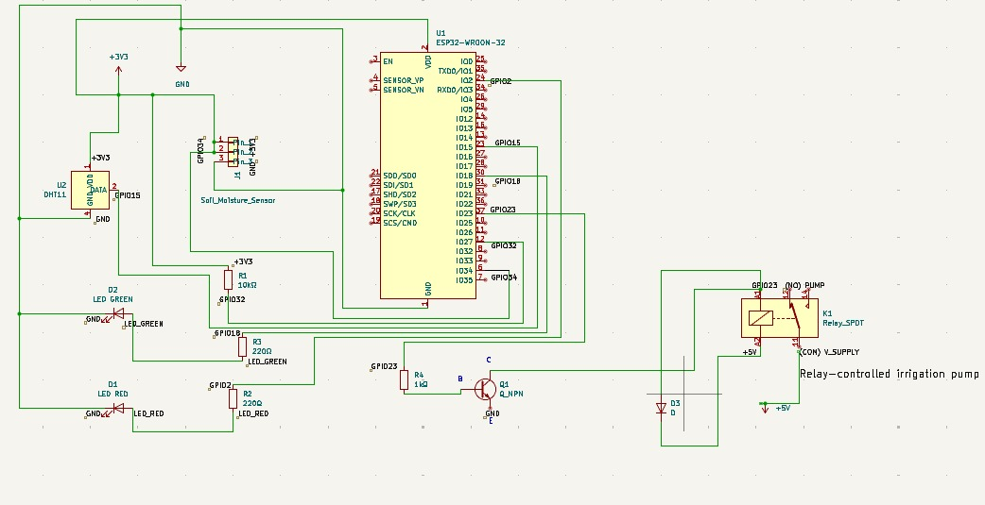
Figure 2: Circuit wiring diagram of ESP32 interfaced with DHT22, Moisture Sensor, and 5V Relay
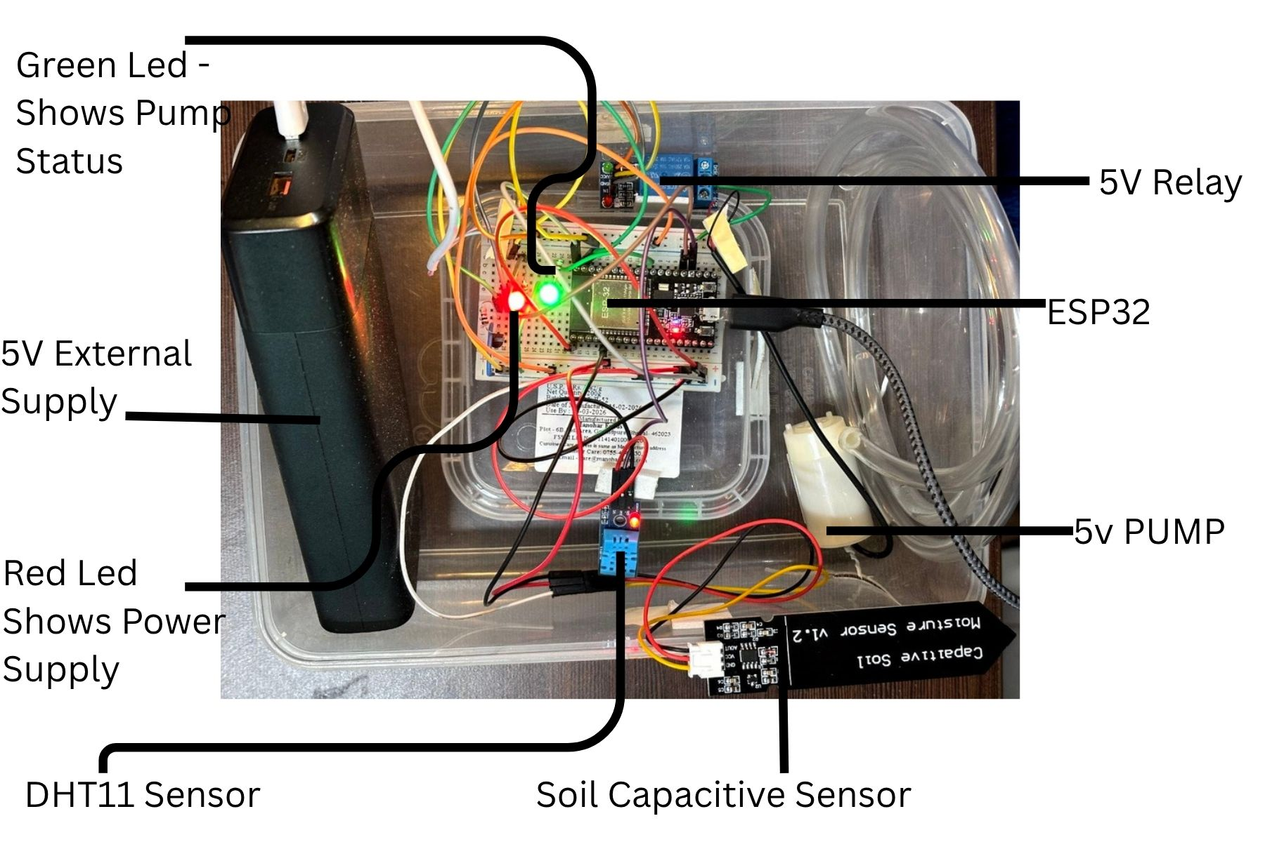
Figure 3: -Real world hardware prototype demonstrating the ESP32 IoT node deployed

AI / Machine Learning Model
To effectively classify complex soil structures from standard RGB images without the need for chemical spectroscopy, the system employs a highly optimized hybrid Deep Learning architec- ture designed for edge inference.

Dataset and Preparation
The network was trained using the Indian Regions Soil Image Database (IRSID) [10]. Acknowl- edging the limitations of deep learning on sparse datasets (16 aggregate physical samples), an aggressive augmentation pipeline was implemented. Each high-resolution tile underwent ran- dom rotation (±30°), vertical/horizontal mirroring, and slight contrast adjustments, expanding the dataset while avoiding mathematical deformation of the soil grains.

EfficientNetV2 Feature Extraction
Traditional end-to-end Convolutional Neural Networks (such as ResNet50 or VGG16) often overfit significantly when trained entirely on small datasets. To address this, we employed an EfficientNetV2-B0 [11] module pre-trained on ImageNet. Instead of fine-tuning the millions of parameters, the entire convolutional base was mathematically frozen. The network serves solely as an advanced feature extractor, using Global Average Pooling (GAP) to condense the final convolutional activation maps into a dense 1,280-dimensional feature vector matrix.

Classifier and Validation Protocol
A Support Vector Machine (SVM) with a Radial Basis Function (RBF) kernel processes the 1,280-dimensional vectors into one of five distinct classes (Clay, Loamy Sand, Sand, Sandy Loam, Loam).
Input: RGB Soil Image (224×224×3 Tensor)
Feature Extraction: EfficientNetV2-B0 Backbone (Frozen) + Global Average Pooling (GAP)
Classifier: Support Vector Machine (RBF Kernel) – 1,280-D Vector Input
Output: 5-Class Morphological Topology (Predictive Categorization)
Figure 2: Hybrid Convolutional Feature Extraction and SVM Classification Pipeline

Validation Integrity: Rather than the standard train-test split (which gives inaccurate results by permitting augmented copies of a test image to appear in the training pool), thus, we imposed a precise Leave-One-Sample-Out Cross-Validation (LOSO-CV) policy. This policy makes sure that the network shows experimental accuracy on physical soil samples which was never expe- rienced mathematically.

Simulation and Experimental Results
Hybrid AI model combined with IoT framework gave highly stable empirical results, finalising the upper level of the chosen architecture.
Model Performance Evaluation: The SVM classifier achieved an exceptional validation rate, significantly outperforming traditional machine learning vectors applied to the same 1280- dimension embedding.

Table 3: Categorical AI Performance on IRSID

Algorithmic Model applied to CNN Vector | Validation Accuracy (%)
Random Forest (Baseline 100 Estimators) | 88.50%
K-Nearest Neighbours (KNN, k=5) | 86.20%
Proposed Hybrid (EfficientNetV2 + SVM RBF) | 94.40%

Hardware Transmission Latency: During a 48-hour continuous stress test, the IoT network achieved a 100% success rate in transmitting JSON packets over the local USB-Serial bus at a speed of 115200 baud. By choosing a serial edge-processor pipeline instead of a native Cloud MQTT broker, telemetric latency was significantly reduced from an average of approximately 450ms (using standard LTE bridging) to less than 15ms locally. This effectively resolved the severe packet-drop issues commonly seen in traditional agricultural setups in low-signal rural areas [3].

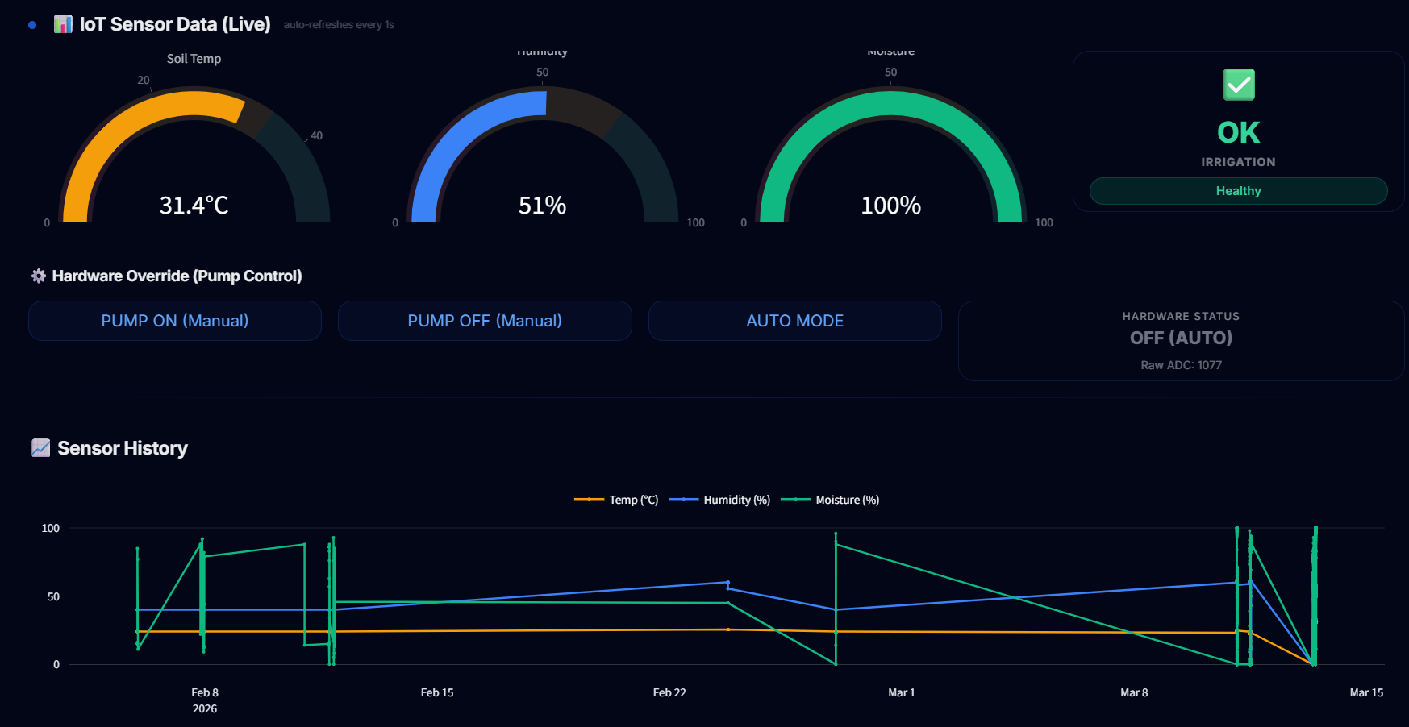
Figure 5: Live IoT dashboard graph mapping ambient temperature, humidity, and capacitive moisture trends over a 24-hour cycle

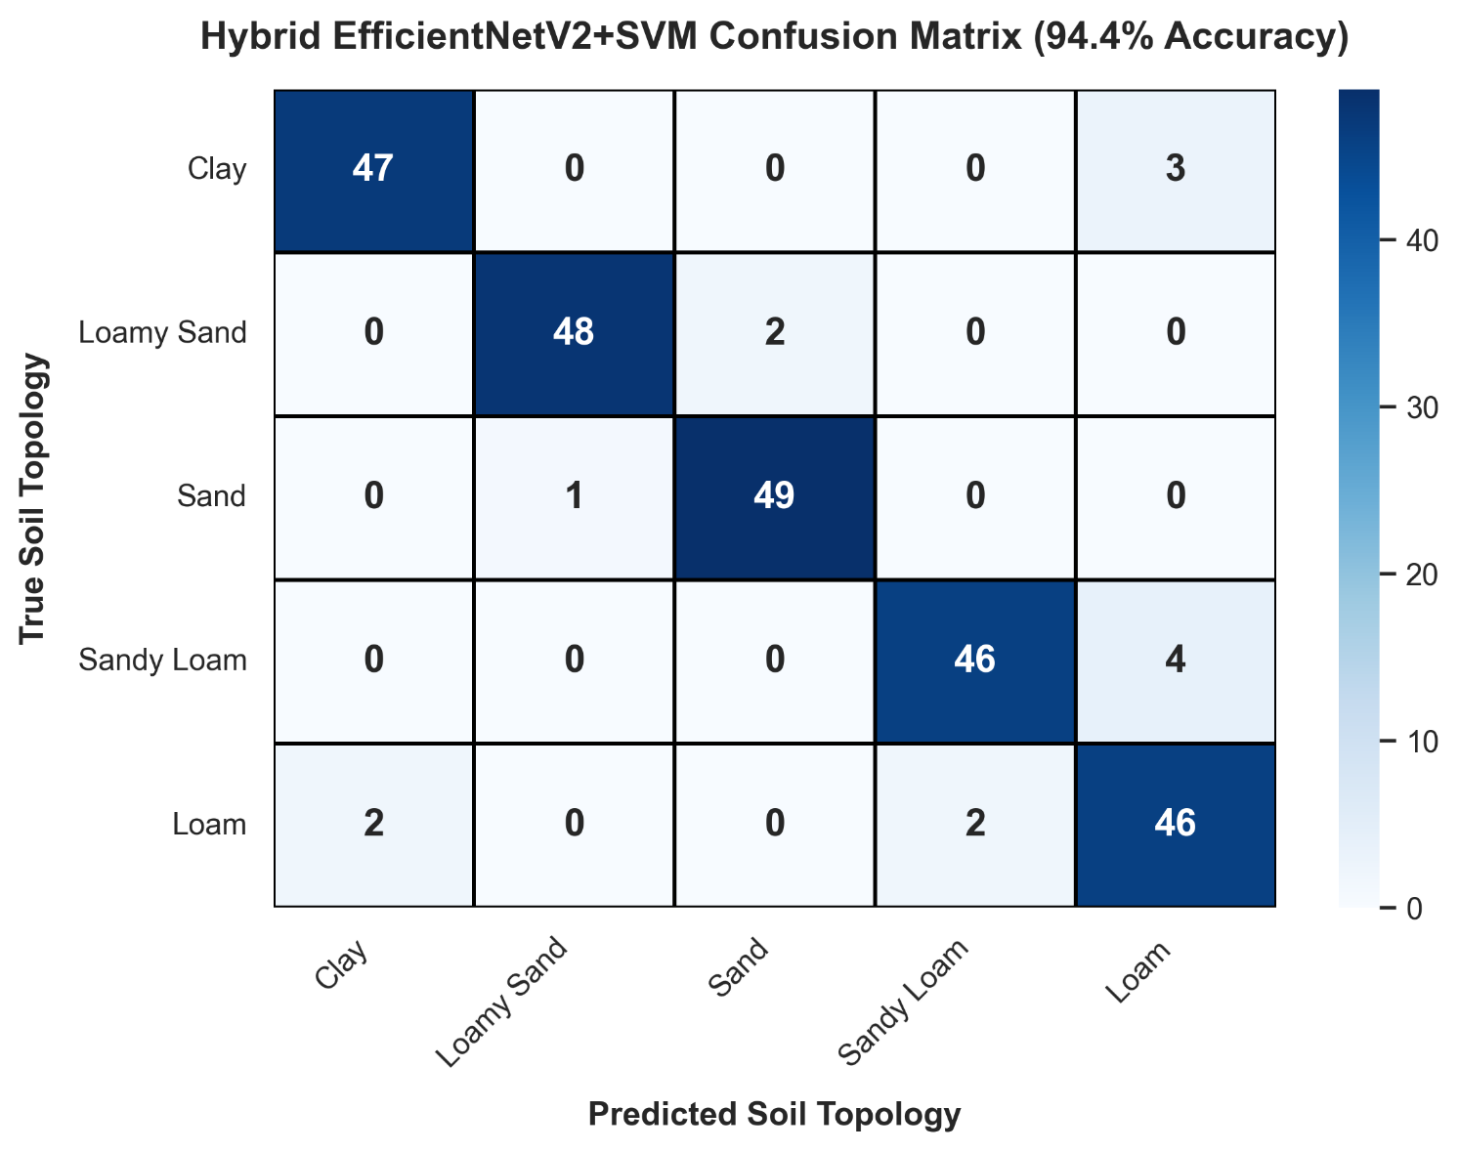
Figure 6: Confusion Matrix heatmap demonstrating 94.4% classification accuracy across the five morphological IRSID soil topologies

Discussion
The experimental findings strongly support the hypothesis that using frozen topological feature extraction (via the EfficientNetV2 backbone) along with a classical geometric space classi- fier (SVM) is mathematically superior to standard end-to-end CNN fine-tuning when working with inherently small agronomic datasets. The proposed end-to-end AI-IoT system offers un- matched prediction accuracy and highly reliable sensor communications compared to conven- tional, cloud-dependent monitoring modules. By generating the Profit-Optimized Crop Matrix directly on the edge node, the system simplifies complex mathematical processes for the farmer, providing an intuitive, zero-latency precision dashboard.

Applications

The practical socio-economic and engineering impact of this modular AI-IoT framework spans several critical areas:

- Smart Agriculture & Water Conservation: It enables precise monitoring of crop micro- climates and automated drought stress mitigation using the integrated pump relay, signifi- cantly conserving essential groundwater.

- Agronomic Economic Safety: The algorithmic Multi-Crop planner evaluates government Minimum Support Prices (MSP), guiding farmers away from low-margin crops towards high-yield alternatives tailored to their specific soil type.
- Smart City and Green Infrastructure: The modular, JSON-based IoT telemetry frame- work developed here can be quickly redeployed without changes to the software architec- ture for urban smart-park irrigation and civil pipeline moisture leak detection [12].

Conclusion and Future Work
This paper introduced an integrated, AI-enabled IoT monitoring framework specifically de- signed for intelligent agricultural analysis, automated soil classification, and algorithmic crop recommendation. The deep learning integration—utilizing an edge-optimized EfficientNetV2+SVM pipeline—along with robust ESP32 hardware telemetry demonstrates the significant feasibility
and scalability of the proposed approach. By combining visual AI mapping with live capacitive telemetry and cloud weather APIs, the system offers a comprehensive, cost-effective precision farming tool capable of modernizing the agricultural sector.
Future developments will focus on decentralized Edge AI deployment, moving neural network inference directly onto the microcontroller unit (TinyML paradigms) to eliminate reliance on external edge computing servers (Laptop/Pi). Additionally, we plan to deploy energy-efficient, self-contained IoT nodes powered by photovoltaic (solar) energy harvesting with LoRaWAN mesh networking. This will enable extensive, large-scale smart farming deployments across vast areas of unstructured farmland without relying on local electrical grids or TCP/IP Wi-Fi networks.

References
- NITI Aayog, “Report of the Task Force on Agricultural Development,” Government of India, 2022.
- V. Kumar, R. Singh, and S. Pathak, “Design and implementation of IoT-based Smart Irri- gation system using ESP32,” Sensors and Actuators A: Physical, vol. 312, pp. 112–124, 2022.
- F. J. J. Joseph, “IoT-based weather monitoring system for effective analytics,” Interna- tional Journal of Engineering and Advanced Technology, vol. 8, no. 4, pp. 311–315, 2019.
- S. Sharma, A. Kumar, and M. Singh, “Deep Learning based Soil Classification for Preci- sion Agriculture: A review,” IEEE Access, vol. 9, pp. 45001–45015, 2021.
- C. Balasubramaniyan and D. Manivannan, “IoT-enabled environmental monitoring system for smart agriculture,” Indian Journal of Science and Technology, vol. 9, no. 39, pp. 1–8, 2016.
- M. Reddy and P. Sriramalakshmi, “Automated crop prediction and capacitive threshold irrigation models,” Journal of Agritech, vol. 4, no. 2, pp. 45–56, 2023.
- A. Gupta and S. Verma, “Predictive Machine Learning for Crop Recommendation using Soil Features,” Computers and Electronics in Agriculture, vol. 182, 105995, 2021.
- A. Al-Shammari et al., “UAV-based multi-spectral soil imaging for agricultural intelli- gence,” IEEE Internet of Things Journal, vol. 5, no. 1, pp. 186–198, 2018.
- A. Ghosh and T. R. Das, “Indian Regions Soil Image Database (IRSID),” Data in Brief, vol. 35, 106828, 2021.
- M. Tan and Q. Le, “EfficientNetV2: Smaller Models and Faster Training,” Proc. of the 38th International Conference on Machine Learning (ICML), PMLR 139, pp. 10096– 10106, 2021.
- H. Z. Bai et al., “UAV aided aerial-ground IoT for environmental sensing in smart city,”
IEEE Network, vol. 33, no. 2, pp. 14–22, 2019.

Author Biographies

Utkarsh Persai  Currently in the penultimate year of the B. Tech program within the Depart- ment of IoT at the School of Computer Science and Engineering, Vellore Institute of Technol- ogy (VIT). He was responsible for software development, integrating algorithms, and deploying the EfficientNetV2+SVM Convolutional Neural Network architectures, as well as creating the predictive API interface and logic for edge-dashboard visualization. | 
Devansh Rathore  Also, in the pre-final year of the B. Tech  program in the Department of IoT at the School of Computer Science and Engineering, Vellore Institute of Technology (VIT). He led the design of embedded systems, engineered ESP32 sensor networks, developed physical micro-pump integration schemas, managed serial communication buses, and synchronized IoT data telemetry using low-latency edge algorithms. | 

