CYBER CAFÉ MANAGEMENT SYSTEM

Team Name: DOPE

Team Members:

Utkarsh Gupta(BE/10526/17)

Karandeep Singh(BE/10547/17)

Aaradhya Jain(BE/10575/17)

* Block Diagram:
* 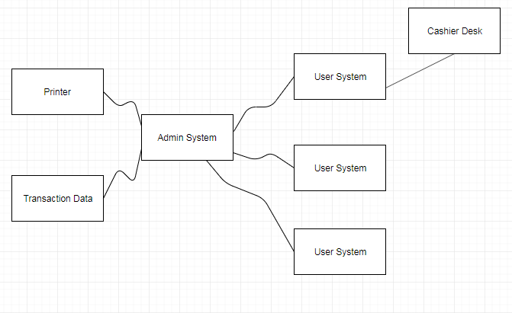
* *Classes:*

1. Software
2. Cyber café network
3. Cashier
4. Computer System
5. Login page
6. Registration page
7. Cyber café
8. Admin’s System
9. Account
10. Transaction
11. Cashier’s desk
12. Account data
13. Transaction data
14. Billing
15. Cash/Card
16. User
17. Printer
18. Scanner
19. Receipt
20. Recordkeeping provision
21. Security provision
22. Usage
23. Cost
24. Time
25. Transaction log
26. Firewall
27. Admin’s name

* *Bad Classes:*

1. Transaction log (redundant)
2. Account (redundant)
3. Cyber Café Network (redundant)
4. Computer System (vague)
5. Admin’s name (attribute)
6. Software (vague)
7. Time (redundant)
8. Billing (redundant)
9. User (vague)
10. Firewall (redundant)
11. Usage (vague)

* *Good classes:*

1. Cashier
2. Login page
3. Registration page
4. Cyber café
5. Admin System
6. Transaction
7. User system
8. Cashier desk
9. Account data
10. Transaction data
11. Cash/Card
12. Printer
13. Scanner
14. Receipt
15. Security provision
16. Cost

* *Data Dictionary:*

1. Cashier: An employee of the café who is authorized to enter transactions into cashier system and accept cash/card from customers, in exchange of their usage.
2. Login Page: A page that allows the users to login into their previously existing accounts before they use the system.
3. Registration Page: A page that allows new users to register themselves.
4. Cyber Café: An institution that allows users to access the computer systems in exchange for money.
5. Admin System: The computer used by the admin of the cyber café to run the cyber café.
6. Transaction: A single integral request for operations on the accounts of a single or multiple users.
7. User System: The computer used by the users to access the internet and to do other tasks.
8. Cashier Desk: A place where the cashier sits and does its job.
9. Account Data: The data relating to various users. A customer cannot hold more than one account. This contains data like users’ previous usage and other details.
10. Transaction Data: The data related to all the transactions that take place every day at the café.
11. Cash/Card: A mode of payment.
12. Printer: A computer peripheral to be used by the users to print documents, pictures etc. Also used by the cashier to print the bills.
13. Scanner: A computer peripheral to be used by the users to scan documents, pictures etc.
14. Receipt: A document printed by the cashier’s printer containing details regarding the usage and the bill and is given to the customer once he/she is done using the system.
15. Security Provision: Security provisions include CCTV cameras, firewalls, antiviruses etc. to prevent any kind of stealing or damage to the systems.
16. Cost: It is the total amount that the user has to pay including the discount, once he/she is done using the system.

* Class Diagram:

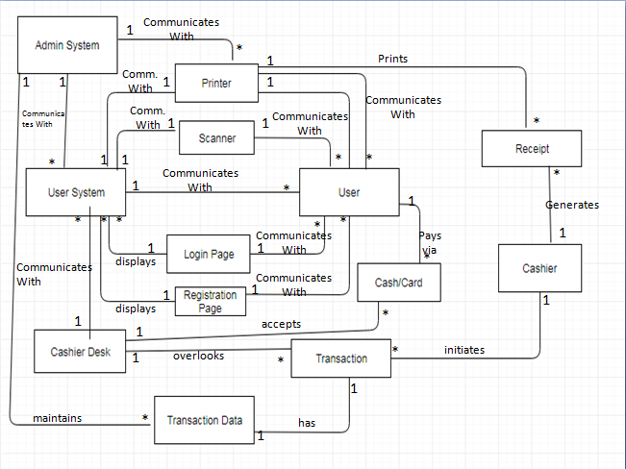

Keeping the Right Associations:

* Irrelevant or implementation associations:

1. Generates: Between ‘cashier’ and ‘receipt’
2. Overlooks between ‘cashier desk’ and ‘transaction’
3. Accepts between ‘cashier desk’ and ‘cash/card’
4. Communicates with between ‘Admin System’ and ‘Printer’
5. Communicates with between ‘User System’ and ‘Scanner’