Exp No: 5
Aim:- Implement Circular Queue ADT using array.

#include <stdio.h>
# define max 6
int queue[max];
int front=-1;
int rear=-1;
void enqueue(int element)
{
if(front==-1 && rear==-1)
{
front=0;
rear=0;
queue[rear]=element;
}
else if((rear+1)%max==front)
{
printf("Queue is overflow..");
}
else
{
rear=(rear+1)%max;
queue[rear]=element;
}
}
int dequeue()
{
if((front==-1) && (rear==-1))
{
printf("\nQueue is underflow..");
}
else if(front==rear)
{
printf("\nThe dequeued element is %d", queue[front]);
front=-1;
rear=-1;
}
else
{
printf("\nThe dequeued element is %d", queue[front]);
front=(front+1)%max;
}
}
void display()
{
int i=front;
if(front==-1 && rear==-1)
{
printf("\n Queue is empty..");
}
else
{
printf("\nElements in a Queue are :");
while(i<=rear)
{
printf("%d,", queue[i]);
i=(i+1)%max;
}
}
}
int main()
{
int choice=1,x;
while(choice<4 && choice!=0)
{
printf("\n Press 1: Insert an element");
printf(" Press 2: Delete an element");
printf(" Press 3: Display the element");
printf("\nEnter your choice");
scanf("%d", &choice);
switch(choice)
{
case 1:
printf("Enter the element which is to be inserted");
scanf("%d", &x);
enqueue(x);
break;
case 2:
dequeue();
break;
case 3:
display();
}}
return 0;
}

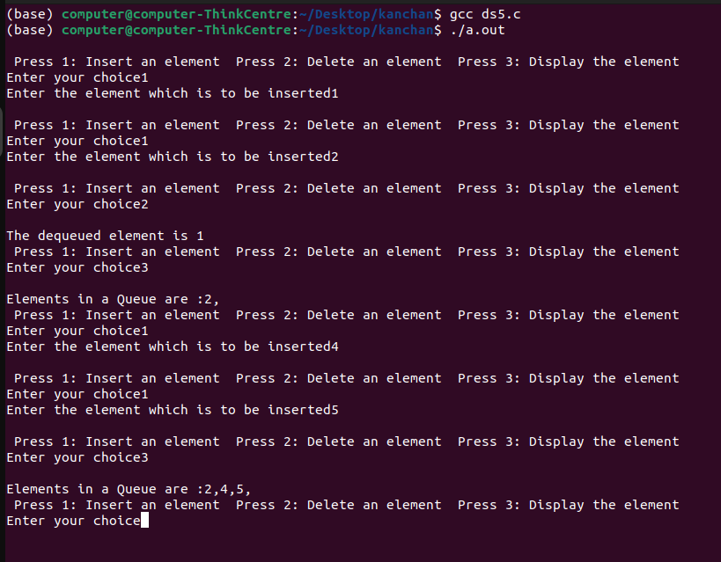
Conclusion :- Hence we have implimented circular queue ADT using array.

