**Utku Güçlü**

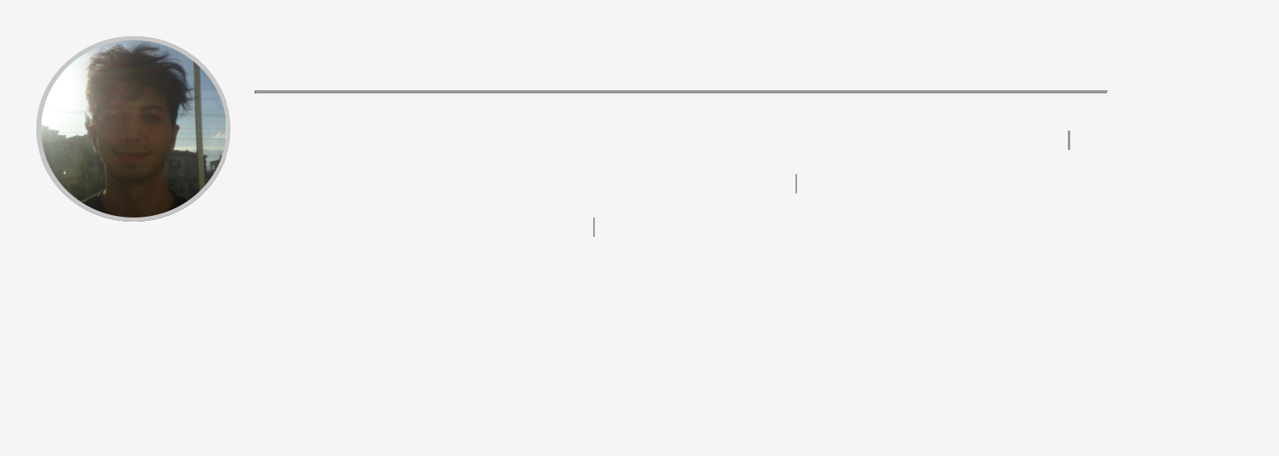

**Date of birth:** 09/09/1992  **Nationality:** Turkish  **Gender:** Male (+90) 5395549512



[utku_guclu@hotmail.com](mailto:utku_guclu@hotmail.com) <https://github.com/utku-guclu> <https://www.linkedin.com/in/utkuin/>



Yeni Mahalle Irmak Sokak 10/2 Saray, 59600, Tekirdağ, Turkey About me:

I am a Frontend developer. I am passionate about Javascript, React and Node.js. I have developed many web applications with React and Javascript. I have great problem solving and communication skills. I am eager to learn new concepts. I am prone to teamwork and communication within the team.

**WORK EXPERIENCE**



29/03/2022 – CURRENT – Turkey

**CLASSROOM TUTOR –** KODLAND



I have been teaching children the basics of programming by hands-on approach with Scratch, Python, Roblox and Web development

**EDUCATION AND TRAINING**



19/09/2019 – 21/05/2022 – Turkey

**WEB SCIENCE AND DEVELOPMENT –** Anadolu University



**Address** Turkey  **Website** <https://www.anadolu.edu.tr>



**Field of study** Information and Communication Technologies  **Final grade** 3.1



08/09/2010 – 09/09/2015 – Turkey

**MATERIAL SCIENCE AND ENGINEERING –** Dumlupınar University



**Address** Turkey  **Website** <https://www.dpu.edu.tr/> **Field of study** Engineering, manufacturing and construction



09/10/2006 – 12/09/2010

**HIGHSCHOOL DEGREE –** Mustafa Elmas Arıcı Anadolu Lisesi



**Website** <https://sarayanadolu.meb.k12.tr/>

**LANGUAGE SKILLS**



Mother tongue(s): **TURKISH**

Other language(s):



|  |  |  |  |  |  |
| --- | --- | --- | --- | --- | --- |
|  | **UNDERSTANDING** | |  | **SPEAKING** | **WRITING** |
|  | Listening | Reading | Spoken production Spoken interaction | |  |
|  |  |  |  |  |  |
| **ENGLISH** | C1 | C1 | C1 | C1 | C1 |
|  |  |  |  |  |  |
| **JAPANESE** | A1 | A1 | A1 | A1 | A1 |



*Levels: A1 and A2: Basic user; B1 and B2: Independent user; C1 and C2: Proficient user*

**DIGITAL SKILLS**



**My Digital Skills**

Computer Science Knowledge Web Design & Web Development HTML5 CSS JS JQuery Git Javascript ES6 / Typescript GraphQLApollo Programming languages: Basic Knowledge of C,C++,CVI,HTML,Python, Matlab&Simulink, Visual Basic, UML MongoDB (Basics) Google Analytics, Google Firebase TypeScript, NodeJS, Express, React, Mongo, GraphQL



**DRIVING LICENCE**



**Driving Licence:** B

**CONFERENCES AND SEMINARS**



10/04/2021 – 10/07/2021

**CS50's Introduction to Computer Science**



https://cs50.harvard.edu/certificates/947a08b6-876e-44c5-9b3a-f19403161358 <https://certificates.cs50.io/947a08b6-876e-44c5-9b3a-f19403161358>

**PROJECTS**



23/03/2022 – 16/05/2022

**Flalingo - Web Development Internship**



<https://ultra-awesome-site-flalingo.webflow.io/>

Responsive Web Design

16/09/2022 – 11/10/2022

**Patika - Popupsmart React Practicum**



**HONOURS AND AWARDS**



19/05/2020

**TURKISH BODYBUILDING FITNESS AND ARM WRESTLING FEDERATION 19 MAY ATATÜRK MEMORIAL, YOUTH AND SPORTS DAY ACTIVITIES - SILVER MEDAL – TVGFBF**



[https://tvgfbf.gov.tr/wp-content/uploads/2020/05/yarışma-sonuçları-logolu.pdf](https://tvgfbf.gov.tr/wp-content/uploads/2020/05/yar%C4%B1%C5%9Fma-sonu%C3%A7lar%C4%B1-logolu.pdf)

**VOLUNTEERING**



25/07/2022 – CURRENT

**Habitat Association - Coding Tomorrow Project**



Turkey <https://verified.cv/tr/verify/14012142833264?ref>