Simple web server for term project:
Admin

Customer
Room
location

booking site that has user login;
If user is admin then they are redirected to admin page
If user is normal they’re redirected to the main page

This is homework so payment can be dummy

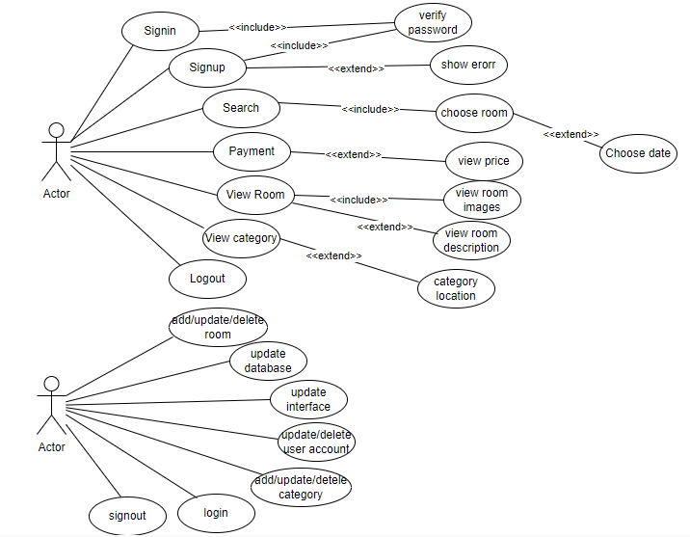

Fixed categories will be:
Hotels, dorms, apartments, roommates, rent a room, guest houses

3. REQUIREMENTS ANALYSIS

3.1 Functional Requirements

3.1.1 User Requirements

R1.1: The user can view their room(s)

R1.2: The user can proceed to checkout page to pay for their booked room(s)

R1.3: The user can sign up with username and password

R1.4: The user can sign in with his account that he created

R1.5: User can remove the object from cart page

R1.6: User can choose the optional packages from realtors

R1.7: User can change password and login

3.1.2 Admin Requirements

R2.1: Admin shall be add,edit,delete and update the avaible rooms and realtors in the website

R2.2: Admin should check the requirements for the booking is already there

R2.3: Admin should check the user have purchase the products with no Erros

R.2.4: Admin should send the receipt after the user purchase the product.

3.1.3 System Requirements

R3.1: Sign up, sign in, logout and checkout buttons should work

R3.2: when the user signs up the system should take information and store in the database

R3.3: When the user signs in the system should know the user if he exists or not

R3.4: When the user logout makes sure the session is ended

R3.5: When the user needs to register before accesing any feature other than registration

R3.6: When the user wants to check the room the “view” button should work

R3.7: When the user wants to book the room “book” button should work

R3.8: When the user views the room all buttons should work

R3.9: User should see the room in question at the payment step page.

R3.10: When the user payment is succesfull, payment information should be stored immediately.

R3.11: After the payment user should be notified of wheter payment was succesful or not.

R3.11: When the user wants to cancel checkout. Room needs to be removed from selection

R3.12: "help chatbot" pop-up should take customer complaint as plain text and customer e-mail. Then send customer email and complaint plain text via email to admin

*What the Application is: * The online platform for booking hotels, dorms, apartments, and private rooms is a web application that aims to make it easier for travelers and students alike to find and book accommodations in turkish republic of northern cyprus .

Note: this is a homework so at payment stage user will enter dummy info and application will only enter payment entries to a table to see them admin’s side.
Like:
purchases:
userid | payment amount | roomid

123 | 9000 | 630

