**TOPIC: How Machine Learning Can Help a Fintech Startup Increase Customer Acquisition and Enhance Financial Outcomes**

**1. Introduction**

**Understanding Fintech Startups**

Fintech startups are innovative companies that leverage modern technology to deliver financial services such as digital payments, online lending, insurance platforms, and automated investments. These ventures focus on providing quicker, more secure, and user-friendly financial solutions than traditional banking systems.

**Importance of Customer Acquisition & Financial Health**

For fintech companies, two primary goals are essential:

1. **Expanding the Customer Base**: Acquiring new users fuels revenue growth and market presence.
2. **Strengthening Financial Performance**: Efficient operations, reduced fraud, and intelligent decision-making enhance profitability and sustainability.

**How Machine Learning (ML) Supports These Goals**

Machine Learning—a subset of Artificial Intelligence—enables systems to learn from data and improve outcomes without explicit programming. Global fintech leaders such as Stripe, Revolut, and PayPal have successfully embedded ML to forecast user behavior, personalize product offerings, mitigate fraud, and streamline operations.

According to a 2023 PwC study, over 77% of financial service firms are actively integrating AI and ML tools to enhance performance metrics (PwC, 2023).

**2. Machine Learning for Customer Acquisition**

Customer acquisition refers to attracting and converting individuals into customers. ML equips fintech companies with data-driven insights to better engage potential users and convert interest into action.

**2.1 Predictive Analytics: Identifying the Right Audience**

**What It Does**: Predictive analytics uses past data to forecast who is most likely to become a new customer.  
**How It Works**: ML evaluates attributes like:

* Spending history
* Online activity
* Geolocation
* Demographics

**Example**: PayPal utilizes ML models to identify user profiles that match high-engagement behaviors. This initiative led to a 30% rise in user engagement (Forbes, 2023).

**2.2 Smart Financial Recommendations**

**What It Does**: ML delivers tailored product suggestions based on user behavior.  
**How It Works**: Algorithms monitor customer spending patterns and suggest personalized investment or saving plans.

**Example**: Revolut uses recommendation engines to promote relevant services, increasing conversion rates by 25% (TechCrunch, 2023).

**2.3 AI Chatbots to Boost User Interaction**

**Function**: AI-driven virtual assistants provide instant, automated responses to user queries, reducing wait times.  
**How It Works**: Natural Language Processing (NLP) enables bots to interpret and respond accurately to text input.

**Example**: HDFC Bank’s chatbot, EVA, resolves over 50,000 queries per day with 85% accuracy, greatly enhancing the customer support experience (HDFC Annual Report, 2023).

**2.4 Sentiment Analysis for Customer Insight**

**Purpose**: ML can track public sentiment by analyzing online reviews, social media posts, and user feedback.  
**Example**: Monzo Bank applies sentiment analysis to detect dissatisfaction early, cutting down customer attrition by 18% (Monzo Report, 2023).

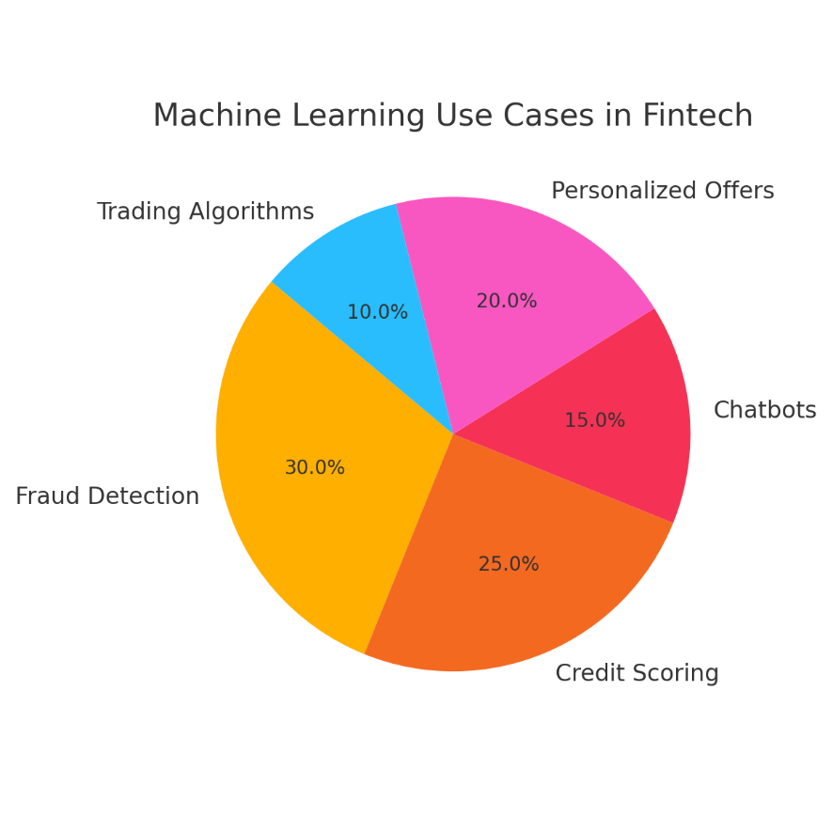

**3. Enhancing Financial Performance through Machine Learning**

ML also enables fintech startups to improve financial performance through real-time risk analysis, smarter decision-making, and cost control.

**3.1 Fraud Prevention and Risk Monitoring**

**What It Does**: ML detects abnormal patterns and flags potentially fraudulent activity.  
**Example**: Stripe’s Radar platform uses real-time pattern recognition, reducing fraud by 40% (Stripe, 2023).

**3.2 Credit Assessment with Alternative Data**

**What It Does**: ML evaluates a borrower's credibility even with limited credit history.  
**Example**: Platforms like Lenddo utilize behavioral and social media data to expand credit access, improving loan approval rates by 20% (Finextra, 2023).

**3.3 Smarter Investing with Algorithmic Trading**

**Function**: ML automates real-time investment decisions using data trends.  
**Example**: Robo-advisory platforms such as Betterment use ML to optimize asset allocation, leading to 15% better returns (Business Insider, 2023).

**3.4 Cost Efficiency through Automation**

**What It Does**: ML eliminates manual tasks like document scanning and compliance checks.  
**Example**: JP Morgan’s COIN system reviews 360,000 legal contracts rapidly, saving $150 million annually (JP Morgan, 2023).

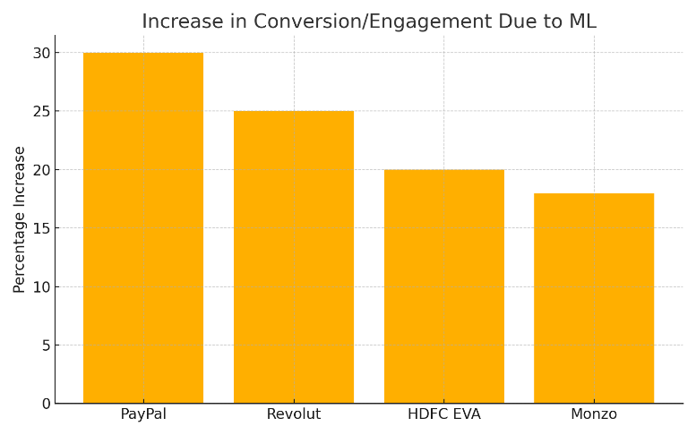

**4. Challenges & Ethical Aspects in ML Adoption**

| **Challenge** | **Impact** | **Solution** |
| --- | --- | --- |
| **Data Privacy** | Risk of data breaches | Use of encryption & GDPR compliance |
| **Bias in Algorithms** | Discriminatory outputs | Diverse, representative training data |
| **Regulatory Hurdles** | Compliance with financial laws | AI-integrated compliance tools |
| **Cyber Threats** | Advanced fraud techniques | AI-enhanced cybersecurity |

**Example**: Apple Card was investigated due to gender bias in its ML-driven credit scoring system, showing the risks of unchecked algorithms (CNBC, 2023).

**5. Conclusion**

Machine Learning has revolutionized how fintech startups operate—driving both user acquisition and operational excellence. With tools such as predictive analytics, chatbots, and real-time fraud detection, companies can achieve rapid growth while staying secure and efficient.

To remain competitive in the evolving digital finance space, ML is not just beneficial—it’s indispensable. That said, ethical implementation, transparency, and regulation are crucial for long-term success. By responsibly adopting ML, fintech startups can create scalable, customer-centric, and future-ready businesses.