Restaurant Recommendation System - Feature Presentation
Date: March 04, 2026
Prepared for: System Feature Explanation & Stakeholder Presentation

1. Executive Overview
This system is an intelligent restaurant recommendation platform that suggests food and drink items based on user preferences, semantic query understanding, and interaction-driven personalization. It combines machine learning ranking algorithms with practical API services.

2. Solution Architecture
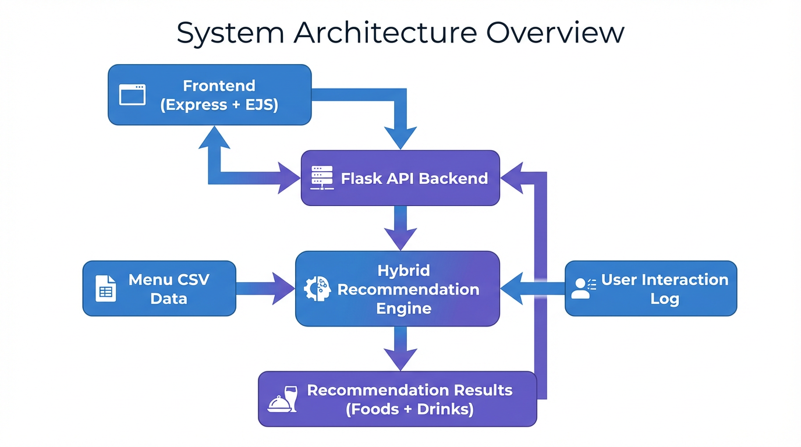
The architecture separates user-facing experience (Express frontend) from ML serving (Flask backend), while the recommendation engine orchestrates multiple models and supports continuous learning.

3. Core System Features
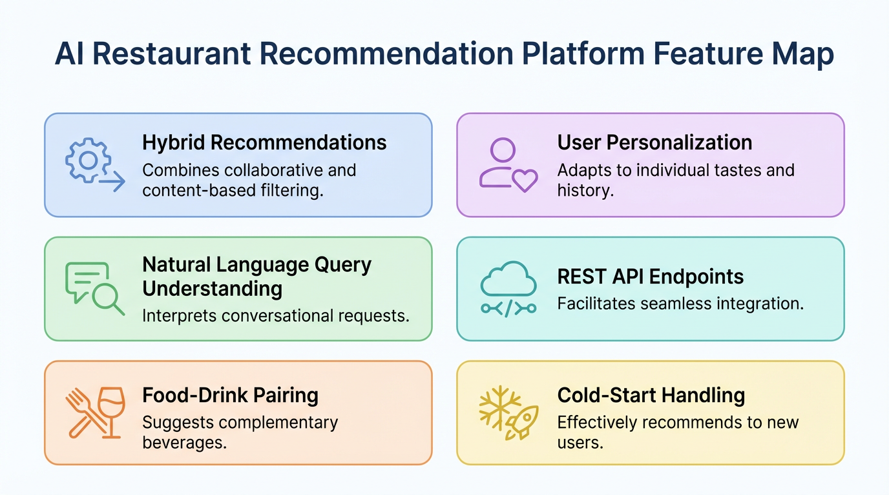
- Hybrid recommendation strategy combining content, fuzzy, collaborative filtering, BPR, and popularity scoring.
- Natural-language query handling with WordNet synonym expansion and broad keyword expansion map.
- Automatic food-drink pairing model for partial or vague user input.
- Personalization through interaction tracking (view/click/like/order/rate) and retrainable user models.
- REST endpoints for recommendations, menu browsing, similarity, popularity, and system stats.
- Cold-start seed profile generation for strong first-run recommendation quality.

4. Recommendation Algorithms Implemented
Content-Based (TF-IDF + Cosine): Ranks items by textual similarity over weighted item/category/description features.
Fuzzy Matching + WordNet: Captures misspellings and lexical variants for better query recall.
Collaborative Filtering (SVD): Learns user-item latent factors from interactions for personalized ranking.
Bayesian Personalized Ranking (BPR): Optimizes pairwise preference ordering for implicit feedback.
Popularity with Time Decay: Surfaces trending items by interaction type and recency weighting.
Drink Pairing Model: Predicts compatible drinks for foods (and reverse) using co-occurrence plus bilinear compatibility.

5. API Capabilities (Flask)
- POST /api/recommend - Main recommendation endpoint with strategy selection and configurable top-N.
- GET /api/menu - Returns full menu split into foods and drinks.
- POST /api/track - Logs user interactions and updates learning signals.
- GET /api/chefs-picks - Returns randomized featured items by category.
- GET /api/popular - Trending items based on decayed popularity.
- GET /api/similar - Similar items from content-space nearest neighbors.
- GET /api/personalized - Personalized recommendations for a given user.
- POST /api/retrain - Retrains trainable model components.
- GET /api/stats - Engine diagnostics (items, users, interactions, strategies).

6. Menu Data Insights
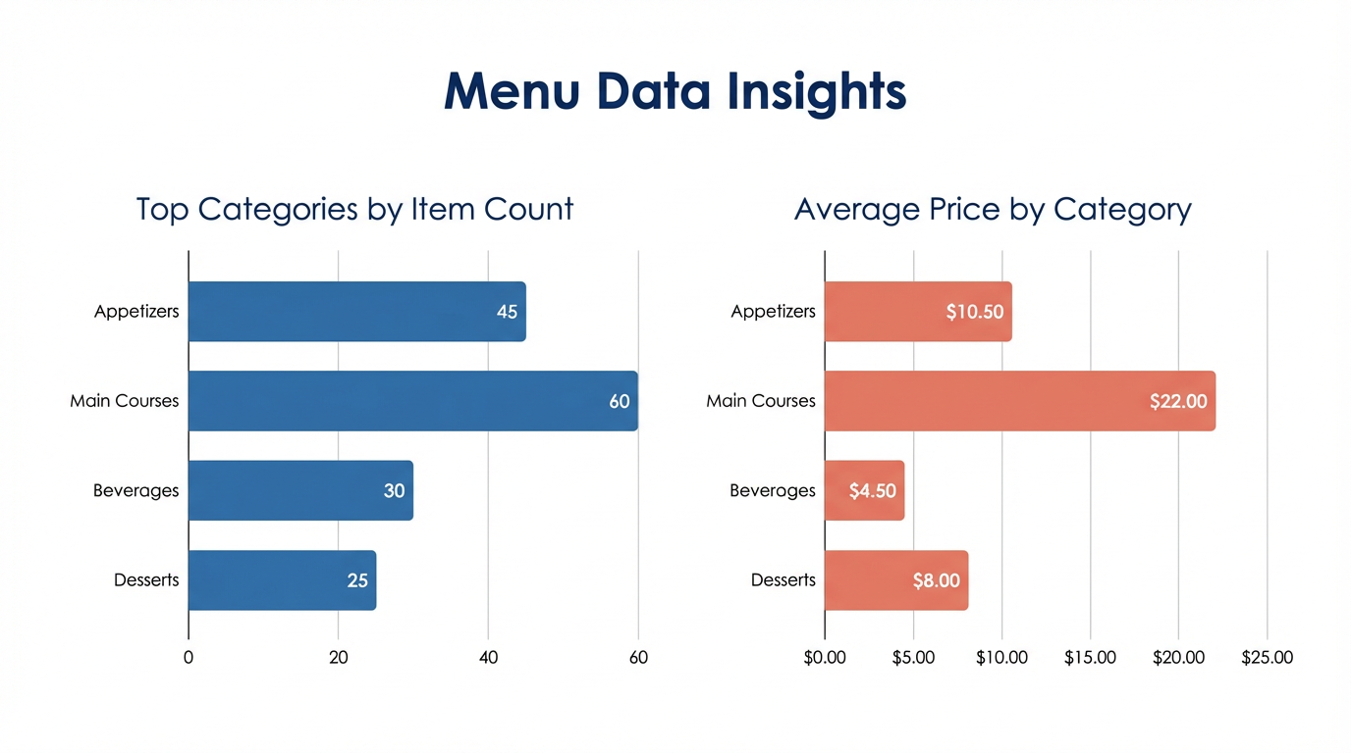
This chart summarizes category distribution and average prices to support stakeholder understanding and recommendation coverage analysis.

7. End-to-End User Flow
- User submits food and/or drink preference from the frontend form.
- Backend preprocesses query and chooses ranking path based on strategy and query confidence.
- Hybrid engine computes candidate scores and optional pairing logic.
- Top food and drink recommendations are returned with score and strategy metadata.
- User actions are tracked and persisted for future personalization improvements.

8. Business Impact
- Improves user decision speed with relevant and explainable suggestions.
- Increases upsell and cross-sell potential through food-drink pairing.
- Supports continuous optimization by learning from real behavior.
- Offers modular architecture for extension to additional menus or branches.

