Restaurant Recommendation System
Feature Overview & Demo Walkthrough • Mar 04, 2026
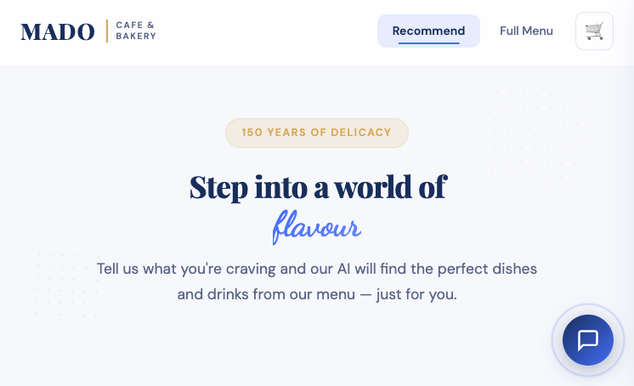
Landing page (Recommend)

What the System Does
- Takes a customer’s food/drink cravings and recommends the best matching menu items.
- Supports multiple recommendation strategies (content, fuzzy, CF, BPR, popularity, hybrid).
- Provides a modern web UI with menu browsing, cart panel, and optional AI concierge chat.
- Learns from interactions (likes/orders) to improve personalization over time.
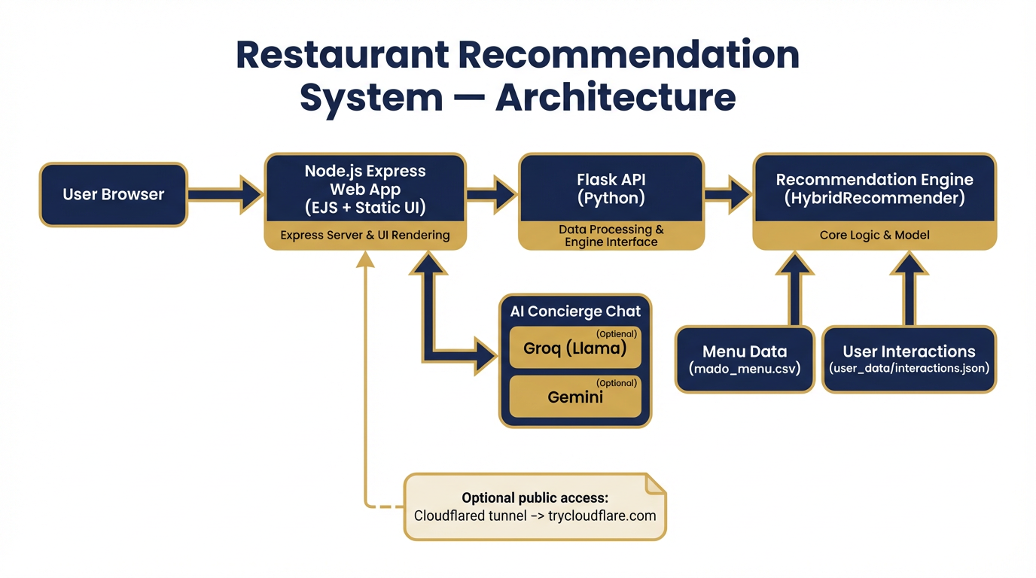
High-level architecture

User Experience — Recommend Flow
- Customer enters a food and/or drink keyword (examples: kebab, coffee, lemonade).
- System returns Top-N foods and drinks with match scores.
- Users can explore similar items and add recommendations to the cart.
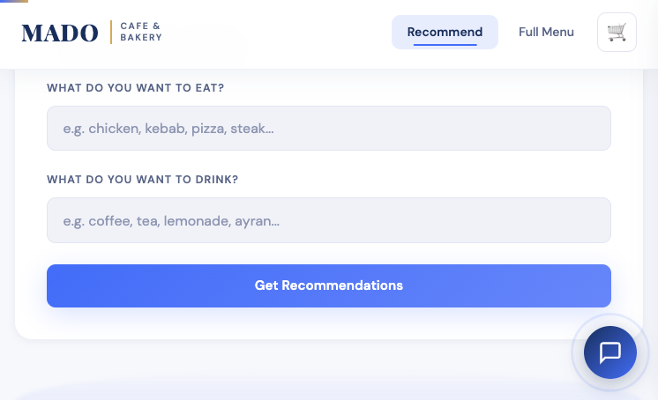
Preference input form
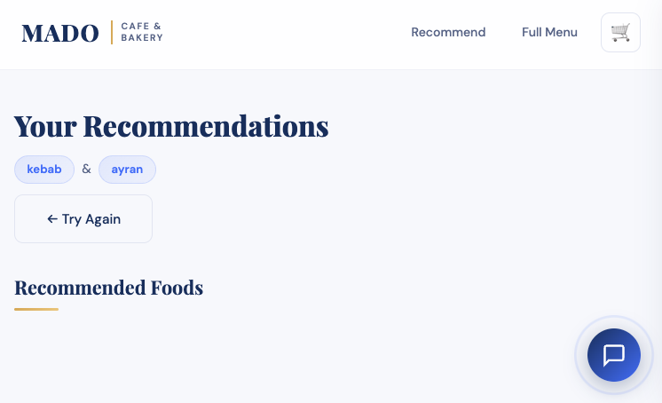
Recommendation results (top)
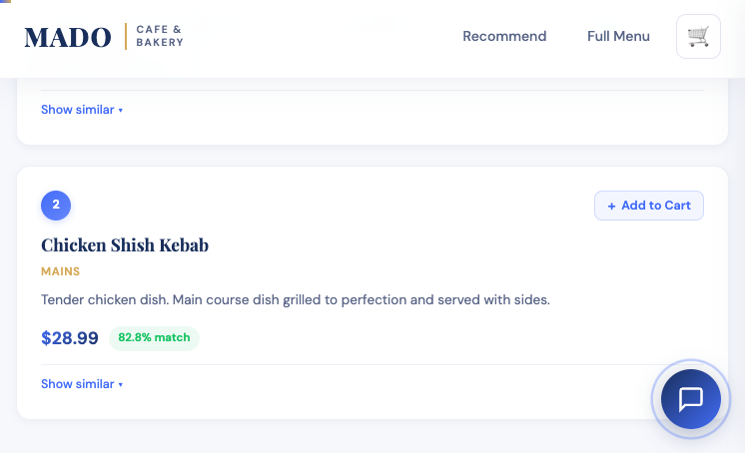
Cards show price + match score + add-to-cart

Chef’s Picks (Home Page)
- Shows curated picks by category (e.g., appetizers/sides, mains, desserts, drinks).
- Each pick includes description and price and can be added to the cart.
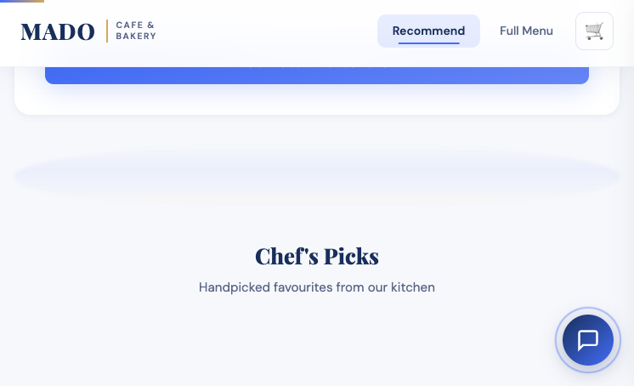
Chef’s Picks section

Full Menu Browsing
- Browse all foods and drinks grouped by category.
- Quick “Add” buttons support faster ordering exploration.
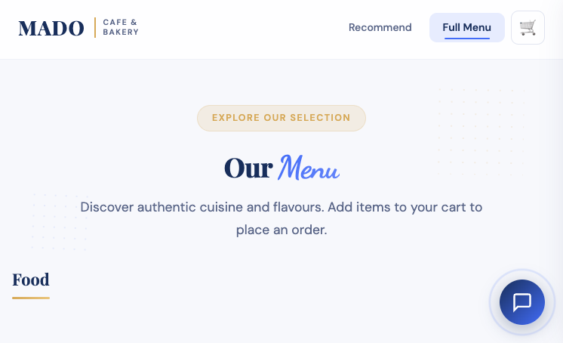
Full Menu page
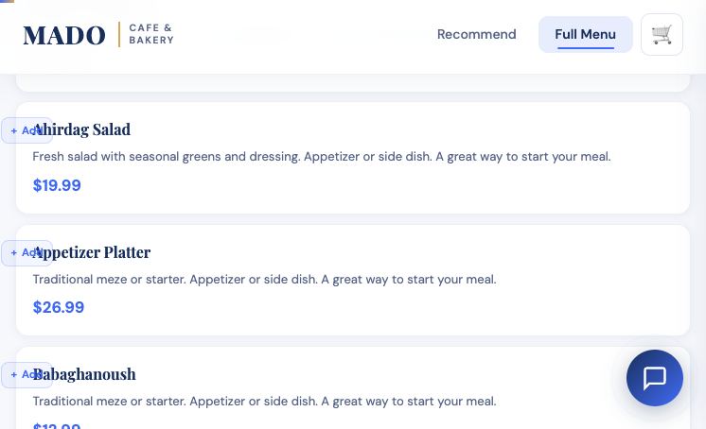
Menu items with quick add buttons

Cart Panel (Order Builder)
- Sticky cart icon opens a side panel.
- Supports quantity changes, remove items, clear cart, and order submission (demo).
- Cart is stored in localStorage for a smooth UX across pages.
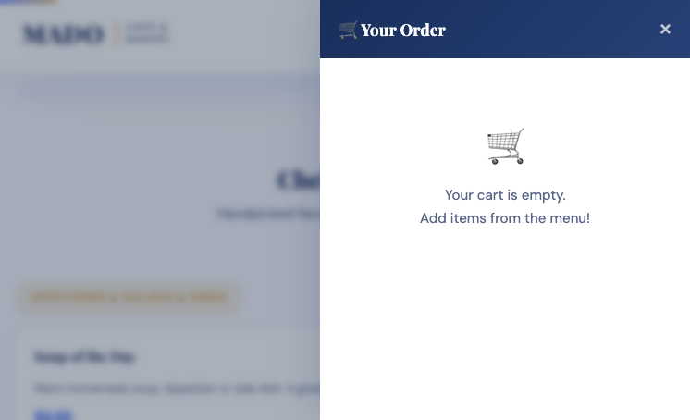
Cart panel UI (example)

AI Concierge Chat (Optional)
- Chat widget answers questions about menu items and makes recommendations.
- Uses only real menu items (no hallucinated items).
- Language-matching: replies in the same language as the customer message.
- Providers: Groq (Llama) if configured, otherwise Gemini (optional).
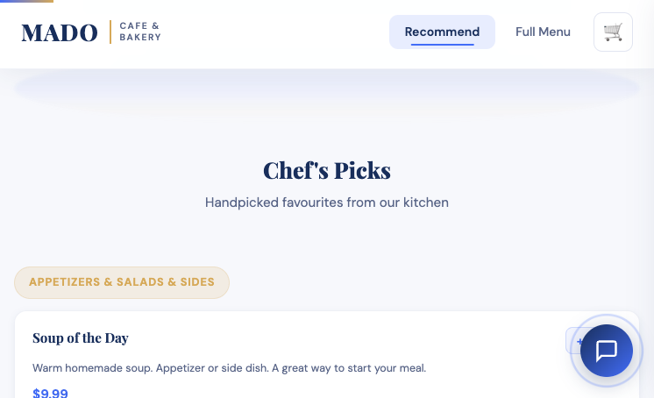
Chat widget entry point

Recommendation Engine — Strategies
- Content-based: TF‑IDF over item name/category/description + cosine similarity.
- Fuzzy matching: Levenshtein ratio + WordNet synonym expansion.
- Collaborative filtering: user×item implicit matrix → Truncated SVD.
- BPR: pairwise ranking optimized with SGD for implicit feedback.
- Popularity: time-decayed interaction-weighted trending score.
- Hybrid: weighted ensemble that redistributes weights if models are not trained yet.
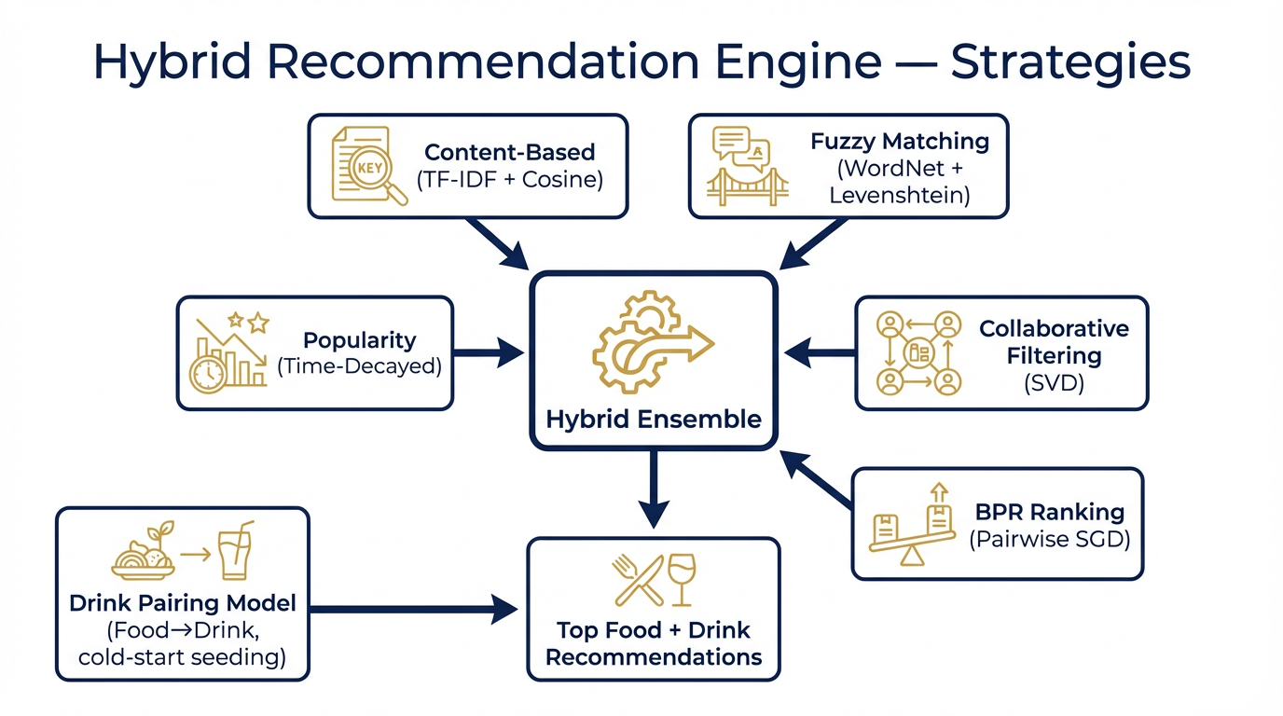
Hybrid ensemble overview

Learning & Personalization
- Tracks interactions such as view/click/like/order to build implicit ratings.
- Persists events to `user_data/interactions.json` (simple, portable storage).
- Cold-start seeding generates synthetic profiles so CF/BPR work immediately.
- Retrain endpoint updates CF/BPR + drink pairing model from recent interactions.

Key API Endpoints

Backend (Flask, port 5008)
Method | Endpoint | Purpose
GET | /api/menu | Full menu (foods + drinks)
POST | /api/recommend | Food+drink recommendations (strategy-based)
POST | /api/track | Track interactions (view/click/like/order/rate)
GET | /api/chefs-picks?per=3 | Chef’s picks (per category)
GET | /api/popular?n=8 | Trending/popular items
GET | /api/similar?item=...&n=6 | Similar items using item-item similarity
GET | /api/personalized?user_id=...&n=8 | Personalized recommendations (CF+BPR)
POST | /api/retrain | Retrain CF/BPR/pairing models from interactions
GET | /api/stats | Engine statistics (items/users/interactions/etc.)

Frontend (Express, port 3001)
Route | Type | Purpose
/ | Page | Recommend form + Chef’s Picks
/preferences | Page | Recommendation results
/menu | Page | Full menu browsing
/api/like | API | Like an item (proxies to backend tracking)
/api/chat | API | AI concierge chat (Groq/Gemini optional)
/api/order | API | Create order (in-memory demo)
/api/orders | API | View received orders (in-memory demo)

Demo Script (5–7 minutes)
- Open Home → enter a craving (food/drink) → show recommendations + match scores.
- Open Full Menu → add a few items → open cart panel.
- Show Like/interaction behavior (improves popularity/personalization over time).
- Optionally show the AI concierge answering a menu question (if API key configured).

Start here

