Restaurant Recommendation System
User Guide Presentation • Mar 04, 2026
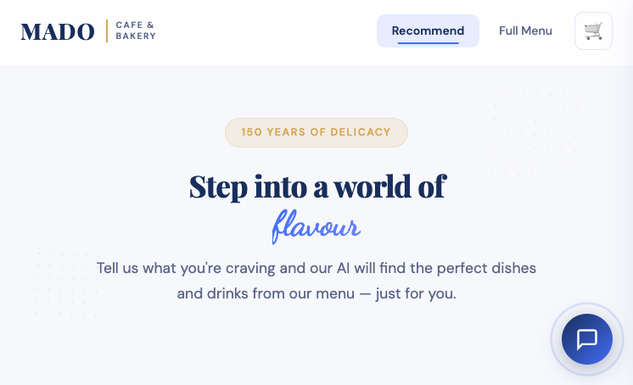
Home page

Overview (What It Does)
- Helps customers quickly find the best food and drink options from the restaurant’s menu.
- You can search by cravings (keywords), browse the full menu, chat with the assistant, and build an order in the cart.

Start from the Home page

How to Use — Recommendations
- On the Home page, type what you want to eat and/or drink (at least one field).
- Click “Get Recommendations”.
- You’ll see recommended foods and drinks with prices (and match indicators).
- Use “Try Again” to quickly run a new search.
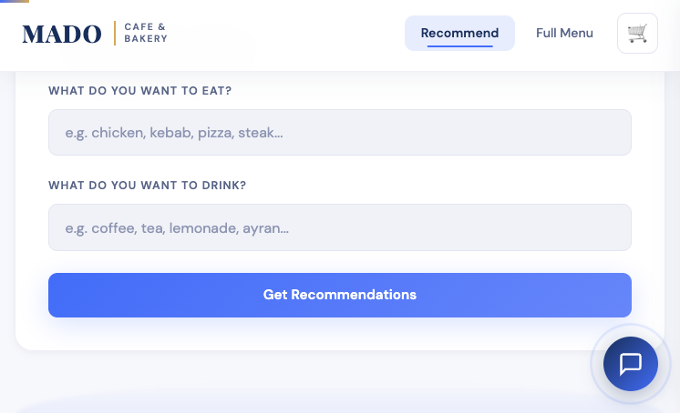
Enter your cravings
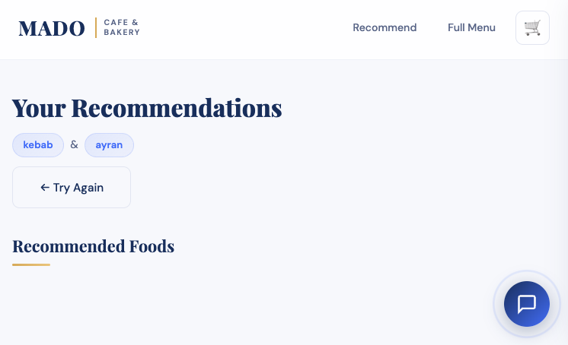
Results page

How to Use — Explore Recommendation Cards
- Each recommendation appears as a card with the item name, short description, and price.
- Use “Add to Cart” to build your order.
- Use “Show similar” to explore alternatives (useful if you want something close but different).
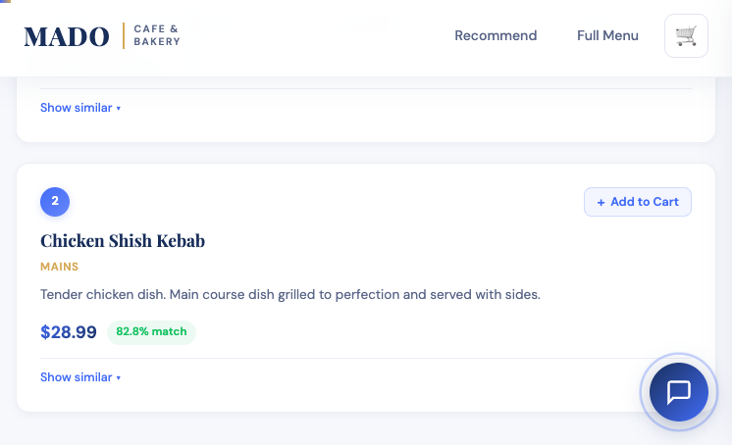
Recommendation cards

How to Use — Chef’s Picks
- Chef’s Picks are curated highlights shown on the Home page.
- Great for quick browsing when you don’t want to type a search.
- You can add picks directly to your cart.
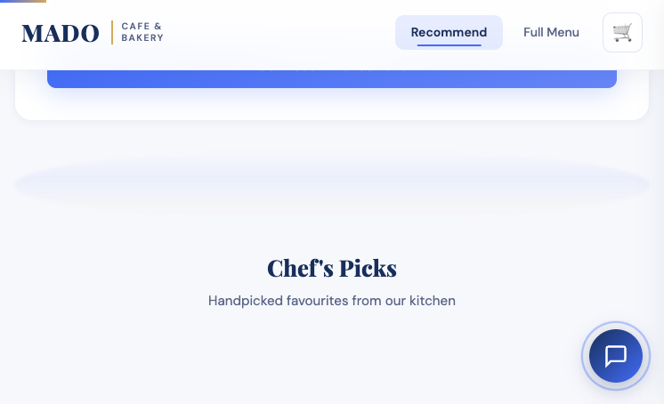
Chef’s Picks section

How to Use — Full Menu
- Click “Full Menu” in the navigation bar.
- Browse foods and drinks grouped by categories.
- Use the “Add” buttons to add items to your cart while browsing.
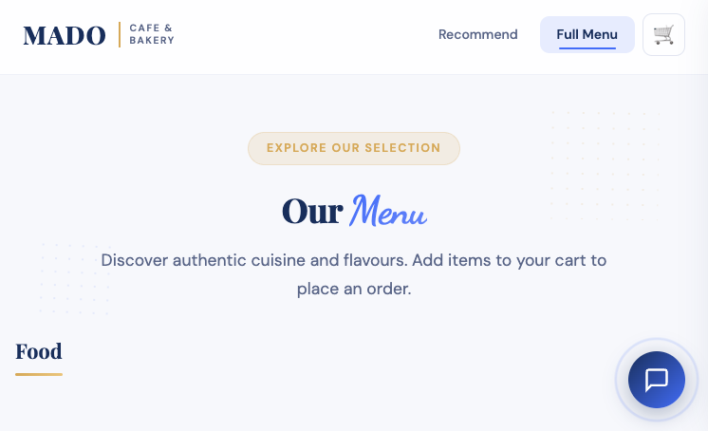
Full Menu page
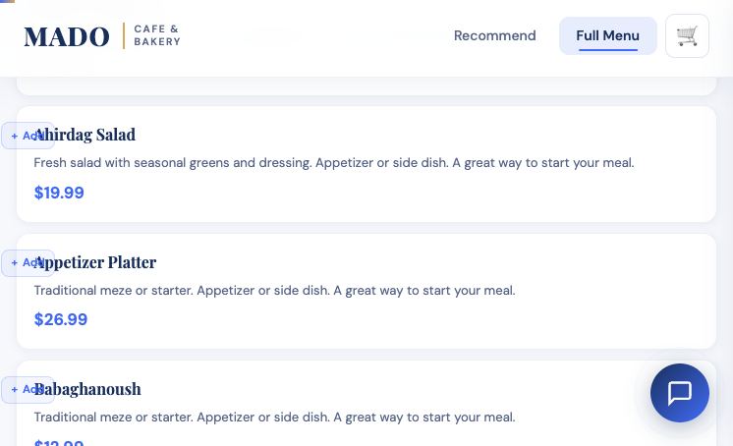
Menu browsing + quick add

How to Use — Cart
- Click the cart icon (🛒) to open the cart panel.
- Increase/decrease quantities, remove items, or clear the cart.
- When ready, you can place the order (demo flow) and get an order number.
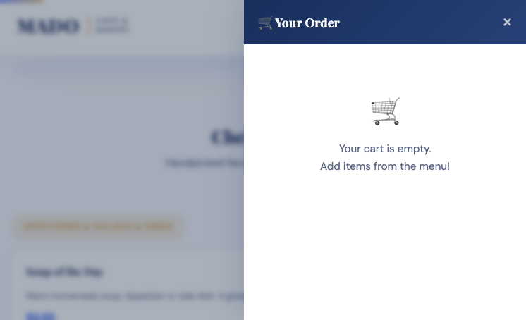
Cart panel

How to Use — Chatbot (Concierge)
- Click the chat bubble to open the concierge assistant.
- Ask questions like: “What do you recommend with kebab?” or “Do you have something sweet?”
- The chatbot helps you discover menu items and make choices faster.
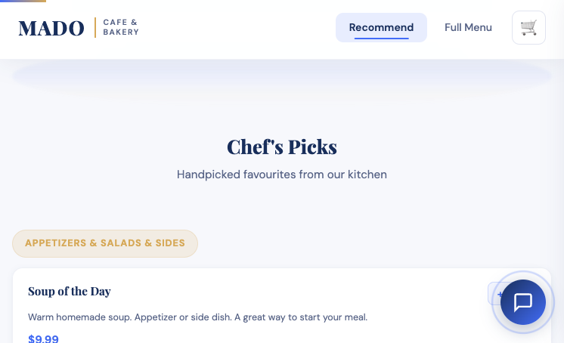
Chat widget

Typical Demo Flow (3–5 minutes)
- Home → type a craving → show recommendations.
- Add 2–3 items to cart → open cart panel and adjust quantities.
- Open Full Menu → browse categories and add one more item.
- Open chatbot → ask a question about a dessert or drink suggestion.

Suggested demo starting point

