Restaurant Recommendation System
Feature Presentation Document
Date: March 04, 2026

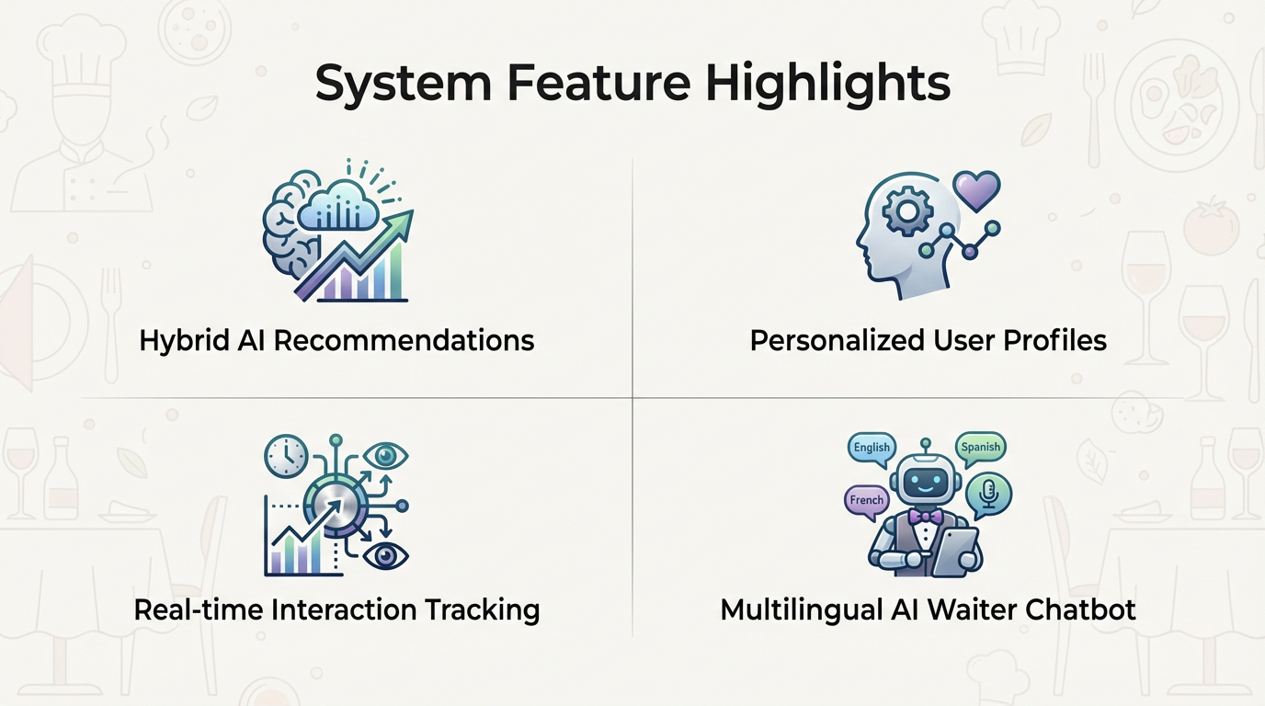

1) System Overview
This system provides intelligent food and drink recommendations for a restaurant menu. It combines a modern web interface with a machine-learning backend and supports personalized, explainable, and continuously improving recommendations.
- Frontend: Express.js + EJS web application
- Backend API: Flask REST service
- Data source: mado_menu.csv menu dataset
- Personalization: user interaction tracking and profile-based ranking
- AI assistant: multilingual waiter chatbot (Groq/Gemini support)

2) Architecture
High-level architecture of the complete solution:
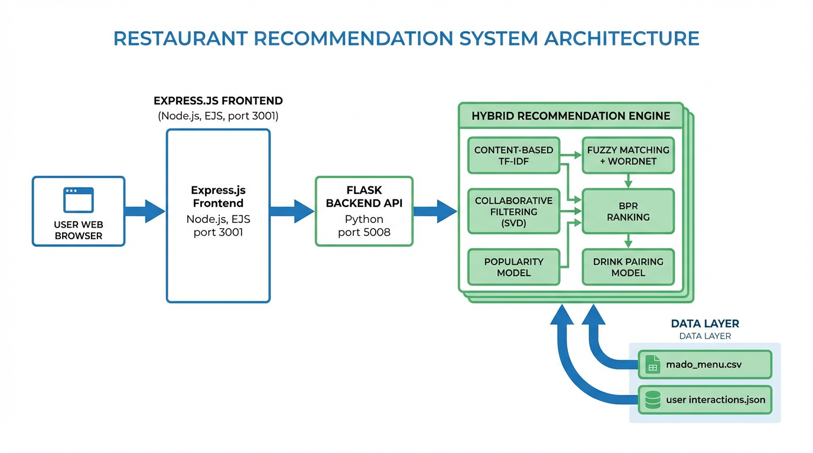

3) Core Recommendation Features
The hybrid engine combines multiple algorithms to improve relevance and robustness.
- Content-Based (TF-IDF + Cosine Similarity): Matches user intent to item names, categories, and descriptions.
- Fuzzy Matching + WordNet Synonyms: Handles spelling variations and semantically related words.
- Collaborative Filtering (SVD): Learns from user-item interaction patterns.
- BPR Ranking (Bayesian Personalized Ranking): Optimizes personalized top-N ranking from implicit feedback.
- Popularity Model: Uses weighted and time-decayed interactions for trending items.
- Drink Pairing Model: Recommends compatible food-drink pairings with gating and thresholds.

4) Recommendation Pipeline
Operational flow from user input to personalized output:
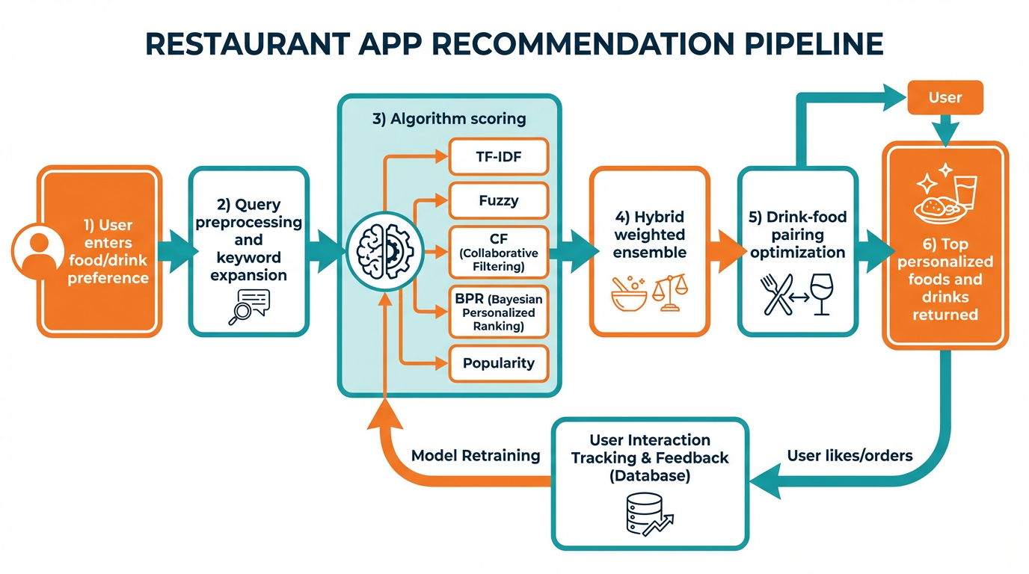

5) User-Facing Features
- Preference form for food and drink queries
- Recommended foods and drinks with category, description, and price
- Chef's picks and popular items endpoints
- Similar-items exploration for menu discovery
- Lightweight order API for request capture
- Multilingual conversational waiter chatbot with menu-grounded responses

6) API Capabilities
- POST /api/recommend: personalized food/drink recommendations
- GET /api/menu: full structured menu (foods and drinks)
- POST /api/track: user interaction tracking (view/click/like/order)
- GET /api/similar: similar-item retrieval
- GET /api/popular: trending foods and drinks
- GET /api/personalized and GET /api/stats: personalization and engine metrics
- POST /api/retrain: model refresh based on latest interactions

7) Why This System Is Strong
- Hybrid design improves accuracy versus single-model recommenders
- Cold-start support with auto-generated seed behavior data
- Continuous learning from real interaction feedback
- Business-ready separation of frontend and ML backend
- Scalable foundation for future analytics and dashboarding

End of Presentation

